Website Accessibility Checklist

**UI Design Document**

**Team 2:** Jacob Mathison, Emily Buzle, Taylor Williams, Jadyn Smith, Javid Ditty

# 

**Table of Contents**

**1.0 Introduction** **3**

1.1 Goals and Objectives 3

1.2 Statement of Scope 3

1.3 Software Context 4

1.4 Major Constraints 4

**2.0 Data Design** **6**

2.1 Internal Software Data Structure 6

2.2 Global Data Structure 6

2.3 Temporary Data Structure 8

2.4 Database Description 8

**3.0 Architectural and Component-Level Design** **9**

3.1 Program Structure 9

3.1.1 Architecture Diagram 9

3.1.2 Alternatives 10

3.2 Description of Components 11

3.2.1 Question 11

3.2.2 ChecklistHandler 12

3.2.3 ChecklistView 17

3.2.4 ResultView 18

3.3 Software Interface Description 20

3.3.1 External Machine Interfaces 20

3.3.2 External System Interfaces 20

3.3.3 Human Interface 20

**4.0 User Interface Design** **22**

4.1 Description of the User Interface 22

4.1.1 Screen Images 24

4.1.2 Objects and Actions 27

4.2 Interface Design Rules 28

4.3 Components Available 29

4.4 UIDS Description 29

**5.0 Restrictions, Limitations, and Constraints** **30**

**6.0 Testing Issues** **31**

6.1 Classes of Tests 31

6.2 Expected Software Response 31

6.3 Performance Bounds 32

6.4 Identification of Critical Components 33

**7.0 Appendices** **34**

7.1 Requirements Traceability Matrix 34

7.2 Packaging and Installation Issues 35

7.3 Design Metrics to be Used 35

7.4 Supplementary Information 36

# 

# **1.0 Introduction**

## **1.1 Goals and Objectives**

The goal of this software is to facilitate the assessment process of a website by using an accessibility checklist in the form of a questionnaire. It will allow the users to evaluate the quality and effectiveness of an app. This will be achieved through a website that allows users to answer questions regarding the organization and presentation of content, the functionality of website components, efficiency of use, ability to find relevant information, as well as overall aesthetics. These questions will be evaluated and interpreted to provide the user with a score that shows the quality of the accessibility of the website.

## **1.2 Statement of Scope**

**Users**

Users of this software will be web application testers and end users (referenced as users in this document) that will evaluate website accessibilities with a questionnaire.

**Inputs**

Users will provide “yes,” “no,” and “n/a” answers to each question in the accessibility checklist.

**Processing Functionality**

User responses will be stored temporarily in order to compute the necessary calculations to determine the score. But results and responses will not be saved long-term. This means that the only data storage will be for the questions. This will be stored in a JSON file.

**Outputs**

There will be three pages for this application. The first will be the user input screen where the questions will be presented, described, and answered. Also on this screen will be the title and a short description of the software scope and functionality. The second screen will be the results screen which will describe the methods and equations used to find the totals for each section of the questionnaire. The final total will be presented as well as final insights based on the score. There will also be a page for the user manual as well, which will answer any questions the user may have and display the calculations used to find the resulting score.

## **1.3 Software Context**

This questionnaire will allow for the easy quantification of the quality of the accessibility of a web application. For users and developers testing and providing feedback on applications that they are using or making, this provides a consistent source of feedback that can be replicated. This makes the testing and reviewing process more objective and allows people to return to our software and take the questionnaire again to gauge improvement on their development. We will use the Web Content Accessibility Guidelines (WCAG), specifically where it applied to web applications. This is a set of documents formulated by the Accessibility Guidelines Working Group which covers recommendations for making web content more accessible, and many of the points covered apply to apps by extension. Another source that we will use as a guide to formulate our questions in order to evaluate the software of other mobile applications is the WC3 Mobile Application Best practices. It is different from the mobile browsing best practices because it considers the development of web applications for mobile devices, which is what our accessibility checklist will be evaluating.

## **1.4 Major Constraints**

One constraint is related to the number and types of questions that the user is required to answer to determine the quality of their application’s accessibility. The development team will determine the types of questions that need to be answered to determine the state of the user’s application.

The questionnaire will be also limited to yes, no and n/a questions. Each question will need to provide hints that will elaborate the question for the user to help them determine if their application answers the question or not. Each hint will only provide guidance on the current question. For each question, the user only has to click the yes or no option to answer the question.

A weighted table will be designed to calculate how important each question is to create an accessible application. It will be constrained based on what the developers determine is important to create an accessible application. The rating that the user will be given on a scale of bad, fair, good, great or excellent with the overall score.

# 

# **2.0 Data Design**

## **2.1 Internal Software Data Structure**

| **Question** – Model that represents a question that can be put into the checklist. | |
| --- | --- |
| **Attribute/Method** | **Definition** |
| - QUESTIONS: Object | Questions read from the database file using read(path). For information about its structure, see Section 2.4. |
| - id: int | Unique number that is used to identify a question. |
| - content: String | That which is being asked by a question. |
| - answer: boolean | That which is given in response to a question. |
| - weight: int | Impact that the question has on the accessibility score. |
| - hint: String | Elaboration on the content of a question. |
| - tip: String | Guide for following guidelines that a question implies. |
| + constructor(id: int) | Constructs a question object and initializes it with the question that has the id in QUESTIONS. |
| - read(path: String): void | Reads object at database file located at path and stores the result in QUESTIONS. For information about its structure, see Section 2.4. |

## **2.2 Global Data Structure**

| **ChecklistHandler** – Controller that handles the checklist and its interactions. | |
| --- | --- |
| **Attribute/Method** | **Definition** |
| - questions: Question[] | Questions that are on the checklist. |
| + constructor() | Constructs a ChecklistHandler object, initializing its question field using its getQuestions() method. |
| + getQuestions(): Question[] | Converts the QUESTIONS attribute in the Question class into Question objects. |
| + sendQuestions(): void | Sends questions to the ChecklistView class to render. |
| + getScore():int | Calculates the accessibility score from each question.answer in ChecklistHandler.questions and returns it. |
| + sendScore(score: int): void | Sends score to the ResultView class to render. |
| + sendTips(ids: String[]): void | Retrieves tips from the questions with an id in ids and sends them to the ResultView class to render. |
| + getNo(): Question[] | Gets each question in ChecklistHandler.questions with a “No” answer and returns them. |
| + getAnswers(): void | Updates each question.answer in ChecklistHandler.questions with the corresponding answer in questionnaire. |
| + submit(href: String): void | Gets the accessibility score and the ids of all the questions with “No” answers; attaches them as query strings to href; and directs the user to the resulting url. |
| + clear(): void | Send a request to ChecklistView to clear the questionnaire. |

## 

| **ChecklistView** – View that represents the checklist. | |
| --- | --- |
| **Attribute/Method** | **Definition** |
| + renderQuestions(questions: { id:String : {content: String, hint: String } }): void | Renders the UI with all the questions in questions. |
| + clear(): void | Resets all the answer radio button groups in the questionnaire to the “N/A” answer. |

## 

| **ResultView** – View that represents the checklist results. | |
| --- | --- |
| **Attribute/Method** | **Definition** |
| + renderScore(score: int, rating: int): void | Renders the accessibility score, the accessibility rating, and the score bar progress with score and rating. |
| + renderTips(tips: String[]): void | Renders the tips section with all the tips in tips. |

## **2.3 Temporary Data Structure**

No temporary data structures are used in this project.

## **2.4 Database Description**

Because only question ids, contents, weights, hints, and tips require permanent storage and JSON files have a high compatibility with JavaScript, this project will use a JSON file as a database. The file will have the format shown in the image titled “2.4 - Database Format” with the id as the primary key.

# 

# **3.0 Architectural and Component-Level Design**

## **3.1 Program Structure**

For this project, we have selected the MVC (Model View Controller) Architecture. The Model component contains content and logic concerning the manipulation of data, and it has sole access to the database. The View component handles the visual aspect of the website, or the UI, and it portrays the data model to the user. The Controller component connects the Model and View, handling the real-time data requests from the browser. For us, this means that it will handle answer collection, and the calculation of the accessibility score, values that will never be stored within the database.

### **3.1.1 Architecture Diagram**

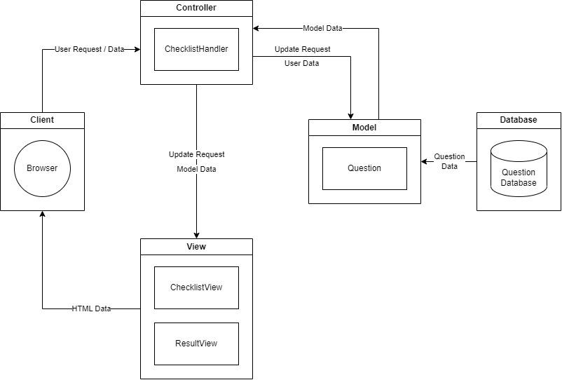

### **3.1.2 Alternatives**

We selected the MVC architecture because:

* It is a popular web development architecture.
* It separates the project into three distinct components that will improve unit testing and maintenance tasks.
* It reduces the coupling between components, improving the reusability of each component.

We considered alternative architectures such as:

* *Data-Centered* – Because our project relies on a database that contains questions, a data store is central to our project. However, data-centered architectures are designed for projects that frequently access and update data within the store. Our project does not modify the store directly, and it only accesses it once at startup, contradicting the purpose of this architecture.
* *Object-Oriented* – Because our project’s functions can be captured by distinct and well-defined objects and their communication, this architecture could have been a good choice for our project. However, it does not define object roles as distinctly as the MVC architecture, making it more difficult to understand and maintain.

## 

## **3.2 Description of Components**

### **3.2.1 Question**

**3.2.1.1 Processing Narrative (PSPEC)**

Before instantiation, the Question class initializes its QUESTIONS field with the object contained in the database file. QUESTIONS is initialized using the read method. Instantiation starts once a question id is passed to the Question class constructor. The constructor retrieves the data from QUESTIONS that have a matching id, creates a question object, and initializes the id, content, weight, hint, and tip fields of the question object with the data. The answer field is initialized with a null value.

**3.2.1.2 Interface Description**

Question receives as input an id from a ChecklistHandler object and an id, content, weight, hint, and tip from the database file. Question sends as output its id, content, weight, hint, answer, and tip fields to the ChecklistHandler.

**3.2.1.3 Description of Sub-Components**

**3.2.1.3.1 constructor(id: int)**

**3.2.1.3.1.1 Interface Description**

It receives as input an id from a ChecklistHandler object and content, weight, hint, and tip from Question.QUESTIONS. It sends as output a Question object.

**3.2.1.3.1.2 Algorithmic Model**

Function constructor(id: int)

this.id = id

this.content = Question.QUESTION[id].content

this.weight = Question.QUESTION[id].weight

this.hint = Question.QUESTIONS[id].hint

this.tip = Question.QUESTIONS[id].tip

this.answer = null

End

**3.2.1.3.1.3 Restrictions/Limitations**

To operate correctly, the database file must exist, and the system must be able to access it. It is used to define the QUESTIONS field.

**3.2.1.3.1.4 Local Data Structures**

It uses the QUESTIONS, id, content, weight, hint, tip, and answer fields.

**3.2.1.3.2 read(path: String): Object**

**3.2.1.3.2.1 Interface Description**

It receives as input a path to the database file with the structure described in section 2.4. It sends as output the object it extracts from the database file.

**3.2.1.3.2.2 Algorithmic Model**

Function read(path: String): void

json = null

read object from file at path into result

Question.QUESTIONS = json

End

**3.2.1.3.2.3 Restrictions/Limitations**

To operate correctly, the database file must exist, and the system must be able to access it.

**3.2.1.3.2.4 Local Data Structures**

It uses QUESTIONS and the object structure defined in section 2.4.

**3.2.1.3.2.5 Performance Issues**

Because this sub-component reads data from a file on the hard drive, the speed of this reading depends on the structure and health of the drive itself as well as the drivers used to read it.

### **3.2.2 ChecklistHandler**

**3.2.2.1 Processing Narrative (PSPEC)**

Instantiation starts without any arguments passed to the ChecklistHandler class constructor. The constructor retrieves the QUESTIONS attribute in the Question class using the getQuestions method and converts it into a collection of Question objects, storing them in the questions field. Upon receiving requests from the browser, ChecklistHandler objects can send questions, accessibility scores, and tips to the views to be rendered using sendQuestions, sendScore, and sendTips respectively. They can also update the answers of their questions field with the answers received from the browser.

**3.2.2.2 Interface Description**

ChecklistHandler receives as an input the object in the QUESTIONS attribute in the Question class and question answers from the browser. It sends as an output questions, accessibility scores, and tips to the views to be rendered using sendQuestions, sendScore, and sendTips respectively.

**3.2.2.3 Description of Sub-Components**

**3.2.2.3.1 constructor()**

**3.2.1.3.1.1 Interface Description**

It receives nothing as an input but updates its questions field as an output with questions from its getQuestions() method.

**3.2.2.3.1.2 Algorithmic Model**

Function constructor()

this.questions = this.getQuestions();

End

**3.2.2.3.1.3 Local Data Structures**

It uses the QUESTIONS attribute in the Question class.

**3.2.2.3.2 getQuestions(): Question[]**

**3.2.1.3.2.1 Interface Description**

It receives as an input the object in the QUESTIONS attribute in the Question class. It sends as an output Question objects to its questions field.

**3.2.2.3.2.2 Algorithmic Model**

Function getQuestions(): Question[]

for each key in Question.QUESTIONS

questions[key] = Question(key)

End

**3.2.2.3.2.3 Local Data Structures**

It uses the QUESTIONS attribute in the Question class.

**3.2.2.3.3 sendQuestions(): void**

**3.2.2.3.3.1 Interface Description**

It receives nothing as an input, and it sends as an output question ids, contents, and hints to the ChecklistView object.

**3.2.2.3.3.2 Algorithmic Model**

Function sendQuestions(): void

questions = {}

[For each question in ChecklistHandler.question, append id : {content, hint} to questions]

ChecklistView.renderQuestions(questions)

End

**3.2.2.3.3.3 Local Data Structures**

It uses the questions attribute in the ChecklistHandler class.

**3.2.2.3.4 getScore(): int**

**3.2.2.3.4.1 Interface Description**

It receives nothing as an input, and it sends as an output an accessibility score.

**3.2.2.3.4.2 Algorithmic Model**

Function getScore(): int

let yes, total = 0;

For each question in ChecklistHandler.questions

if (question.answer != null) total += question.weight

if (question.answer === true) yes += question.weight

return (total === 0) ? 100 : (100 * yes) / total

End

**3.2.2.3.4.3 Local Data Structures**

It uses the questions attribute in the ChecklistHandler

class.

**3.2.2.3.5 sendScore(score: int, rating: int): void**

**3.2.2.3.5.1 Interface Description**

It receives a score and rating as input, and it sends as an output an accessibility score to the ResultView object.

**3.2.2.3.5.2 Algorithmic Model**

Function sendScore(score: int, rating: int): void

rating = “”

Calculate the rating from score and store it in rating

ResultView.renderScore(score, rating)

End

**3.2.2.3.6 sendTips(ids: String[]): void**

**3.2.2.3.6.1 Interface Description**

It receives question ids as input, and it sends as an output question tips to the ResultView object.

**3.2.2.3.6.2 Algorithmic Model**

Function sendTips(ids: String[]): void

tips = [];

for each question in ChecklistHandler.questions with id in ids

tips.push(question.tip);

ResultView.renderTips(tips)

End

**3.2.2.3.6.3 Local Data Structures**

It uses the questions attribute in the ChecklistHandler

class.

**3.2.2.3.7 getNo(): Question[]**

**3.2.2.3.7.1 Interface Description**

It receives nothing as input, and it sends as an output questions in ChecklistHandler with “No” answers.

**3.2.2.3.7.2 Algorithmic Model**

Function getNo(): Question[]

no = []

for each question in questions with answer === false

no.push(question);

return no;

End

**3.2.2.3.7.3 Local Data Structures**

It uses the questions attribute in the ChecklistHandler

class.

**3.2.2.3.8 getAnswers(): void**

**3.2.2.3.8.1 Interface Description**

It receives nothing as input, and it sends as an output updated answers to questions in ChecklistHandler.questions.

**3.2.2.3.8.2 Algorithmic Model**

Function getAnswers(): void

for each answer in the document

assign answer to corresponding question in questions

End

**3.2.2.3.8.3 Local Data Structures**

It uses the questions attribute in the ChecklistHandler

Class.

**3.2.2.3.9 submit(href: String): void**

**3.2.2.3.9.1 Interface Description**

It receives a href as an input, and it sends as an output a navigation request to the browser.

**3.2.2.3.9.2 Algorithmic Model**

Function submit(href: String): void

getAnswers()

score = getScore()

no = getNo()

url = `${href}?score=${score}&tips=`

Append each question id in no to url’s query string

Navigate browser to url

End

**3.2.2.3.9.3 Local Data Structures**

It uses the questions attribute in the ChecklistHandler

class.

**3.2.2.3.10 clear(): void**

**3.2.2.3.10.1 Interface Description**

It receives nothing as input and returns a render request to ChecklistView to reset answers in the document to “N/A.”

**3.2.2.3.10.2 Algorithmic Model**

Function clear(): void

ChecklistView.clear();

End

### **3.2.3 ChecklistView**

**3.2.3.1 Processing Narrative (PSPEC)**

ChecklistView is not supposed to be instantiated; all its operations are on the class, rather than the object, level. It receives as inputs an object filled with question ids, contents, and hints. It outputs question UI elements to the browser.

**3.2.3.2 Interface Description**

It receives as inputs an object filled with question ids, contents, and hints from the ChecklistHandler. It outputs question UI elements to the browser.

**3.2.3.3 Description of Sub-Components**

**3.2.3.3.1 renderQuestions(questions: {id:String {content: String, hint: String}}): void**

**3.2.3.3.1.1 Interface Description**

It receives as inputs an object filled with question ids, contents, and hints from the ChecklistHandler. It outputs question UI elements to the browser.

**3.2.3.3.1.2 Algorithmic Model**

Function renderQuestions(questions: {id:String {content: String, hint: String}}): void

html = “”

for each id in questions

html += html for questions[id] (See section 4)

Add html to the questions section of the UI

End

**3.2.3.3.1.3 Local Data Structures**

It uses an object filled with question ids, contents, and hints from the ChecklistHandler

**3.2.3.3.2 clear(): void**

**3.2.3.3.2.1 Interface Description**

It receives nothing as input, and it resets answer radio buttons on the UI to “N/A” as output.

**3.2.3.3.2.2 Algorithmic Model**

Function clear(): void

Select all the answer radio buttons on the document

Set the “N/A” radio buttons and unset all other buttons

End

### **3.2.4 ResultView**

**3.2.4.1 Processing Narrative (PSPEC)**

ResultView is not supposed to be instantiated; all its operations are on the class level, rather than the object. It receives as inputs an accessibility score and tips. It sends as output accessibility score and tip UI elements to the browser.

**3.2.4.2 Interface Description**

It receives as inputs an accessibility score and tips. It sends as output accessibility score and tip UI elements to the browser.

**3.2.4.3 Description of Sub-Components**

**3.2.4.3.1 renderScore(score: int): void**

**3.2.4.3.1.1 Interface Description**

It receives as inputs an accessibility score. It sends as output accessibility score UI elements to the browser.

**3.2.4.3.1.2 Algorithmic Model**

Function renderScore(score: int): void

Set the text accessibility score on the document to score.

Set the accessibility score bar on the document to score.

End

**3.2.4.3.2 renderTips(tips: String[]): void**

**3.2.4.3.2.1 Interface Description**

It receives as input question tips. It sends as output tip UI elements to the browser.

**3.2.4.3.2.2 Algorithmic Model**

Function renderTips(tips: String[]): void

html = “”

For each tip in tips

html += html for tip

Add html to the tips section in the document.

End

## 

## **3.3 Software Interface Description**

### **3.3.1 External Machine Interfaces**

This software system will only have a few optional external machine interfaces. In order for a user to configure the software system with ease then serial interfaces can be connected. If the user decides to access the system through a computer then such serial interfaces can be keyboard and mouse devices. However, these serial interfaces are not required to manipulate the system as there are alternatives, such as an on-screen keyboard that generally are pre-installed on computer devices and touchpads that are also usually built onto laptop devices.

### **3.3.2 External System Interfaces**

This software system will mainly function on its own website. The website in question would have to be accessed through an operating system, then to an internet browser. Examples of available operating systems that can be used to access this system can possibly be Microsoft Windows or Mac OS. Upon the user obtaining an operating system, they can navigate to the software’s website by using an internet browser such as Google Chrome, FireFox, or Microsoft Edge. Each of these example internet browsers have search engines like Google or Yahoo, where the user can search for the system’s website URL if they choose to do so. For this to be functional, the system must be able to connect to a server and/or the internet. The user will be responsible for connecting to a local internet server.

### **3.3.3 Human Interface**

This software will primarily feature a human interface. This specific interface being a user interface that allows the user to easily interact with the software system’s features. The user interface will consist of three components: homepage, results page, and manual page. The homepage will display the accessibility checklist the user can fill out. The results page that will show the user how well their system fits in terms of accessibility. Lastly, the manual page will provide information to the user on how to work the accessibility checklist if they need help. More information on human interfaces are available in section 4.0.

# 

# **4.0 User Interface Design**

The user interface in this project will consist of 3 screens. The home screen will be where the user inputs their answers into the accessibility questionnaire. The results screen will output the user’s accessibility score calculated from their answers and give some tips to improve their application’s accessibility. The third screen is a help manual screen where information will be provided to the user on how to use the questionnaire and the website.

## **4.1 Description of the User Interface**

**Home Page**

The home page starts with the application title at the top. The button for accessing the help manual page is on the top right of the home page. Below the title is a text that has instructions for using the hints option for each question. Below that are the questions that the user will have to answer to generate an accessibility score.

The question section will contain yes/no questions for the user to answer based on their website. The user can hover over the hint icon to get help with answering that specific question. The user can also select the N/A option to skip answering that specific question.

Below the questions section there are two buttons at the bottom of the page. The clear button will clear all answers in the questionnaire and reset them to N/A. The submit button will signal the application to calculate the user's answer and then send the user to the output page.

**Results Page**

The output page also has the website application and the help manual button at the top of the page. Below that is the primary output container for the web application. The first output is the calculated accessibility score based on the user's answers on the previous page. Below that is a bar that will give the user an idea of how good they scored on accessibility. Below that is the tips section where tips will be presented to the users based on their no answers in the questionnaire. There is also a home button below the container to take the user back to the home page.

**Manual Page**

The manual page will contain the application title again, and it will also have a container for application help. The container will have different sections that will instruct the user in how to use the application, particularly the questionnaire, and the website. Below the help container is a home button to return to the home page.

### 

### **4.1.1 Screen Images**

**UI Concept Images**

**Home Page Concept with Hints**

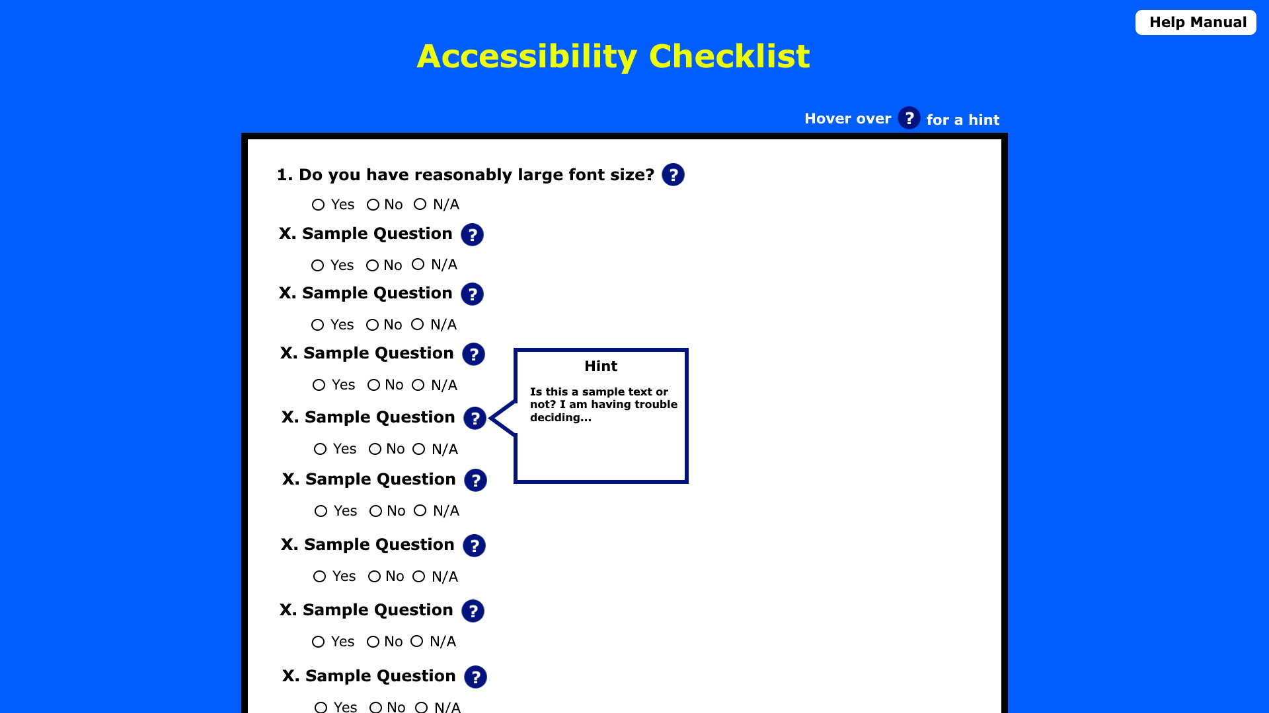

**Results Page Concept**

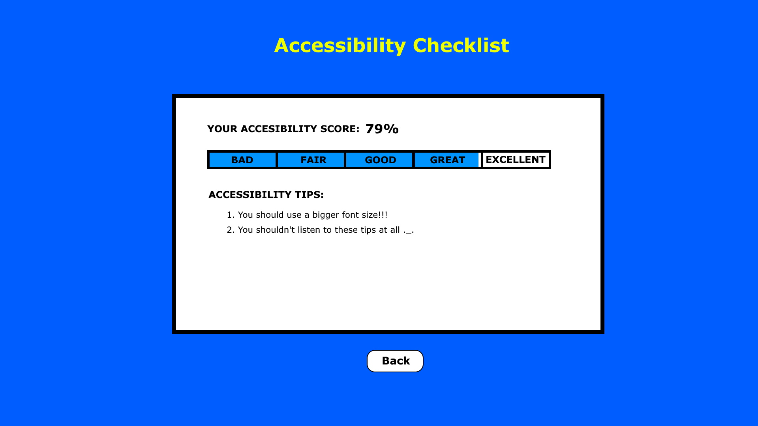

**Actual UI Images**

**Top of Home Page**

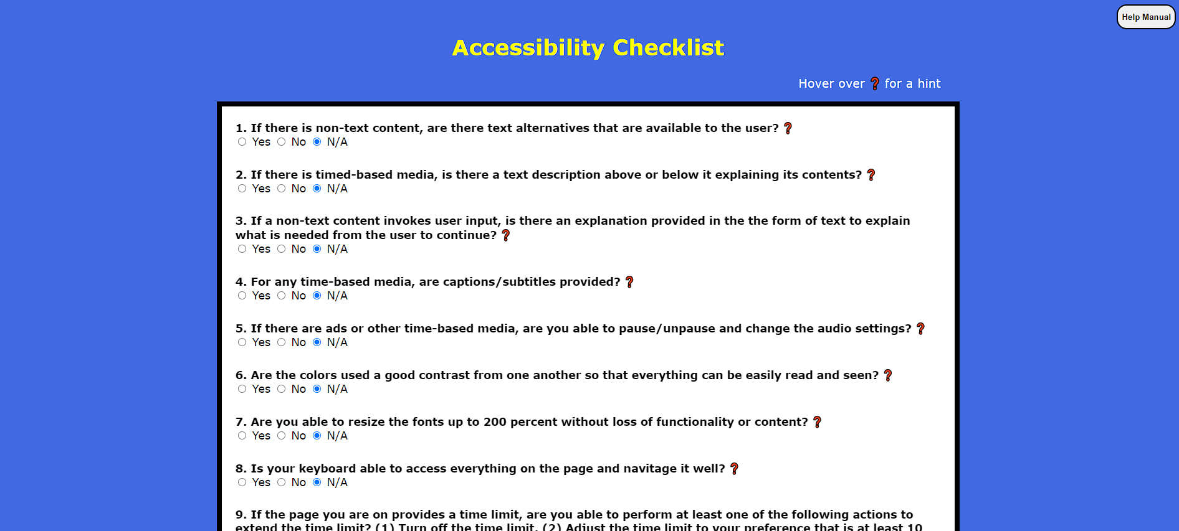

**Bottom of Home Page**

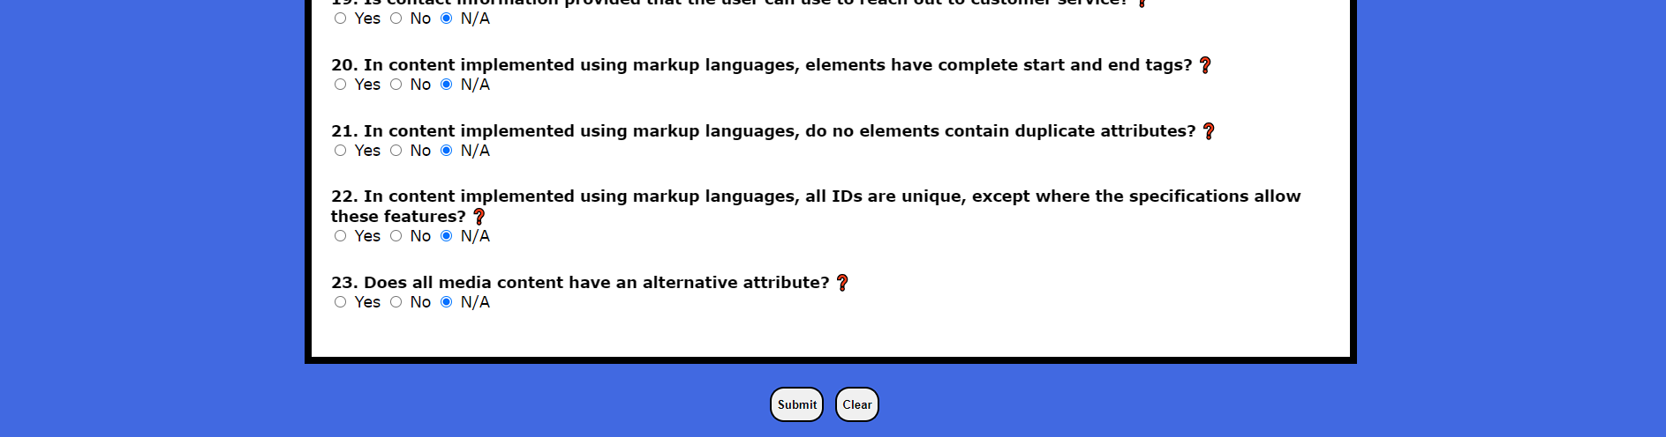

**Results Page**

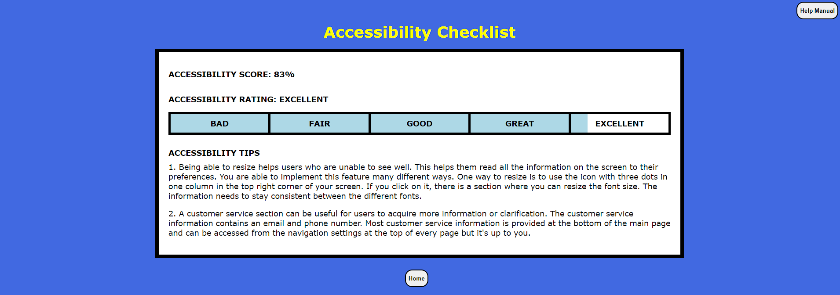

**User Manual Page**

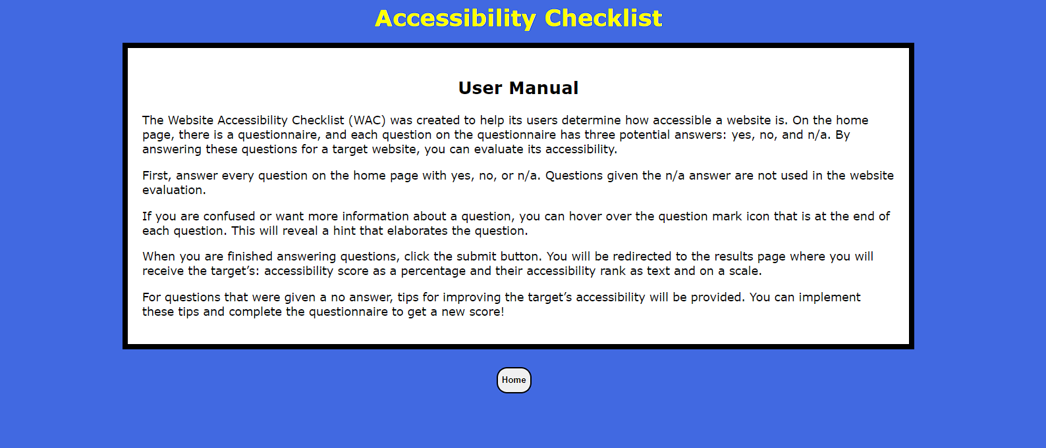

### 

### **4.1.2 Objects and Actions**

**Home Page**

* Help Manual Button – Directs the user to the manual page when clicked.
* Application Title – Displays the title of the application.
* Questionnaire Container – Container that holds questions.
* Question – Question in the questionnaire. Each question has the same format consisting of the following elements:
  + Number – Question’s place in the questionnaire.
  + Content – Question that the user is asked.
  + Hint Icon – Icon next to the content that presents a textbox that explains the question to the user when held on to or hovered over.
  + Answer Buttons – Radio buttons beneath the content that the user can select to indicate their answer to the question. Only one button can be selected per question.
* Control Buttons – Section beneath the questionnaire that contains buttons that can be used to control the questionnaire. It contains the following buttons:
  + Submit Button – Sends answers to the questionnaire to be processed and directs the user to the result page when clicked.
  + Clear Button – Resets all answers in the questionnaire to their default (i.e. N/A) when clicked.

**Results Page**

* Help Manual Button – Directs the user to the manual page when clicked.
* Application Title – Displays the title of the application.
* Result Container – Container that holds the results of the questionnaire, including the accessibility score and tip elements.
* Accessibility Score – Percentage calculated using the answers that the user gave to the questionnaire. It is represented as text.
* Accessibility Rating – Textual representation of the score bar.
* Score Bar – Graphical representation of the accessibility score as a progress bar. It consists of the following elements:
  + Categories – Equal width sections on the score bar with the following labels going left (low score) to right (high score): bad, fair, good, great, excellent.
  + Progress – Color bar beneath the categories whose width is identical to the accessibility score. It indicates the category that score is in.
* Tips – Section within the result container that contains tips.
  + Tips Title - Displays the title of the tips section within the tips section.
  + Tip – Text which indicates how the user can improve their accessibility score, or provide more “Yes” answers in the questionnaire.
* Home Button – Directs the user to the home page when clicked.

**Manual Page**

* Application Title – Displays the title of the application.
* Manual Container – Container that holds user manual information.
  + Manual Title – Displays the title of the manual within the container.
  + Manual Content – Content that is presented in the manual, including instructions to assist the user in using the application.
* Home Button – Directs the user to the home page when clicked.

## **4.2 Interface Design Rules**

The user interface has a couple universal design conventions. The first being the font. The UI uses Verdana font for every piece of text. This was chosen because it looks nice and it has good readability. Another almost universal design standard is that text is bolded. The title, questions, buttons, score, and sections are all bold font weight. The only things that don’t use bold text are the question answers and accessibility tips.

When it comes to color, blue was chosen as the whole site background. The same blue is also used for the score bar, and a darker blue was chosen for the question hints. All of the containers and buttons use white as their background color. All text inside the containers and buttons is a regular black, and the borders to containers and buttons are also black. The title was chosen to be yellow just to add a little bit of brightness and variety in color to the website.

## **4.3 Components Available**

The application currently has 4 main UI components available for implementation into the final package. The first is the website design. Design has been mostly completed for the UI, and the basic layout/design of the website has been implemented into a rudimentary and working prototype. The other 3 UI components available are the skeletons for each webpage.

The home page has the containers for the questionnaire setup and the questions designed. The questionnaire still needs to be implemented with the question database to load the questions into the webpage but the design for that is complete. The hints also need to be generated and their functionality implemented. The results page is also complete in design except that it needs to be implemented with the database as well to display accessibility tips. The score processing system also needs to be implemented between these two pages to give the user an accessibility score. The last thing that has been completed is the manual page. The container is all set except help documentation may need to be refined for completeness and altered based on changes to be ready for full release.

## **4.4 UIDS Description**

The prototype user interface presented in this section of the document was developed using visual studio code to edit html/css and the live server extension to run javascript code on it. The UI contains 3 HTML files: 1 for each webpage on the app. It also contains 4 css files: 1 for global use and 1 css file for every page. There are 3 javascript files: 1 for global use, 1 for the home page, and 1 for the results page. Finally there is a JSON file for the questions and related content that will be loaded into the UI.

# **5.0 Restrictions, Limitations, and Constraints**

The development team was restricted on time to complete this design document. The development team had less than a month to determine what tiny tool that they would focus on and the basic functionalities and features needed to help the user determine their application’s accessibility. We had to make sure to delegate the workload evenly and complete each section to the best of our ability to create a great tiny tool.

Another constraint is the length of the questionnaire. It should be able to be completed within a ten to fifteen minute interval to maximize the efficiency and effectiveness of the website. If the questionnaire is too long, it could overwhelm the user and could cause the data to be inconclusive. The questions need to be specific and intentional to provide the best analysis of the application and eliminate redundancies. The length of the questionnaire will focus on the qualitative, yes or no, questions.

The website must be able to scale with the user’s screen and be able to be viewed and used effectively on mobile devices as well as traditional browsers. All functionality and features need to be available on all screens. The questions must be easy to read, and more information/clarification to each question must be provided to the user in the form of hints, when needed. The navigation of the questions must be clear and separated into different sections based on the type of question. All the questions need to be on the home page and all the answers and tips need to be on the result page.

The site must conduct accurate calculations quickly, and the results page must load within 5 seconds of the user selecting the ‘submit’ button. The calculations need to be correct and provide a good assessment of the user’s application. The weight distribution for the yes or no questions need to also represent the importance to the overall application. If the weight distribution is incorrect, the application in question could be evaluated incorrectly and provide the user with faulty information. These constraints are also outlined in the Performance Bounds (Section 6.3).

# **6.0 Testing Issues**

## **6.1 Classes of Tests**

*For more detailed information regarding testing strategy, procedure, and classification, see the test plan for this system.*

Testing will be conducted in two ways. Black box testing will have defined inputs and outputs, which will be defined below in Section 6.2. It will be divided into three sections: functional testing, non-functional testing (for improvements on efficiency, user experience, and other features), and regression testing. Functional and non-functional testing will be conducted after each step of coding, and will be repeated as necessary with regression testing as changes are made. For the questionnaire, yes and no questions will be tested to ensure that the correct points are tabulated.

White box testing will test the inner functionality of the code, specifically the calculations that result in the final accessibility score and the weighted table. This is something that we cannot test exclusively with black box testing because black-box testing only provides testers with access to inputs and outputs. This will be done by setting test flags at key points within the code to check each step of the calculation and checking that all the weights are working correctly. Similarly, regression testing will be performed here as well to ensure that subsequent changes are not impacting previous code.

## **6.2 Expected Software Response**

*For more detailed test cases, see the test plan for this system.*

| **Black Box** | | |
| --- | --- | --- |
| **ID#** | **Test** | **Expected Results** |
| B1 | Webpage loads in browser | Webpage loads within five seconds. |
| B2 | Questions added to the database are displayed in the UI | Questions are added to the database and updated in the UI. |
| B3 | ‘Yes’ responses are totaled | The final score reflects the responses provided by the user. |
| B4 | Tips to ‘no’ responses displayed | Relevant tips are displayed below the final result. |
| B5 | ‘?’ provides a hint when clicked | When the user selects the button next to the question, a corresponding hit about the purpose of the question shows. |
| B6 | No score or tip is provided when the user selects ‘NA’ | No changes to the output for assessments that do not apply to the application being tested by the user. |
| B7 | All user responses are displayed on the results page. | View all questions and answers |
| B8 | Final result will be displayed | Correct total of all answers is displayed |
| B9 | Progress bar with quality description is displayed | Correct results will be applied based on a conversion from raw score. |
| B10 | View user manual | When the user clicks the button, they are able to navigate to the user manual page |
| B11 | Return Home | Anywhere in the webpage, the user is able to click the home button and they return to the original questions screen. |
| B12 | Navigate to results page | Once the user selects to submit their responses they are automatically sent to the results page. |

| **White Box** | | | |
| --- | --- | --- | --- |
| **ID#** | **Test** | **Execution** | **Expected Results** |
| W1 | Question Score Assignment | After each question, print out the new score to verify the correct sum. | If ‘yes’, then the score is added to the total application score. |
| W2 | Time Metric Score Total | As the user traverses the website and adds time to their total, the new total is printed. | The appropriate amount of time is added for each action as the user navigates the website. |

## **6.3 Performance Bounds**

1. **Loading Time** – Browser must load the page within 5 seconds.
2. **Result Delay** – Time between submitting the questionnaire and displaying the results must be less than 5 seconds.
3. **Question Number** – Expected test metrics should be met as long as the number of questions in the questionnaire is less than or equal to 25.
4. **Average Time** – Average time spent answering questions on the questionnaire must be less than 15 minutes.

## **6.4 Identification of Critical Components**

Critical components of this program will all stem from the host server. Within the actual program itself, collecting and displaying the questions from the database with their respective hints. These questions are the center of the program and not only must they function, but they must be formulated to highlight key components of the application they are assessing. For maintainability, the program should be able to update the current questions and add new ones when necessary.

# 

# **7.0 Appendices**

## **7.1 Requirements Traceability Matrix**

| **Requirements Traceability Matrix** | | | | | |
| --- | --- | --- | --- | --- | --- |
| **Project Name: Website Accessibility Checklist (WAC)** | | | | | |
| **Business Requirements Document (BRD)** | | **Functional Requirements Document (FSD)** | | **Testing Document** | |
| **BR ID#** | **Business Requirement** | **FR ID#** | **Functional Requirement** | **Priority** | **Test Case ID#** |
| BR_1 | Navigation | FR_1 | Webpage loads in browser | High | B1 |
|  |  | FR_2 | User can read hints to supplement the question information | Medium | B5 |
|  |  | FR_3 | User can read user manual | Medium | B10 |
|  |  | FR_4 | User can return home from anywhere on the website | Medium | B11 |
|  |  | FR_5 | Software automatically navigates to the results page when users submit | High | B12 |
| BR_2 | Questions | FR_8 | Questions manually added to the database are displayed in the UI | High | B2 |
|  |  | FR_9 | Yes responses are totaled | High | B3  W1 |
|  |  | FR_10 | No responses are saved and tips for each are displayed on the results page | High | B4  W1 |
|  |  | FR_11 | User can input qualitative data into the chart | High | W2 |
| BR_3 | Results | FR_13 | No score or tip when user selects NA | High | B6 |
|  |  | FR_14 | All user responses are displayed | High | B7  B12  W1  W2 |
|  |  | FR_15 | Final result is displayed correctly | High | B8  W1  W2 |
|  |  | FR_16 | Progress bar with quality description is displayed | Low | B9 |

## **7.2 Packaging and Installation Issues**

For the packaging of this software, the development team decided to use a zip file to contain the software. A zip file is easy to use and can hold all the software that creates this tiny tool. The zip file can be sent through email, canvas or on a flash drive, making this packaging portable. It shouldn’t hinder the usability of the software and should help the user quickly access the software.

The installation should be straightforward using a zip file. The user just needs to unzip the file and have a web browser to access this questionnaire. To unzip the file, the user would either have to open it from their email or canvas or insert a flash drive into their computer. The questionnaire should have no problems, while running after installation.

## **7.3 Design Metrics to be Used**

To evaluate your design we will use a few different design analysis metrics. This is actually very similar to the website we are designing, and we will be using similar strategies ourselves.

1. *System Usability Scale (SUS)* - a ten question survey to be given to users at the end which will gauge the initial usability.
2. *Time on Task* - this will measure the average amount of time that users spend on the website.
3. *Task Accomplishment Rate* - industry standards is around a seventy-five percent task completion rate, but for a site as simple as ours the rate should be as close to 100% as possible.
4. *Error Rate* - this counts the number of errors that the user makes, which will help us mitigate them and evaluate the quality of the end product.

## **7.4 Supplementary Information**

“10 Most Common Web Accessibility Issues to Solve For.” BrowserStack, 2 Sept. 2022, https://www.browserstack.com/guide/common-web-accessibility-issues.

Hamilton, Thomas. “White Box Testing – What Is, Techniques” Guru99, 15 Sept. 2022, https://www.guru99.com/white-box-testing.html.

“Introducing JSON.” JSON, https://www.json.org/json-en.html.

Kumar, Nishant. “How the Model View Controller Architecture Works – MVC Explained.” FreeCodeCamp.org, FreeCodeCamp.org, 30 July 2021, https://www.freecodecamp.org/news/model-view-architecture/.

Mobile Accessibility: How WCAG 2.0 and Other W3C/WAI Guidelines Apply to Mobile, https://www.w3.org/TR/mobile-accessibility-mapping/.

Mobile Web Application Best Practices, https://www.w3.org/TR/mwabp/.

“MVC - MDN Web Docs Glossary: Definitions of Web-Related Terms: MDN.” MDN Web Docs Glossary: Definitions of Web-Related Terms | MDN, https://developer.mozilla.org/en-US/docs/Glossary/MVC.

Pressman, Roger S. *Software Engineering: A Practitioner's Approach 9th ed*. MCGRAW-HILL COMPANIES (OH), 2005.

“Understanding WCAG 2.1.” W3C, https://www.w3.org/WAI/WCAG21/Understanding/.

“What Is Black Box Testing: Techniques” Learning Center, 24 Sept. 2020, https://www.imperva.com/learn/application-security/black-box-testing/#:~:text=Black%20box%20testing%20can%20test,log%20in%20using%20wrong%20credentials.