ASSIGNMENT MANAGEMENT SYSTEM FOR STUDENTS

Assignment Plan

Group members: TASK
- Muhammad Tayyab-04072413011 (Team Lead)
- Umar Farooq-04072413022 (Team Member 2)
- Nasiba Raoufi-04072413054 (Team Member 3)

Submission date: 16/9/2026

Supervised by: Dr. Onaiza Maqbool

Department of Computer Science
QUAID-E-AZAM UNIVERSITY,ISLAMABAD

Signature Page
Name | Role | Signature
Muhammad Tayyab | Team Leader
Umar Farooq | Team member
Nasiba Raoufi | Team member

Preface:
This document outlines the assignment plan for the development of a Assignment Management System for the Department of Computer Science at Quaid-i-Azam University. The plan follows ISO/IEC/IEEE 16326 guidelines and provides a structured approach to assignment execution, covering objectives, constraints, planning, and risk management. The goal is to facilitate communication between students and teachers during the final-year assignment process.

Table of Contents
1. Assignment Overview 5
1.1 Assignment Summary 5
1.2 Purpose, Scope, and Objectives 5
1.2.1 Purpose: 5
1.2.2 Scope: 5
1.2.3 Objectives: 6
1.3 Assumptions and Constraints 6
Assumptions: 6
Constraints: 7
1.4 Assignment Deliverables 7
1.5 Schedule Summary 7
2. References 8
3. Definitions: 8
4. Assignment Context: 9
4.1 Process Model: 9
4.2 Methods, Tools and Techniques: 10
4.3 Product acceptance plan: 12
Acceptance Criteria: 12
4.4 Product Acceptance Methods: 12
5. Assignment Planning 12
5.1 Assignment Work Plan 12
5.2 Work Activities 15
5.3 Schedule Allocation: 15
5.4 Resource Allocation: 16
8. Supporting Process Plans: 16
8.1 Risk Management 16
8.1.1 Risk Identification: 16
8.1.2 Risk Analysis: 17
8.2 Risk Mitigation Strategies 17
8.3 Risk Monitoring and Control 18

List of Figures:

Figure1: Assignment Timeline
Figure2: Resource allocation

List of Tables:

Table 1: Change History
Table2: Schedule Summary

1. Assignment Overview:

1.1 Assignment Summary
The Department of Computer Science at Quaid-e-Azam University seeks to develop a Assignment Management System which serves as a communication platform between students and teachers. For each semester, it maintains a list of courses, teachers and students who have registered for the course. The site allows teachers to upload course material that includes lectures and assignments. When a lecture or assignment is uploaded, students registered for the course are alerted. Students can use the website to view the lectures and assignments, and also to submit their assignments within the allocated time. For one assignment, multiple versions may be submitted before the deadline.

1.2 Purpose, Scope, and Objectives

1.2.1 Purpose:
The Assignment Management System aims to improve efficiency, transparency, and collaboration in managing final-year assignments within the Department of Computer Science at Quaid-i-Azam University. This system will:
- Offer a central platform for students and teachers to organize assignment-related activities.
- Simplify communication by allowing formalized feedback and progress monitoring.
- Enable secure and systematic submission of work products (documents, reports, code files).
- Support accountability and transparency through a computerized record of submissions and feedback.
- Automate reminders and notifications to update students and teachers regarding deadlines.

1.2.2 Scope:
- Context:
It is a standalone system.
- User Authentication & Role Management:
Secure student and teacher login with varying levels of access.
- Teacher resource management:
Allow teachers to upload assignments and course materials.
- Work Product Submission & Version Control:
Students can submit assignments; multiple versions will also be accepted before deadline.
- Teacher’s Feedback & Marks:
Teachers can view submissions, leave comments, and assign grades.
- Academic Progress Tracking:
Students can view their academic records and lectures.
- Notifications & Alerts: Automated notifications for outstanding submissions, classes, and critical deadlines.
- Basic Administrative Control:
Admin will maintain list of courses offered, students, and teachers.

1.2.3 Objectives:
The goal is to develop a functional and user-friendly platform that improves communication between teachers and students within the department. The key objectives are:
- Facilitate effective communication and collaboration between students and teachers through a centralized web-based platform.
- Provide a simple and responsive interface that allows students and teachers to easily access courses, assignments, feedback, and academic information.
- Enable students to easily submit assignments online and track the status of their submissions and deadlines.
- Allow teachers to upload and manage assignments and course materials so students can access the required learning resources conveniently.
- Provide structured feedback mechanisms that allow teachers to review submissions, add comments, and provide constructive feedback to students.
- Enable version control for assignments so students can update their work while maintaining previous versions when required.
- Secure user accounts and academic information through authentication and role-based access, providing appropriate features for students and teachers.
- Provide automated reminders and notifications to help students keep track of assignment deadlines, course updates, and teacher feedback.
- Provide personalized dashboards that allow students and teachers to monitor courses, assignments, submissions, feedback, and academic progress.
- Maintain accurate and organized academic data to reduce duplication and make course, student, and teacher information easier to manage.
4“By implementing this system, the assignment process will become more efficient, organized, and transparent, benefiting both students and faculty”.

1.3 Assumptions and Constraints

Assumptions:
- Users (students, teachers, and administrators) will have reliable internet access to use the system.
- Teachers will actively engage with the platform and provide timely feedback on assignment submissions.
- The system will be accessible to students, teachers, and administrators both on and off campus.
- Students will submit work within the specified deadlines.
- Each assignment will have a designated teacher who will oversee progress and evaluations.
- Users will have basic technical knowledge to navigate and interact with the system efficiently.
- Authentication will be required to ensure only authorized users (students, faculty, and administrators) can access the system.

Constraints:
- Development must be completed within the academic semester, limiting the time for implementation and testing.
- The system must comply with university data security policies and privacy regulations.
- Access will be restricted to registered users (students, faculty, and administrators) via university email authentication rather than limiting access by network.
- The platform should be lightweight and optimized to function efficiently on various devices and internet connections.
- The system will only support assignment-related document formats (e.g., PDFs, DOCX, and ZIP files for code submissions).
- The scope of features will be limited to core assignment management functionalities to ensure timely completion and smooth operation.
- Data encryption and secure login mechanisms (e.g., multi-factor authentication) will be implemented to protect user data.

1.4 Assignment Deliverables
Assignment Deliverables include:
- Assignment Plan.
- Gannt chart for timeline.
- Software Requirements Specification (SRS) Document.
- Design Plan Document.
- Use case diagrams.
- Final design.
- Functional Prototype.
- Final System.
- Final Presentation.

1.5 Schedule Summary

Task or Phase | Time Period | Deliverables
Planning | 16/9/26 | Assignment Plan Document
Analysis | 17/9/26 -15/10/2026 | Use Case Diagrams, SRS Document.
Design | 16/10/2026-19/11/2026 | Design Plan Document,  Use case diagrams.
Development | 20/11/2026-22/12/2026 | Functional Prototype.
Testing | 23/12/2026-29/12/2026 | Refined System
Submission | 30/12/2026 | Final System
Presentation | 31/12/2026 | Final Presentation.

2. References:
- ISO/IEC/IEEE 16326: Systems and Software Engineering – Assignment Management
- Software Engineering: A Practitioner's Approach – Roger S. Pressman
- Assignment Management for Software Engineering – Richard H. Thayer

3. Definitions:
Student: A student who submits an assignment, submits work products, and interacts with the teacher through the system.
Teacher: A faculty member responsible for guiding and assessing a student’s assignment.
Work Product: Any document, code, or deliverable submitted by a student for evaluation.
Version Control: The process of managing multiple iterations of a work product.
Assignment Portal: The web-based system used for assignment management.
Milestone: A key assignment phase or deadline that marks significant progress in the assignment lifecycle.
Submission System: The feature that allows students to upload work products and teachers to provide feedback.
Feedback Mechanism: The process through which teachers review, comment on, and approve student submissions.
Assignment Repository: A centralized storage system within the assignment portal where all assignment-related files and documents are maintained.
Authentication: The process of verifying a user’s identity via email verification before granting access to the system.
Dashboard: The main interface where users (students, teachers, administrators) can access relevant assignment details, submissions, and feedback.
Gantt Chart: A visual representation of the assignment schedule, showing tasks, durations, and dependencies.
System Documentation: Comprehensive documents outlining the system's functionality, user guides, and technical specifications.
Access Control: The system’s mechanism to restrict access to authorized users based on their roles (student, teacher, administrator).
Assignment Evaluation: The assessment process conducted by teachers based on submitted work products and adherence to assignment requirements.

4. Assignment Context:

4.1 Process Model:
We will use Scrum, an incremental and iterative agile process, for our assignment management system.
Reason for using Scrum model:
Frequent Feedback: Students and teacher interact often, scrum iterative process allows frequent feedback.
Incremental development: Assignment submission, feedback, and version control aspects can be developed in steps (sprints).
- Sprints: The development shall be divided into brief sprints, each with a focus on one features For example assignment registration, submission, feedback.
Flexibility: As new features or improvements might be needed in the process of development, Scrum iterative approach allows for alterations easily.
- Scrum enables us to manage work products, feedbacks and notifications with continuous development.
Major Assignment Activities:
- Gathering Requirements from students and teachers.
- System Design to give an effective framework for assignment management.
- System development, testing, and deployment in multiple iterations (sprints),which is the largest advantage of using scrum model.
Function Increments based on Sprints will include:
- Student Assignment Registration
- Assignment of Teachers to Assignments
- Student Work Product Upload
- Teacher Feedback
- Assignment Progress Tracking
Each sprint will be finished with feedback sessions in order to gather feedback and change the system if necessary.

4.2 Methods, Tools and Techniques:
Methods:
- Agile principles for iterative development and flexibility.
- Version controls GitHub for multiple submissions of work products.
Tools:
VS Code: Provides an integrated development environment (IDE) for coding, debugging, and testing code.
MySQL: Stores student, teacher, and assignment data, including multiple versions of submitted work.
HTML, CSS, JavaScript: For front-end design and interaction required in any browser-based user interface in order to create an intuitive experience for the students and teachers.
C#: for development of working prototypes.
Assignment Management tool:
- ProjectLibre: For creating Gantt chart to set deadlines and track overall assignment scheduling
Programming Language:
- Java: Programming language having strong OOP features and wide community support, suitable for secure and scalable development
Webserver:
- Apache Tomcat: As a web application server online so that students and teachers can access it online.
Communication tool:
- Microsoft Teams: Maintained student and teacher in sync by chat, call, and work product sharing and reviewing.
Version Control tool:
- GitHub: Manages code changes effectively, enabling collaboration and version tracking.
Techniques:
- Weekly Meetings:
Provides a specific time to receive feedback from teacher, discuss assignment status, and remove any changing requirements and handle unnecessary blockers during assignment development.
- Version Indexing: When students upload multiple versions of a work product, each file is stored with a version index (For example v1,v2,v3) to track changes and easily retrieve previous versions.

4.3 Product acceptance plan:
The product acceptance plan will include:

Acceptance Criteria:
Defined for each feature and functionality ensure they meet the defined requirement
- Assignment Registration: Students should be able to register their assignments.
- Submission of Work: Multiple versions of work product must be submitted by students.
- Feedback by Teacher: Teachers must be able to see and comment on student submissions.
- Authentication of Users: Secure login for teachers and students.
- Integration with the Database: All assignment-related data must be stored and fetched in the correct way.

4.4 Product Acceptance Methods:
- Unit Testing: Tests individual modules to ensure each component works correctly.
- Integration Testing: After individual modules are verified, they are tested together to ensure smooth interaction between components For example: how the submission module communicates with the feedback module.
- User Acceptance Testing (UAT): Involves actual end-users final year students and teachers to ensure that the system fulfill real-world needs and check the system's functionality and usability. Because the system is utilized intensively by teachers and students, involving them in UAT ensures that the interface is easy to use and the functionalities like multiple version uploads, feedbacks works as intended

5. Assignment Planning

5.1 Assignment Work Plan
Features:
Student Assignment Registration:
- Students can sign up for assignments and select assignment teachers.
Submission of Work Products:
- Students are permitted to submit more than one version of their work.
Teachers could give feedback on students' work products using a feedback system that allows for several revisions.
Assignment tracking:
- Students and teachers can monitor the assignment's progress.

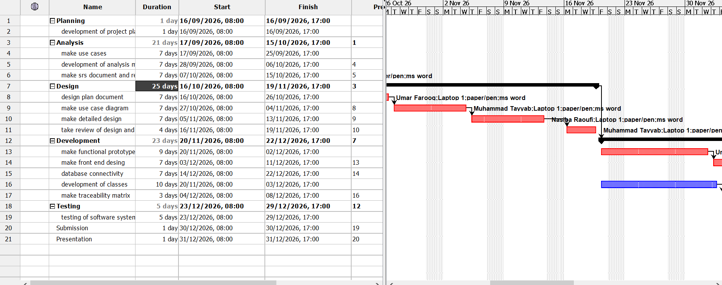
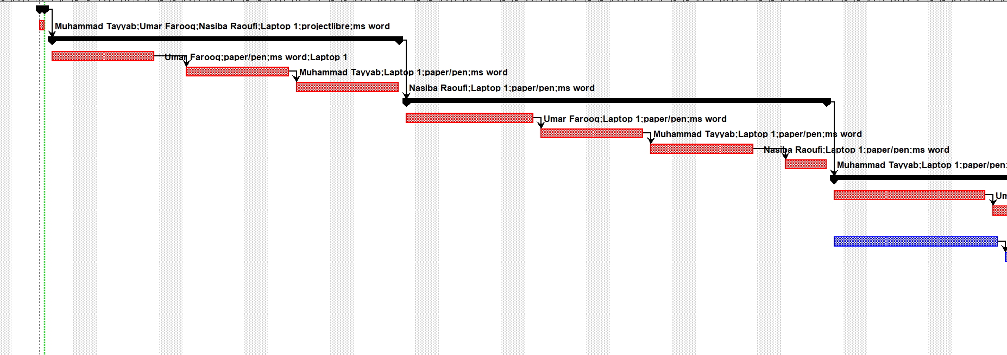

5.2 Work Activities

5.3 Schedule Allocation:
  - Assignment Setup & Initial Planning (Duration: 2 Week)
Define assignment scope, set up the development environment, and prepare the assignment management tools.
Key Activities:
- Set up the GitHub repository for version control.
- Design the system's database schema in MySQL.
- Set up VS Code as the development environment.
- Develop a detailed Gantt chart in ProjectLibre to outline the overall assignment timeline and dependencies.

  - System Design & Analysis (Duration: 6 weeks)
- Designing the system architecture (how data flows from front-end to back-end).
- To create database schema and plan the structure of tables in MySQL.
- Designing the UI for the registration page, submission system, feedback form, and progress tracking page.
  - Development Phase:(duration:5 weeks)
- Sprint 1: Functional Prototype (Duration: 9 days)
- Sprint 2: Front end development (Duration: 1 Week)
- Sprint 3: Database connectivity (Duration: 1 Week)
- Sprint 4: Traceability matrix (Duration: 6 days)
- Sprint 5: Classes (Duration:1 week)
  - Testing Phase & Submission & presentation (Duration: 1 week)
- Perform integration testing on all system features to ensure everything works together.
- Run user acceptance testing (UAT) with a few students and teachers to verify that the system meets their needs.
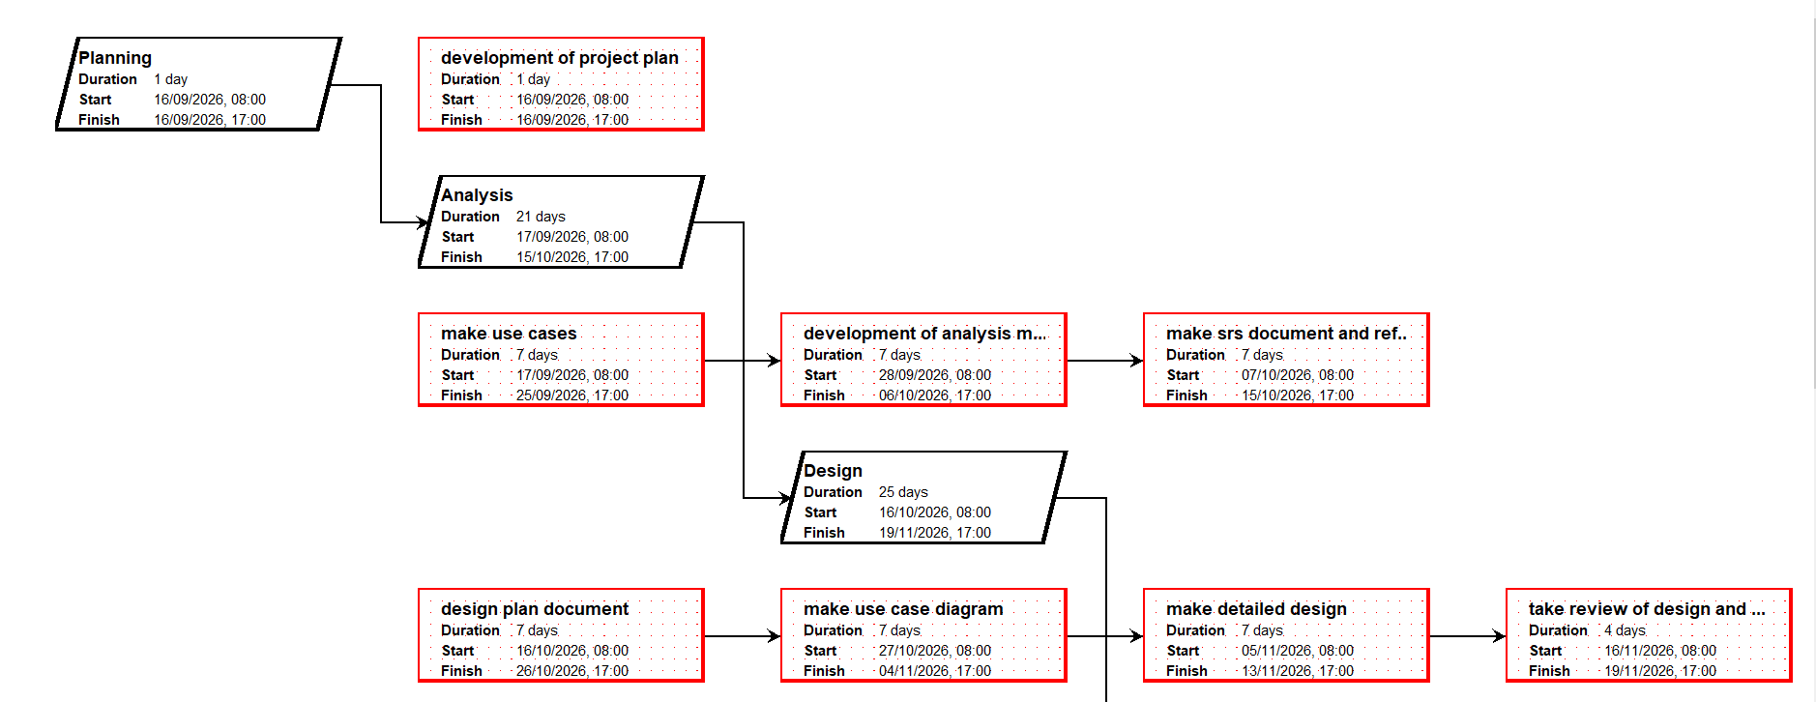
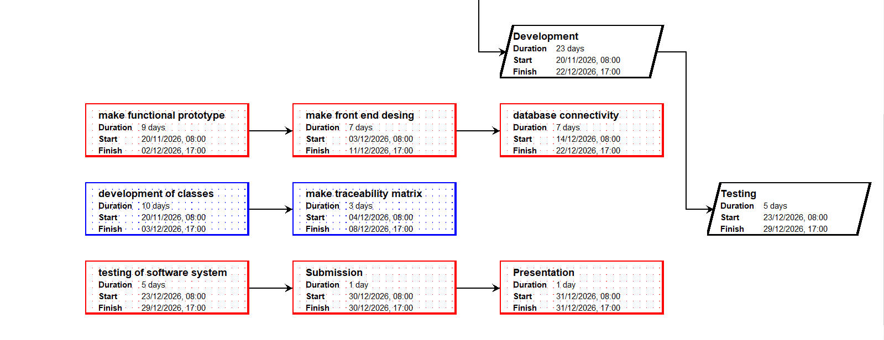

5.4Resource Allocation:
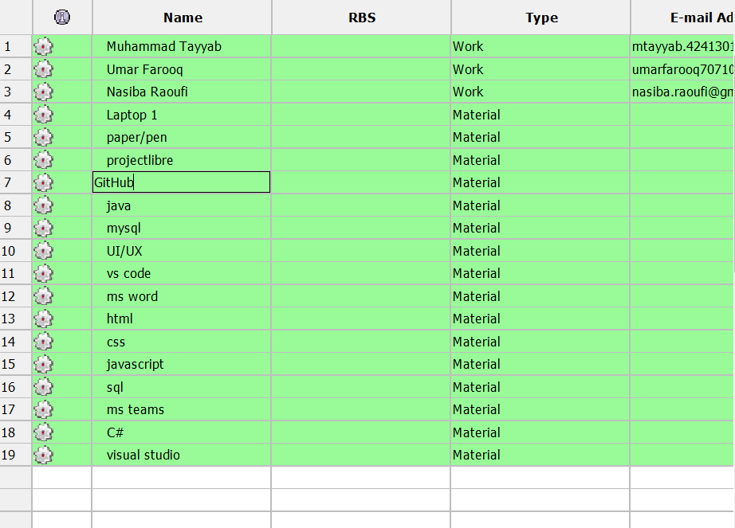

8. Supporting Process Plans:

8.1 Risk Management

8.1.1 Risk Identification:
Technical Risks
Lack of Java experience: We risk generating poor or faulty code because we are not yet experienced with Java, which could present developmental challenges and raise the risk of error.
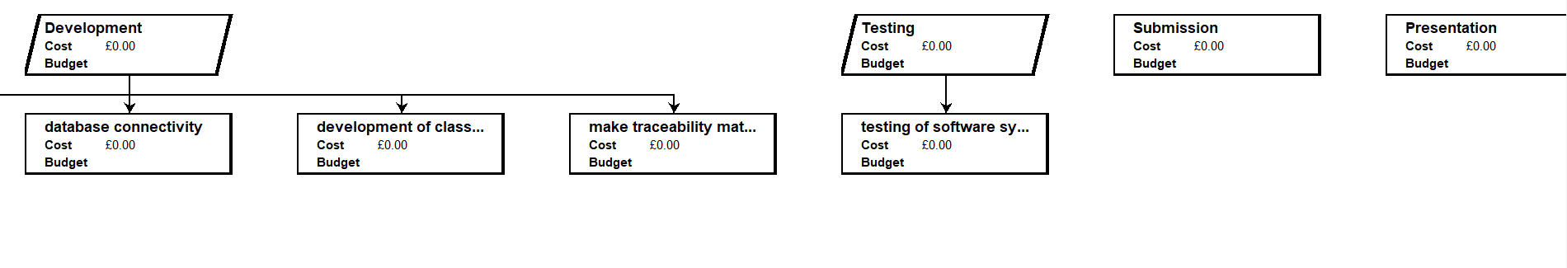
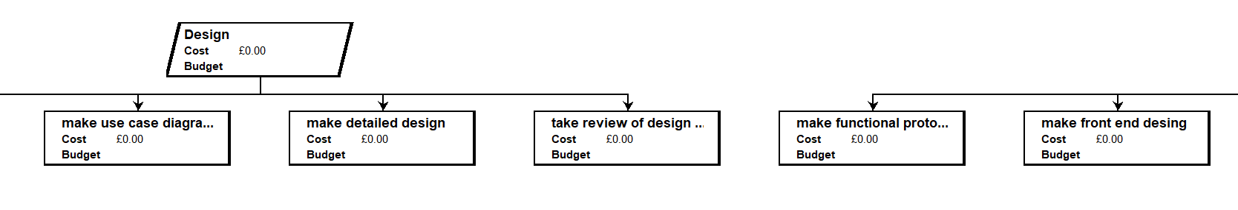
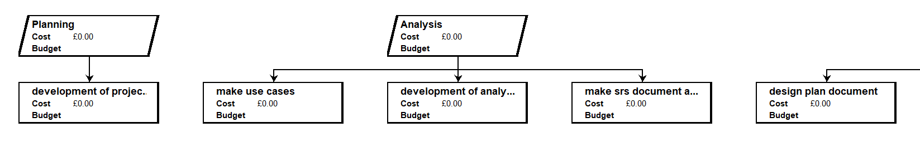

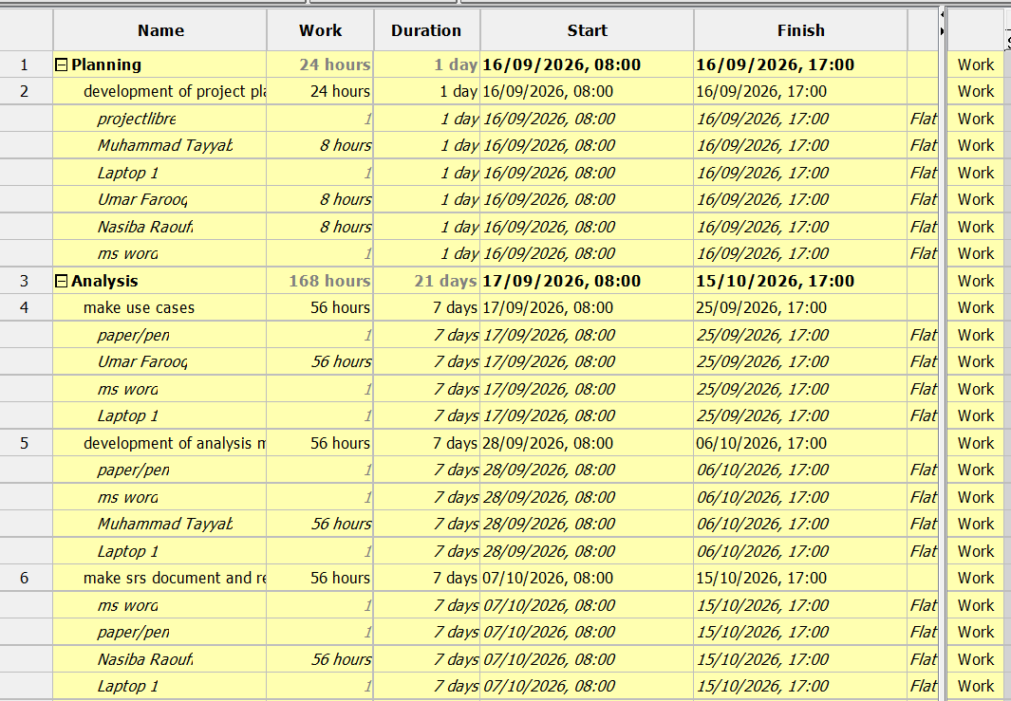
Probability | Impact
Medium | High
Data Security: Storing multiple versions of work products could lead to security risks if access is not controlled properly
Probability | Impact
Medium | High
Operational Risks
Development Delays: Academic responsibilities (exams, other assignments and assignments) may slow the assignment progress
Probability | Impact
High | Medium
Resource Availability: Unavailable tools, equipment, or limited hardware and Teacher unavailability cause schedule disturb.
Probability | Impact
Medium | Medium
Scope Changes: When new functionality is requested, it has the potential to increase the assignment scope and create rework.

Probability | Impact
Medium | Medium

8.1.2 Risk Analysis:
Probability and Impact Assessment: Every risk is considered for how likely it is to happen (low, medium, high) and how bad the consequences would be (low, medium, high). For example: Data security can be medium probability but high impact, so it calls for strict security measures.
Risk Prioritization: Prioritize risks by their severity. Critical security issues and high-severity risks get addressed first, with medium or low-severity risks being watched over and treated when needed.

8.2 Risk Mitigation Strategies
Technical Risks
Code Reviews & Pair Programming: Error detection at an early stage and peer-to-peer learning help to solve java programming problems efficiently.
Security Measures: Use role-based access, encryption, and safe login to protect student data.
Module Testing: Test each component (registration, submission, feedback) separately before they are integrated, to prevent massive integration problems.
Version Indexing: Each version of a work product will be clearly labeled (For example: v1, v2) and secured so that no files are accidentally overwritten or mixed up.
Operational Risks
Clearance Assignment Planning: Use a Gantt chart to put in deadlines and divide up the tasks equally.
Regular Progress Checks: Have weekly meetings to find out if there are delays or shortages of resources and correct them.
Change Control Process: Record new feature requests and see how they impact the timeline and resources before implementing them.

8.3 Risk Monitoring and Control
Regular Risk Reviews: At the end of each sprint or during assignment updates, we’ll look over our risk list to see if anything has changed or if new risks have popped up.
Risk Register: We'll keep one overall file like MS Word with a list of all risks, the seriousness of them, and how we are addressing each one. In that way, everybody knows exactly where to obtain the up-to-date details.
Regular Communication: We will keep communicating regularly with students, teachers so that we can recognize any new issues easily and resolve them before they become big problems.

