**Reply from Ste.. dated 10-04-2025**

OEM replied as following:

The information currently you provided is actually too general, but as you could choose the model, this machine should be able to meet your needs.

Preferably you please provide samples to OEM for sampling. Before shipment, OEM can set corresponding process parameters and select suitable abrasives, so that you can take them back and use them directly, avoiding wasting materials and time.

Anyhow, if you are not very interested in making samples by OEM, at least some numerical information needs to be provided so that OEM can accurately match the corresponding abrasives. Because there are many types of abrasives (with different mesh sizes), if OEM provides you each type and then you take back to try, it will be costly and troublesome for you.

For example, what is the surface roughness of the aluminum workpiece to be processed and how much needs to be achieved? What is the level of surface cleaning? What specifically does surface texture improvement refer to (OEM believes that surface texture improvement is also a type of surface cleaning)?

**1. Sample jobs**

Sample jobs will be provided to perform the Wet sand blasting operation

**2. Machine Table Size**

As per our understanding, machine table size mentioned in catalogue is 420 (w) x 300 (d) mm which means operation can be performed on maximum width of job 420 mm and maximum height of job 300 mm. Please mention maximum length of job that can be operated on machine?

Our jobs size range is diameter 350 mm and height 250 mm. If this model can not handle our job size then please refer any other model that can handle bigger job size for wet sand blasting operation.

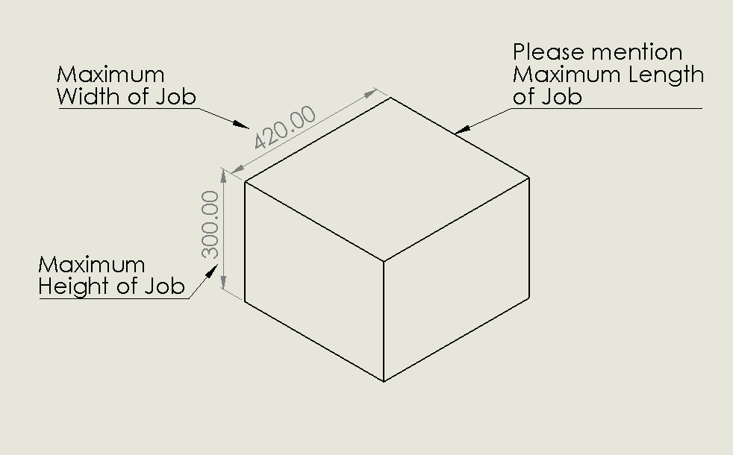

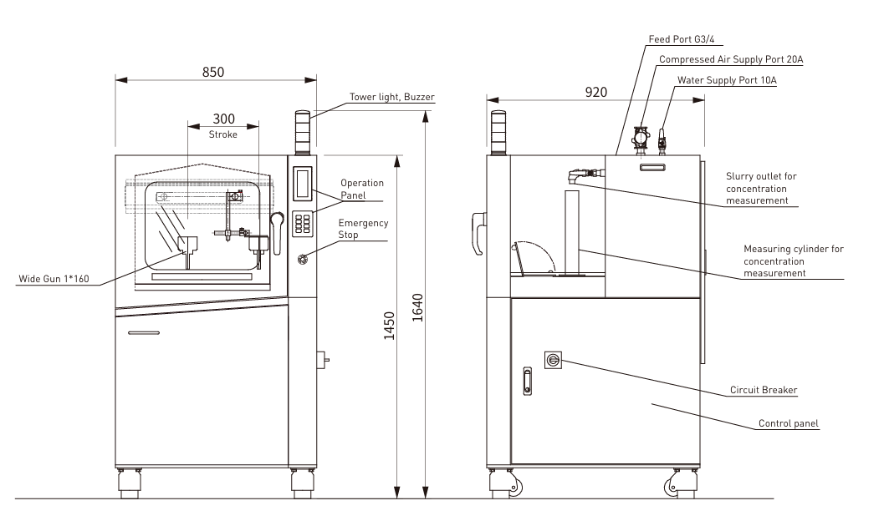

**3. Numerical information regarding surface finish and material.**

Surface finish of Ra 0.5 to 0.6 µm required on material **Ni32Co4Nb**

Other Materials of parts used for wet sand blasting operation are as per following;

1. Maraging Steel Grade 300 series e.g. 3J31, 3J32, 3J33
2. Aluminium Series AA6061, AA2024, AA2219-T6
3. Engine parts made of Titanium Alloy (Ti6Al-4V)

**4. Process Parameters and suitable abrasive**

Process parameters and suitable Abrasive will be finalized after successful operation of our required job.

**5. Level of surface cleaning and surface texture**

A reference sample part will be provided for level of surface cleaning and surface texture on our required job.