**CODE FOR LOGGER CLASS:**

**package** com.singleton;

**public** **class** Logger {

// Step 1: Create a private static instance of the same class

**private** **static** Logger *instance*;

// Step 2: Make the constructor private

**private** Logger() {

System.***out***.println("Logger initialized...");

}

// Step 3: Provide a public static method to get the instance

**public** **static** Logger getInstance() {

**if** (*instance* == **null**) {

*instance* = **new** Logger();

}

**return** *instance*;

}

// Sample method

**public** **void** log(String message) {

System.***out***.println("Log: " + message);

}

}

**CODE FOR MAIN CLASS:**

**package** com.singleton;

**public** **class** Main {

**public** **static** **void** main(String[] args) {

// Getting two instances

Logger logger1 = Logger.*getInstance*();

Logger logger2 = Logger.*getInstance*();

// Logging a message

logger1.log("This is the first log message.");

// Verify if both instances are the same

**if** (logger1 == logger2) {

System.***out***.println("\nBoth logger instances are the same.");

} **else** {

System.***out***.println("\nDifferent logger instances exist.");

}

}

}

**SCREENSHOTS:**

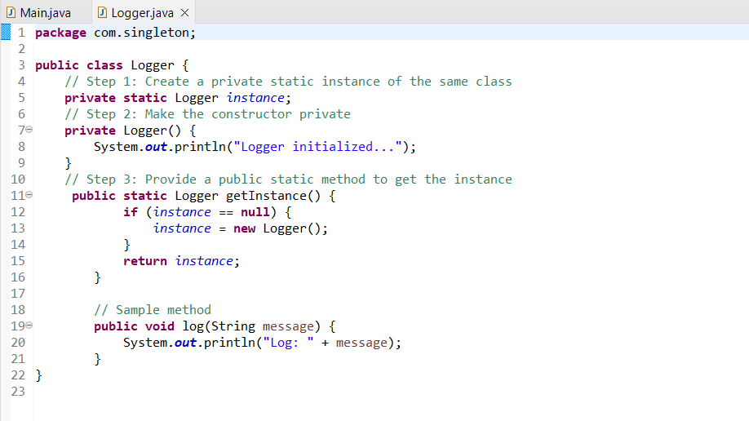

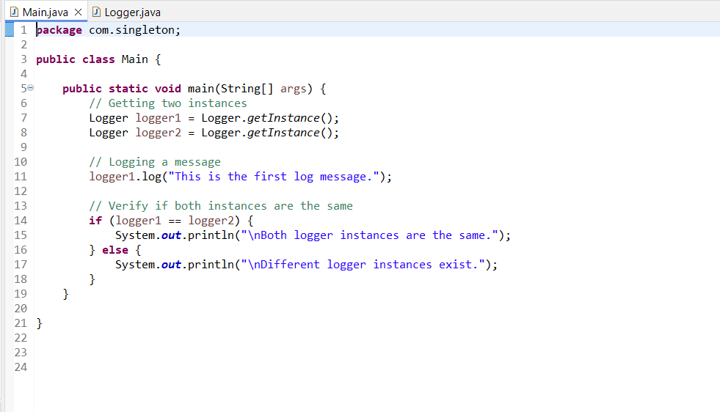

**OUTPUT:**

