**Address book**

**Project group members**

|  |  |
| --- | --- |
| Students id | Student names |
| Student 1425430 | **Muhammad Talha** |
| Student 142464 | **Tayyaba muslim** |
| Student 1424363 | **Sadia bader** |

**CURRICULUM: 7062**

**Batch code: 2210c2**

**Faculty: Ebad uddin**

**Co-ordinator: miss munnazah**

**Certificate**

This is to certify that the dissertation entitled **“ADDRESS BOOK”** is  **MUHAMMAD TALHA (student1425430) , TAYYABA MUSLIM (Student142464) , SADIA BADER (Student1424363)** in their partial fulfilment of the requirement of the award of the Aptech Computer Certified.

**Acknowledgement**

The success and final outcome of this project required a lot of guidance and assistance from many people and I am extremely privileged to have got this all along the completion of my project. All that I have done is only due to such supervision and assistance and I would not forget to thank them.

I respect and thank Aptech for providing me an opportunity to do the project work in ACE and giving us all support and guidance, which made me complete the project duly. I am extremely thankful to Aptech for providing such a nice support and guidance.

I owe my deep gratitude to our project guide **SIR EBAD-UDDIN**, who took keen interest on our project work and guided us all along, till the completion of our project work by providing all the necessary information for developing a good system.

**MUHAMMAD TALHA (student1425430)**

**TAYYABA MUSLIM (Student142464)**

**SADIA BADER (Student1424363)**

**Abstact**

**This project is aimed at developing “ADDRESS BOOK” for the facilities of the campus. This is an internet based application that can be accessed throughout the campus. This system can be used to automate the workflow of service requests for the various facilities in the campus. This is an integrated system that covers different kinds of facilities like class-rooms, labs, hostels, mess, canteen, gymnasium, computer center, faculty club etc. Registered users (students, faculty, lab-assistants and others) will be able to log in a request for service for any of the supported facilities. These requests will be sent to the concerned people, who are also valid users of the system, to get them resolved. There are features like email notifications/reminders**

**INTRODUCTION**

**INTRODUCTION:**

Welcome to Jenny's Radiance, your enchanting haven for all things beautiful and brilliant. Nestled in the heart of online elegance, our e-commerce platform is a treasure trove of meticulously crafted cosmetics and breathtaking imitation jewelry. At Jenny's, we believe in the transformative power of beauty, and our curated collection reflects a perfect fusion of glamour, style, and affordability.

**Modules:**

The entire project mainly consists of 3 modules, which are

* + - ADMIN
    - CUSTOMER (USER)

**ADMIN:**

* All users details.
* All products details.
* All category details.
* Register.
* Login.
* Add or view category with update / trash / and delete functions.
* Add or view products with update / trash / and delete functions.
* View orders

**CUSTOMER (USER):**

* Users can view product categories and available products.
* Users can add products to their shopping basket.
* Users can specify the quantity of products they want.
* Users can complete/finalize their orders.
* Users can search for a products by name.
* Register
* Login

# REQUIREMENTS

**For Admin:**

1. Product Management

Administrators can add/delete categories and products to the website.

They can update information for existing products.

2. Website Maintenance

Administrators can maintain the website, ensuring its functionality.

3. Database Management

Administrators can add/delete records in the database.

They can back up the database.

4. Reporting

Generate/view reports on the top 10 best-selling products.

Generate/view reports on the top 10 clients/users who shop the most.

**For User:**

**Browse Products**

**• Users can view product categories and available products.**

**• Users can add products to their shopping basket.**

**2. Shopping Cart**

**• Users can specify the quantity of products they want.**

**• Users can complete/finalize their orders.**

**3. Order Information**

**• Users should input the following information while ordering:**

**• Name**

**• Address**

**• Email**

**• Work Phone Number**

**• Cell Number**

**• Date of Birth**

**• Category**

**• Remarks (additional information)**

**• Users can search for a product by name.**

# REQUIREMENT SPECIFICATION

# Hardware

# A minimum computer system that will help you access all the tools in the

# courses is a Pentium 166 or better

# 128 Megabytes of RAM or better

# Operating System

# LINUX / Windows 7 (or higher if possible)

# Software

# PHP

# MySQL

# PERL

# Apache

**DIAGRAM:**

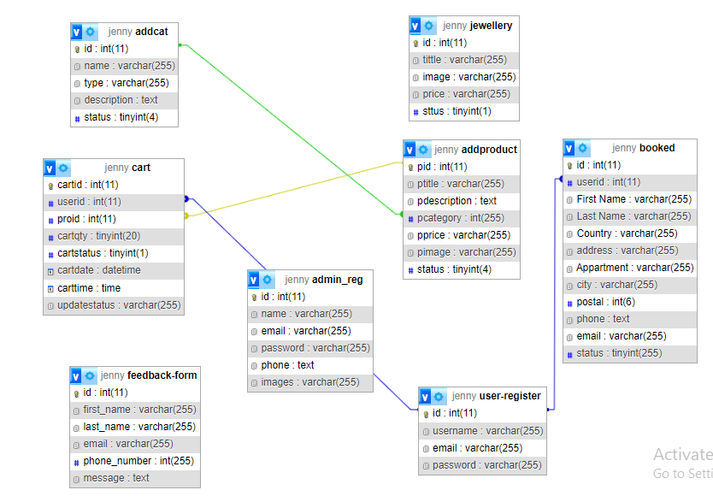

**ADMIN SCREENSHOTS**

**LOGIN**

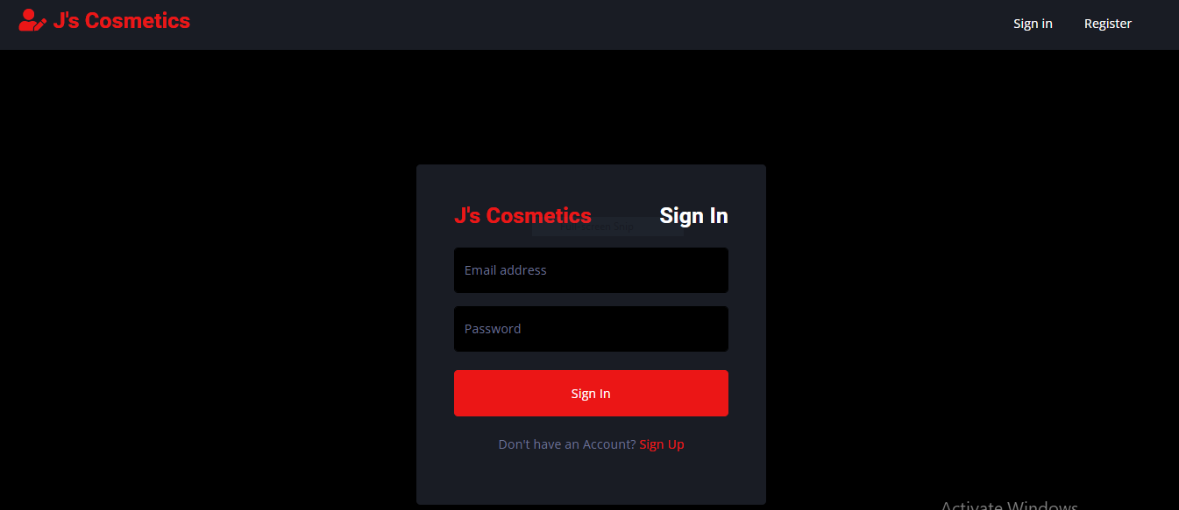

**UPDATE PASSWORD**

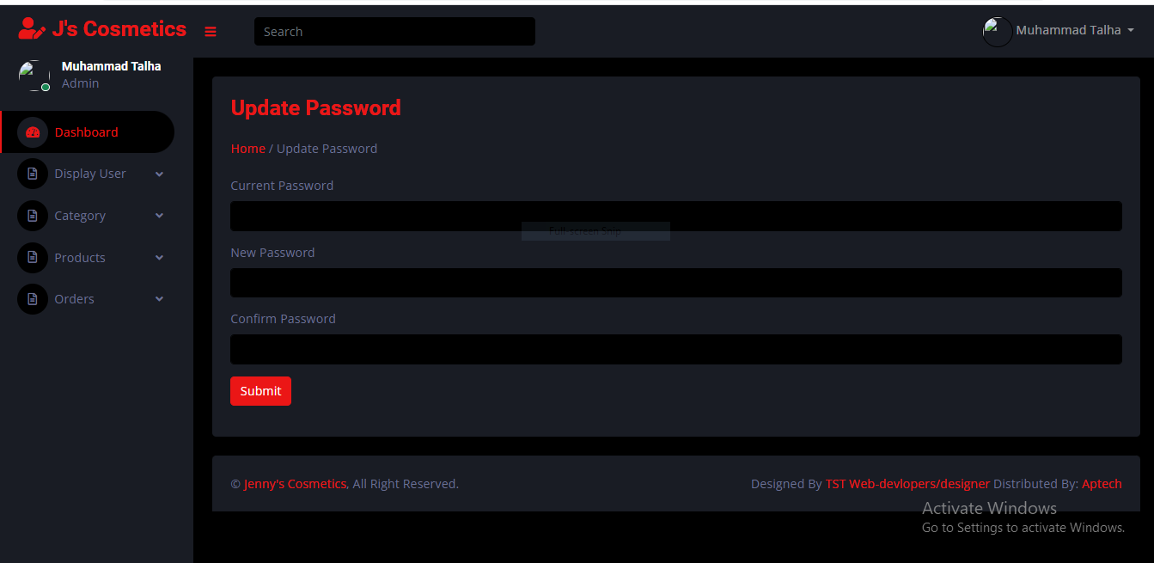

**HEADER**

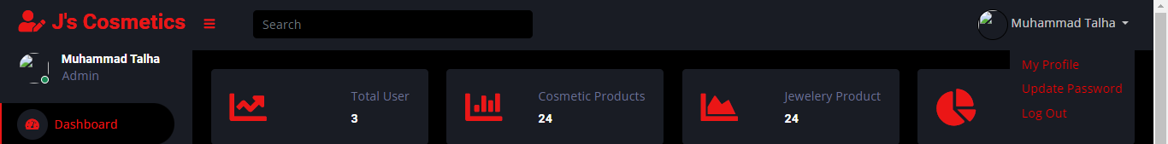

**SIDEBAR**

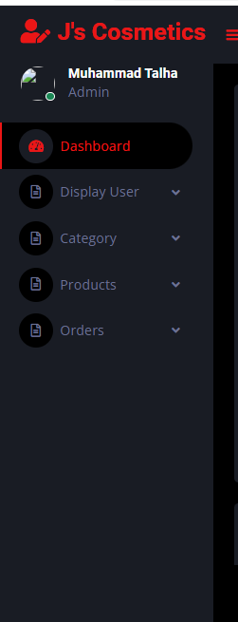

**HOME**

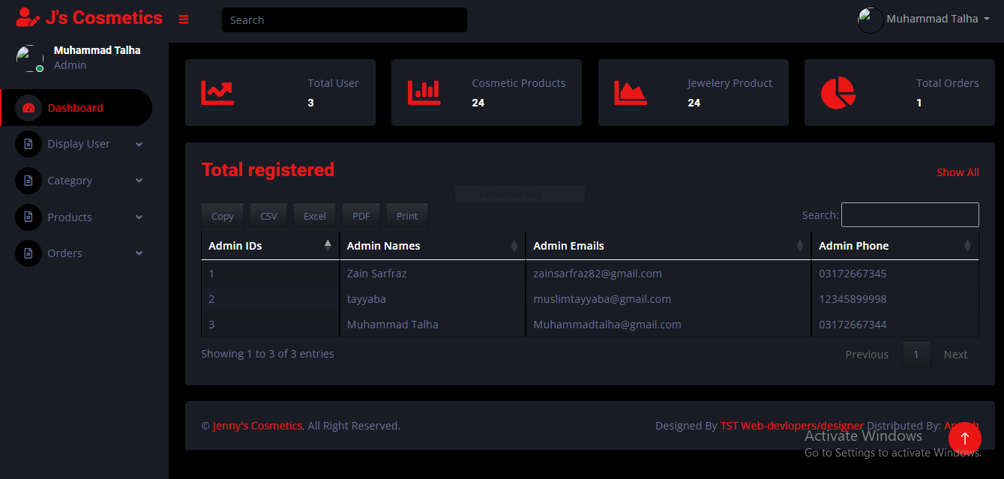

**ADMIN PROFILE**

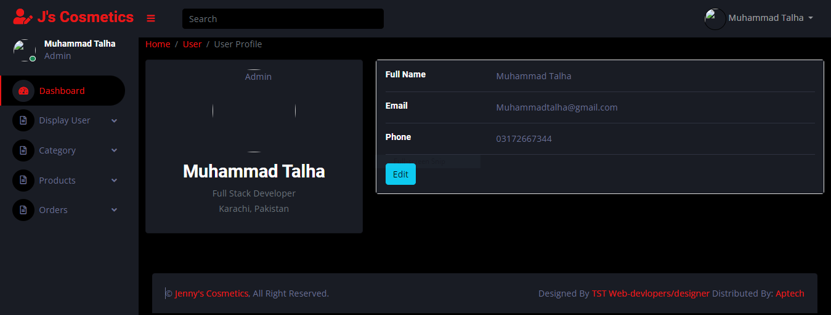

**UPDATE PROFILE**

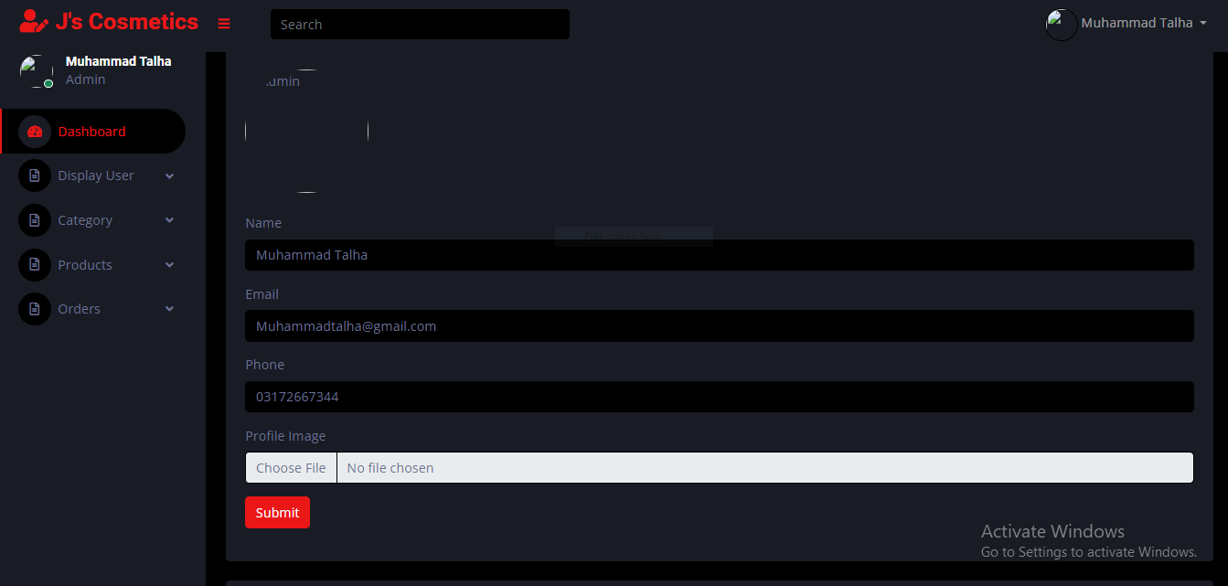

**VIEW CATEGORIES**

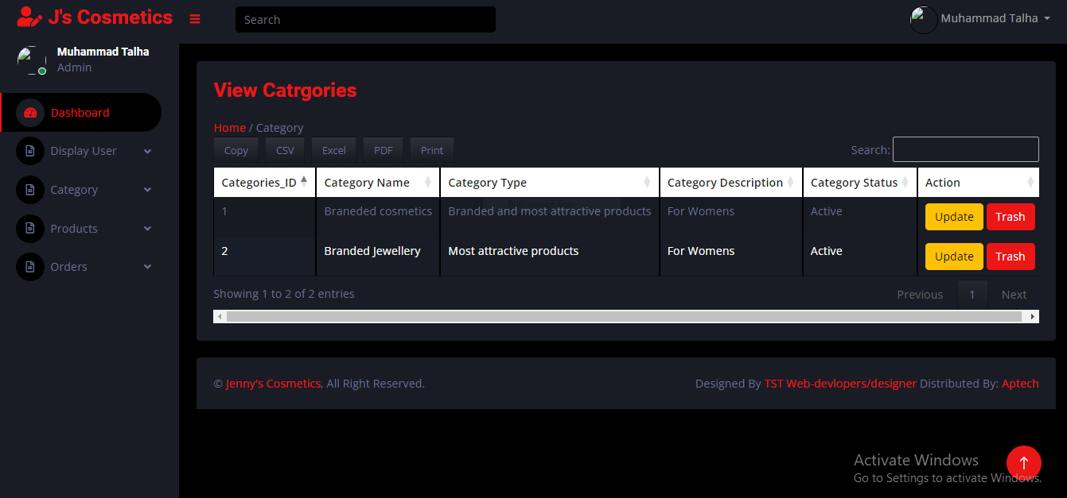

**VIEW PRODUCTS**

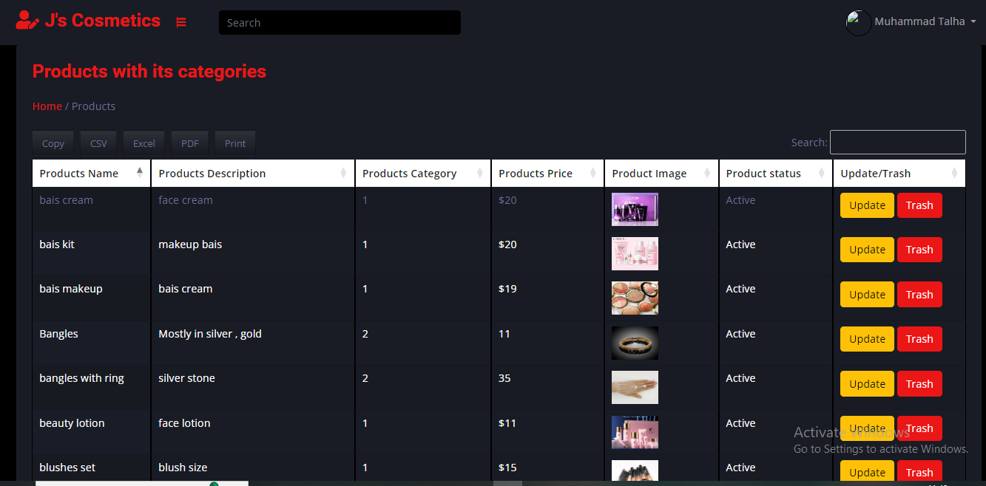

**VIEW ORDERS**

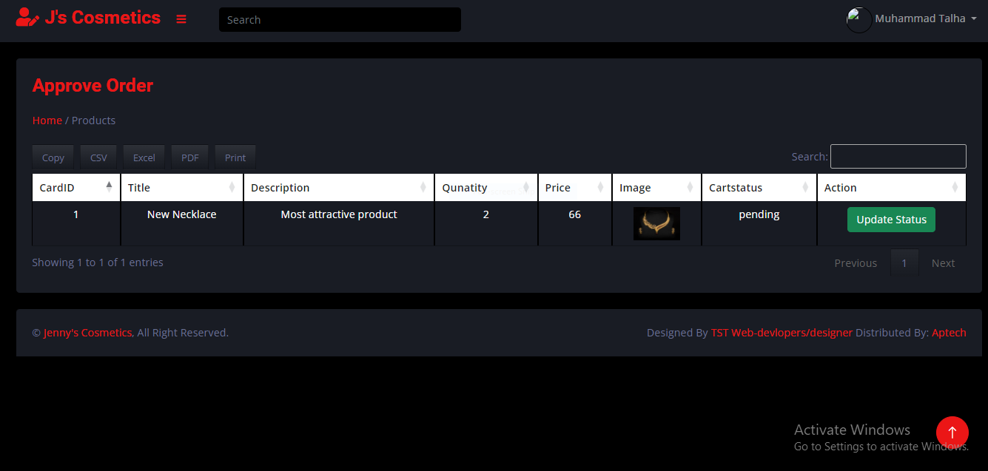

**USER SCREENSHOTS**

**HEADER**



**FOOTER**

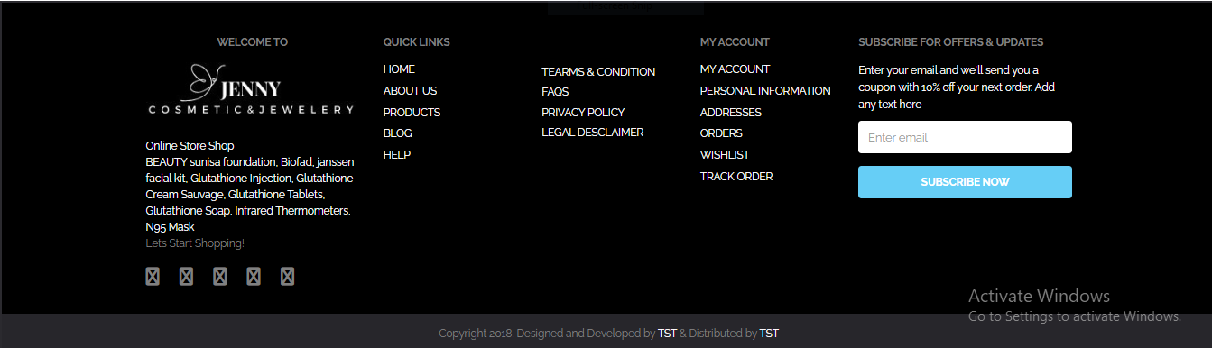

**USER REGISTRATION**

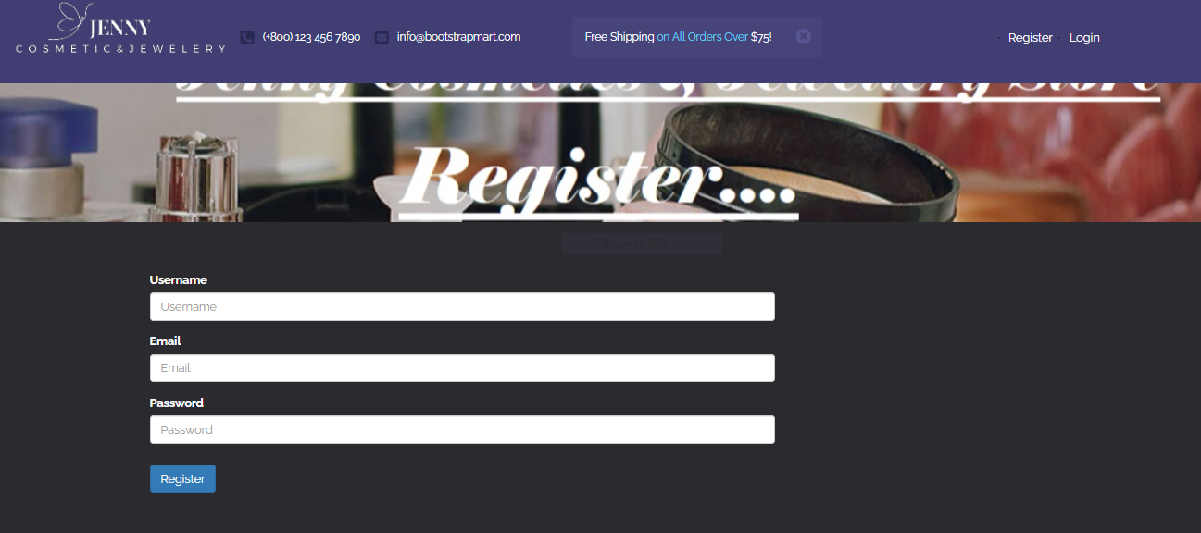

**USER LOGIN**

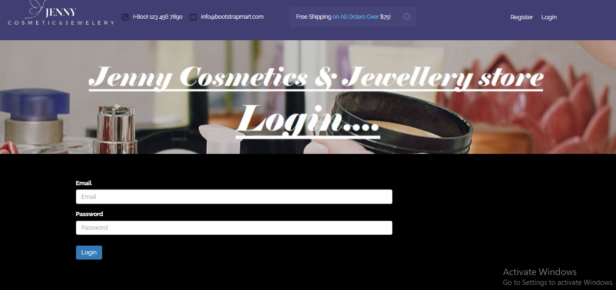

**CHANGE PASSWORD**

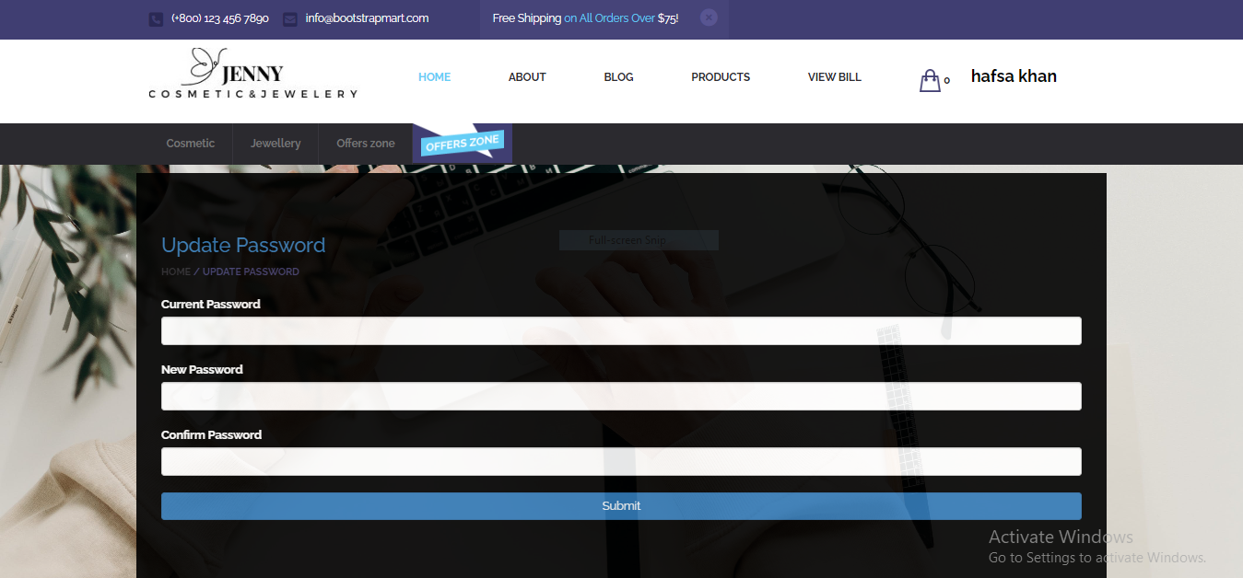

**HOME**

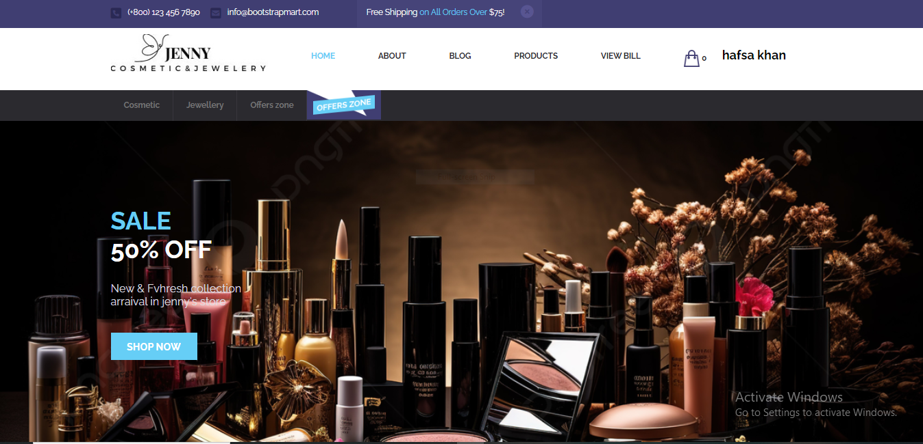

**ABOUT**

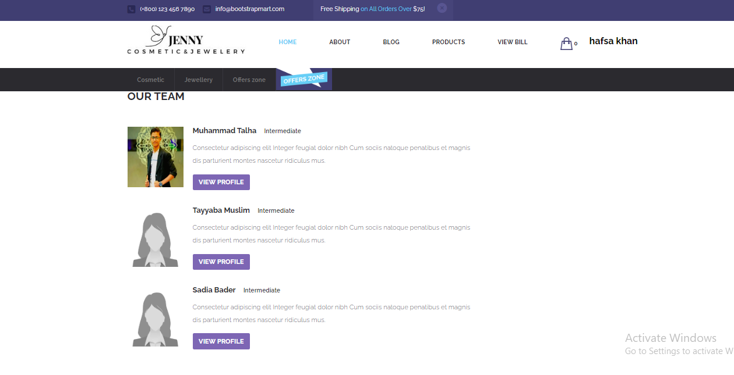

**BLOG**

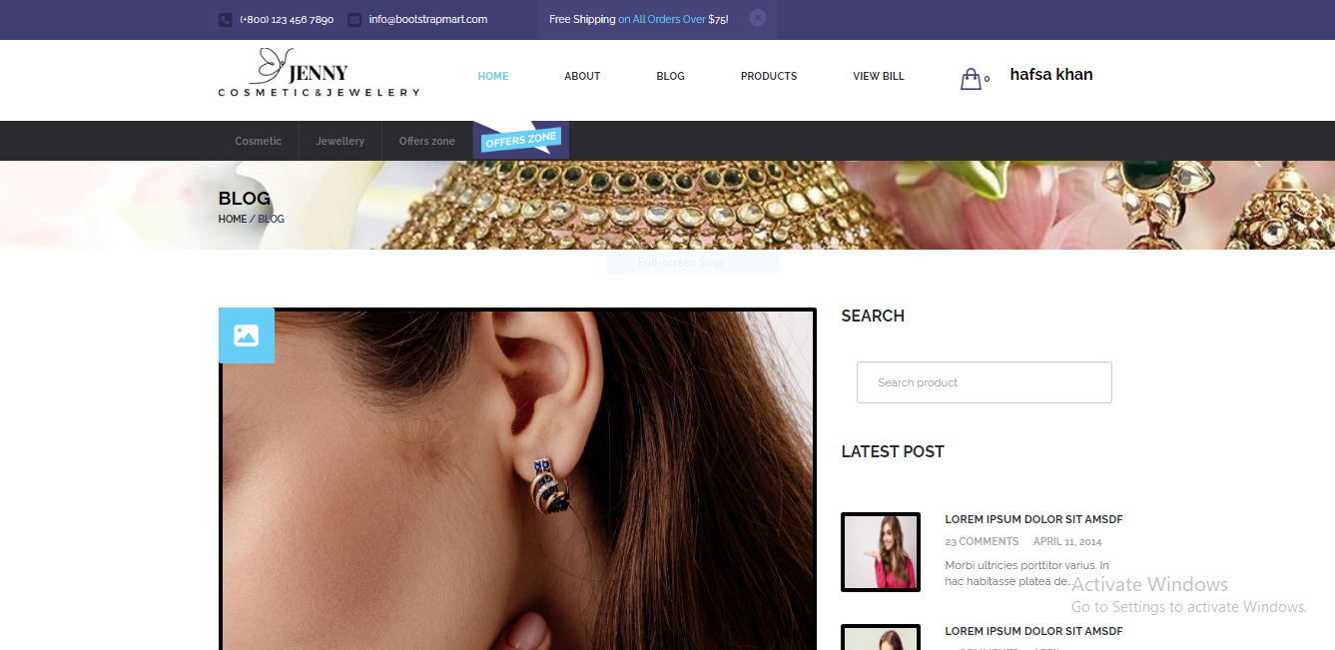

**OUR PRODUCTS**

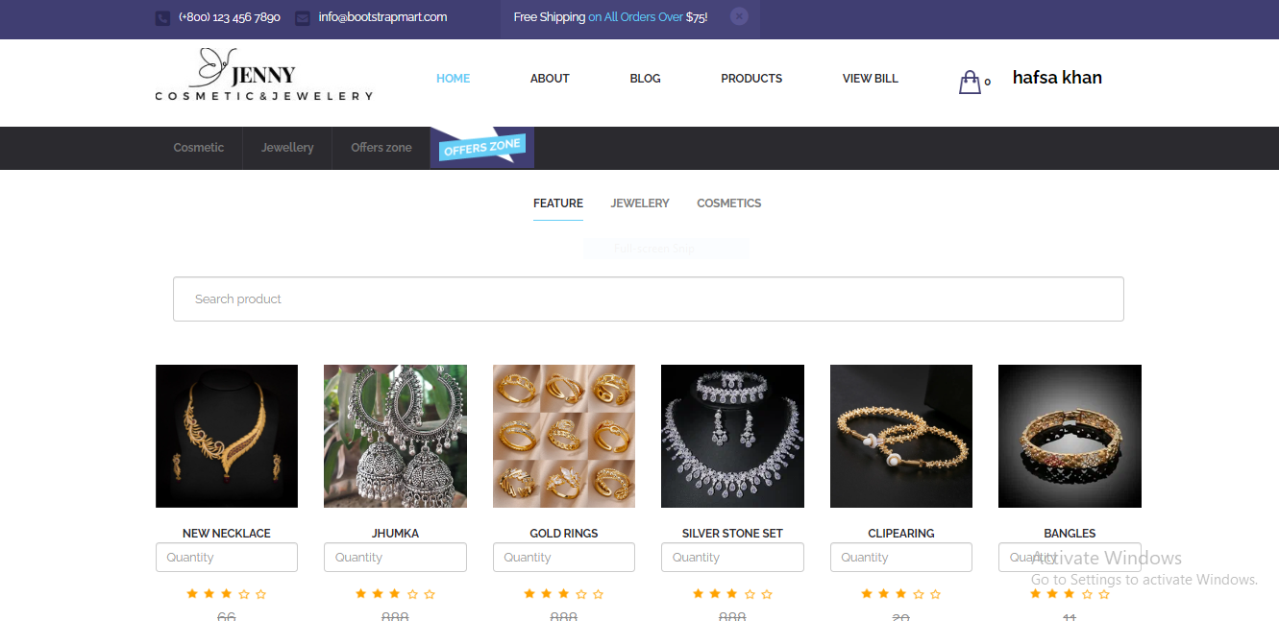

**CONTACT**

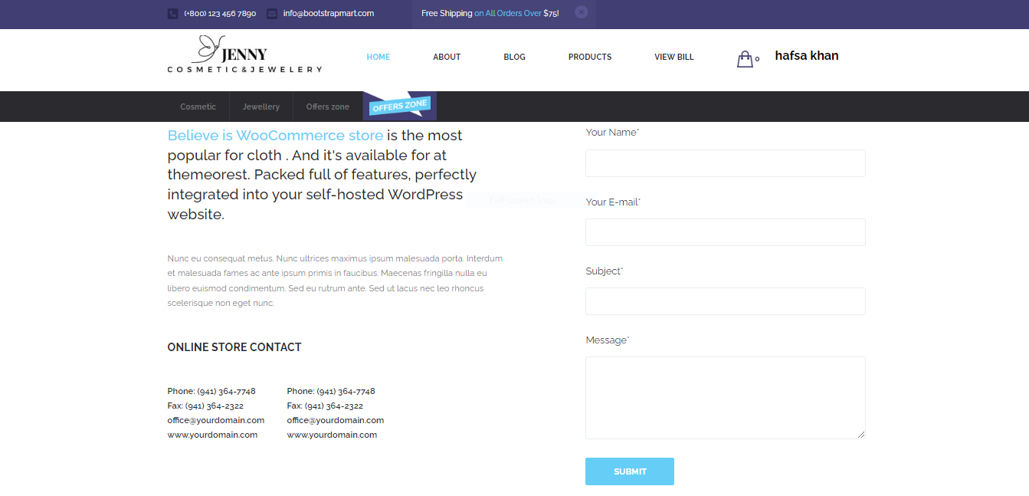

**ADD TO CART**

