**Address book**

**Project group members**

|  |  |
| --- | --- |
| Students id | Student names |
| Student 1425430 | **Muhammad Talha** |
| Student 142464 | **Tayyaba muslim** |
| Student 1424363 | **Sadia bader** |

**CURRICULUM: 7062**

**Batch code: 2210c2**

**Faculty: Ebad uddin**

**Co-ordinator: miss munnazah**

**Certificate**

This is to certify that the dissertation entitled **“ADDRESS BOOK”** is  **MUHAMMAD TALHA (student1425430) , TAYYABA MUSLIM (Student142464) , SADIA BADER (Student1424363)** in their partial fulfilment of the requirement of the award of the Aptech Computer Certified.

**ADMIN PANEL**

**LOGIN**

Here You can Login in Your Admin Account.

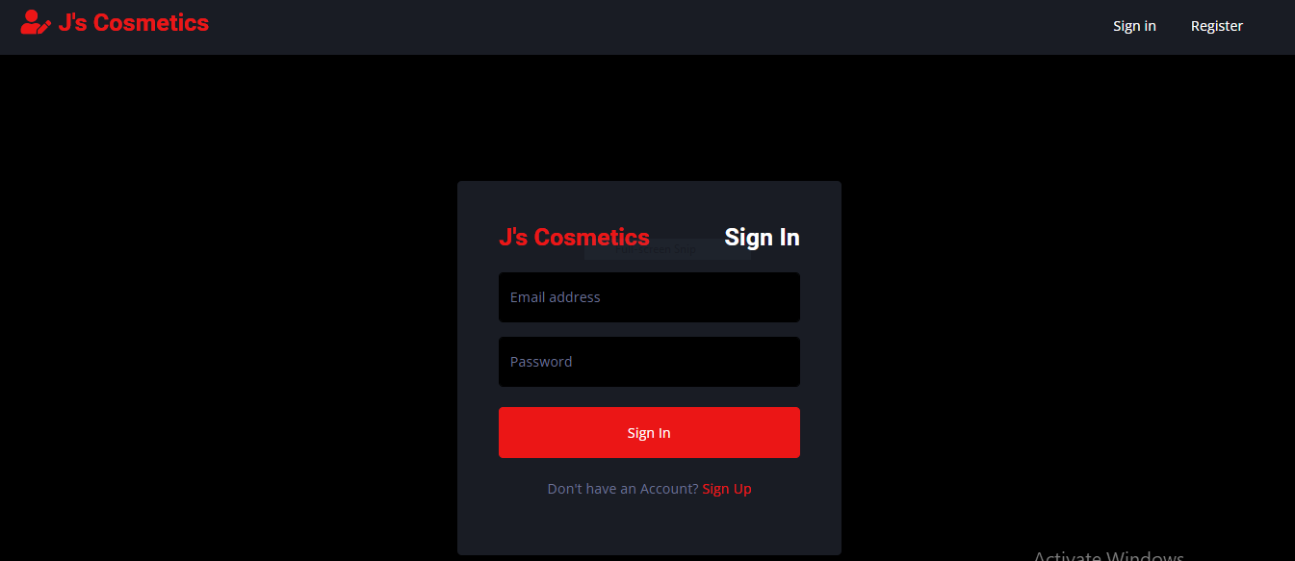

**UPDATE PASSWORD**

Here you can update or change password

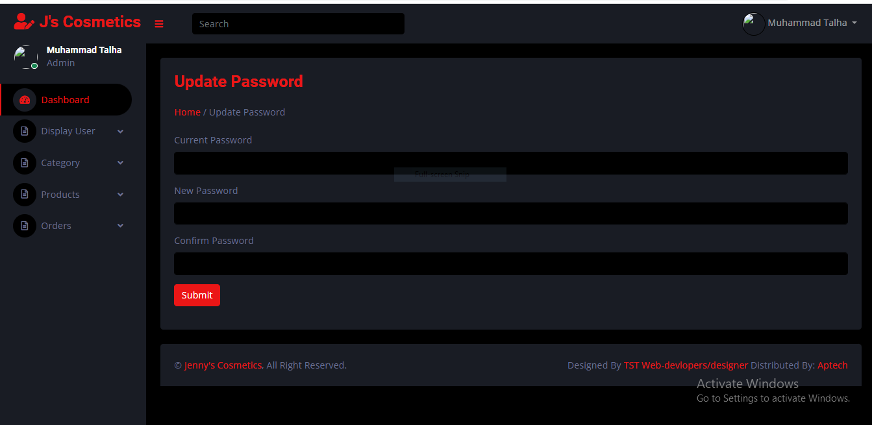

**HEADER**

**This is a header of Admin Panel**

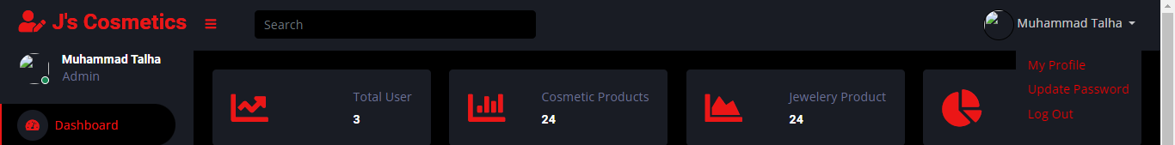

**SIDEBAR**

Here you can see a sidebar of Admin Panel



**HOME**

Here you can see a Home page of Admin Panel

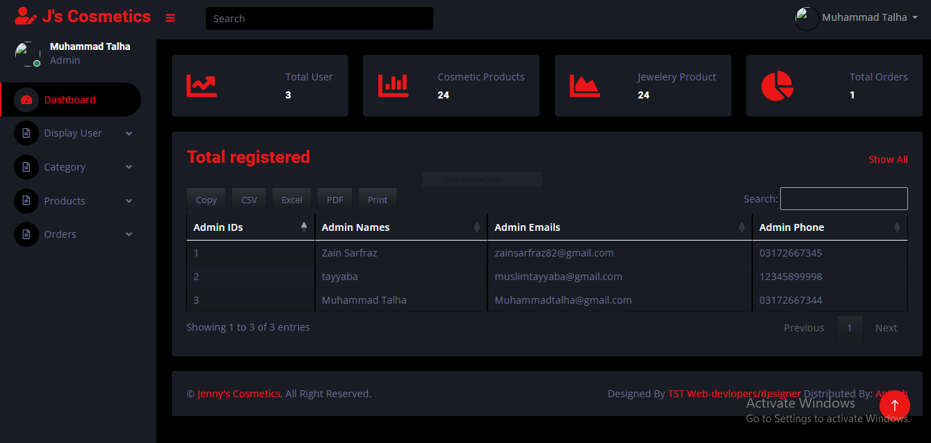

**ADMIN PROFILE**

Here you can see a profile of Admin

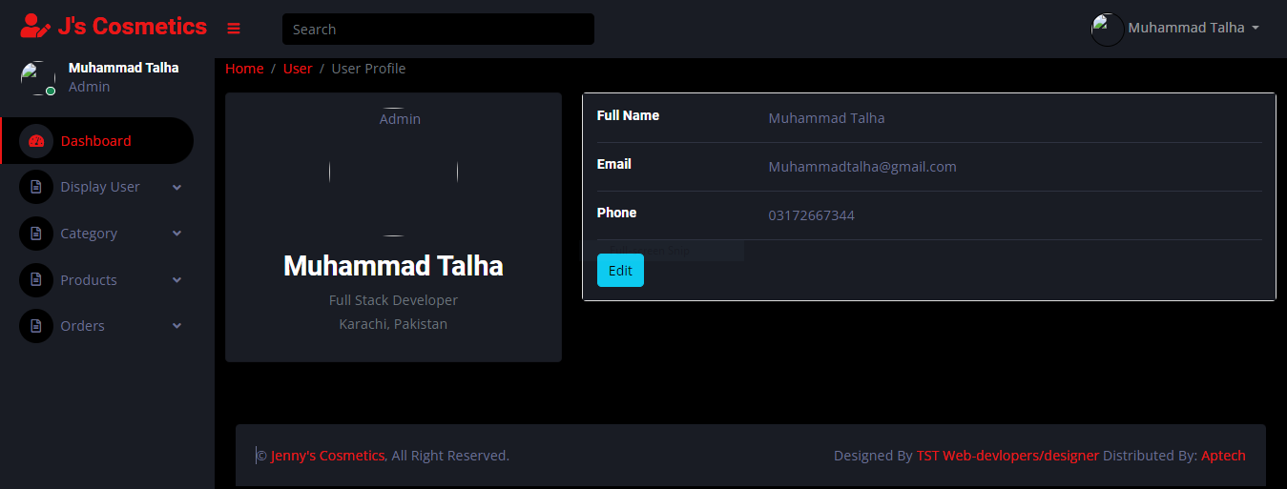

**UPDATE PROFILE**

Here you can update your admin profile

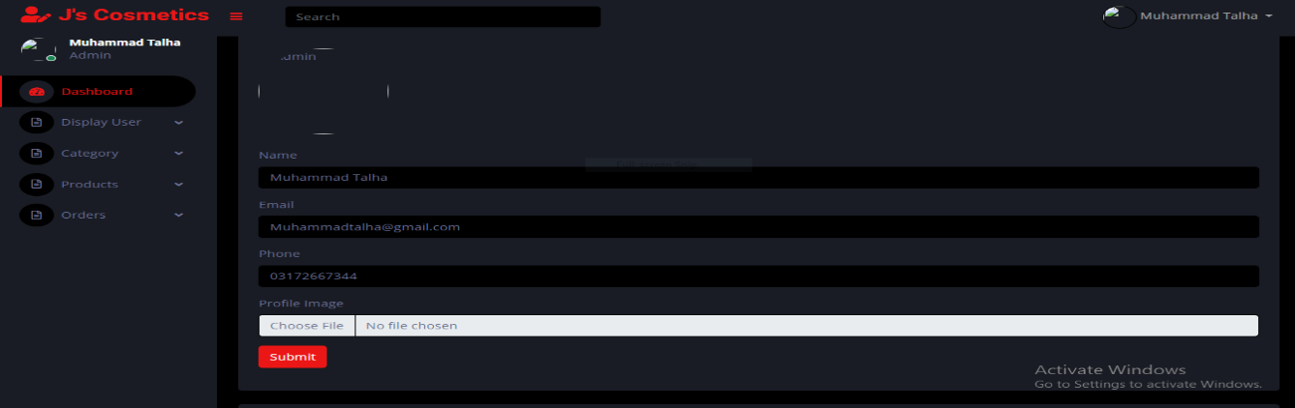

**VIEW CATEGORIES**

Here you can see all categories of our website

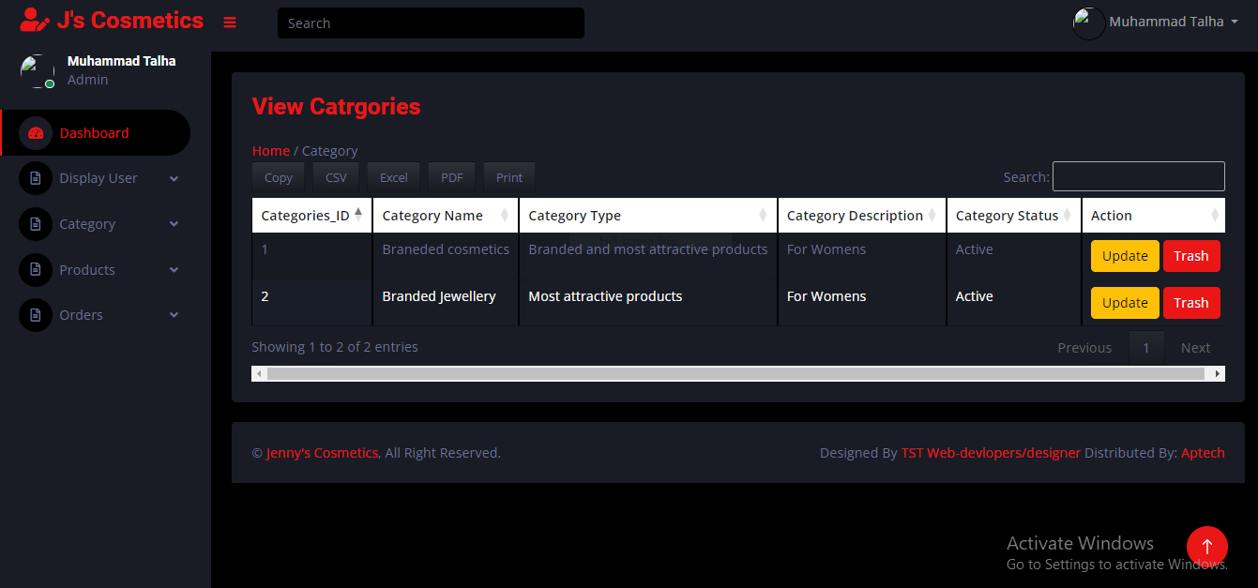

**VIEW PRODUCTS**

Here you can see all products of our website

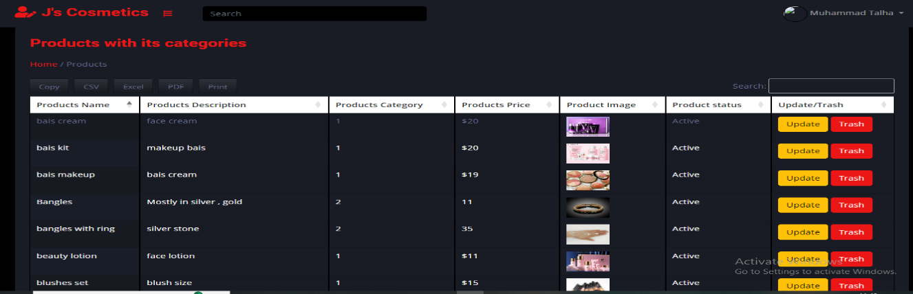

**VIEW ORDERS**

Here you can see all orders of our website

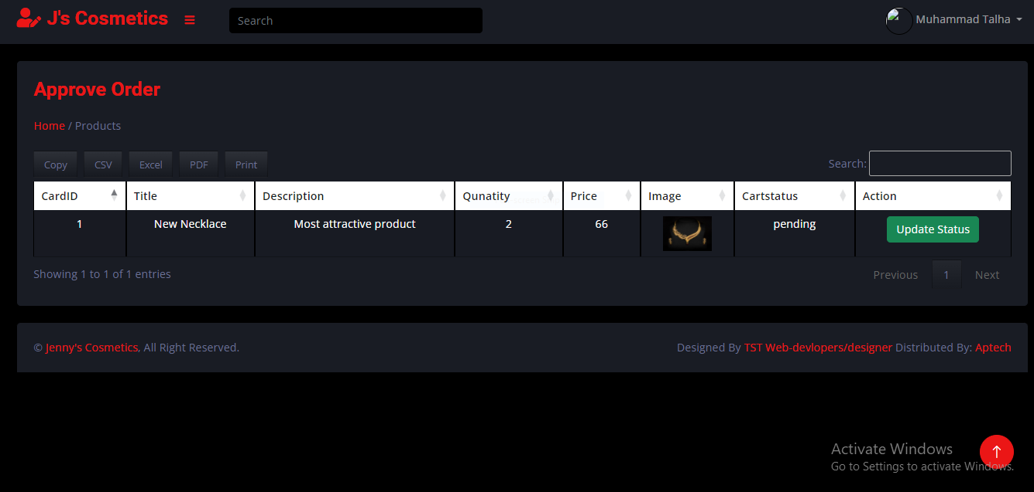

**USER:**

**HEADER**

**Here you can see a header of our website**



**FOOTER**

**Here you can see a footer of our website**

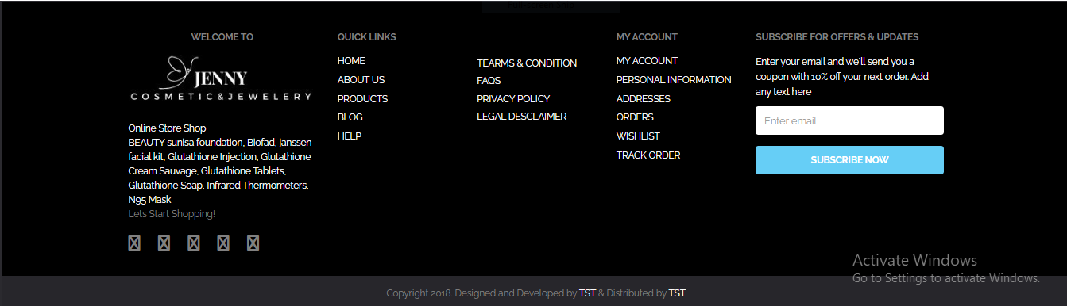

**USER REGISTRATION**

**Here is a registration page for users**

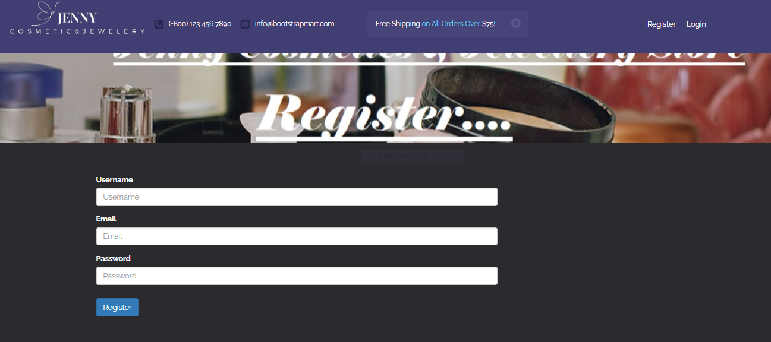

**USER LOGIN**

**Here is a registration page for users**

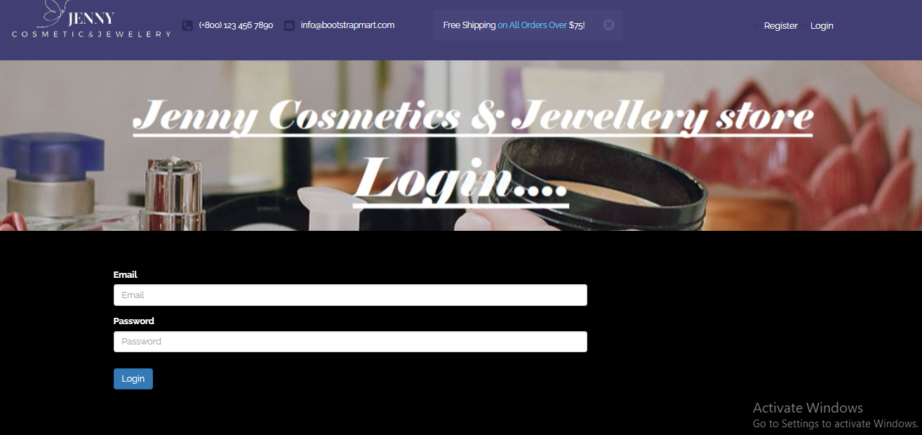

**CHANGE PASSWORD**

Here you can update or change password

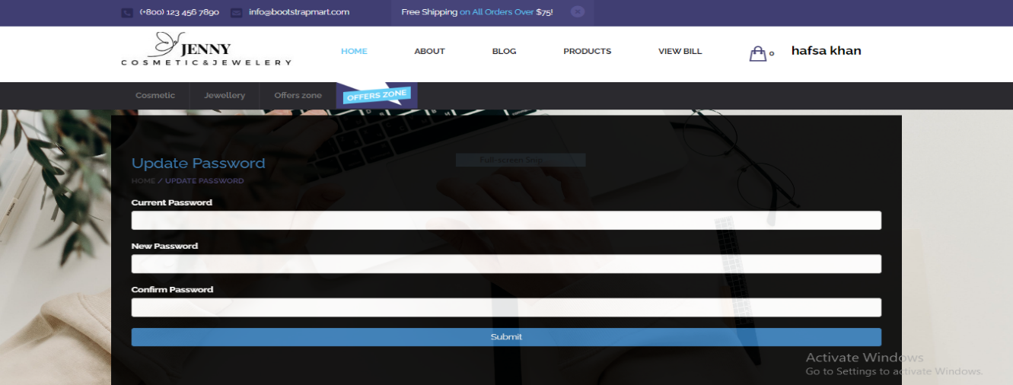

**HOME**

**This is a Home page of our website**

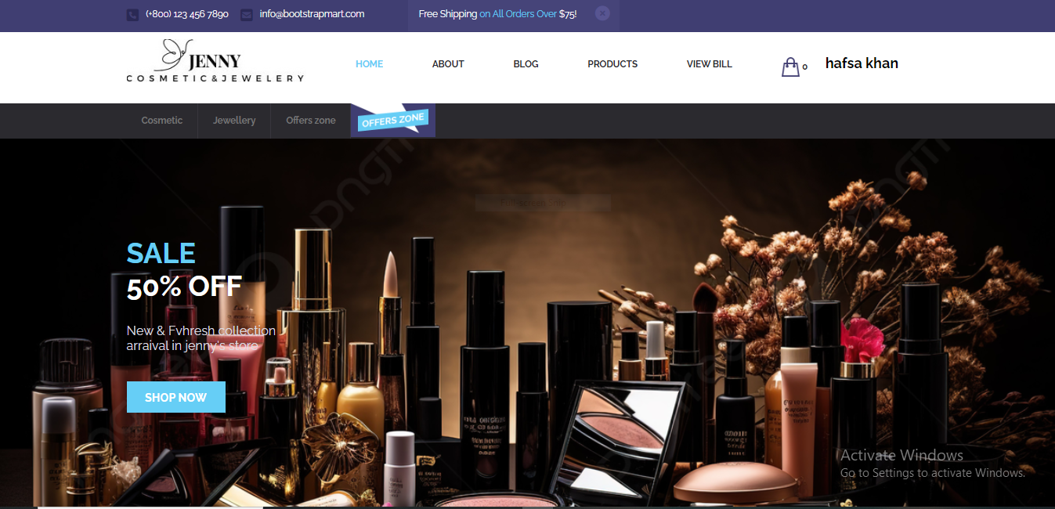

**ABOUT**

**This is a about page of our website**

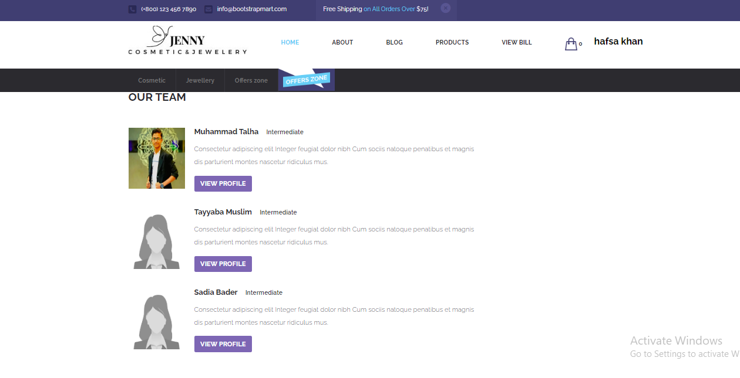

**BLOG**

**This is a Blog page of our website**

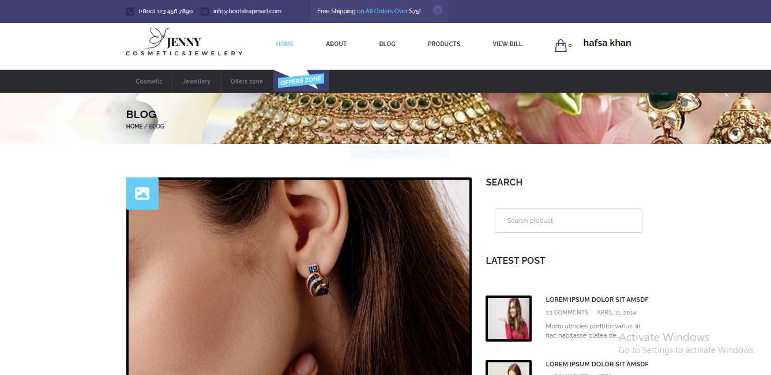

**OUR PRODUCTS**

**Here you can see our products**

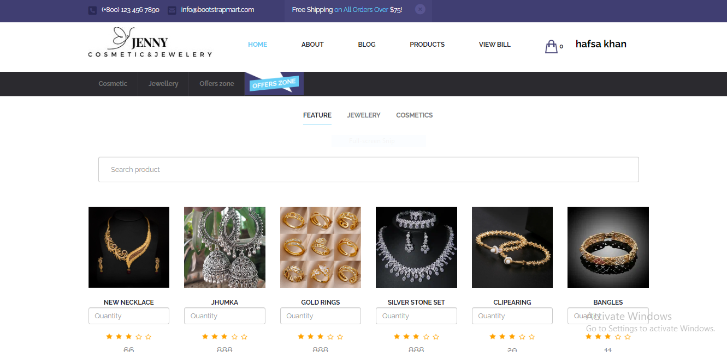

**FEEDBACK**

**Form**

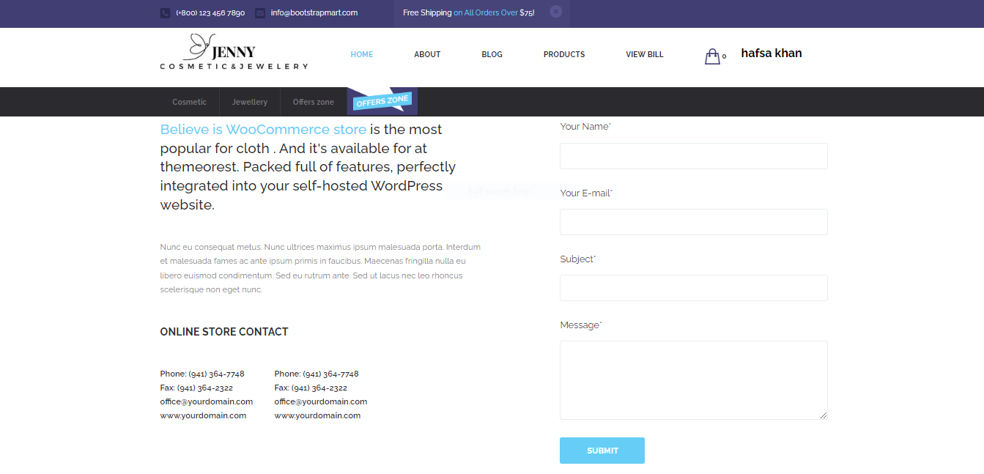

**ADD TO CART**

**This is our add to cart page which can visible after click on add to cart button**

