RECIPEFUSION: RECIPE GENERATION AND RECOMMENDATION SYSTEM



Tayyaba Ejaz
Laiba Hassan

Supervised By
Dr. Sadia Ashraf

Submitted for the partial fulfillment of BS Computer Science degree to the Faculty of Engineering & Computing

DEPARTMENT OF COMPUTER SCIENCE
NATIONAL UNIVERSITY OF MODERN LANGUAGES ISLAMABAD
February, 2026
ABSTRACT
Healthy eating and effective meal planning play a vital role in maintaining overall well-being. However, many individuals face challenges in preparing nutritious meals due to limited food availability, lack of time, or insufficient cooking knowledge. Traditional recipe websites typically offer fixed suggestions that do not adapt to users' available ingredients, dietary habits, or nutritional requirements. These limitations highlight the need for an intelligent and interactive system capable of generating personalized recipes and meal plans based on real-time user inputs.
To address this need, RecipeFusion is developed with the modern web technologies to offer both intelligent recipe creation and recommendation. The system uses ReactJS, which has a responsive and easy front end interface and Node.js with Express.js handles backend services. MongoDB is utilized to store and manage the data of users, recipes and history of interaction. Gen-AI based logic module analyzes user-provided ingredients and dietary preferences to generate customized recipes.
RecipeFusion has been tested, based on a software testing plan, which involved unit testing, integration testing, system testing, black-box testing, API testing, and user acceptance testing. Unit testing validated modules separately like the authentication, recipe search, ingredient-matching logic, and meal planning. Integration testing verified that frontend, backend APIs, database and AI logic interacted correctly offering a secure session handling and role-based access control. System and performance testing were done to ensure the responsiveness and stability of the device-to-device. Functional behavior and endpoint stability were tested by black-box testing and API request-response testing, whereas usability and the flow of navigation were tested using the user acceptance testing. The findings proved the accuracy, reliability and usability of the system.
Despite its strengths, RecipeFusion has certain limitations. The quality of the recipes provided by AI is determined by the quality and form of ingredients information and known nutritional values. The current version lacks sophisticated features like real time integration of the price of groceries and personalized health tracking because it is time-constrained. However, RecipeFusion is a convenient and smart assistant in meal planning and recipe search. Some improvements that can be made in future are better AI models, more dietary support, and also the addition of external support provided by health and nutrition elements.

CERTIFICATE

Dated:

Final Approval
It is certified that project report titled “RecipeFusion” submitted by Tayyaba Ejaz, and Laiba Hassan for the partial fulfillment of the requirement of “Bachelor’s in Computer Science” is approved.

COMMITTEE

Dr. Noman Malik

Acting Dean Engineering & Computing Signature:

Dr. Fazli Subhan

HoD Computer Science Signature:

Dr. Farhad Muhammad Riaz

Head Project Committee Signature:

Dr. Sadia Ashraf

Supervisor Signature:

DECLARATION
We hereby declare that our dissertation is entirely our work and original. We understand that in case of discovery of any PLAGIARISM at any stage, our group will be assigned an F (FAIL) grade and it may result in withdrawal of our Bachelor’s degree.

Group Members Signature

- Tayyaba Ejaz

- Laiba Hassan

PLAIGRISM CERTIFICATE
This is to certify that the project entitled ‘RecipeFusion’ which is being submitted here with for the award of the “Degree of Bachelor’s in Computer Science”. This is the result of the original work by Tayyaba Ejaz, and Laiba Hassan under my supervision and guidance. The work embodied in this project has not been done earlier for the basis of award of any degree or compatible certificate or similar title of this for any other diploma/examining body or university to the best of my knowledge and belief.
Turn-it-in Originality Report
Processed on 23-Dec-2025 02:37AM (UTC-0800)
ID: 2745842586
Word Count: 15053
Similarity Index: 3%
Internet Sources: 1%
Publications: 0%
Student Papers: 2%

Date: 23/12/2025 Sadia Ashraf

TURNITIN ORIGINALITY REPORT
RecipeFusion by Tayyaba Ejaz and Laiba Hassan.
From Sadia Ashraf
Processed on 23-Dec-2025 02:37AM (UTC-0800)
ID: 2745842586
Word Count: 15053
Similarity Index: 3%
Internet Sources: 1%
Publications: 0%
Student Papers: 2%
SOURCES:
- 1% Match (Student Paper)
Submitted to Higher Education Commission Pakistan
- <1% Match (Internet Source)
ijnrd.org
- <1% Match (Student Paper)
Submitted to University of Greenwich
- <1% Match (Internet Source)
etd.aau.edu.et
- <1% Match (Internet Source)
www.ijsat .org
- <1% Match (Student Paper)
Submitted to Our Lady of Fatima University - Valenzuela
- <1% Match (Student Paper)
Submitted to National School of Business Management NSBM, Sri Lanka
- <1% Match (Internet Source)
repository.president.ac.id
- <1% Match (Internet Source)
rgu-repository.worktribe.com
- <1% Match (Student Paper)
Submitted to Quaid-e-Azam University, Islamabad
- <1% Match (Internet Source)
eprints.utm.my
- <1% Match (Internet Source)
www.genxguys.com
- <1% Match (Internet Source)
umpir.ump.edu.my
- <1% Match (Internet Source)
e-archivo.uc3m.es
- <1% Match (Student Paper)
Submitted to National Textile University, Faisalabad
- <1% Match (Internet Source)
docshare.tips
- <1% Match (Internet Source)
github.com
- <1% Match (Internet Source)
irigs.iiu.edu.pk:64447

TABLE OF CONTENTS
Chapter Page
CHAPTER 1: INTRODUCTION 1
1.1. Motivation 2
1.2. Problem Statement 3
1.3. Goals & Objectives 3
1.4. Scope of Study 4
1.5. Process Model 4
1.6. Nature of the Project 5
1.7. Report Layout 6
CHAPTER 2: BACKGROUND & EXISTING SYSTEMS 8
2.1. Literature Review 9
2.2. Comparison of Existing Systems 10
2.3. Identified Problems from Existing Work 11
2.4. Summary 12
CHAPTER 3: SYSTEM MODEL / PROPOSED SYSTEM 13
3.1. Interface Requirements 14
3.1.1. Hardware Interface Requirements 14
3.1.2. Software Interface Requirements 15
3.2. System Modules 15
3.2.1. Recipe Generation Module 16
3.2.2. Recommendation & Personalization Module 16
3.2.3. Meal Planner Module 17
3.2.4. UI Module 17
3.3. Functional Requirements 17
3.3.1. Authentication & Authorization 18
3.3.2. Recipe Recovery & Filtering 18
3.3.3. Custom Recipe Generation 18
3.3.4. Shopping List Generation 18
3.3.5. Recipe Saving & Retrieval 18
3.3.6. Meal Planning & Saving 18
3.4. Use Case 19
3.4.1. User Registration 20
3.4.2. User Login 20
3.4.3. Search Recipe by Name 21
3.4.4. Search Recipe by Ingredients 21
3.4.5. Apply Filters 22
3.4.6. Generate Shopping List 23
3.4.7. Recipe Recommendation 23
3.4.8. Save Recipe 24
3.4.9. Add Review 25
3.4.10. Meal Planner 25
3.4.11. View Users 26
3.4.12. Manage Users 26
3.4.13. View/Delete Reviews 27
3.4.14. View Search History 28
3.5. Non-Functional Requirements 28
3.5.1. Performance Requirements 29
3.5.2. Usability Requirements 29
3.5.3. Security Requirements 29
3.5.4. Consistency Requirements 30
3.6. Project Feasibility 30
3.6.1. Technical Feasibility 30
3.6.2. Operational Feasibility 30
3.6.3. Legal & Ethical Feasibility 31
3.7. Summary 31
CHAPTER 4: SYSTEM MODELLING 32
4.1. System Design 33
4.2. Design Approach 34
4.3. Interface Design 34
4.3.1. Landing Page 35
4.3.2. Login/Signup Screen 37
4.3.3. Admin Dashboard 38
4.3.4. User Dashboard 40
4.4. View Model of Architecture 43
4.4.1. Logical View 44
4.4.2. Process View 45
4.4.3. Deployment View 50
4.4.4. Physical View 51
4.5. Data Flow Diagram 52
4.5.1. Data Flow Diagram Level 0 52
4.5.2. Data Flow Diagram Level 1 53
4.6. Summary 54
CHAPTER 5: IMPLEMENTATION 55
5.1. Modules of the Project 56
5.1.1. Recipe Recommendation Module 56
5.1.2. Recipe Generation Module 56
5.1.3. Meal Planning Module 57
5.1.4. Search Tracking Module 57
5.1.5. User Authentication Module 57
5.1.6. User Management Module (Admin) 58
5.1.7. Review & Rating Module 58
5.1.8. Analytics & Insights Module (Admin) 58
5.1.9. Saved Recipes & Meal Plans Module 59
5.2. Summary 59
CHAPTER 6: RESULT/TESTING, ANALYSIS AND VALIDATION 60
6.1. Testing, Analysis, and Validation 61
6.1.1. Test Case 1 – User Registration Module 62
6.1.2. Test Case 2 – Login & Role based Access Module 64
6.1.3. Test Case 3 – Ingredient Based Recipe Search 66
6.1.4. Test Case 4 – Search Recipe by Name Module 68
6.1.5. Test Case 5 – Filtering on Recipes Module 70
6.1.6. Test Case 6 – View Complete Recipe Details 72
6.1.7. Test Case 7 – Meal Plan Generation 74
6.1.8. Test Case 8 – Save a Recipe 75
6.1.9. Test Case 9 – Save a Meal Plan 77
6.1.10. Test Case 10 – Admin Manage Users & Reviews 79
6.2. Summary 81
CHAPTER 7: CONCLUSION AND FUTURE WORK 82
7.1. Project Review and Achievements 83
7.2. Advantages of the Proposed System 84
7.3. Limitations of the Proposed System 85
7.4. Future Work 85
7.5. Summary 86
REFERENCES 87

LIST OF FIGURES
Figure Caption Page No.
1.1: Process Model 5
3.1: Use Case Diagram 19
4.1: Landing Page Loader……………………………………………………………………………………...35
4.2: Landing Page 36
4.3: Login Screen 37
4.4: Signup Screen 38
4.5: Admin Dashboard Home 39
4.6: Admin Dashboard - Manage Users 40
4.7: Admin Dashboard - Manage Reviews 40
4.8: User Dashboard – Home 41
4.9: User Dashboard - Search Page 42
4.10: User Dashboard - Meal Plan Page 42
4.11: User Dashboard - Saved Recipes Page 43
4.12: User Dashboard - Profile Setting 43
4.13: Class Diagram 44
4.14: Activity Diagram 46
4.15: System Sequence Diagram 48
4.16: Sequence Diagram for Recipe Generation Module 49
4.17: Component Diagram 51
4.18: Deployment Diagram 52
4.19: Data Flow Diagram Level 0 53
4.20: Data Flow Diagram Level 1 54

LIST OF TABLES
Table Caption Page No.
2.1: Summary Existing Systems/Work/App 11
3.1: Hardware Interface Requirements 14
3.2: Recipe Generation Features 16
3.3: Recommendation Module Features 16
3.4: Meal Planner Features 17
3.5: User Registration – Full Dress Use Case 20
3.6: User Login – Full Dress Use Case 20
3.7: Search Recipe by Name – Full Dress Use Case 21
3.8: Search recipe by Ingredients – Full Dress Use Case 22
3.9: Apply Filters – Full Dress Use Case 22
3.10: Generate Shopping List - Full Dress Use Case 23
3.11: Recipe Recommendation - Full Dress Use Case 23
3.12: Save Recipe - Full Dress Use Case 24
3.13: Add Review - Full Dress Use Case 25
3.14: Meal Planner - Full Dress Use Case 25
3.15: View Users - Full Dress Use Case 26
3.16: Manage Users - Full Dress Use Code 26
3.17: View/Delete Reviews - Full Dress Use Case 27
3.18: View Search History - Full Dress Use Case 28
6.1: Test Case 1- User Registration Module…………………………………………………..…………63
6.2: Test Case 2- Login & Role based Access Module 65
6.3: Test Case 3- Ingredient Based Recipe Search 67
6.4: Test Case 4- Search recipe by Name 69
6.5: Test Case 5- Filtering on Recipes Module 70
6.6: Test Case 6- View Complete Recipe Details 72
6.7: Test Case 7- Meal Plan Generation 74
6. 8: Test Case 8- Save a Recipe 76
6. 9: Test Case 9 - Save a Meal Plan 78
6.10: Test Case 10- Admin Management 79

CHAPTER 1

INTRODUCTION

IT technologies force people to alter their attitudes to their every-day life, and meal planning is no exception. However, the majority of traditional type of recipe websites lack much customization since they fail to take into account one-on-one diets and also fail to offer the chance to align suggestions with those ingredients available or the target markets health objectives. This creates a generic user experience, and this will not serve the requirements of those with a distinct dieting style - i.e. whole-food or plant-based users or sustainable and health-conscious users. These limitations create work and efficiency inefficiencies, and extra effort to those users who desire to receive customized recipe recommendations that would be resource, as well as preferences-based. This gap is addressed through the intelligence Recipe fusion: intelligent recipe generation and recommends system which offers an intelligent easy to use web site that narrows meal recommendations based on user input, includes dietary restrictions, access to ingredients, and health goals, among others. It is a system based on artificial intelligence and data-driven analysis and provides both personalized and healthy recipes and gives detailed nutritional information to enable making informed choices. By making planning meals more lifestyle-based and more intuitive, RecipeFusion will support healthier lifestyles, reduce wastage of food, as well as, promote a sustainable approach to nutrition.

Motivation
RecipeFusion has been established due to the growing market need of the smart, personalized and health conscious online meal planning services. The traditional recipe services are unlikely to work in the world where the awareness of health and sustainability is becoming a focal point of daily life, especially to its people that may follow some eating pattern or a lifestyle. These websites tend to offer the amount of content that is relatively close in scale, so that it is difficult to locate meals that would suit the nutritional goals of patients, the ingredients that they possess and their own nutritional constraints. This is so because planning healthy meals that fit in their schedule has become so frustrating, and time consuming to the users. The desire of many consumers is to eat better, and a significant part of them cannot locate the recipes, which can assist them in satisfying their desires in a viable and personalized way. According to this dichotomy there is an apparent need of complex mechanisms in comparison to naked search features and provides dynamic and customer-centric meal planning services. There is also the recent global trend of health awareness and the shift toward sustainable living which has led to the wish to utilize systems characterized by a high level of Intelligence in order to encourage not only a healthy eating habit, but the ability to act in a manner that is sustainable to the environment. The long term potential of delivering smart and AI-driven digital solutions to this market segment is vast by all means since by 2027 the world market of health and wellness food will have reached more than one trillion dollars. RecipeFusion will seal this gap because it will offer a new service that gives a search based on ingredients with a specific diet based on nutritional values, and a multitude of diets. It gives meal recommendations via AI, which allows a person to make informed, nutritious decisions and also reduce food waste and promote safer consumption practices through the application of generative AI. In that regard, one can say that RecipeFusion can serve the purpose of not only benefit the user in the context of cooking as such, but also serve to achieve other broader goals, including the betterment of the health of the population and environmental protection.

Problem Statement
The traditional recipe finding apps are not endorsing the growing necessity of a customized, health conscious and effective food planning. The users also have a tendency to use generalized search filters or a system that works according to the specific search by keywords without taking into account the particular dietary restrictions, ingredients on hand, and achievement of particular nutrition goals. Disconnection like this leads to frustration, since users are not able to locate meals, which actually fit and match their preferences and lifestyles.
According to a survey made by the International Food Information Council, over 63 percent of consumers are trying their best to obtain the information related to healthy eating, but they are not even aware of where the food meeting their requirements could be found. Furthermore, the persons, who subscribe to special diets, such as vegetarian or allergen-free, are even more disadvantaged with using the regular platforms. Absence of inherent nutritional literacy and customization can be translated to wasteful research that is translated to unplanned planning, improper nutrition and food wastage. These problems show that there is a need to find a solution to offer smart recipe recommendations that could be based on the input of the user in addition to encouraging informed, healthy, and sustainable diet practices.

Goals & Objectives
RecipeFusion aims to create a smart recipe generator that is web-based and can help to plan meals based on the unique preferences and dietary needs of users and help them with the selection of recipes, which can be made using the ingredients they have available. The platform will focus on the objectives of developing a convenient and health-conscience and interesting experience that will stimulate the users to make informed and sustainable food choices. The objectives of RecipeFusion are:
- To create a recipe recommendation system that will provide users with personalized meal recommendations using their preferences.
- To adopt AI-based filtering of dietary requirements including vegan, whole-food plant-based diets, etc.
- To enhance and promote healthy food practices by minimizing food waste by matching recipes efficiently.
- To adopt a meal planner that will help to plan a weekly meal in an easy way.

Scope of Study
The project aims at the creation of an online site that would improve the meal planning process by offering custom-made recipes. Through the assistance of gen AI, users will get customized meal recommendations according to their diet and accessible food supplies. The system will provide an interactive and smooth experience, which is coupled with the integration of tools simplifying meal preparation and advanced healthy eating habits.
RecipeFusion is the scope of development of the web based solution providing a smart and tailored recipe suggestions and effective meal planning. The platform will give the users option to; Find recipes with the help of an intuitive interface basing on existing ingredients. Filters on searching: Type of Cuisine, max cook time, difficulty level and diet Create personal recipes using GenAI, depending on the ingredients/query typed by the user. Get calorie count on each recipe for the nutritional point of view. Create and maintain user accounts to have a personal experience in terms of saved preferences and history. Add reviews to the recipes which users like or dislike.

Process Model
RecipeFusion is developed according to the Agile process model, which offers iterative development and constant user feedback during the project life. It was initiated by the needs and planning where the scope of the system was delineated, including the ability to create recipes based on ingredients, personalization, and meal planning features. It was followed by the design of UI/UX, which is attention to an easy interface and the flow of interaction. The requirements were redefined and improved according to the design knowledge to suit the needs of the users better.
This was followed by a parallel development of modules such as Recipe Generation Module that allows creating recipes using ingredients and the Recommendation and Personalization Module which has built-in meal planning. As soon as these modules reached the stable level, they were incorporated into a single system. This integrated system was then tested and quality assured to prove functionality, performance and usability. Lastly the system was implemented and further refinement was done by receiving feedback which made the development process both iterative and adaptive. Figure 1.1 illustrate the development process and its phases.
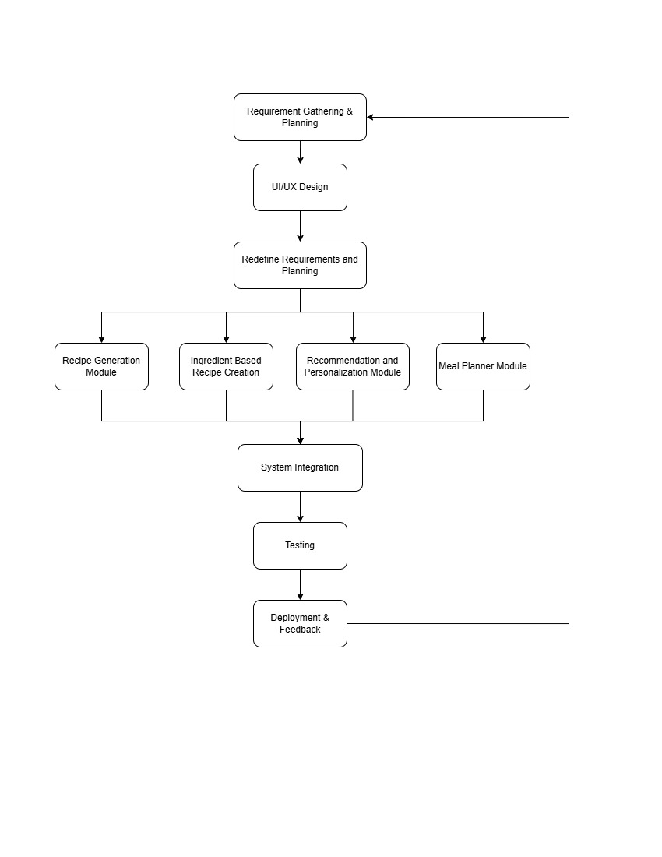
Figure 1.1: Process Model

Nature of the Project
It is a web-based project and is interested in personalized recipe recommendations and meal planning in the health and wellness area. The project will combine the GenAI, user preference filters, and convenient UI elements to provide an interactive and smart platform to the modern, health-conscious users. The most important aspects of the platform are Smart recipe discovery, where the user inputs the ingredients, dietary restrictions, and health goals, interactive recipe pages, which give the cooking instructions, nutritional breakdown, and healthy and sustainable meals preparation tips. The features of user engagement, like favorites recipes, the possibility of leaving a review, and following the personal search to improve further recommendation. The backend is done using Node.js with Express.js and for database MongoDB. It gave us a best and efficient framework to manage the user’s data, their reviews added, search histories and all. For security purpose JWT-based authentication is done with role based access control.

Report Layout
This report is presented in a systematic way to give a clear and detailed knowledge of RecipeFusion project, the background, the proposed system and methodologies used in developing the system. The chapters are structured to give significant areas of the project in a logical order to make sure that the chapter is clear, coherent and easy to comprehend by the reader.
Chapter 1 is an introduction of the project, where it describes the motivation of the project, the problem statement, the goals, objectives, scope and nature of the project. It lays the background of the research by pointing out the necessity of the intelligent and personalized system to produce recipes and recommendations and the obstacles that the suggested solution will overcome.
Chapter 2 is a review of available systems, technologies, and research pertaining to recipe recommendation and meal planning. It compares their features, strengths, and limitations and finds a gap in existing solutions. The following comparison analysis supports the necessity of RecipeFusion and its contribution to this field.
In chapter 3, the requirement specifications of the system are offered. It outlines what the system should do and what it should not do as well as non-functional requirements that are regarded as the technical limitations that the system must meet. This chapter gives a clear insight of the behavior of the system, the expectation of performance and usability.
Chapter 4 is on system design and modeling. It describes the architectural design, interface design, database design, and other system views based on diagrams like the activity diagrams, sequence diagrams, component diagrams, and deployment diagrams to show Sand interactions and workflows of the system.
In chapter 5, the author covers the specifics of implementing RecipeFusion. It explains the modules of person system, person used technologies, frameworks and tools involved in the development and how these are integrated with the rest of the system. This chapter underlines how the information about design decisions was transformed into a working application.
Chapter 6 is system testing, analysis and validation. It gives the test strategies employed, the test cases done, the anticipated results, and the real results in order to guarantee the reliability, correctness, and performance of the system.
The last chapter is the conclusion of the report summarizing the project achievements, limitations, and the general impact. It also gives future improvements and further research opportunities that are possible which gives an idea of how RecipeFusion can move past the way it is currently implemented.
Through this systematic manner, the report is able to follow a logical flow of information and the readers can have a clear idea of the process of development, design choices and contributions of the RecipeFusion project.

CHAPTER 2

BACKGROUND & EXISTING SYSTEMS

The chapter covers the history and current system regarding recipe recommendation and meal planning solutions. It will create an insight regarding significant concepts, technologies, and constraints of existing solutions, making the applicability and innovation of RecipeFusion relevant to these shortcomings.

Literature Review
During the last twenty years, the issue of digital technologies in nutrition management and diet planning has gained considerable momentum. Evidence-based practice [1] indicates that technology-assisted dietary guidance enhances awareness, decision-making, and long-term adherence to healthier eating patterns among users [2]. Owing to today’s fast-paced and increasingly constrained lifestyles, users now expect smart food systems that go beyond a fixed set of recipes and instead provide personalized, context-aware, and adaptive dietary recommendations.
Food informatics research emphasizes the importance of customizing dietary systems. Recommender systems that incorporate user preferences, health goals, and dietary restrictions have been shown to significantly improve user satisfaction and engagement [3].
Ingredient-based recommendation has also emerged as an important research area, as it has proven effective in reducing food waste and improving cooking convenience. Studies show that ingredient-driven search enables users to utilize available food resources more efficiently and promotes sustainable consumption practices [4]. These studies also report that most real-world systems still rely on shallow ingredient matching and lack sufficient semantic understanding and flexibility [5].
Another critical aspect of intelligent food systems is nutritional awareness. Research demonstrates that integrating nutritional values, calorie content, and portion-size recommendations into meal-planning systems can significantly improve overall diet quality [6]. This impact becomes even more significant when such tools are embedded into personalized diet planning environments [7].
Even though all these studies are evidence of the potential of intelligent products in the field of food, most of the available ones are relatively isolated solutions, like recipe search, calorie counting, or AI-guided cooking. Such fundamental functions as real-time flexibility of ingredients and personalization, built-in nutrition analysis, and unified meal planning are yet to be developed. It is based on these drawbacks that the idea of RecipeFusion is rooted as a concept that seeks to integrate all these features in one smart and user-friendly system.
The website Yummly [8] offers a list of recipes depending on the preferences of the user, dietary limitation, and history of visiting. It has an aesthetically pleasing interface, and it is compatible with various devices. Although they exist, Yummly is heavily dependent on canned recommendation logic and has no long capabilities of ingredient-based search, which limits the flexibility of the service to users whose ingredient availability is limited.
One of the most popular recipe websites AllRecipes [9] has a huge amount of community recipes, as well as user ratings. Although it allows ingredient-based search to a small degree, it does not have a built-in AI-driven meals creation or structured meal planning, which makes it less useful to users that want personalized dietary advice.
The system Eat This Much [10] dedicated to the meal planning, which is based on the calorie intake, creating meal plans based on the nutritional and calorie requirements. Though it is a good-calorie manager, the site does not emphasize ingredient availability, cultural foods, and generative recipes, which is less favorable to those with complicated diets.
More recent applications in artificial intelligence have brought with them tools like ChefGPT [11], which creates recipes and uses natural language processing and machine learning algorithms to create recipes based on what the user enters. Although these systems show the prospect of AI-driven content development, they might not have extended meal systems, nutrition surveillance, and long-term customized services, which causes disjointed user experiences.
Even though these platforms all indicate the possibility of digital tools in handling the topic of recipe discovery and meal planning, they are more concerned with unconnected features than with comprehensive and smart approach. Among the most important limitations, one could single out a lack of personalization, ineffective ingredient-based recommendations, inadequate nutritional analysis, and the lack of adaptive meal planning features.

Comparison of Existing Systems
There are a number of systems, which provide recipe discovery and meal planning services, each having its advantages and disadvantages. Although they show the feasibility of digital tools to help make better dietary choices, the majority of them intensely lacks the provision of an intelligent and personalized experience. Some of the most popular systems, their functionality, technologies, and gaps that RecipeFusion tries to fill are highlighted in the Table 2.1.
Table 2.1: Summary Existing Systems
System | Year | Features | Strength | Limitations
Yummly [8] | 2014 | Preference-based recommendations | User-friendly UI, wide recipe database. | Limited ingredient-based search, basic personalization.
All Recipes [9] | 2012 | Community recipes, ratings. | Large content repository. | No AI generated recipes, no meal planner.
Eat This Much [10] | 2013 | Calorie-based meal planning | Strong nutritional focus. | Limited personalization, ingredient constraints ignored
ChefGPT [11] | 2021 | AI-generated recipes | Demonstrates AI potential. | No structured meal planning, limited nutrition support.

Identified Problems from Existing Work
Some general challenges have been identified based on review of the existing systems. The vast majority of platforms have static or semi-personalized recommendations which is not capable of dynamically changing response to the real-time availability of ingredients and changing diets. Ingredient searches are typically partial or lacking and nutritional information is simple or not present at all.
In addition, most of the systems view recipe generation, meal planning, and personalization as different features but not as unified experience. Although innovative, AI-based systems often do not involve long-term planning and do not engage the user on a meaningful level other than responding to single query. These shortcomings diminish the effectiveness of the existing platforms with regards to their usefulness to users who want to have an all-round dietary support.
These concerns demonstrate the necessity of a smart, dynamic, and user-based system that can merge recipe generation, customization, nutrition awareness, and meal planning in one system.

Summary
This chapter revised the knowledge available in the domain and the current systems that were applicant to the project. Although there are a number of platforms that give advice on recipes and provide meal planning services, not many platforms provide a fully customized, ingredient conscious and nutrition built experience. Getting rid of these gaps, the proposed system RecipeFusion incorporates the latest technologies GenAI, real-time search by ingredients, and support of the interactive UI. RecipeFusion offers an advanced, scalable, and user-friendly solution to the current needs that today are more intelligent, personalized and health based by offering usability, scalability and capabilities to meet individual dietary requirements.

CHAPTER 3

SYSTEM MODEL / PROPOSED SYSTEM

This chapter explicates the specifications that would be required to develop the RecipeFusion - a recipe generation and recommendation system. These requirements can be defined as interface requirements and functional requirements which enable smooth interaction among the various parts of the system and its basic features that the system should provide respectively. Moreover, the chapter differentiates software and hardware interface requirements to present a detailed picture of the work of the system in terms of operation and technical requirements. Combined, these specifications can guarantee that RecipeFusion will be efficient, scalable, and meet the expectations of the users relating to intelligent meal timing.

Interface Requirements
The interface requirements of RecipeFusion are those requirements that are necessary to enable effective communication between the different subsystems of the system. These requirements outline the nature of interaction and integration between various modules including the recommendation engine, user interface and the APIs. Also, this part provides the system interaction with external environments such as the web browsers, the cloud services, and other third-party data sources.

Hardware Interface Requirements
The quality of RecipeFusion hardware interface depends on the hardware of endless devices. Table 3.1 is the adherence to the system hardware requirements of RecipeFusion.
Table 3.1: Hardware Interface Requirements
Component | Specification
Devices | A device that can connect to the internet such as a desktop, laptop, or table.
Processor | A Dual-core or some greater core in ensuring a good flow to visualizations.
RAM | RAM 4 GB or more is the minimum requirement in order to enable the smooth dynamic render and interaction.
Internet | 5 Mbps or above is stable connection that is required to run optimally.

Software Interface Requirements
To develop and run the suggested product, RecipeFusion, various software instruments and solutions are needed. The tools facilitate the creation, implementation, and the effective operation of the web-based application.
The system can only be accessed by a modern web browser like the most recent ones of Google Chrome, Mozilla Firefox, or Microsoft Edge. The program is operating system independent and can be run on any operating system such as windows, macOS, and Linux.
To develop the frontend, the common web technologies, including React, Tailwind, and JavaScript are used to create the framework, design, and interactivity of the application. The ReactJS is a programming framework that is applied to create dynamic and responsive user interfaces in order to make the navigation seamless and improve user experience.
On the server side, the system framework is built on Node.js and Express.js, allowing to use the server-side logic and be efficient in API communication. The database management system is MongoDB which will store the user data, recipes, preferences, meal plans, and history of interactions.
The process of development and debugging is performed with the help of Integrated Development Environments (IDEs) and text editors including Visual Studio Code that has support for version control, extensions, and debugging tools. All these software interfaces will guarantee effective development, scalability, and maintainability of RecipeFusion system.

System Modules
RecipeFusion is an intelligent recipe generation and recommendation site based on the web and created with the aim of helping people to find recipes, plan meals, and make more healthier dietary selections according to their tastes and the ingredients they have on hand. The system is according to a modular architecture such that a module has a certain role and it can freely integrate with other elements.
The key modules of the system are as follows:

Recipe Generation Module
The RecipeFusion includes the Recipe Generation Module as one of its major parts. It allows users to create recipes on-the-fly, depending on the ingredients of the recipe, preferences, and limitations. The system is capable of analyzing user inputs to generate appropriate recipes that have step-by-step cooking instructions. Table 3.2 shows the implementation of Recipe Generation Features.
Table 3.2: Recipe Generation Features
Category | Features
Ingredient-Based Generation | Recipes generated using user-provided ingredients
Gen-AI Based Logic | Smart recipe creation using Gen-AI
Dietary Customization | Vegetarian, vegan, gluten-free, allergy-sensitive recipes
Instruction Generation | Step-by-step cooking procedures

Recommendation & Personalization Module
The Recommendation and Personalization Module gives users recommendations of specific recipes, which they would prefer to eat, based on their preferences, dietary objectives, and interaction history. This module keeps on modifying suggestions based on user preferences and past search history. The module’s implementation is outlined in following Table 3.3.
Table 3.3: Recommendation Module Features
Category | Features
Personalized Suggestions | Individual Advice Recommendations, according to history and preferences
Preference Learning | Learns user taste and dietary habits
Adaptive Filtering | Updates suggestions dynamically
Smart Ranking | Prioritizes relevant and healthy recipe

Meal Planner Module
The Meal Planner Module helps users to plan their meals either daily or weekly in an organized way. It is connected to the recipe and recommendation modules to create balanced meal plans in accordance to the type of diet, preferences and nutritional goals of the user. Features of this module are shown in Table 3.4.
Table 3.4: Meal Planner Features
Category | Features
Meal Scheduling | Daily and weekly meal plans
Nutritional Balance | Balanced meals based on health goals
Recipe Integration | Uses generated and recommended recipes
Flexibility | Allows manual edits and substitutions

UI Module
The UI Module of recipe fusion is simple, usable and accessible. It guarantees free flow among the user and system capabilities including recipe creation, recommendations, meal planning and assistance of AI.
The significant duties of this module are:
- Navigation Management: Paves the way to navigation between various parts of the platform.
- Input Handling Control: Processes the input of the system, selection of ingredients, preference filters, form validations.
- Information Display: Displays recipes, meal plans, and nutritional data in simplicity and in an ordered manner.
- Component Interaction: Communicates with the backend services and AI modules to show live results.
UI module is very important in the improvement of the overall user experience and that the user can easily peruse and use the functionality of RecipeFusion.

Functional Requirements
RecipeFusion has the main goal of giving a personalized and intelligent recipe discovery, generation, and meal planning based on interactive user input and AI controlled suggestions. The system incorporates numerous functional elements to provide a smooth and convenient experience and healthy informed choices to make about diet.

Authentication & Authorization
The users must authenticate themselves and then have personalized features like saved recipes, meal plans and preferences. Role-based authorization will allow accessing only relevant pages and features by the user according to his or her roles, ensuring the data security and privacy.

Recipe Recovery & Filtering
The system will allow users to find recipes using smart search and filtering features. Dietary filters like vegan, vegetarian, gluten-free, and other preference-based restrictions can be used by the users. This feature enables users to browse recipes with ease based on their dietary requirements and lifestyles.

Custom Recipe Generation
RecipeFusion promotes the use of AI in the generation of recipes, where the users can come up with their own recipes depending on the available ingredients and their preferences and health goals. This allows it to create dynamic content and allows users to make the most use of the available ingredients they possess which narrows the divide between what is available and what could be made into a healthy meal.

Shopping List Generation
It is a system that creates a shopping list automatically in the case of chosen or created recipes. The feature makes grocery planning easier as required ingredients are listed in a structured way, and this saves time and minimizes food waste among the users.

Recipe Saving & Retrieval
It gives its users the option of storing their favorite recipes in order to access them in the future. Recipes may be saved, which means that one can easily access the saved recipes and create his or her own unique collection of recipes and come back to favorite meals whenever they wished.

Meal Planning & Saving
RecipeFusion enables one to add and maintain customized meal plans, either per daily or per week. Meal plans can be saved and the estimated calorie intake can be tracked by users, which helps to plan and stick to a healthy diet in the long term.

Use Case
The Use Case Diagram gives a diagrammatic view of how the users (actors) and the functionality which the RecipeFusion system provides are interacting. It shows the interactions of the system with various users to execute various tasks namely registering, recipe search, meal plan generation and content management. The use case diagram (Figure 3.1) allows identifying the key actors and actions in the system.
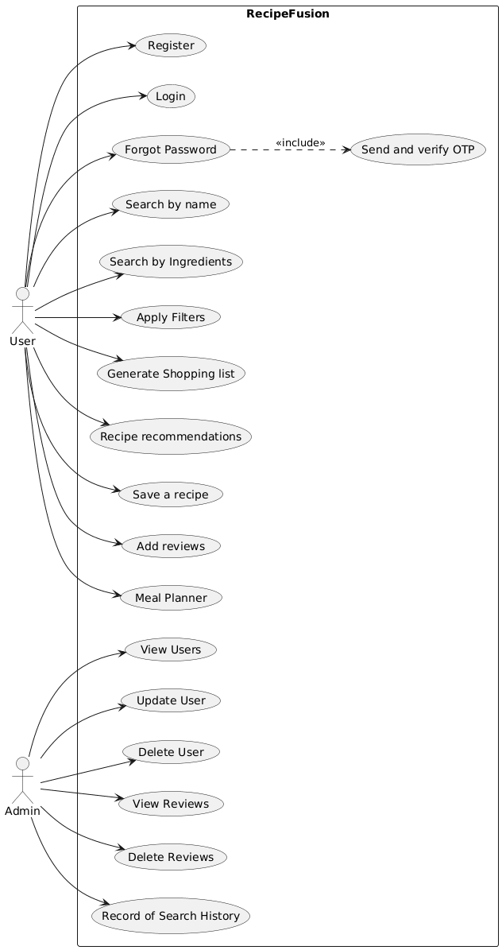
Figure 3.1: Use Case Diagram

User Registration
The registration use case allows newly registered users to have an account on the RecipeFusion platform, which provides access to personal features like saved recipes and meal plan. The use case of User Registration is shown in Table 3.5:
Table 3.5: User Registration – Full Dress Use Case
Use Case Selection | Comment
Use Case Name | Register User
Scope | RecipeFusion System – User Function
Level | High
Primary Actor | User
Stakeholders and Interests | Users want to access personalized recipe and meal planning features.
Pre-Conditions | User is not logged in.
Success Guarantee | User account is successfully created.
Main Success Scenario | User fills registration for, System validates data, Account is created, Confirmation message displayed.
Extensions | If duplicate email or username is entered error message show.
Special Requirements | Input validation and secure password handling.

User Login
This use case allows registered users to authenticate themselves and gain access to system functionalities. The use case of User Registration is shown in Table 3.6:
Table 3.6: User Login – Full Dress Use Case
Use Case Selection | Comment
Use Case Name | Login
Scope | RecipeFusion System – User Function
Level | High
Primary Actor | User
Stakeholders and Interests | Users want secure access to their personalized dashboard.
Pre-Conditions | User is registered.
Success Guarantee | User is successfully authenticated.
Main Success Scenario | User enters credentials, System verifies, User redirected to dashboard.
Extensions | If the user enters invalid credentials error message is displayed.
Special Requirements | Secure authentication mechanism.

Search Recipe by Name
This use case allows users to search for recipes by entering a recipe name. Table 3.7 outlines the discussed use case as below.
Table 3.7: Search Recipe by Name – Full Dress Use Case
Use Case Selection | Comment
Use Case Name | Search Recipe by Name
Scope | RecipeFusion System – User Function
Level | Medium
Primary Actor | User
Stakeholders and Interests | Users want to quickly find a specific recipe.
Pre-Conditions | User is logged in.
Success Guarantee | Matching recipes are displayed.
Main Success Scenario | User enters recipe name, System searches for that recipe and results are displayed.
Extensions | If no results the message “No recipes found” is displayed.
Special Requirements | Efficient text-based search.

Search Recipe by Ingredients
This use case enables users to find recipes by using the list of available ingredients in their kitchen. Table 3.8 details this use case as follows.
Table 3.8: Search recipe by Ingredients – Full Dress Use Case
Use Case Selection | Comment
Use Case Name | Search by Ingredients
Scope | RecipeFusion System – User Function
Level | High
Primary Actor | User
Stakeholders and Interests | Users want recipes based on available ingredients.
Pre-Conditions | User is logged in.
Success Guarantee | Ingredient-matched recipes are displayed.
Main Success Scenario | User enters ingredients, System matches, Recipes displayed.
Extensions | No matches, system suggests alternatives.
Special Requirements | Ingredient matching logic.

Apply Filters
Before searching for a recipe the user is allowed to apply filters for cuisine type, difficulty level, maximum cooking time and diet type to refine the recipe search. Table 3.9 details this use case as follows.
Table 3.9: Apply Filters – Full Dress Use Case
Use Case Selection | Comment
Use Case Name | Apply Filters
Scope | RecipeFusion System – User Function
Level | Medium
Primary Actor | User
Stakeholders and Interests | User wants refined search results.
Pre-Conditions | Search initiated.
Success Guarantee | Filtered results displayed.
Main Success Scenario | User selects filters, System applies filters, Filtered results shown.
Extensions | If there are no results, the popup for results unavailable will be displayed.
Special Requirements | Real-time filtering.

Generate Shopping List
This use case generates a shopping list based of a particular selected recipe which help user in groceries, as the user can download the shopping list as pdf for later user. The following Table 3.10 shows this use case.
Table 3.10: Generate Shopping List - Full Dress Use Case
Use Case Selection | Comment
Use Case Name | Generate Shopping List
Scope | RecipeFusion System – User Function
Level | Medium
Primary Actor | User
Stakeholders and Interests | Users want easier grocery planning.
Pre-Conditions | A recipe detail page is opened for a particular recipe.
Success Guarantee | Shopping list is generated.
Main Success Scenario | User selects recipe, System extracts ingredients, List displayed.
Extensions | No recipe selected, prompt shown.
Special Requirements | Accurate ingredient extraction.

Recipe Recommendation
This use case provides personalized recipe recommendations based on user’s dietary preferences and search history is also tracked and used for these recommendations. Table 3.11 details this use case as follows.
Table 3.11: Recipe Recommendation - Full Dress Use Case
Use Case Selection | Comment
Use Case Name | Recipe Recommendations
Scope | RecipeFusion System – User Function
Level | High
Primary Actor | User
Stakeholders and Interests | Users want personalized suggestions.
Pre-Conditions | User is logged in.
Success Guarantee | Recommendations displayed.
Main Success Scenario | System analyzes preferences and track search history, Displays recommended recipes.
Extensions | If there’s no search history system shows the recipes based on preferences.
Special Requirements | Recommendation logic.

Save Recipe
This use case allows user to save a recipe in his respective account so that the user can access that bookmarked recipe in the saved recipes page of that user. Table 3.12 details this use case as follows.
Table 3.12: Save Recipe - Full Dress Use Case
Use Case Selection | Comment
Use Case Name | Save Recipe
Scope | RecipeFusion System – User Function
Level | High
Primary Actor | User
Stakeholders and Interests | Users want quick access to favorite recipes.
Pre-Conditions | User logged in and viewing recipe.
Success Guarantee | Recipe saved successfully and user can view that recipe whenever he needs.
Main Success Scenario | User clicks save button, System stores recipe in the database and Confirmation shown.
Extensions | If recipe is already saved warning will be displayed
Special Requirements | Persistent storage.

Add Review
This use case allows user to submit a review on any recipe to show his personal opinion or feedback. Table 3.13 details this use case as follows.
Table 3.13: Add Review - Full Dress Use Case
Use Case Selection | Comment
Use Case Name | Add Review
Scope | RecipeFusion System – User Function
Level | Medium
Primary Actor | User
Stakeholders and Interests | Users want to share feedback.
Pre-Conditions | The user is logged in and viewing a recipe.
Success Guarantee | Review Stored successfully.
Main Success Scenario | User submits review along with rating, System validates and Review is saved.
Extensions | Invalid input will show the error.
Special Requirements | Input validation.

Meal Planner
This use case allows user to get a weekly meal plan that will include all three meals of a day for whole week with the calorie count too. Table 3.14 details this use case as follows.
Table 3.14: Meal Planner - Full Dress Use Case
Use Case Selection | Comment
Use Case Name | Meal Planner
Scope | RecipeFusion System – User Function
Level | High
Primary Actor | User
Stakeholders and Interests | Users want structured meal planning.
Pre-Conditions | User is logged in.
Success Guarantee | Meal plan generated
Main Success Scenario | User requests to generate meal plan, system generates the plan and them user is able to save that plan.
Extensions | Server unavailable, retry message.
Special Requirements | Gen-AI based planning logic.

View Users
The primary objective of this use case is to provide the System Administrator with a centralized interface to monitor the user base. This is essential for verifying identity, troubleshooting login issues, and maintaining the overall integrity of the platform's social or corporate directory. Table 3.15 details this use case as follows.
Table 3.15: View Users - Full Dress Use Case
Use Case Selection | Comment
Use Case Name | View Users
Scope | RecipeFusion System – Admin Function
Level | Medium
Primary Actor | Admin
Stakeholders and Interests | Admin wants user overview.
Pre-Conditions | Admin is logged in.
Success Guarantee | The list of all the registered users of Recipe Fusion are shown.
Main Success Scenario | Admin opens users tab and system displays list of all the registered users.
Extensions | Database error, message will be shown.
Special Requirements | Role-based access.

Manage Users
This use case allows admin to manage users, update or delete them when needed. Table 3.16 details this use case as follows.

Table 3.16: Manage Users - Full Dress Use Code
Use Case Selection | Comment
Use Case Name | Manage Users
Scope | RecipeFusion System – Admin Function
Level | High
Primary Actor | Admin
Stakeholders and Interests | Admin wants to update user’s data or delete a user.
Pre-Conditions | Admin authenticated.
Success Guarantee | User updated/deleted.
Main Success Scenario | Admin edits/delete user, system updated the data.
Extensions | If user not found error will be shown.
Special Requirements | Authorization checks.

View/Delete Reviews
This use case outlines the procedures for an Administrator to monitor, moderate, and remove user-generated content in the form of reviews. The goal is to ensure that all public feedback complies with the platform’s "Terms of Service" and to maintain a high-quality, spam-free environment for other users. Table 3.17 details this use case as follows.
Table 3.17: View/Delete Reviews - Full Dress Use Case
Use Case Selection | Comment
Use Case Name | Review Management – Admin Function
Scope | RecipeFusion System
Level | Medium
Primary Actor | Admin
Stakeholders and Interests | Admin wants content moderation.
Pre-Conditions | Admin is logged in.
Success Guarantee | Review removed if user clicks the delete button.
Main Success Scenario | Admin selects a review to delete and system deleted that review.
Extensions | Review not found.
Special Requirements | Moderation logic.

View Search History
The Manage and Delete Reviews use case is a critical administrative function designed to uphold the quality of user-generated content. It allows authorized personnel to oversee feedback, ensuring it remains constructive, relevant, and free from malicious content. This use case covers the entire spectrum from manual auditing to the permanent removal of data. Table 3.18 details this use case as follows.
Table 3.18: View Search History - Full Dress Use Case
Use Case Selection | Comment
Use Case Name | View Search History
Scope | RecipeFusion System – Admin Function
Level | Medium
Primary Actor | Admin
Stakeholders and Interests | Admin wants usage insights.
Pre-Conditions | Admin is logged in.
Success Guarantee | Search graph displayed for the admin where count of search histories is shown per day.
Main Success Scenario | Admin opens his dashboard the system show the complete search graph.
Extensions | Data unavailable.
Special Requirements | Data visualization support.

Non-Functional Requirements
The quality attributes that guarantee reliability, usability, performance as well as security are the non-functional requirements of the proposed RecipeFusion system that goes beyond the fundamental functionality. These features are necessary to give an inclusive, safe, and easy-to-use system of finding recipes, planning the meals and custom suggestions.

Performance Requirements
The system also ought to respond effectively to the user demands like a recipe search, ingredient based query and a recipe detail query. The basic system functions of searching and loading recipes information should take not more than 5 to 8 seconds to finish once a request has been run.
The application should be optimized to be able to facilitate high traffic and peak performance with steady performance. Efficient API processing, efficient database processing and scalable server architecture should be used to ensure that the service delivery is continuous.

Usability Requirements
RecipeFusion would need to have high availability whereby the system is up 99.9 percent (of no more than one hour downtime per year). This is necessary in all the integrated elements as well as the back-end services, APIs, and the database layer.
The platform must also have automatic backup systems and failover provisions as a measure to protect against data loss and system failure. Such precautions will allow time-saving in restoring the servers when they crash or the database fails.

Security Requirements
Every Security would be a significant necessity because of the work with confidential user information. Any information between the client and server is to be encrypted by HTTPS to avoid information interception and man-in-the-middle attacks.
The passwords that users use should be stored safely through highly secured hashing functions like bcrypt such that the original passwords are not stored at all. Other security provisions are:
- Password reset functionality
- Secure session management
- User and administrator access control: Role-based
All these mechanisms help to safeguard data confidentiality, data integrity, and data access control to system resources.

Consistency Requirements
The system should be able to ensure data consistency in all the interactions with users. Real time changes could be made throughout the application regarding any changes in user preferences, recipes saved, meal plans, or reviews. This guarantees that the users will continue to work with the latest and pertinent information no matter the device or the session in which it is done.

Project Feasibility
The feasibility of projects will determine the viability and investability of RecipeFusion in terms of technical, operational, and ethical aspects. Through this analysis, the system would be able to be implemented and sustained in the long term.

Technical Feasibility
RecipeFusion can be technically implemented because of the presence of established and stable web development technologies. MERN stack (MongoDB, Express.js, React.js, Node.js) is a robust and scalable platform to develop the frontend and the backend of the application.
React.js is easier to use in terms of creating interactive and responsive interfaces and the use of Node.js and Express.js allows to manage the API effectively and process it with considerable efficiency. The MongoDB system also provides an elastic and scalable storage of data, thus making the system ideal in the case of future growth.

Operational Feasibility
Operational feasibility is concerned with practical feasibility and efficiency. RecipeFusion will have a user friendly model; it captures the ease of use, responsiveness and automation. The major processes like ingredient-based search process, recommendation of recipes and meal planning are optimized to deliver quick and precise outputs.
The system will only need moderate server maintenance, regular database backups, and feature upgrades on the system. It is scalable architecture which enables it in the large-scale deployment, having the potential of serving surge of users at both the small and large scale deployment.

Legal & Ethical Feasibility
RecipeFusion is within the law and ethical practices concerning the privacy of the users and the safety of their data. The emails and passwords are encrypted and hashed by the use of hash algorithms like bcrypt and stored safely.
The unauthorized access is prohibited by access control mechanism and protection of the session. The system meets all the ethical standards through transparency, data security, and responsible management of the information provided by the users.

Summary
In this chapter, the key non-functional requirements of the RecipeFusion recipe recommendation and generation system reflected were on performance, scale, security, and reliability. These factors play a vital role in facilitating the response, safety, and reliability of the system by the users as well as multiple simultaneous sessions and preserving and maintaining accuracy of the data.
Lastly, the feasibility study validated the fact that it is a technically, operationally, and ethically sound project. RecipeFusion combines a user-friendly format and a technical infrastructure that will be highly successful in achieving its goals and delivering intelligent, personalized service of performing meal planning and healthy eating in the present day. All these factors create a powerful foundation of the successful implementation of the system.

CHAPTER 4

SYSTEM MODELLING

Chapter 4 gives the system modeling and design of the RecipeFusion platform. System modeling is also critical in the process of knowing how the proposed system works, the interactions between the system components and the processing of user activities in a formal way. Sound system design and analysis aids in structuring the development process, planning and executing the development process in an effective manner as well as establishing challenges that may be encountered in the development process at an early stage of the development life cycle.
System modeling offers something that is visual and conceptual that represents the system architecture, the workflow, the data flow and the user interaction. These models are used as a medium of communication among the developers, designers and stakeholders as they clearly show how the system will look and how it will behave. This chapter applies a number of design and analysis models in defining the functionality of the system and the interfaces of the system.
RecipeFusion is a web interface, recipe suggestion and creation site that helps users find recipes by their dietary and nutritional objective and their ingredients. The system aims at making meal planning easier, healthier eating habits, and customized advice through smart data methods. To describe the system architecture and the internal processes within the system clearly, several modeling techniques have been reasoned out in the following sections which include the class diagrams, the activity diagrams, the sequence diagrams, the component diagrams, the deployment diagrams and the data flow diagrams.

System Design
The system modeling is essential in the representation, planning, and realization of a software system as it effectively portrays the structure, behavior, and interaction of the software system. It serves as a linkage between theory and practice so that requirements of systems are properly converted into a practical solution. System modeling is utilized through visual and analytical models to make the developers, designers, and stakeholders get an idea of workflow, data flow, and interaction between components.
The chapter gives an overview of the system modeling and design of RecipeFusion, a web-based, Generative AI-driven recipe recommendation and meal planner platform. RecipeFusion is meant to help the user to find appropriate recipes depending on the type of ingredients they have, their dietary needs, and dietary aims. The objective of the platform will be to make cooking choices easier, promote better eating behaviors and minimize food waste by making smart suggestions and creating tailored food plans.
The various modeling techniques applied to explain the system architecture and functionality clearly include Use Case Diagrams, Class Diagrams, Activity Diagrams, System Sequence Diagrams, Data Flow Diagrams (DFD), Component Diagrams and Deployment Diagrams. These models bring a broad view in the operations of RecipeFusion on how it works internally and with the users and other external services.

Design Approach
In designing RecipeFusion, bottom-up design style was employed with emphasis laid on the design and testing of the basic functional modules before connecting them together to create a complete application. The first step was to design and implement the backend infrastructure in the form of Node.js, Express.js, and MongoDB that acted as the basis of user management, and API endpoints. Similarly, the frontend interface was created with React.js, which puts a particular emphasis on the creation of an interactive and user-friendly environment in which recipes could be browsed, filtered, and saved.
All modules, frontend, and backend, were created separately and tested to make sure that they worked and were stable. Integration was also done progressively and it provided smooth connectivity between the user interface, API services and the underlying database. This disciplined model did not only increase defects of reliability and maintainability, but also made the task of debugging and quality assurance across the development spectrum simpler. By ensuring that every single element works independently and then connecting it to another, the team formed an easy and steady experience to end users and allowed problems to be scaled up later as well as adding features.

Interface Design
The user interface system of RecipeFusion is centered on being simple, easy to use, and conveniently accessible to all types of users which could include casual users, people who are more nutrition-oriented and the administrators. An efficient layout and easy navigation pattern were embraced to be able to communicate with the system easily. The interface will comprise the elements of registration, logging in, defining the food preferences, food browsing, meal planning, and feedback. The last interface is developed according to the recommendations of the best practices of the user interface/user experience, which guarantees its functionality and appearance.

Landing Page
The landing page is crafted with utmost focus and emphasis on aesthetics, visuals and user experience. A visually attractive design with a nicely complementing theme and colors and animated illustrations, grabs user attention. The Figure 4.1 shows the loader that is shown on opening the website.
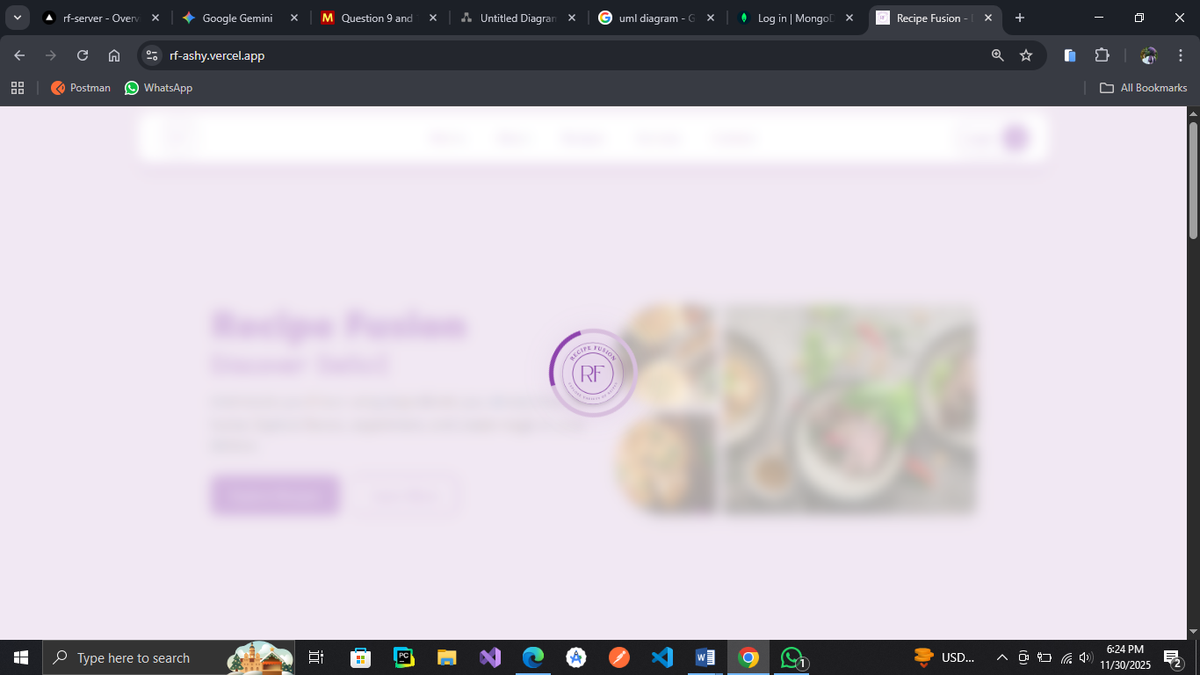
Figure 4.1: Landing Page Loader
The landing page of Recipe Fusion is a masterfully crafted digital gateway that harmonizes high-tech functionality with an inviting, gourmet aesthetic. Wrapped in a sophisticated palette of soft lavender and deep violet, the site establishes an immediate sense of culinary inspiration and modern reliability. This journey of discovery is underpinned by a robust "About" section that humanizes the AI-driven system, showcasing professional chefs alongside impressive social proof. The visual heart of the page is the "Popular Recipes" gallery, a vibrant, high-definition grid that spans the globe from savory about the most popular recipes. This inspiration is then grounded in practical utility through a streamlined "Our Services" quadrant, which highlights the platform’s core technical pillars: intelligent ingredient-based searching, personalized dietary filters, time-efficient meal generation, and a user-centric "save your favorites" feature. As the user reaches the footer, the experience concludes with a clean, accessible contact interface and a compelling "Ready to cook something new?" call-to-action, punctuated by a thoughtful culinary quote that reinforces the brand's philosophy that cooking should be an act of love and creative abandon. By balancing sleek UI design with rich, appetite-whetting content, Recipe Fusion positions itself as both an essential tool for the pragmatic home cook and a boundless playground for the culinary explorer. The landing page is indicated in the Figure 4.2 below.
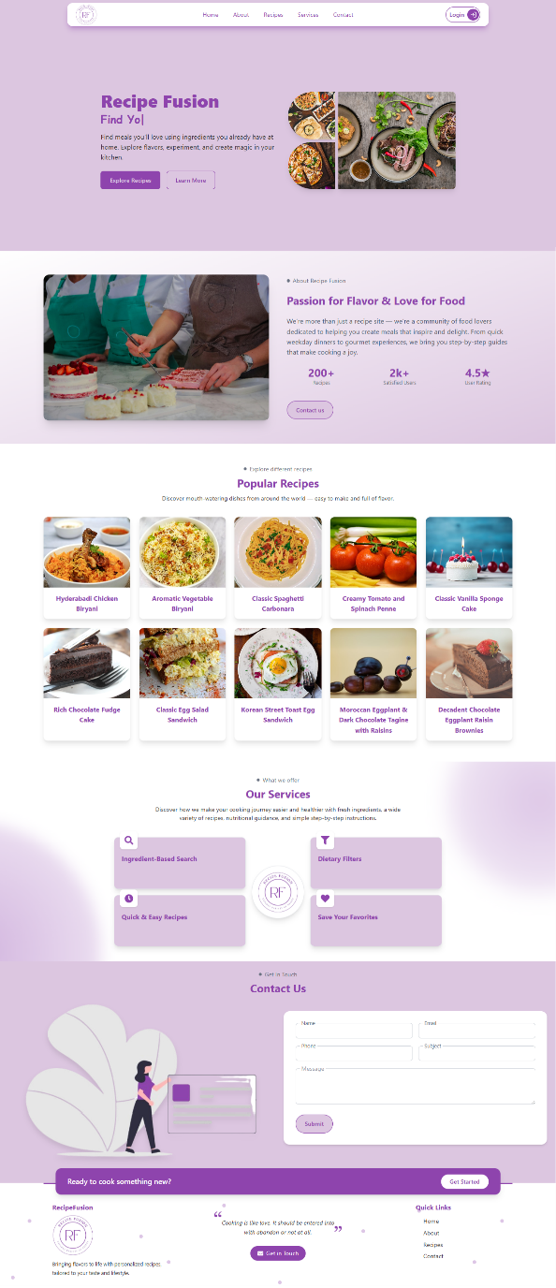
Figure 4.2: Landing Page

Login/Signup Screen
The RecipeFusion system relies on the Login Screen to provide access to the system. It enables users and administrators who are registered to identify themselves through credible credentials. The interface will be based on the email and password input fields and a validation method to verify that right data has been entered.
After the authentication, the system checks user credentials using the end-backend authentication system and provides access based on the assigned role. When regular users are creative, all the users will be redirected to the User Dashboard whereas administrators will be redirected to the Admin Dashboard. Where there is an invalid group of credentials, relevant error messages are shown to help the user.
Such a screen guarantees security of access into the system through application of encrypted communication as well as token based authentication to safeguard user information and integrity of the system. The following Figure 4.3 shows the login screen.
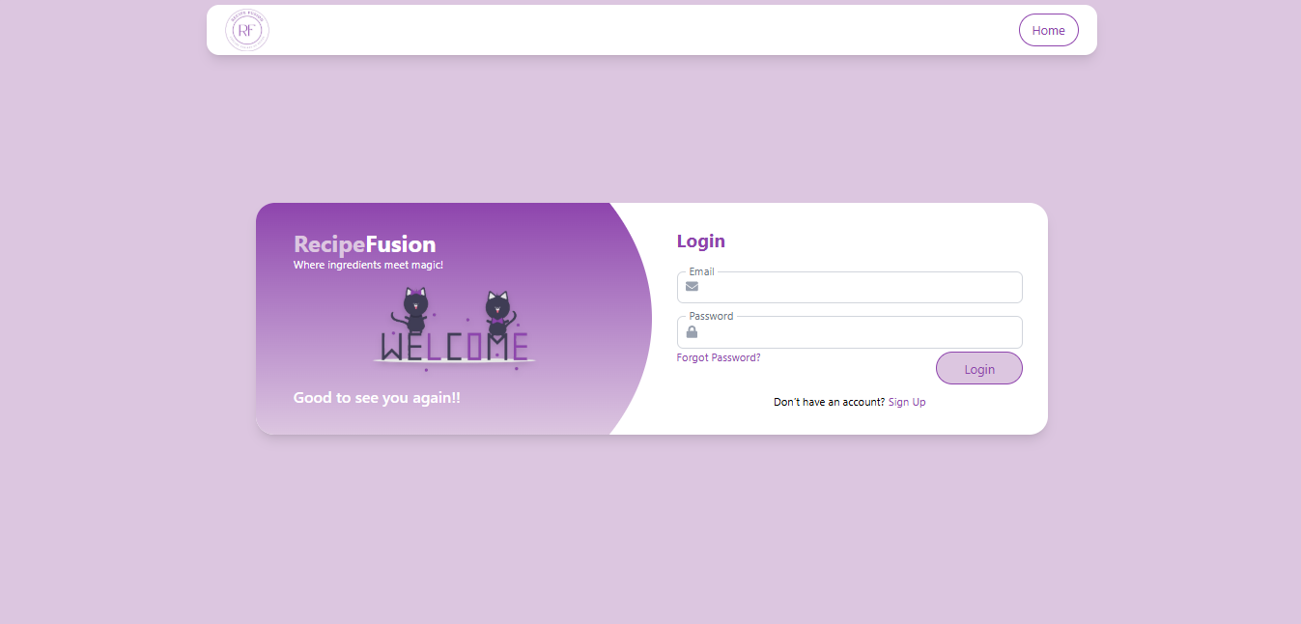
Figure 4.3: Login Screen
The Signup Screen allows the user to create an account on RecipeFusion. The interface comprises first name, last name, username, email address, phone and password fields. And in second form we have height, weight, age, cuisine preference, allergies and health conditions fields. Input validation is used to make sure that the data is correct, e.g. the correct format of the email and the strength of the password used.
After the user is registered, the email and username uniqueness are checked by the system and then the data are stored safely in the database. The hashing technique is used in encryption of passwords to improve security. Upon successful registration, the user can then log in and use personalized functionality including saved recipes, meal plans and recommendations.. The following Figure 4.4 shows the signup form.
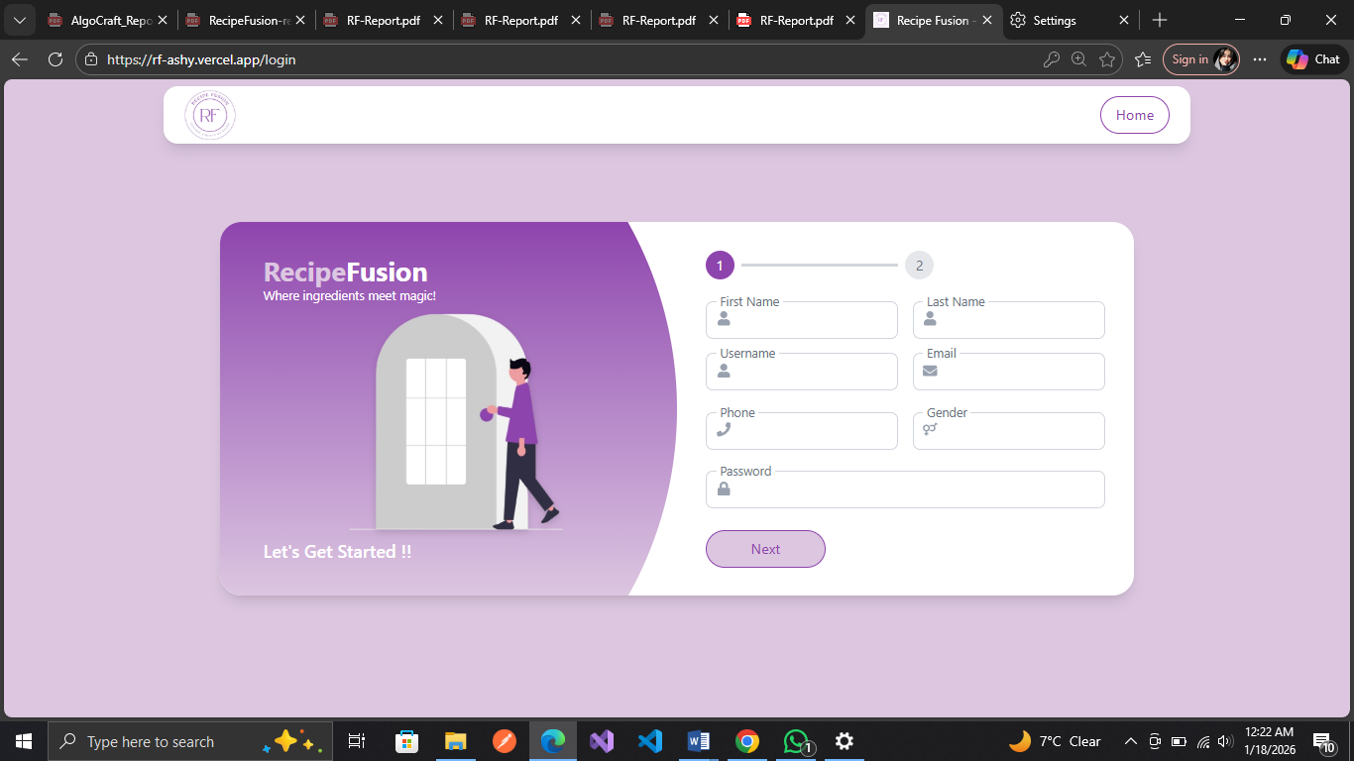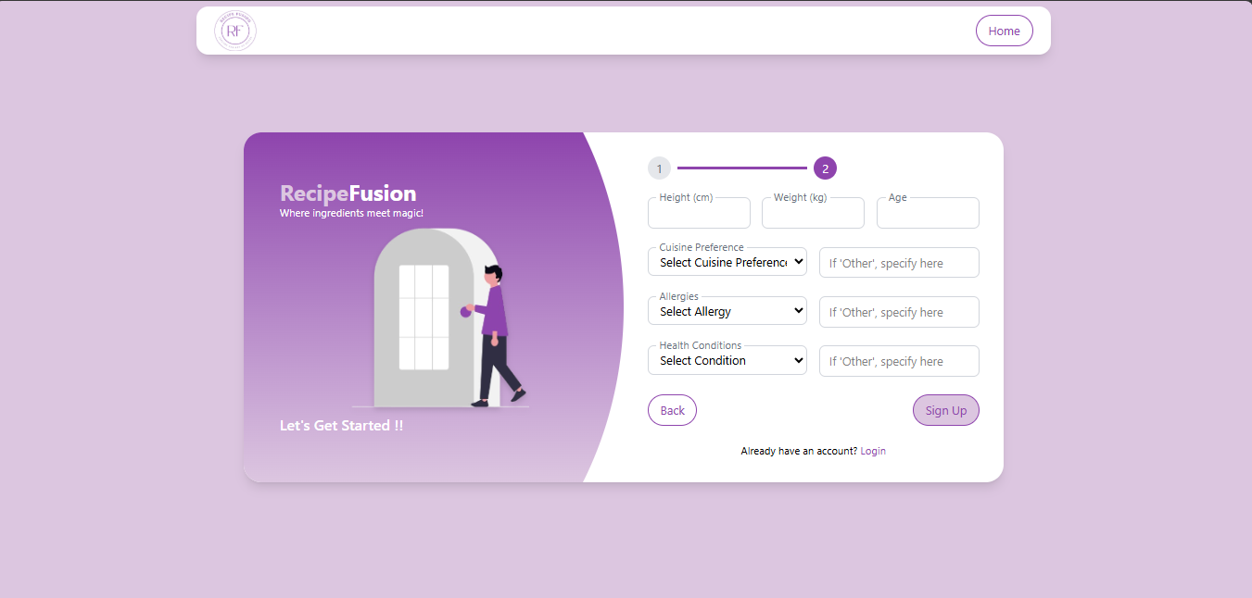
Figure 4.4: Signup Screen

Admin Dashboard
Admin Dashboard is an interface that allows the administrator to keep track of system activities. It provides a summary of the statistics of its most important systems, such as number of registered users, number of recipes offered, user reviews and trends of search activities.
The dashboard also has modules of:
- Seeing and controlling users (active and non-active status)
- Reviewing and controlling user feedback.
- User search behavior examined as part of a graph.
Role-based access control implies that those functionalities access is restricted to authorized administrators. The design is organized and information based, which allows the administrator to make successful decisions and achieve quality of the system. The following Figure 4.5 shows the home page of Admin dashboard.
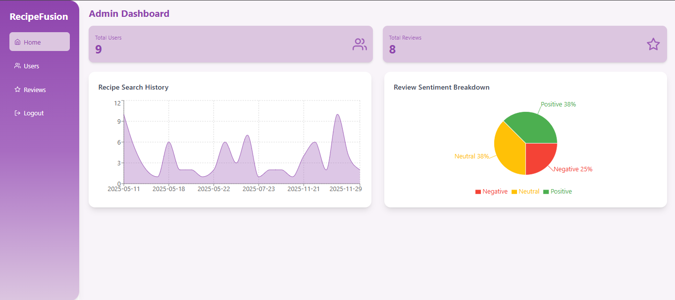
Figure 4.5: Admin Dashboard Home
The Recipe Fusion Admin Dashboard has its own secure user management page, which has a clean and purple clearance where the management of the community of the Indirect Fusion site is efficiently managed. The outstanding element is a detailed data table which presents detailed profile of the individual registered users, their complete name, unique name which they utilize, their email address, and the contact phone. In addition to mere identification, the table also offers useful personal data, such as the cuisine preferences of the user (e.g., Pakistani, Italian, or Vegan), selected health issues, including Hypertension or Diabetes, and the number of the recipes, which are saved by the user. The rows are also provided with working action buttons of Edit and Delete so that, the admin can edit the account information or delete users where the need be in order to preserve the integrity of the platform. Figure 4.6 below presents the account of all the registered users.
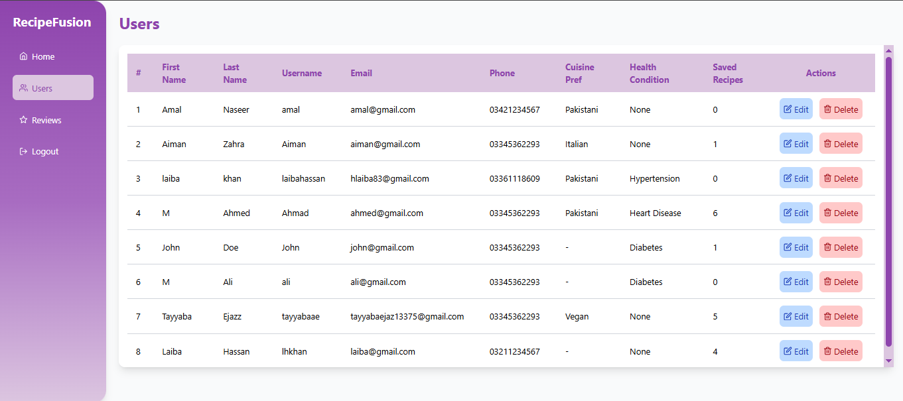
Figure 4.6: Admin Dashboard - Manage Users
The Reviews management section of the Recipe Fusion administration dashboard allows a centralized management of feedback in the community. These key data of the specific Recipe name, the Username and Email of the author and preview of the actual Review text are presented in the key data of each of the entries in the primary table. The list of reviews is illustrated in the following Figure 4.7.
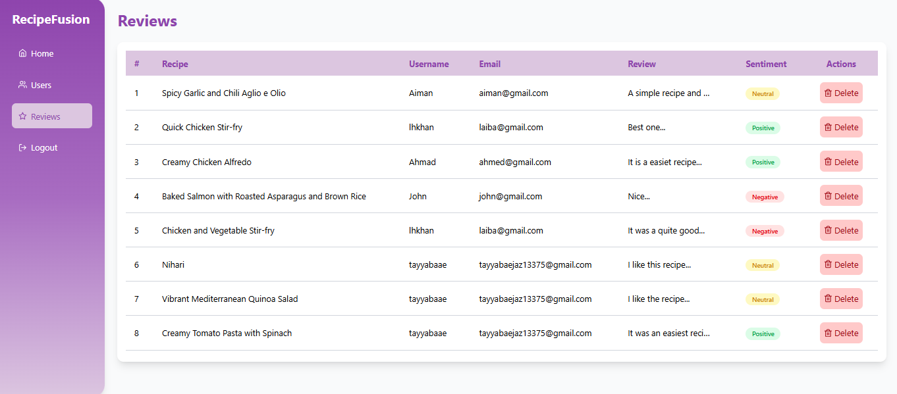
Figure 4.7: Admin Dashboard - Manage Reviews

User Dashboard
The workspace where authenticated users are allocated is the User Dashboard. It also offers individualized access to the key functionality of RecipeFusion such as search of recipes, AI-generated recipes, meal planner, and content management.
From the dashboard, users can:
- Recipe search by name or ingredients
- Use food and nutritional sieves.
- Generate AI-powered recipes
- Create and save meal plans
- Browse favorite recipes, and control your profile.
The interface focuses on simplicity and clarity, and it is easy to use various features without complexity. Individualized recommendations are shown with regard to user likes and past interactions, which improves the overall user experience. The following Figure 4.8 shows the home page of user dashboard.
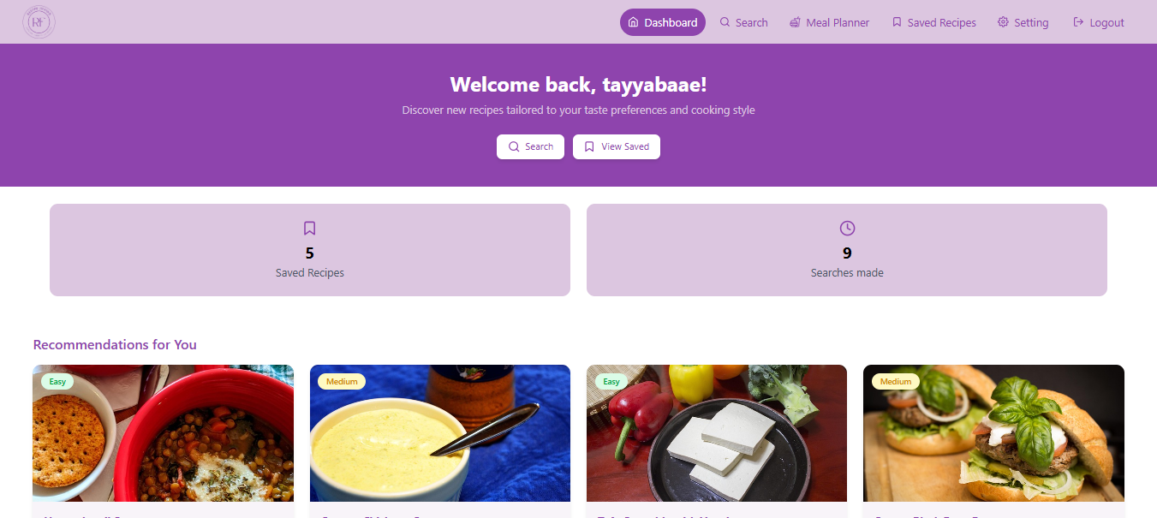Figure 4.8: User Dashboard – Home
The Recipe Fusion platform Search Page is also made such that it enables its users to find new recipes in a generally flexible and intuitive manner. On the top, there is a devoted navigation bar that will enable one to easily change the core functions such as the Meal Planner, Saved Recipes, and Settings. The main search platform provides two different search options, among them being the Search by the Name so that users can find particular cravings and the Search by Ingredients that will aid the user to prepare the food that he/she has at their disposal. The search page of user dashboard looks as indicated in the following Figure 4.9.
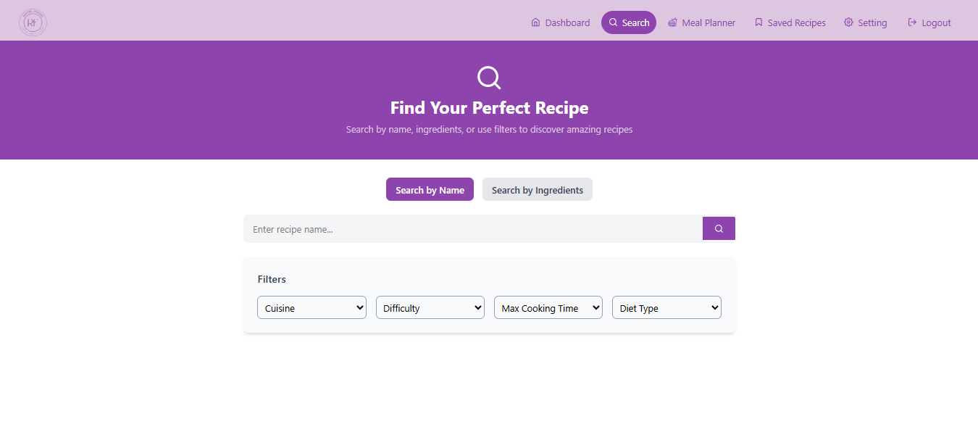
Figure 4.9: User Dashboard - Search Page
Weekly Meal Planner page displays the food plan of a user during the entire week. On the top, a summary section shows the significant metrics of the week in the form of the total amount of number meals, the average amount of calories, and the number of cuisines. The meal planner page of user dashboard appears in Figure 4.10.

Figure 4.10: User Dashboard - Meal Plan Page
Saved Recipes page of the RecipeFusion serves as a digital cookbook for saved content. The page indicates that the recipes saved by user for later use. Each card provides essential information of the whole recipe. Figure 4.11 shows the saved recipes page of user dashboard.
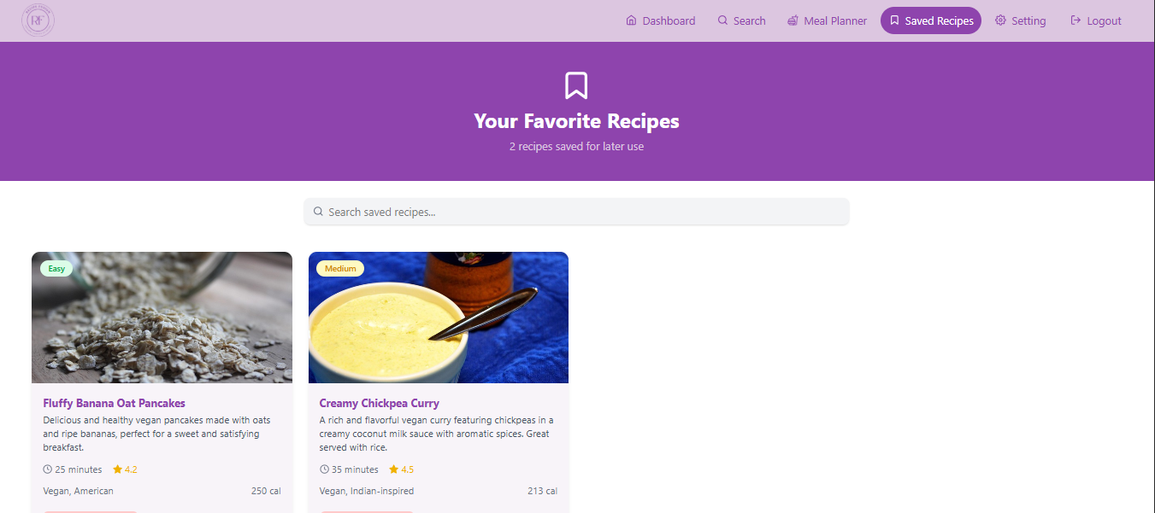
Figure 4.11: User Dashboard - Saved Recipes Page
Account settings page of RecipeFusion allows users to view and update their personal profile and health data that they provided at the time of registration. Figure 4.12 shows the account settings page of user dashboard.
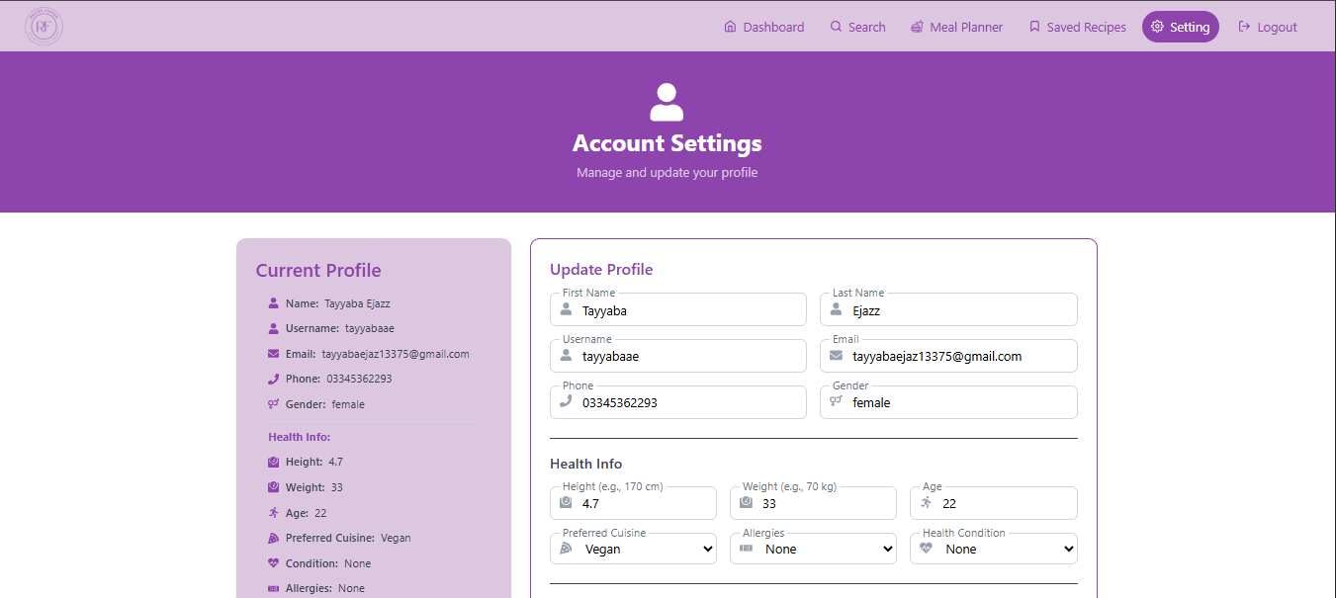
Figure 4.12: User Dashboard - Profile Setting

View Model of Architecture
View Model of Architecture of RecipeFusion presents organized representation of the system under various perspective that aid to the stakeholders in knowing the organization, behavior and deployment of the system. Its architecture is in 4+1 View Model which is the Logical View, Process View, Development/Component View, and Physical/Deployment View.
This model explains the interaction of the system components, data flow within the system and how the platform is able to perform, be used and scaled.

Logical View
The logical perspective RecipeFusion specifies the system structure in the context of the main entities and their interactions. It is created in such a way that it is modular, data consistent and easy to scale. The system consists of such key components like user management, recipe handling, meal planning, search tracking and review management. All these elements are devoted to the functionality basis such as user authentication, role-based access control, personal recipes recommendations, ingredient-based search, meal planning, and interaction history monitoring. The class diagram in Figure 4.13 pays attention to structural attributes of the system identifying its classes, attributes, and their relationships.
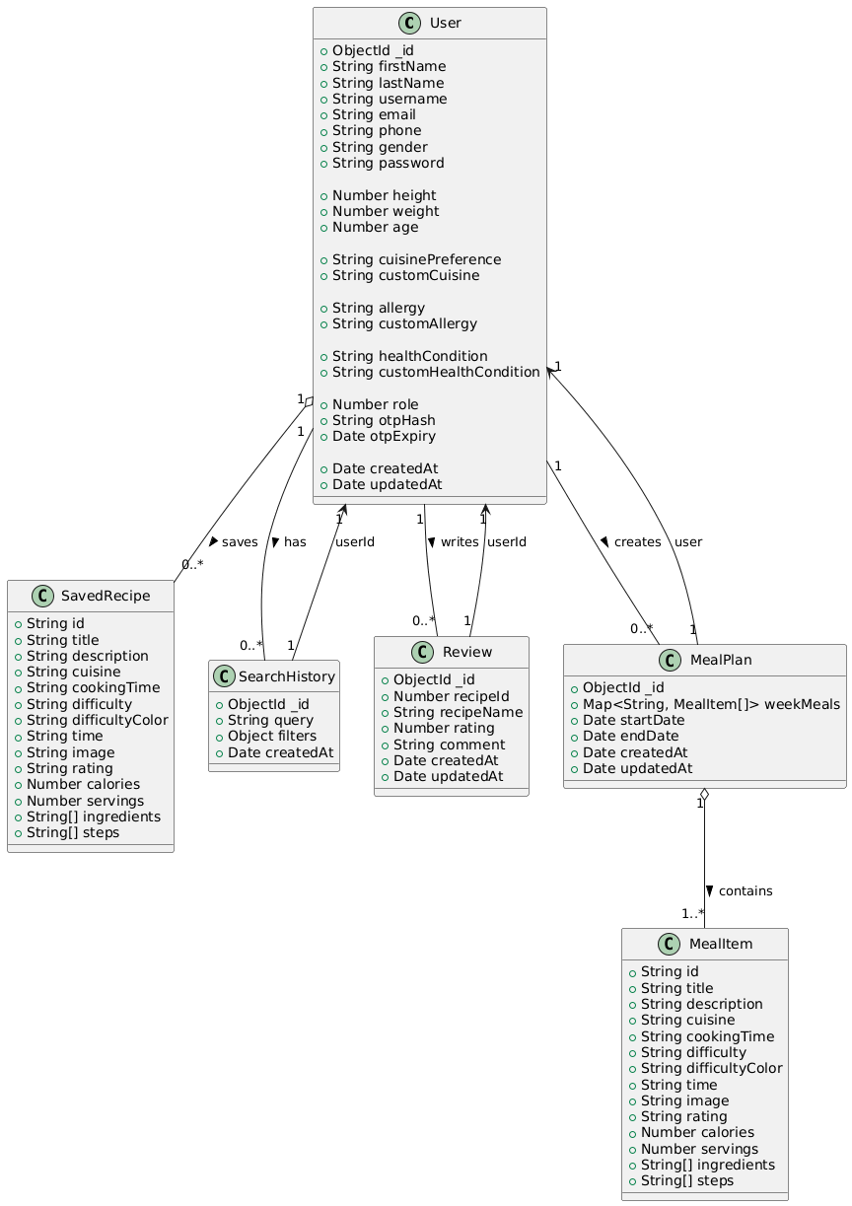
Figure 4.13: Class Diagram
This diagram will provide a blueprint of the system architecture, which will enable developers to know how various parts of the system will interact, as well as the flow of data among them. As far as RecipeFusion is concerned, the class diagram comprises of significant classes, including User, SavedRecipe, SearchHistory, Review, Meal plan and Meal item, exhibiting of their property and relations with each other. The embedded document structures, including the saved recipes in the user entity and the meal items in the meal plans, and the relationships mentioned in the diagram as the user-linked reviews, search histories, and meal plans are also highlighted. This logical model is required to provide integrity of data, facilitate personalization and makes user interactions to be managed efficiently inside of the RecipeFusion system.

Process View
The process view of the RecipeFusion platform describes the major runtime behaviors, simultaneous processes, and system interactions enabling to discover the personalized recipes and interact with users. This perception describes the real-time exposure of the system components to make it responsive, scaled and efficient.
The frontend consists of a registration or logging-in interface where the user will start his or her journey. On the terms of submitting the credentials of the login, the backend (Node.js/Express) authenticates the codes, provides a JWT token to manage a session, and loads a role-based dashboard. Several individuals can log in to the system and communicate with it at the same time without interfering with each other.
After authentication, users will have the opportunity to enter the available ingredients, choose the dietary preference or search recipes. At the same time, the system asks GenAI to search and return similar data on recipes, which is filtered in the same way according to the products used, the type of cuisine or even the diet restrictions. These filters and search are done simultaneously giving the user a smooth view.
Reviewing can be made by users and it is saved and compiles up to affect the rating of recipes as well as its recommendations. At the same time, this has logged the search history to tailor other subsequent suggestions using collaborative filtering.
The admin is able to handle users, search history and reviews in an administrative dashboard. They are able to carry out tasks such as deleting objectionable content, evaluating the search history of the user, and other tasks of the entire content store. These processes are initiated without user-side interactions, and system fluidity is ensured.
The system is designed to have a frontend designed in React.js that responds to users and is also dynamic and a backend that processes API logic, authentication, and database communication. MongoDB allows each recipe, user and preference to be elastically stored so that it can handle many read/writes at a time. The Activity Diagram illustrates the operations shown in Figure 4.14 is presenting the sequence of activities, decision making, and transition between different states. It will give a perfect picture of the execution of processes and assist in maintaining the flow of work organization.
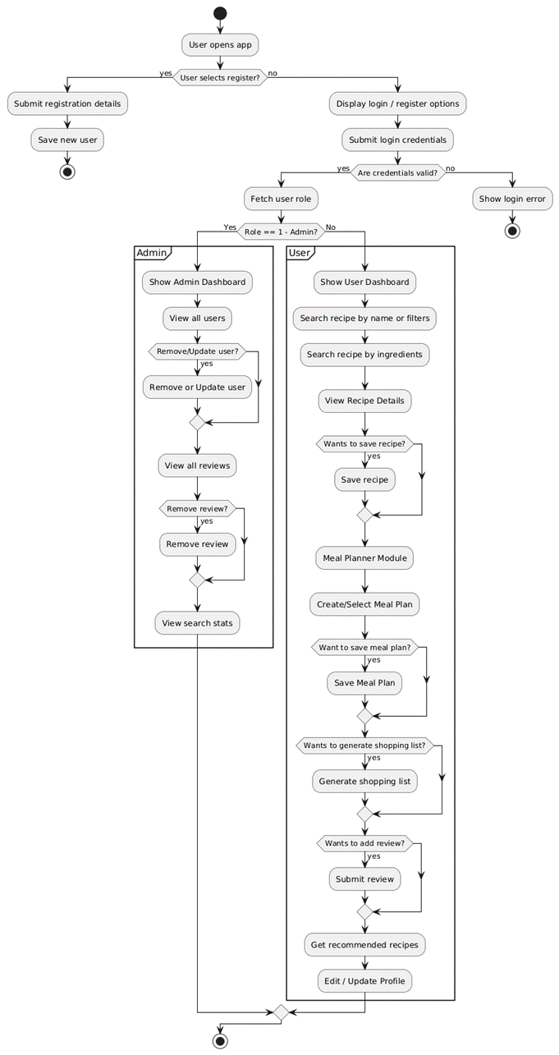
Figure 4.14: Activity Diagram
The system sequence diagram (SSD) shows the high level interaction of the user (actor) and the RecipeFusion system, where the chronological sequence of events is provided in significant functional areas. It describes the way in which the user-based actions are handled by the system, the AI engine and the database to give personalized services, including authentication, role-based dashboards, recipe discovery, meal planning, and recommendations.
The chain starts upon opening up of the webpage by the user and the system shows the landing page. The user is then brought to the login or registration page with the authentication form being displayed by the system. When the credentials are entered, the system authenticates the input and authenticates the user data on the database. Using this, a user is redirected to the correct dashboard after making a successful authentication, depending on his/her role. In case the trusted user is an administrator, the system loads the administration dashboard, which retrieves user records, reviews, and search history data in the database. Conversely, when the authenticated user is a normal user, the system loads the user dashboard by retrieving preferences and search history stored about them and summoning the AI engine to give them personalized recommendations on recipes, which are then shown to the user.
After using dashboard, the user is redirected to the page of recipes search, and the system provides a search form to the user. The user enters a search query with a recipe name or accessible ingredients and uses filters and choices and types of cuisine, type of diet, level of difficulty, and the required length of time to cook. The system enters the query into the AI engine to derive recipes and filter them. The resulting recipes and nutritional data are sent back to the system to the user. Concurrently, the search query is captured in the database as the search history of the user to be used in future customizing to the user.
The meal planning module will give the user access to the plans of meals saved in the past or create a new meal plan on a weekly basis. When a request of a generation of a meal plan is made, the system activates the AI engine to generate a specific menu plan depending on the preferences that the user has registered. The plan development generated is saved in the database and displayed to the user. And further, the user can access as well as the user has saved recipes page where the favorites recipes saved in the database are accessed and seen. The profile page also allows the user to update and view personal and preference information and this data is again stored in the database on being submitted. The following Figure 4.15 shows the System Sequence diagram of Recipe Fusion.
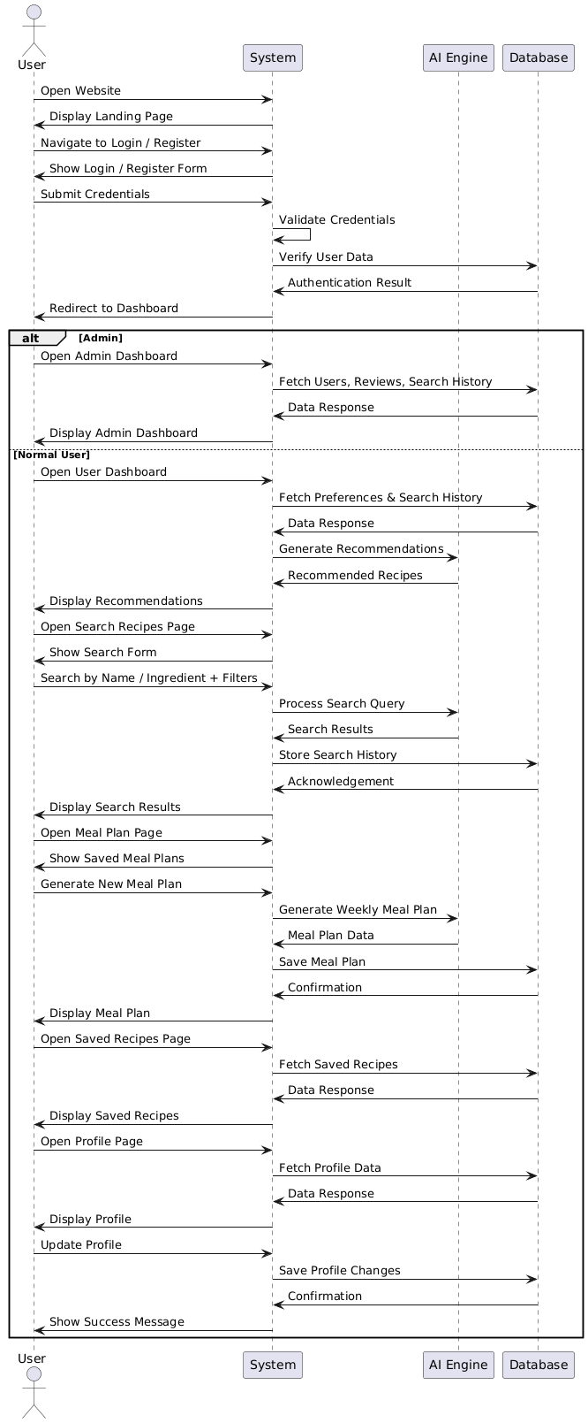
Figure 4.15: System Sequence Diagram
The sequence diagram of Recipe Generation Module that specifically deals with the search and creation of the recipe. The sequence begins with the user opening the search recipes page whereby the system presents the search form. The user types a recipe name or ingredients and makes optional filters, including the cuisine, type of diet, difficulty level, and cooking time. Upon acceptance of the inputs, the system also sends the request to the AI engine that produces appropriate recipes and nutritional information. The system returns the results as it is shown to the user, the search query is stored in the database as search history.
The chart also explains the user access to detailed information of any chosen recipe and ingredients and steps to prepare and nutrients among others. When the user decides to save a recipe, the system will put the chosen recipe in the saved recipes section of the user in the database and give the user a response on the same. Following Figure 4.16 shows the sequence diagram for Recipe Generation Module.
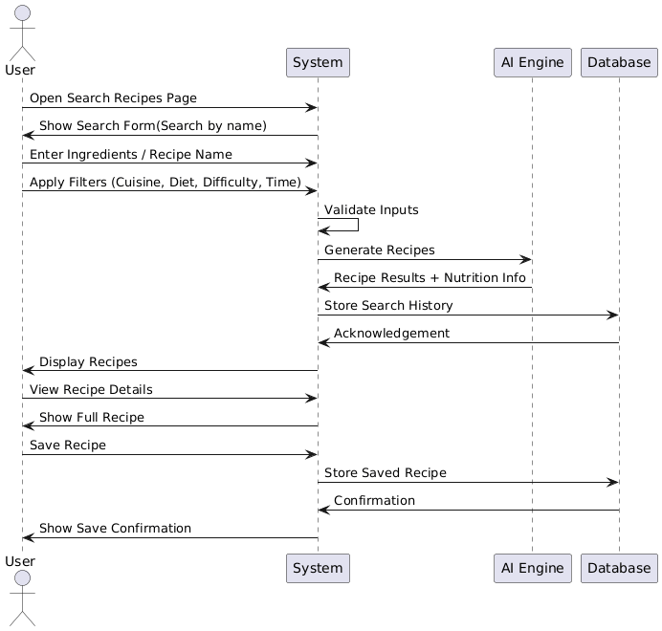
Figure 4. 16: Sequence Diagram for Recipe Generation Module
Comprehensively, these sequence diagrams outline the modular, role-based and interactive quality of RecipeFusion. They show the well-organized interactions between frontend and backend services, database processes, and artificial intelligence-grounded computations towards personalized recommendations, recipe finding, meal plans, and profile interactions. The diagrams also highlight that the system can offer real-time response, data integrity, and offer its users a personalized and interactive cooking experience in all the key functional modules.

Deployment View
The Deployment View of the RecipeFusion platform shows the distribution and hosting of the core software components in the various physical and cloud based infrastructure layers to provide high availability, performance as well as scalability.
Project of the system was created on the basis of React.js, Node.js and express.js and is deployed on the cloud hosting service like Vercel which provides responsive implementation to the user device. The layer allows users to engage with such features as ingredient-based search of recipes, personalized recipes, dietary filters, and dashboards to manage recipes.
A database is hosted on mongoDB Atlas cloud database service that contains user data, recipe data, reviews, search history and saved recipes. It guarantees high availability data access that is reliable, secure with high replication capacity.
The deployment infrastructure contains environmental configuration management, secure communication based on HTTPS and role-based access control, the data integrity and safe communication between the user and the system are guaranteed. The use of load balancing and auto-scaling where appropriate are used to keep the performance within the range of traffic loads.
This deployment diagram shows the operating footprint of RecipeFusion in the cloud ecosystem with the focus on its modularity, scaling to the user-friendly bonds formed in the browsers and devices. Following Figure 4.17 shows the component diagram of RecipeFusion.
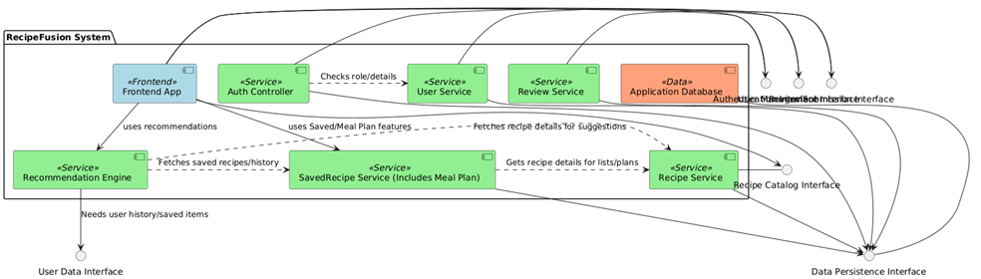
Figure 4.17: Component Diagram

Physical View
The Physical View of the RecipeFusion platform provides an overview of the underlying hardware, cloud infrastructure and network components that support the operation of the system. RecipeFusion is implemented using a fully cloud-based approach for optimum performance, scalability and access.
The frontend interface, which is developed with the help of React.js, is hosted on platforms which are cloud-based, like Vercel that distribute static assets across the global content delivery networks (CDNs) to provide fast and responsive user experiences across both desktop and mobile devices.
The backend services using Node.js and Express.js are deployed on the cloud infrastructure Vercel. These services handle API requests, business logic, authentication, integration with external services, such as cloud media storage, and integration with recommendation logic.
The Mongo DB database is hosted on the basis of Mongo DB Atlas, a fully-managed cloud-based database cuckoo service that provides high availability, backup, encryption and automatic scaling. It contains important data such as user profile, recipes, ingredients, reviews, and search history.
All the communication between clients and servers is secured by using the protocol called the https protocol. Environment Variables and Secrets: Environment variables/ secretes are securely handled using the configuration in our cloud platform in order to safeguard sensitive credentials and API keys.
The physical infrastructure is designed with an emphasis on reliability, redundancy and security that ensures that the RecipeFusion platform remains available, scalable and responsive to all users - from recipe seekers to administrators. Figure 4.18 illustrates the deployment Diagram of the system.
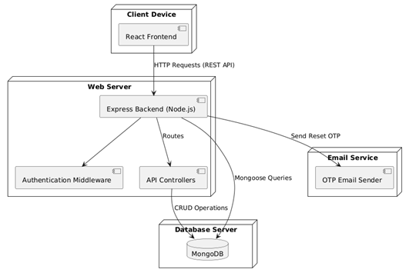
Figure 4.18: Deployment Diagram

Data Flow Diagram
The Data Flow Diagram of RecipeFusion is a diagram used to show how inputs received by users are handled to produce intelligent recipe suggestions and meal planning suggestions. The system receives user-supplied ingredients, caloric preferences, and meal needs and transforms the information with the help of AI-based logic to provide a personalized recipe and nutritional information.
At Level 0, the DFD gives a high-level view of how the users interact with RecipeFusion system, starting with inputting of ingredients till delivery of generated recipes and meal plans. Level 1 also breaks down the system into processes down to detail, and the processes include input validation, recipe matching, AI generated recipes, nutritional analysis, and meal plan generation, which assure the efficient and smooth flow of data through the application.

Data Flow Diagram Level 0
The Level 0 Data Flow Diagram is an overview of what the data flow in RecipeFusion system looks like on a bigger picture. It portrays the whole system as a unified procedure and is concerned with the communication between the user and the RecipeFusion system.
At this tier, clients key in their meals, likes, and their meal arrangements into the system. This system works with such inputs and reacts by showing recommendations, AI-made recipes, and nutritional information, as well as meal plans related to the specific individual. Figure 4.19 illustrates the Level 0 Data Flow Diagram of RecipeFusion.
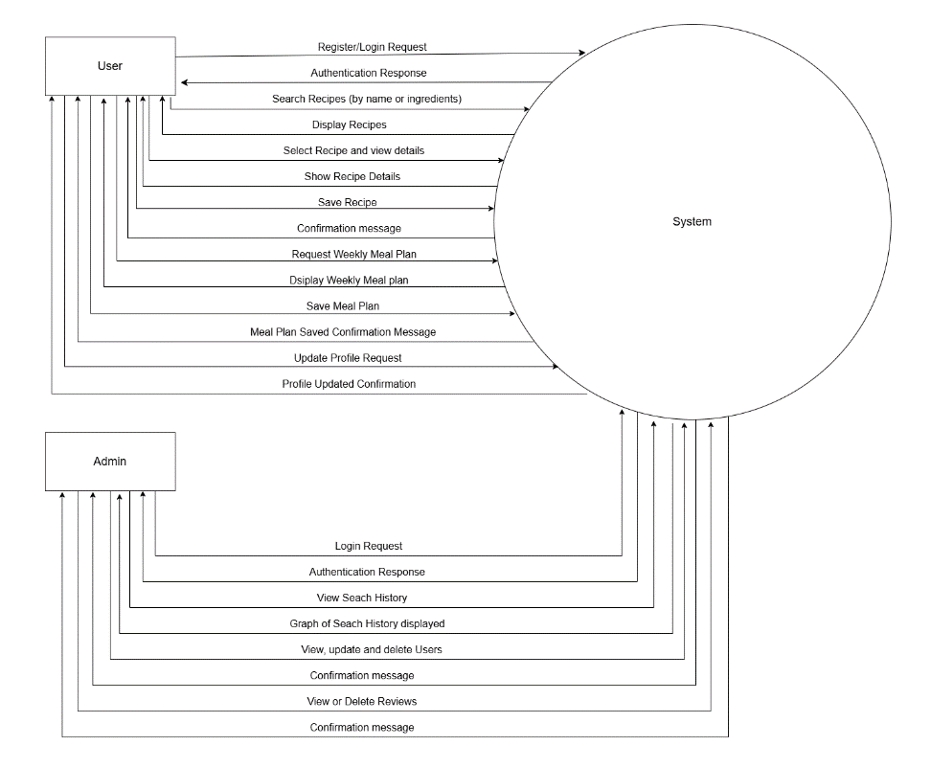
Figure 4.19: Data Flow Diagram Level 0

Data Flow Diagram Level 1
The Level 1 Data Flow Diagram further breaks down the RecipeFusion system into sub-processes to give a better insight on the internal data processing. It divides the system into various functional units such as input of ingredients, verification of preferences, matching of recipes, AI generation of recipes, nutritional analysis, and planning the meal.
This tier explains the movement of data among the various processes and the system entities, it displays the validation, analysis, and conversion of user input into meaningful output. It also shows the importance of artificial intelligence in creating personalized recipes and enhancing the level of recommendation.
The Level 1 DFD shows a more detailed picture of the working process and data flow of RecipeFusion. Figure 4.20 represents the Level 1 Data Flow Diagram of RecipeFusion.
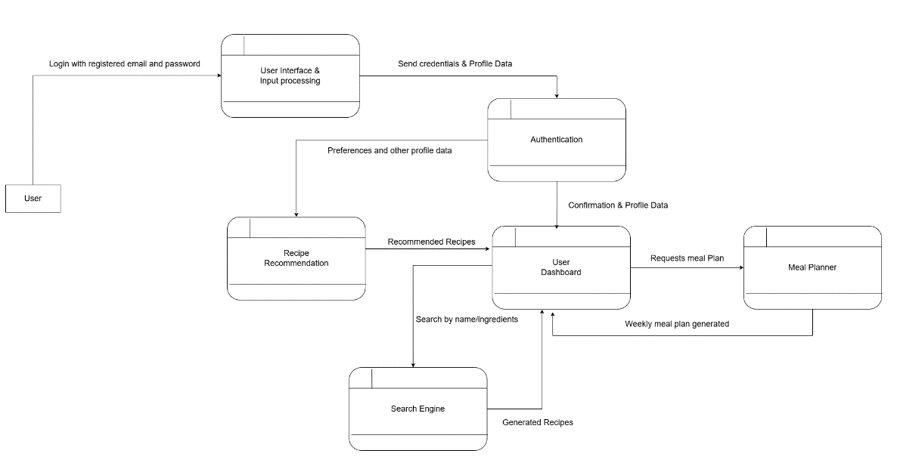
Figure 4.20: Data Flow Diagram Level 1

Summary
This This chapter specifically involved the design and the system analysis of the proposed RecipeFusion application wherein the key keys to the development of the effective system were to be placed on the structured planning and the architectural model of the proposed system. The chapter outlined some of the important design diagrams, such as the Use Case Diagram, the Activity Diagram, the Class Diagram, the Sequence Diagram and Data Flow Diagrams that helped in the overall mechanism of the system.
All of these models show the translation of user requirements to system processes, interaction between various system components and data flow through the system, and the results of this process as an intelligent system providing intelligent recipe suggestions and meal planning features. With these therefore representations as a design, RecipeFusion guarantees an integrated, scalable, user-friendliness system.

CHAPTER 5

IMPLEMENTATION

This is a chapter that discusses the entire implementation of the RecipeFusion system, how each of the modules was implemented and combined in order to build a seamless AI-based recipe discovery and meal planning system. The implementation phase is the translation of the conceptual design and requirements into working components by utilizing modern web development technologies. RecipeFusion is written with React and Tailwind CSS on the frontend side, Node.js and Express services on backend, utilizing MongoDB as the database management system and it has been deployed on Vercel for quick global access. Generative AI models are ingrained throughout the system to deal with things such as recipe creation and ingredient-based suggestions, and the intelligent planning of meals.
Each module was implemented separately to ensure clarity, maintainability and ease of testing. Once individual functions were confirmed they were linked together using rest APIs and react state management to achieve a consistent process flow both to users and administrators.

Modules of the Project
This section explains some of the core modules which together form the RecipeFusion application. Each sub-module performs a specific set of tasks and contributes to the entire process recipe generation, recommendation, user management, meal planning.

Recipe Recommendation Module
This module is responsible for the task of recommending recipes based on user preference and available ingredients.
It integrates:
- A custom-made Node.js API for analyzing user requests
- MongoDB collections having trending recipes
- GenAI which gives recommendations for recipes
The system fetches user inputs and feeds those parameters into certain set of filtering rules (e.g. diet type, cooking time, ingredient availability) and produces a curated list of recipes which is shared at the frontend using the responsive React components.

Recipe Generation Module
This module lets the user create recipes from either the recipe name or a list of available ingredients.
The backend uses GenAI to:
- Give all the details with step by step procedure
- Suggest the quantity of ingredients
- Give the calories information of a generated recipe
- Suggest appropriate categories of meals
The recipe goes to the frontend, where the React renders the recipe nicely formatted and styled (Tailwind CSS). Users could save, copy and add the recipe to their meal plan.

Meal Planning Module
This module offers AI- care weekly meal plans.
It performs:
- Dietary preferences analysis (Vegan, vegetarian, low carb, etc.)
- Meals balancing (Calorie based)
- Automatic distribution of breakfast, lunch and dinner
This module keeps a close communication with AI Recipe Generation module to get customized meals for each day of the week. The resulting plan is stored in MongoDB, and can be viewed, edited, and/or regenerated at a later time by the user.

Search Tracking Module
The results users have looked at and interacted with are stored to personalize the recommendations.
This module logs:
- Top searched queries
- AI recipe generation history
This data is stored to a specific collection of MongoDB and is expended through APIs for good user experience over a period of time.

User Authentication Module
The authentication module provides security access to all users.
It includes:
- Encryption of credentials
- JWT token generation
- Session handling using cookies
- Role- based redirection
React Hook Form is used to control input validation and Node.js is responsible for signup, login, and logout initialization and session verifications by structured APIs.

User Management Module (Admin)
This module allows the admin's to manage accounts of users.
Key actions include:
- Viewing registered users
- Editing or remove any user(if necessary)
It ensures that the platform is secure, organized and as per the guidelines of the community.

Review & Rating Module
This module is the modules which handle user response on recipes. It enables them to leave their reviews, to rate meals and to add to the community-level quality upgrades.
Functions include:
  - Enabling users to post recipes reviews
  - Saving ratings and comments
  - Showing the average ratings at recipe page.
  - Allowing the administrator to access, delete or control the uncivilized reviews
All the data of reviews is stored on MongoDB and obtained by means of secure Node.js APIs. This module assists in keeping the quality in recipes and also increases recommendations accuracy because user preferences are analyzed over time.

Analytics & Insights Module (Admin)
The module is beneficial by equipping administrators with information regarding the use of platforms. It applies both MongoDB data and Node.js APIs to create visual reports which are shown on the panel of the administrator.
Key actions include:
- Showing a graph of the history of recipe searches.
- Showing the overall reviews statistics
React charts and track user behavior give Admin these insights on how to improve the platform.

Saved Recipes & Meal Plans Module
The personalization of the users is managed in this module as the user can save recipes and save AI-generated meal plans on their profile.
It supports:
- Storing favorite recipes and easy access to those recipes.
- Saving meal plans obtained on a weekly basis, developed by AI.
- Giving users an opportunity to remove the stored recipes and meal plans.
- Saving information that is synchronized on devices by using the same account
All the items are saved in MongoDB collections and are dynamically displayed in React with protection routes. This module makes the process of cooking and planning more convenient due to its personalized approach.

Summary
In this chapter, the implementation process of the RecipeFusion is written in detail. Every single module was designed in terms of modularity, performance, and the user-friendly interaction. Through combining the applications of cloud deployment, MongoDB to handle scalable storage, Node.js to provide API services, and React with Tailwind CSS to make the interface dynamic, RecipeFusion provides a cooking assistant which is highly responsive and smart.
Combination of AI-based recipe generation, ingredient-guided suggestions, meal planning, and administrative level of management means a wholesome and contemporary solution to the users who would love to have convenience, customization, and healthy eating assistance. The modules cooperate to build some unified platform that effectively echoes the aims, which it was planned at the very beginning of the work.

CHAPTER 6

RESULT/TESTING, ANALYSIS AND VALIDATION

This chapter gives the test processes, processes and outcomes applied to test the functional performance and general reliability of RecipeFusion system. Being an AI-powered recipe recommendation and meal-planning system, RecipeFusion needs to be thoroughly validated to provide accurate recipe creation, properly generated recommendations, stability of back-end functions, smooth front-end interactions, and valuable user authentication.
The testing stage was aimed at evaluating the functionality of the individual modules, the relationship between the different parts of the system as well as how the end user experience was as envisioned in the project objectives. Structured testing methods were used to test both the functional and non-functional factors.

Testing, Analysis, and Validation
The RecipeFusion testing process was done in a systematic manner aiming to test the system at various levels to consider reliability, correctness, performance and usability. An organized testing plan was implemented in order to ensure that all the functional modules, including authentication, recipe discovery, ingredient-based search, meal planning, and recommendation services, all works well and correctly.
The first stage of testing was the unit testing whereby each part was tested separately. The basic functions, including user authentication, recipe search, ingredient-matching logic, generation of a meal planner, and creation of a shopping list, were tested on their own. The phase was used to detect logical errors, invalidations and API issues and resolve them before the system was completely integrated. The manual tests together with manual test cases were conducted to make sure that each module would generate the desired result in normal and edge-case tests.
The unit testing was followed by the integration testing that was done to check the interaction of various modules of RecipeFusion. This stage facilitated a smooth flow between the frontend interface, the back end APIs, the database services and the AI based recommendation logic. The major workflows, including searching recipes by ingredients, filtering them with dietary requirements, creating individualized recommendations, saving recipes, and creating meal plans, were used to ensure that data was transferred and processed properly among the system parts. Secure session control and user and administrator role-based access were also tested in terms of integration testing.
System testing were done following an integration testing to test RecipeFusion as a whole application. This step entailed putting the system through the realistic conditions of use to confirm that all the functionalities fit as expected. To evaluate how quickly recipes could be searched, recommendation generated and the dashboard loaded it was tested in the performance to analyze the performance especially in situations of peak use. Different devices and screen sizes were also tested to establish the responsiveness and compatibility of the system.
Last but not the least was the conduct of validation and user acceptance testing to determine the usability of the system and its practicality. Any user was requested to carry out typical tasks that included the creation of an account, recipe search by selecting available ingredients, the use of diet filters, the creation and saving of meal plans, recipe search, and the fulfillment of reviews. The response obtained at this stage was used to optimize the user interface, fine-tune the navigation flow, and the accuracy of the recommendations.
With this extensive test, review, and debugging, RecipeFusion was narrowed down to a solid, effective, and easy to use framework that could offer smart, personalized recipe suggestions and meal planning advice and compile with both functional and non-functional specifications.

Test Case 1 – User Registration Module
This module provides an effective way of ensuring that once new users want to create an account, they will be able to do so by defining the necessary information about personal preferences and other required details. It confirms the accuracy of the input fields like name, username, email, password, gender, age, height, weight, preferences in cuisine, and allergies. The process of registration can be segmented into two steps, and this test case confirms both the form-level and backend-level validation. It makes sure that all the verified user data is safely stored in MongoDB, whereas invalid data elicits relevant error messages.
Additionally, this test case verifies that password security measures, such as minimum length and complexity requirements, are enforced, and that duplicate accounts are not created using the same email or username. It also checks that optional fields are handled correctly and that the system provides appropriate feedback for any missing or incorrectly formatted information. Overall, this ensures system integrity, reliable data management, and a smooth onboarding process for new users. This test case is described in detail in Table 6.1 as follows.

Table 6.1: Test Case 1- User Registration Module
INFORMATION IN GENERAL
Test Stage | Unit  User Registration
Date of Test | 20-11-2025 | System Date, if applicable | 20-11-2025
Testers | Tayyaba Ejaz | Test Case Number | TC-01
Description | Checks that user can be registered with reasonable credentials and invalid input attracts appropriate response
Test Result | Pass | Incident number (if Applicable) | N/A
INTRODUCTION
Requirement(s) to be tested | The user must have an option of registering with their name, username, email, password and a little more. The system should be able to make input validation and record of user to MongoDB
Roles and Responsibilities | Tester verifies by means of validation and backend response. Fix, set DB or validation error in case it has been found
Stop Procedures | Failure to pass the test is caused by failures on repeated validation, severe failures, and write errors in the DB
ENVIRONMENTAL NEEDS
Hardware | Laptops, Desktops or Cellular Phones
Software | React Frontend, Node database, MongoDB
Procedural Requirements | The back-end server should be active, the internet should also be on, and the frontend should be available
TEST
Test Items and Features | UI-form registration, backend registration validation, password regulations, (detect possible) duplicate e-mail
Input Specifications | Name, Username, Email, Gender, Phone number, Password, Height, Weight, Age, Cuisine preference, Allergies and Health condition
Procedural Steps | - Navigate to /register route  - Type in valid user details in form 1  - Re-tests on invalid inputs( missing field, weak password, etc)  - The next option is to move on to form 2 by clicking next  - Click on all credentials to create 2  - Submit the form  - Re-test with the means of validations
Expected Results of Case | Registering successful valid input  Invalid error message on input fields
ACTUAL RESULTS
Output Specifications | All tests were effectively passed, as well as Valid registrations saved. The invalid inputs were accompanied by how they should have.

Test Case 2 – Login & Role based Access Module
In this module, users are able to log into the system using their registered credentials. The system receives the username and password provided by the user, validates them against the stored records in the database, and grants access accordingly. Based on the authenticated user’s role (admin or regular user), the system redirects the user to the appropriate dashboard and enables only the features permitted for that role.
The test case allows verifying that the authentication mechanism is functioning correctly, invalid login attempts are handled securely, and proper error messages are displayed when incorrect credentials are entered. It also tests whether role-based access control is enforced properly by restricting unauthorized access to admin-only or user-only functionalities. This test case is described in detail in Table 6.2 as follows.
Table 6.2: Test Case 2- Login & Role based Access Module
INFORMATION IN GENERAL
Test Stage | Unit  User Login and redirect to respective panel
Date of Test | 20-11-2025 | System Date, if applicable | 20-11-2025
Testers | Tayyaba Ejaz | Test Case Number | TC-02
Description | Authenticates that the user is able to log in with valid credentials and will be redirected depending on his or her role(user/ admin)
Test Result | Pass | Incident number (if Applicable) | N/A
INTRODUCTION
Requirement(s) to be tested | System is required to check the validity of a user and access to authorized roles only.
Roles and Responsibilities | Tester confirms the flow of logins and access, developer solves the problems with incorrect routing or tokens.
Stop Procedures | Stop in case of frequent failures in making the login because of problems with the server or database.
ENVIRONMENTAL NEEDS
Hardware | Laptop, Desktop, or Mobile device
Software | React Frontend, Node.js backend, MongoDB Database
Procedural Requirements | Backend server should be operational, have access to the internet.
TEST
Test Items and Features | UI form of the login form, token generation and role based routing
Input Specifications | Email and Password
Procedural Steps | - Navigate to /login route  - Enter valid credentials  - Try invalid credentials too  - Try login to admin dashboard
Expected Results of Case | Accepted Results of Case Valid input into the system via successful login  Invalid error message on input fields
ACTUAL RESULTS
Output Specifications | Output Specifications All flows were as expected

Test Case 3 – Ingredient Based Recipe Search
In In this module, one is able to retrieve recipes by using the available ingredients at home. The system receives the input of ingredients provided by the user and processes them and retrieves the appropriate recipes through an AI-based recommendation logic. The test case allows verifying that the ingredient parser is functioning properly, the back end is properly filtering recipes, and only the information that is of interest is displayed. It also tests the behavior of the system in circumstances where none of the recipes correspond to the provided ingredients to make sure that there is appropriate error or fallback management.
Additionally, this test case validates the accuracy and relevance of the recommended recipes based on partial or complete ingredient matches. It also ensures that user inputs with spelling variations or extra spaces are handled gracefully by the system. This test case is described in detail in Table 6.3 as follows.

Table 6.3: Test Case 3- Ingredient Based Recipe Search
INFORMATION IN GENERAL
Test Stage | Unit  Ingredients search Recipe search
Date of Test | 20-11-2025 | System Date, if applicable | 20-11-2025
Testers | Tayyaba Ejaz | Test Case Number | TC-03
Description | Verifies that customer is capable of searching recipe with available ingredients as input (using commas to separate the ingredients)
Test Result | Pass | Incident number (if Applicable) | N/A
INTRODUCTION
Requirement(s) to be tested | System should be able to filter recipes on the basis of ingredients that are entered by the user
Roles and Responsibilities | Tester decides how search results are accurate. Mismatches are solved by the developer
Stop Procedures | Stop Procedures Stop in case results are irrelevant or the server is dead
ENVIRONMENTAL NEEDS
Hardware | Laptop, Desktop, or Mobile device
Software | React Frontend, Node.js backend, MongoDB Database
Procedural Requirements | Backend server should be operational, internet connection should exist to receive generated recipes by GenAI
TEST
Test Items and Features | Add ingredients and click the Search button
Input Specifications | Chicken, tomato, etc.
Procedural Steps | - Navigate to /search route  - Enter ingredients separated by commas  - Click the search button  - Get the generated recipes
Expected Results of Case | Anticipated Findings of Case Relevant recipes displayed upon successful response.  No results presented in the case of some error.
ACTUAL RESULTS
Output Specifications | All the outputs were within the expected behavior

Test Case 4 – Search Recipe by Name Module
The module will enable users to retrieve recipes by typing in a particular name or a keyword of the recipe. It communicates with the AI-powered recipe generator to give relevant and complete recipe suggestions. The test case confirms the accuracy of the search query in bringing out the right recipe, verifies that the system is able to respond to various forms of queries including partial names or misspellings, and ensures that the results presented to the user are relevant, complete, and well-formatted. It also ascertains that appropriate error handling is in place when a query is either unclear, invalid, or when there are network or API problems during recipe generation. Furthermore, this test case validates the system’s ability to prioritize results based on relevance, popularity, and user preferences, while also ensuring that the user interface displays results in a clear and accessible manner. This test case is described in detail in Table 6.4 as follows.

Table 6.4: Test Case 4- Search recipe by Name
INFORMATION IN GENERAL
Test Stage | Unit  Recipe Search by name
Date of Test | 20-11-2025 | System Date, if applicable | 20-11-2025
Testers | Tayyaba Ejaz | Test Case Number | TC-04
Description | Confirms that GenAI works out recipes according to the query of a user.
Test Result | Pass | Incident number (if Applicable) | N/A
INTRODUCTION
Requirement(s) to be tested | AI must produce full recipes.
Roles and Responsibilities | Tester approved the quality of recipes produced, API issues are dealt with by the developer
Stop Procedures | Stop if internet connection has gone dead
ENVIRONMENTAL NEEDS
Hardware | Laptop, Desktop, or Mobile device
Software | React Frontend, Node.js backend, MongoDB Database
Procedural Requirements | Backend server must be running, internet connection must be active to get generated recipes by GenAI
TEST
Test Items and Features | Search box with search button
Input Specifications | Input such as query like Pasta.
Procedural Steps | - Navigate to /search route  - Enter query for the recipe  - Press search button  - Get the generated recipes
Expected Results of Case | Relevant recipes displayed upon successful response.  No results presented in the case of some error
ACTUAL RESULTS
Output Specifications | All the outputs were within the expected behavior

Test Case 5 – Filtering on Recipes Module
The current module also will improve the search experience of the users, as they can narrow down the list of recipes according to the cuisine type, cooking duration, and level of difficulty. It makes sure that the opposing actions the filtering specifications are appropriately introduced to the created or fetched recipes and that only the matching results are retrieved. The test case will also make sure that filter logic is implanted properly, and users get clean, sorted and relevant results as per their choices. It also analyzes the reaction of the system in cases where the filters used do not find any matching recipes. This test case is described in detail in Table 6.5 as follows.
Table 6.5: Test Case 5- Filtering on Recipes Module
INFORMATION IN GENERAL
Test Stage | Unit  Recipe Filters
Date of Test | 20-11-2025 | System Date, if applicable | 20-11-2025
Testers | Tayyaba Ejaz | Test Case Number | TC-05
Description | Ensures that it has created recipes based on the query made by the user and the filters have been applied
Test Result | Pass | Incident number (if Applicable) | N/A
INTRODUCTION
Requirement(s) to be tested | Bug(s) to test AI should form recipes in which filtering items added by a user are used.
Roles and Responsibilities | Tester checked whether the filters are present or not on the generated recipes
Stop Procedures | Stop when the internet connection is not available or there is no such recipes with the filters used.
ENVIRONMENTAL NEEDS
Hardware | Laptop, Desktop, or Mobile device
Software | React Frontend, Node.js backend, MongoDB Database
Procedural Requirements | Backend server should be available, the internet should be active to receive recipes generated by GenAI.
TEST
Test Items and Features | Searching option with filters Cuisine type, highest time of cooking, difficulty level
Input Specifications | Search as Biryani
Procedural Steps | - Navigate to /search route  - Enter query for the recipe  - Apply filters for cuisine, max cooking time, difficulty level  - Press search button  - Get the generated recipes
Expected Results of Case | Anticipated Findings of Case Relevant recipes displayed upon successful response.  No results presented in the case of some error
ACTUAL RESULTS
Output Specifications | Output Specifications All the outputs were within the expected behavior

Test Case 6 – View Complete Recipe Details
The module interface shows all the information about a chosen recipe and offers its user to have all the details. The test case will also help in making sure that the recipe detail page loads successfully and that all the necessary fields have been included and are well designed accordingly. It also checks the system to ensure all the information is available in the backend and that the absent or partial data is managed respectively. This test case is described in detail in Table 6.6 as follows.
Table 6.6: Test Case 6- View Complete Recipe Details
INFORMATION IN GENERAL
Test Stage | Unit  Recipe detail page
Date of Test | 20-11-2025 | System Date, if applicable | 20-11-2025
Testers | Tayyaba Ejaz | Test Case Number | TC-06
Description | Checks that recipes generated contain all the needed details or not.
Test Result | Pass | Incident number (if Applicable) | N/A
INTRODUCTION
Requirement(s) to be tested | On the generated recipe, there should be recipe title, picture, description, etc.
Roles and Responsibilities | Tester errors by taking care as to whether the recipe is progressing with everything or not.
Stop Procedures | Stop in case the internet connection is dead was not able to locate the detail page of the chosen recipe.
ENVIRONMENTAL NEEDS
Hardware | Laptop, Desktop, or Mobile device
Software | React Frontend, Node.js backend, MongoDB Database
Procedural Requirements | Backend server should be in operation, internet connection should be stable
TEST
Test Items and Features | Recipe detail page must include title of the recipe, image, description, ingredients, procedure, calories, level of difficulty, cuisine type and cooking time
Input Specifications | Click Card of a created recipe
Procedural Steps | - Navigate to /search route  - Enter query for the recipe  - Get the generated recipe cards  - Click on the card to navigate to the recipe detail page  - Get all the details of selected recipe here
Expected Results of Case | The ingredients of the chosen recipe appear on recipe detail page
ACTUAL RESULTS
Output Specifications | All the outputs were in line with the expectations

Test Case 7 – Meal Plan Generation
The current module creates a customized meal plan each week, and it is designed on a weekly basis to serve its users according to their health history, dietary requests, and food allergies. With AI-powered reasoning, it comes up with a structured 7-day plan which has breakfast, lunch, and dinner program per day. The case study confirms that the created plan is comprehensive, balanced, and user-preferred. It also looks at the presence of the correct details in all recipes in the plan and makes sure that the system is able to process any error, including the API failure, or missing data about the user in a graceful manner. This test case is described in detail in Table 6.7 as follows.
Table 6.7: Test Case 7- Meal Plan Generation
INFORMATION IN GENERAL
Test Stage | Unit  Meal Planner
Date of Test | 20-11-2025 | System Date, if applicable | 20-11-2025
Testers | Tayyaba Ejaz | Test Case Number | TC-07
Description | Checks the creation of meal plan by the user data
Test Result | Pass | Incident number (if Applicable) | N/A
INTRODUCTION
Requirement(s) to be tested | Meal plan has to contain planned breakfast, lunch and dinner
Roles and Responsibilities | Tester checks completeness
Stop Procedures | Stop In case plan is not created or generated.
ENVIRONMENTAL NEEDS
Hardware | Laptop, Desktop, or Mobile device
Software | React Frontend, Node.js backend, MongoDB Database
Procedural Requirements | Backend server must be running, internet connection must be stable.
TEST
Test Items and Features | Meal plan is of all 7 days which has 21 total meals
Input Specifications | Click the button of generate meal plan
Procedural Steps | - Navigate to /mealPlan route  - Click the button of generate new meal plan  - Get the generated meal plan of 7 days  - Click on the card to navigate to the recipe detail page included in the plan  - Get all the details of selected recipe here  - Can save the recipe or meal plan too
Expected Results of Case | he results of Case to be expected 7-day meal plan with three meals in a day breakfast, lunch, and dinner
ACTUAL RESULTS
Output Specifications | Output Specifications All the outputs were in line with the expectations

Test Case 8 – Save a Recipe
This module allows the user to save the recipes they like or generate as their favorites to be accessed with a lot of ease in the future. It verifies that the recipe that has been chosen is properly saved on the user- saved recipes list on the database. In the test case, the frontend and backend are tested to ensure interaction to confirm that the save action is reliable, demonstrates the right success messages, and does not save the same item twice. It also ensures that recipes that are saved are shown in the proper way when revisited using the saved recipes page. This test case is described in detail in Table 6.8 as follows.
Table 6. 8: Test Case 8- Save a Recipe
INFORMATION IN GENERAL
Test Stage | Unit  Saving recipe to profile
Date of Test | 20-11-2025 | System Date, if applicable | 20-11-2025
Testers | Tayyaba Ejaz | Test Case Number | TC-08
Description | Recipe is saved by a given user
Test Result | Pass | Incident number (if Applicable) | N/A
INTRODUCTION
Requirement(s) to be tested | Recipe has to be stored in the profile of the user
Roles and Responsibilities | Tester checks on the DB writes or write not
Stop Procedures | Stop if save fails
ENVIRONMENTAL NEEDS
Hardware | Laptop, Desktop, or Mobile device
Software | React Frontend, Node.js backend, MongoDB Database
Procedural Requirements | Backend server must be running, internet connection must be stable.
TEST
Test Items and Features | Recipe saved or not
Input Specifications | Click on save recipe button
Procedural Steps | - Navigate to /recipeDetail route  - Click the button of save recipe  - Get the success message of Recipe Saved Successfully  - Recipe will be added to the saved recipe page from where it can also be removed
Expected Results of Case | Recipe saved successfully popup shows
ACTUAL RESULTS
Output Specifications | Output Specifications All the outputs were in line with the expectations

Test Case 9 – Save a Meal Plan
This module allows the user to save a complete weekly meal plan for future use. The purpose of this feature is to ensure that when users gets a meal plan, they can store it under their profile and access it later whenever needed. The saved meal plan includes all selected meals for each time and is linked with the respective user account. The test case verifies that the meal plan data is correctly written to the database and properly associated with the correct user ID. It also confirms that the saved meal plan appears in the Saved Meal Plans section of the user profile and can be retrieved successfully. In addition, the test case checks the system’s response handling by validating successful save confirmations as well as appropriate error messages in case the save operation fails due to network issues or backend-related problems. Furthermore, this test case evaluates the system’s response handling by ensuring that a successful save operation returns an appropriate confirmation message or status code to the user. The detailed steps and expected outcomes of this test case are presented in Table 6.9.

Table 6. 9: Test Case 9 - Save a Meal Plan
INFORMATION IN GENERAL
Test Stage | Unit  Saving Meal plan
Date of Test | 20-11-2025 | System Date, if applicable | 20-11-2025
Testers | Tayyaba Ejaz | Test Case Number | TC-09
Description | Meal plan is a saved one of the particular user
Test Result | Pass | Incident number (if Applicable) | N/A
INTRODUCTION
Requirement(s) to be tested | Tester checks Meal Plan should be saved in the particular user
Roles and Responsibilities | Tester verifies the DB writing of saved meal or not.
Stop Procedures | Stop in case of save meal plan failure
ENVIRONMENTAL NEEDS
Hardware | Laptop, Desktop, or Mobile device
Software | React Frontend, Node.js backend, MongoDB Database
Procedural Requirements | Backend server must be running, internet connection must be stable.
TEST
Test Items and Features | Meal Plan is saved or not
Input Specifications | Click the button of Save Meal plan
Procedural Steps | - Navigate to /mealPlan route  - Click the button of save meal plan  - Get the success message of Meal Plan Saved Successfully
Expected Results of Case | Meal Plan Saved Successfully Meal Plan Success Message appears
ACTUAL RESULTS
Output Specifications | Output Specifications All the outputs were in line with the expectations

Test Case 10 – Admin Manage Users & Reviews
This module enables the administrator to control users of the platform and reviews left on recipes. It also has the features to see all the registered users, update user details, delete the inappropriate users, view user reviews and delete abusive or irrelevant reviews. Test case helps in assuring that the privileges of an admin are enforced properly, data loads, all the CRUDs are carried out as desired. It also certifies access control, consistency and error tolerance in case of failover of the backend operations by the administrator. This test case is described in detail in Table 6.10 as follows.
Table 6. 10: Test Case 10- Admin Management
INFORMATION IN GENERAL
Test Stage | Unit  Admin Management
Date of Test | 20-11-2025 | System Date, if applicable | 20-11-2025
Testers | Tayyaba Ejaz | Test Case Number | TC-10
Description | Verifies the permission of the admin to see edit or delete user. Admin is authorized to read reviews and delete them
Test Result | Pass | Incident number (if Applicable) | N/A
INTRODUCTION
Requirement(s) to be tested | Users and reviews must exit in admin page
Roles and Responsibilities | Tester has to check the functionality of the operations at the admin page or not
Stop Procedures | Stop when the data load of the administrator fails
ENVIRONMENTAL NEEDS
Hardware | Laptop, Desktop, or Mobile device
Software | React Frontend, Node.js backend, MongoDB Database
Procedural Requirements | Backend server must be running, internet connection must be stable.
TEST
Test Items and Features | Admin is reading users and reviews, must be able to delete
Input Specifications | Login with the credentials of admin
Procedural Steps | - Navigate to /adminDashboard route  - See the total users, option to edit and delete on Mange Users page  - See the total reviews and option to delete on Mange Reviews page
Expected Results of Case | All the details appear
ACTUAL RESULTS
Output Specifications | All the outputs were in line with the expectations.

Summary
The chapter was the introduction of testing procedures and results of RecipeFusion system. With structured software testing techniques, such as black-box testing, functional testing, integration testing and usability review, every one of the modules was tested on high accuracy, stability and performance. The findings underscore the idea that the system is achieving its target goals as it has effective recipe suggestions, informative AI-generated meals plans, adequate authentication, and an easy-to-use interface based on all key functions. Even though there are some small drawbacks that may be noted, they do not add to the overall system functionality and usage. According to the results of the testing, RecipeFusion has a high level of performance, preserves data integrity, and is completely ready to be used in end users.

CHAPTER 7

CONCLUSION AND FUTURE WORK

This chapter gives the general conclusion of the RecipeFusion project and gives the possible future improvements which can bring more improvements to the system. The RecipeFusion development was to build an intelligent, user-friendly service that will be able to write a recipe and suggest a dish based on the available ingredients and give meal planning with the help of AI to help consumers to eat healthier and more organized. The system is effective in achieving its goals, through the structured design, the use of modern technologies, and a comprehensive testing.

Project Review and Achievements
The RecipeFusion has accomplished its main goal, which was to deliver an intelligent and AI-enabled recipe generation and meal planning application that tackles the popular issues in everyday cooking and nutrition. RecipeFusion presents a convenient and unique solution to the contemporary lifestyle requirements through the involvement of ingredient-based recipe discovery, person-centered suggestions, meal planning, and the interaction avenue in one system.
RecipeFusion has proven its ability to turn the conventional recipe browsing into a personalized and interactive system in the course of the development process. Generative AI allows producing recipes automatically, finding ingredients that best fit, and planning meals individually depending on the preferences and nutrition objectives of the user. The modular structure of the system allows unrestricted communication between the frontend elements, the wedding service, databases, and third-party AI services.
The frontend application based on the React and the Tailwind CSS gave the platform a clean, responsive, and user-friendly interface making it available to users with differing technical skills. At the server-end, Node.js and express.js were utilized to build a scalable well-organized structure to control authentication, API calls, recipe information, and user actions. MongoDB Atlas helped to provide safe and organized storage of user profiles, dishes, reviews, meal plans, and search history. In addition to this, deployment on Vercel made performance of the systems better and made continuity deployment easier.
This was done through extensive testing which includes unit testing, integration testing as well as usability testing which assured the reliability of RecipeFusion in all its major modules. The basic features like user registration, searching by ingredients, saving recipes, meal planning, and user reviews proved to be accurate and efficient. In general, the project achieves its objective of producing a smart, user-friendly cooking assistant that helps to have a healthier diet, less food waste, and easier meal preparation.

Advantages of the Proposed System
RecipeFusion system has a number of benefits that support its development and highlight its relevance within the sphere of intelligent food and nutrition control. One of the main advantages is smart recipe creation and suggestion. RecipeFusion is able to propose suitable recipes according to the food available at hand, users’ dietary habits, and lifestyle ambitions by using Generative AI, which saves users time and effort spent deciding what to prepare.
Another important benefit is custom meal planning. With this system, users are able to create and save personalized meal plans, track calories, and manage their nutritional preferences so that they can maintain a healthy and balanced diet. This feature is especially useful for users with specific dietary goals such as weight management, fitness optimization, or medical dietary restrictions.
The interface of RecipeFusion is also user-friendly and responsive. The platform is designed to be simple, intuitive, and accessible so that users can easily navigate it on desktops, tablets, and mobile devices without necessarily being technically savvy. This improves overall usability and encourages consistent user engagement with the system.
The system also provides features for saving recipes, submitting reviews, and tracking search history, enabling users to revisit their favorite recipes and receive improved recommendations over time. This continuous learning and personalization capability strengthens user interaction, enhances satisfaction, and builds long-term user loyalty.
Moreover, RecipeFusion is designed to be expandable and scalable. Its flexible architecture allows new features to be integrated in the future, such as predictive analytics, mobile applications, advanced nutritional tracking, and more refined artificial intelligence models, without requiring major system reengineering.
Lastly, the platform promotes health education and helps minimize food waste by encouraging users to cook with available ingredients and make informed eating decisions. This adds practical value beyond simple recipe selection and contributes to sustainable consumption habits, making RecipeFusion both a socially responsible and technologically innovative solution.

Limitations of the Proposed System
Although it has several weaknesses, there are several limitations associated with RecipeFusion that were found during development and testing.
The system being a web based and AI reliant platform needs a stable internet connection to operate fully. The connectivity can be too weak or not sufficiently reliable, which can influence the response time, especially when using AI to generate recipes.
The other limitation is the inconsistency of nutrition accuracy. Nutritional values are to some extent calculated based on the data produced by artificial intelligence and data received externally, so there will be slight inconsistencies in comparison with real world measurements.
The present form also has less interaction features. Some of the advanced features like the voice-based cooking have not been introduced yet like the ability to work in different languages as well as share with others.
Also, external API rate restrictions can have an impact on system stability when using it heavily. Such limitations do not affect usability in a major way, but put the focus on what can be enhanced in the next iterations.

Future Work
There RecipeFusion has multiple opportunities that can be improved in future versions in order to overcome the current constraints.
The next step will involve advanced personalization based on machine learning that will allow the system to improve several propositions and be more accurate and proactive based on user actions with time.
The use of specific mobile apps, Android and iOS versions, will make it more accessible and enable users to communicate with the system and conveniently interact with it during the process of cooking.
The introduction of multilingual support could be used to reach out a wide range of people all over the world and enhance inclusiveness.
Additional enhancements will come in the form of improved nutritional analysis by incorporating specialized nutritional API in order to come up with better calorie and nutrient results.
Finally, voice activated cooking assistant may be implemented that enables hands free approach to the cooking process and makes the work of a cook less tedious and more entertaining.

Summary
This chapter discussed the general success of the RecipeFusion project, its smart application of AI, innovative internet technologies, and user-friendly design, which resulted in a practical online cooking assistant. Although there are some drawbacks, the system has been found to be trustworthy, scalable and successful in helping to discover recipes, meal planning, and maintaining healthy eating habits. The further development will aim at broadening the capabilities, enhancing customization, and adding accessibility, so that RecipeFusion turns into a full-fledged and smartest meal management system.

REFERENCES

[1] | E. S. Berkovsky, "Personalized nutrition: Trends and challenges," ACM Computing Surveys (CSUR), vol. 52, no. 3, pp. 1-35, 2019.
[2] | J. A. T. et al., "Digital interventions for dietary behavior change," Journal of Medical Internet Research, vol. 20, no. 4, p. e12345, 2018.
[3] | J. Freyne and S. Berkovsky, "Recommending food: Reasoning on recipes and ingredients," User Modeling and User-Adapted Interaction, vol. 20 no. 1, pp. 44-68, 2010.
[4] | M. Ueda.et al., "Recipe recommendation based on ingredient availability," in Proceedings of the Web Conference (WWW), pp, 1-10, 2014.
[5] | C. Trattner and D. Elsweiler, "Food recommender systems: Important contributions, challenges and future research directions," IEEE Intelligent Systems, vol. 32, no.2, pp. 8-18, 2017.
[6] | S. K. et al., "Nutrition-aware food recommendation," in Proceedings of 13th ACM Conference on Recommender System (RecSys), pp. 1-9, 2019.
[7] | C. C.-M. et al., "Effect of personalized nutrition on dietary behavior,"The American Journal of Clinical Nutrition, vol. 104, no. 3, pp. 1-12, 2016.
[8] | Yummly, "About Yummly," 2024. [Online]. Available: https://www.yummly.com/about. [Accessed: Apr. 10, 2025].
[9] | AllRecipes, "AllRecipes," 1997. [Online]. Available: https://www.allrecipes.com/. [Accessed: Apr. 10, 2025].
[10] | Eat This Much, "Eat this Much," 2024. [Online]. Available: https://www.eatthismuch.com/. [Accessed: Apr. 10, 2025].
[11] | ChefGPT, "ChefGPT," 2025. [Online]. Available: https://www.chefgpt.xyz/. [Accessed: Apr. 10, 2025].

