H. M. Faisal (03455275108) Computer Organization and Assembly Language (CS-530)

Lesson Plan 1

Objectives: The main objectives are: (a) Introduction to Assembly Language; (b) Micro Computer.

Content: Assembly language is a symbolic representation of a processor's native code. Using machine code allows the programmer to control precisely what the processor does. Timings, for example, can be calculated very precisely and program flow is easily controlled. It is often used for small, real time applications.

CPU is the abbreviation for central processing unit. Sometimes referred to simply as the central processor, but more commonly called processor the CPU is the brains of the computer where most calculations take place.

The computer memory is a temporary storage area. It holds the data and instructions that the Central Processing Unit (CPU) needs. Before a program can be run, the program is loaded from some storage medium into the memory.

Methods: I will first provide the definition and the introduction of assembly language, then I will ask students about CPU and memory unit, this will give them confidence and after that I will give them information about memory operations and will discuss about bytes.

Resources: Besides the lecture handout, this lesson will draw from the following Text books: Assembly Language Programming and Organization of the IBM-PC, by Ytha Yu and Charles Marut.

Evaluation: In this lecture I will do formal evaluation process because it is basic lecture and most of students already have some idea about it. I will be using formal techniques to monitor if the students have absorbed the material or not: By asking the students about what they have idea about these topics.

Time  Plan  (min) | Contents of Lecture | Lecture  Strategy  (Remarks)
20 mins | Introduction  Assembly language is a symbolic representation of a processor's native code. Using machine code allows the programmer to control precisely what the processor does. It offers a great deal of power to use all of the features of the processor. The resulting program is normally very fast and very compact. In small programs timing is also very predictable.  Timings, for example, can be calculated very precisely and program flow is easily controlled. It is often used for small, real time applications. However, the programmer needs to have a good understanding of the hardware being used. As programs become larger, assembly language get very cumbersome.  Maintenance of assembly language is notoriously difficult, especially if another programmer is brought in to carry out modifications after the code has been written. Assembly language also has no support of an operating system, nor does it have any complex instructions.

Time  Plan  (min) | Contents of Lecture | Lecture  Strategy  (Remarks)
15  mins | Micro Computer:  - CPU  - MEMORY UNIT  - I/O CIRCUIT  - CPU  CPU is the abbreviation for central processing unit. Sometimes referred to simply as the central processor, but more commonly called processor the CPU is the brains of the computer where most calculations take place. In terms of computing power, the CPU is the most important element of a computer system.  - Memory Unit (Bytes and words)  - Smallest unit is bit.  - 8 bit groups of bits referred as byte.  - Each memory byte is identified by an identifier called address.  - The data stored in byte is called contents.  - Difference of address byte contents & address.  Q: How many memory bytes can be accessed by a processor using ‘20’ bits address?  - Some pc treats consecutive word as a single unit, called a memory word.  - The lower byte address is used as a word address.  High byte low byte  15----------8(MSB) 7---------0(LSB)  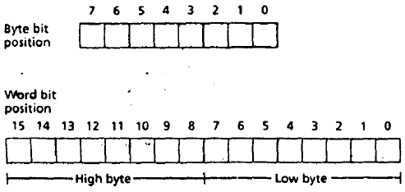

Time  Plan  (min) | Contents of Lecture | Lecture  Strategy  (Remarks)
15  mins  15  mins | - Memory operations.  - Read/Write  - Ram /Rom  - Buses  - Address bus CPU places the address of  - Data bus the content (memory  - Control bus location)  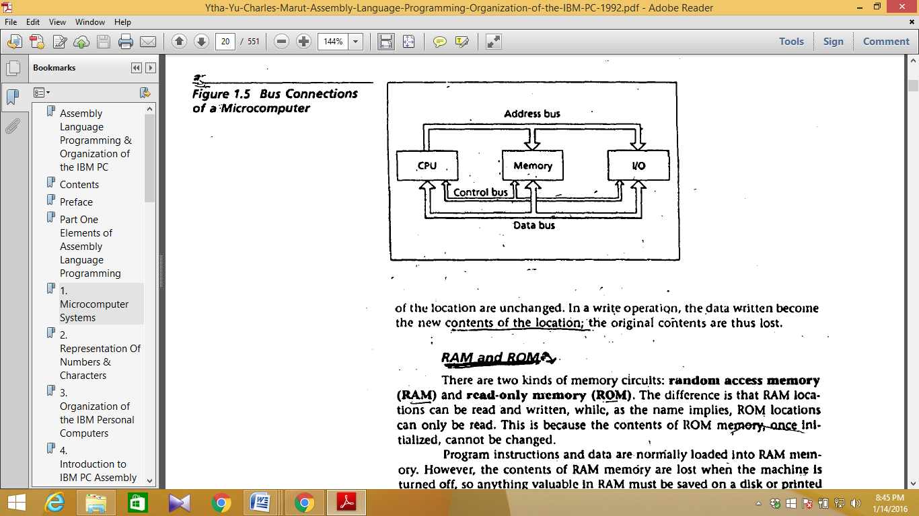  - CPU  - Machine code usage.  - Instruction set defined.  - Instruction set of every CPU is unique.  - CPU has two units  - Execution unit (ALU)  - Bus interface unit(LU)  - Instruction execution  How an instruction is executed?  Machine instruction has two parts.  - OP-Code  OP-code specifies the type of operation.  - Operand  Operand on which the operation is performed (mostly memory location).  - Execution of instruction

Time  Plan  (min) | Contents of Lecture | Lecture  Strategy  (Remarks)
20  mins | Fetch:  - Fetch an instruction from memory.  - Decode the instruction to determine the operation.  - Fetch data from memory.  Execution:  - Perform the operation on data.  - Store the result in memory if needed.  Timing:  To ensure steps are carried out in timely manner.  - A clock circuit controls the processor by generating a train of clock pulse.  - The time interval between the pulses is called clock period.  - Number of pulse per second is called the clock rate measures in MHZ.  