H. M. Faisal (03455275108) Computer Organization and Assembly Language (CS-530)

Lesson Plan 9

Objectives: The main objectives are: (a) MUL; (b) Simple Application of MUL; (c) DIV; (d) Sign Extension of the Dividend; (e) Decimal Input and Output Procedures.

Content: This lecture will cover Signed verses unsigned multiplication, Division and Decimal Input and Output procedures.

Methods: For every new topic, I will first provide the definition and the basic working, then I will request some student to come to the board and with the help of class discussion repeat that discussion. This process will not only give them confidence, but will also clear their idea and encourage them to openly discuss any complications with this topic.

Resources: Besides the lecture handout, this lesson will draw from the following Text books: Assembly Language Programming and Organization of the IBM-PC, Ytha Yu and Charles Marut.

Evaluation: In this lecture I will not be using any formal evaluation process. I will be using informal techniques to monitor if the students have absorbed the material or not: (i) By making the students step up to the board and solve some examples. (iii) By judging the class interaction, which is a clear indicator of their interest.

Assignment: Give them a home assignment on programming practices.

Time  Plan  (min) | Contents of Lecture | Lecture  Strategy  (Remarks)
10 mins | - MUL(Signed Versus Unsigned Multiplication):  In binary multiplication signed and unsigned numbers must be treated differently. For example, suppose we want to multiply the eight-bit numbers 10000000 and 11111111. Interpreted as unsigned numbers they represent 128 and 255; respectively. The product is 32,640 =0111111110000000b. However taken as signed numbers, they represent-128 and-1, respectively; and the product is 128 = 0000000001000000b.  Because signed and unsigned multiplication lead to different results. There are two multiplication Instructions: MUL (multiply) for unsigned multiplication and IMUL (integer multiply) for signed multiplication.  The syntax of these instructions is:  MUL source  Byte form:  For byte multiplication, one number is contained in the source and the other is assumed to be in AL. The 16-bit product will be in AX. The source may be a byte register or memory byte, but not a constant.  Word Form:  For word multiplication, one number is contained in the source and the other is assumed to be in AX. The most significant 16-bits of the double word product will be in DX and the least significant 16 bits will be in AX (we sometimes write this as DX:AX). The source may be a 16-bit register or memory word, but not a constant.  For multiplication of positive numbers (0 in the most significant bit), MUL and IMUL give the same result.  Effect of MUL on the status flags:  SF, ZF, PF, CF, OF: undefined  After MUL, CF/OF = 0 if the upper half of the result is  Zero = 1 otherwise.  Example: Suppose AX contains 1 and BX contains FFFFh:  For MUL DX = 0, so CF/OF= 0.

Time  Plan  (min) | Contents of Lecture | Lecture  Strategy  (Remarks)
10  mins | Example: Suppose AX contains FFFh and BX contains FFFFh:  For MUL CF/OF = 1 because DX is not 0. This reflects the fact that the product FFFE000h is too big to fit in AX.  Simple Applications of MUL:  .MODEL SMALL  .STACK 100H  .CODE  MAIN PROC  MOV CX, 5  MOV AX, 1  FACT:  MUL CX  LOOP FACT  CALL DECOUT  MAIN ENDP  INCLUDE D:\DECOUT.ASM  END MAIN  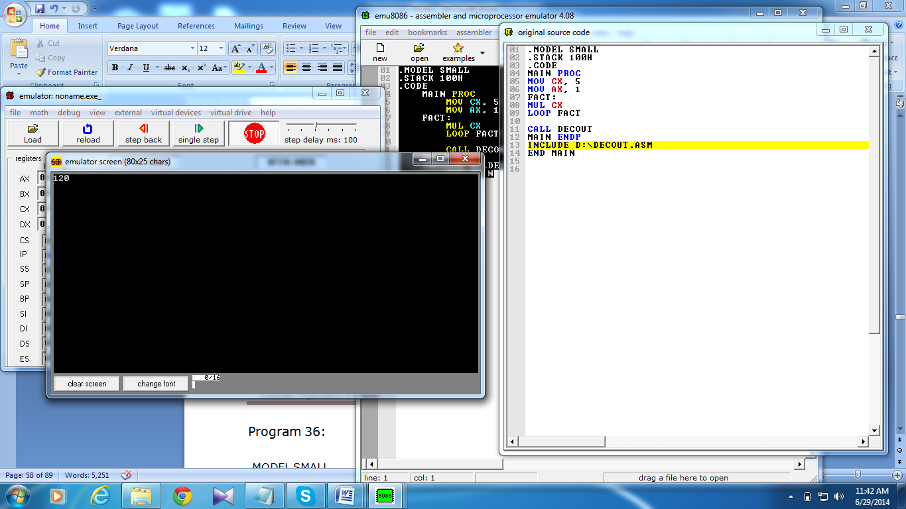  - DIVISION:  When division is performed, we obtain two results, the quotient and the remainder. As with multiplication, there are separate Instructions for unsigned and signed division, DIV (divide) is used for unsigned division and IDIV-(integer divide)-for signed division.  The syntax is:  DIV divisor  Byte Form:  In this form, the divisor is an 8-bit register or memory byte. The 16-bit dividend is assumed to be in AX. After division, the 8-bit quotient is in AL and the 8-bit remainder is in AH. The divisor may not be a constant.

Time  Plan  (min) | Contents of Lecture | Lecture  Strategy  (Remarks)
5  mins | Word Form:  Here the divisor is a 16-bit register or memory word. The 32-bit dividend Is assumed to be In DX : AX, After division, the 16-bit quotient is in AX and the 16-bit remainder is In DX. The divisor may not be a constant.  Divide Overflow:  It is possible that the quotient will be too big to fit in the specified destination (AL or AX). This can happen if the divisor is much smaller than the dividend: When this happens, the program terminates and the system displays 'the message "Divide Overflow"  Example: Suppose DX contains 000h, AX contains 0005h, and BX contains 0002h.  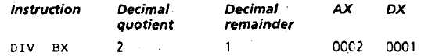  - Decimal Input and Output Procedures:  Even though the computer represents everything in binary, it's more convenient for the user to see input and output expressed in decimal In this section, we write procedures for handling decimal I/O.  DECIMAL INPUT:  To do decimal input, we need to convert a string of ASCII digits to the binary representation of a decimal integer. We will write a procedure INDEC to do this. In procedure OUTDEC, to output the contents of AX in decimal we repeatedly divided AX by 10. For INDEC we need repeated multiplication by 10.  Decimal Input Algorithm  total = 0  read an ASCII digit  REPEAT  convert character to a binary value  total = 10 x total + value  read a character  UNTIL character is a carriage return

Time  Plan  (min) | Contents of Lecture | Lecture  Strategy  (Remarks)
5  mins | For example, an input of 123 is processed as follows:  total = 0  read '1'  convert '1'. to 1  total = 10 x 0 + = 1  read '2'  convert '2' to 2  total = 10 x 1 + 2 = 12  read '3'  convert '3' to 3.  total = 10 x 12 + 3 – 123  We will design INDEC so that it can handle signed decimal integers in the range -32768 to 32767. The program prints a question mark, and lets the user enter an optional sign, followed by a string of digits, followed by a carriage return. If the user enters a character outside the range "0" ... "9", the procedure goes to a new line and starts over.  Procedure:  DECIN PROC  PUSH BX  PUSH CX  PUSH DX  BEGIN:  MOV AH, 2  MOV DL, '?'  INT 21H  XOR BX, BX  XOR CX, CX  MOV AH, 1  INT 21H  CMP AL, '-'  JE MINUS  CMP AL, '+'  JE PLUS  JMP REPEAT2  MINUS:  MOV CX, 1  PLUS:  INT 21H

Time  Plan  (min) | Contents of Lecture | Lecture  Strategy  (Remarks)
5  mins | REPEAT2:  CMP AL, '0'  JNGE NOT_DIGIT  CMP AL, '9'  JNLE NOT_DIGIT  AND AX, 000FH  PUSH AX  MOV AX, 10  MUL BX  POP BX  ADD BX, AX  MOV AH, 1  INT 21H  CMP AL, 0DH  JNE REPEAT2  MOV AX, BX  OR CX, CX  JE EXIT  NEG AX  EXIT:  POP DX  POP CX  POP BX  RET  NOT_DIGIT:  MOV AH, 2  MOV DL, 0DH  INT 21H  MOV DL, 0AH  INT 21H  JMP BEGIN  DECIN ENDP  Decimal Output:  We will write a procedure OUTDEC to print the contents of AX as a signed decimal integer. If AX >= 0, OUTDEC will print the contents in decimal; if AX < 0, OUTDEC will print a minus sign, replace AX by -AX (so that AX now contains a positive number), and print the contents in decimal.

Time  Plan  (min) | Contents of Lecture | Lecture  Strategy  (Remarks)
5  mins | Algorithm for Decimal Output  1. IF AX < 0 /*AX holds output value */  2. THEN  3. Print a minus sign  4. Replace AX by its two's complement  5. END IF  6. Get the digits in AX’s decimal representation  7. Convert these digits to characters and print them  To see what line 6 entails, suppose the content of AX, expressed in decimal, is 24168. To get the digits In the decimal representation, we cal)proceed as follows:  Divide 24618 t1y 10. Quotient= 2461, remainder= 8  Divide 2461 by 10. Quotient= 246, remainder = 1  Divide 246 by 10. Quotient= 24, remainder= 6  Divide 24 by 10. Quotient 2, remainder = 4  Divide 2 by 10. Quotient = 0, remainder = 2  DECOUT PROC  PUSH AX  PUSH BX  PUSH CX  PUSH DX  ADD AX, 655D  CMP AX, 0  JG ALPHA  PUSH AX  MOV DL, '-'  MOV AH, 2  INT 21H  POP AX  NEG AX  ALPHA:  XOR CX, CX  MOV BX, 10D

Time  Plan  (min) | Contents of Lecture | Lecture  Strategy  (Remarks)
10  mins | WHILE_:  XOR DX, DX  DIV BX  PUSH DX  INC CX  CMP AX, 0  JNE WHILE_  MOV AH, 2  PRINT:  POP DX  ADD DL, 48  INT 21H  LOOP PRINT  POP DX  POP CX  POP BX  POP AX  RET  DECOUT ENDP  Exercise:  DECIMAL INPUT/OUTPUT  .MODEL SMALL  .STACK 100H  .CODE  MAIN PROC  CALL DECIN  CALL DECOUT  MOV AH, 4CH  INT 21H  MAIN ENDP  DECIN PROC  PUSH BX  PUSH CX  PUSH DX  BEGIN:  MOV AH, 2  MOV DL, '?'  INT 21H  XOR BX, BX  XOR CX, CX

Time  Plan  (min) | Contents of Lecture | Lecture  Strategy  (Remarks)
MOV AH, 1
INT 21H

CMP AL, '-'
JE MINUS
CMP AL, '+'
JE PLUS
JMP REPEAT2

MINUS:
MOV CX, 1
PLUS:
INT 21H

REPEAT2:
CMP AL, '0'
JNGE NOT_DIGIT
CMP AL, '9'
JNLE NOT_DIGIT

AND AX, 000FH
PUSH AX

MOV AX, 10
MUL BX
POP BX
ADD BX, AX

MOV AH, 1
INT 21H
CMP AL, 0DH
JNE REPEAT2

MOV AX, BX
OR CX, CX
JE EXIT
NEG AX

EXIT:
POP DX
POP CX
POP BX
RET

NOT_DIGIT:
MOV AH, 2
MOV DL, 0DH
INT 21H

Time  Plan  (min) | Contents of Lecture | Lecture  Strategy  (Remarks)
10 mins | MOV DL, 0AH  INT 21H  JMP BEGIN  DECIN ENDP  ;;;;;;;;;;;;;;;;;;;;;;;  DECOUT PROC  PUSH AX  PUSH BX  PUSH CX  PUSH DX  CMP AX, 0  JG ALPHA  PUSH AX  MOV DL, '-'  MOV AH, 2  INT 21H  POP AX  NEG AX  ALPHA:  XOR CX, CX  MOV BX, 10D  WHILE_:  XOR DX, DX  DIV BX  PUSH DX  INC CX  CMP AX, 0  JNE WHILE_  MOV AH,2  MOV DL,10  INT 21H  MOV DL,13  INT 21H

Time  Plan  (min) | Contents of Lecture | Lecture  Strategy  (Remarks)
10  mins | MOV AH, 2  PRINT:  POP DX  ADD DL, 48  INT 21H  LOOP PRINT  POP DX  POP CX  POP BX  POP AX  RET  DECOUT ENDP  ;;;;;;;;;;;;;;;;;;;;;;;;;;;;;;;  END MAIN  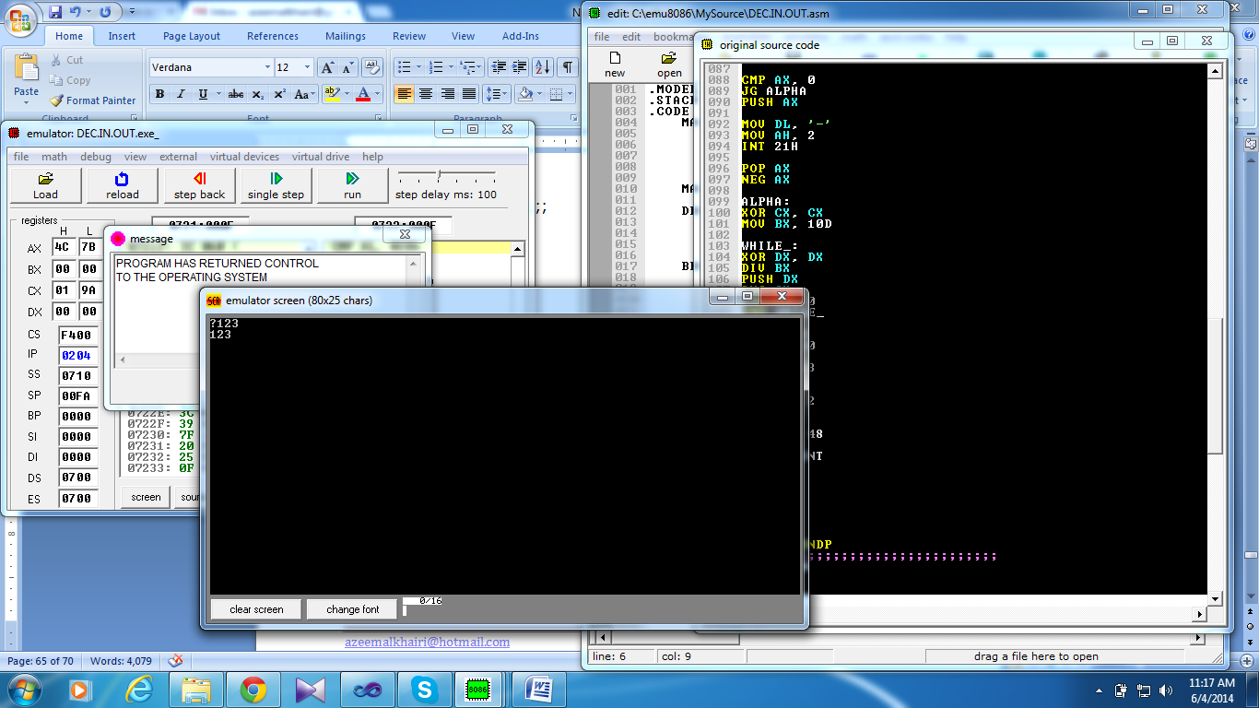  ADD DECIMAL INPUT  .MODEL SMALL  .STACK 100H  .CODE  MAIN PROC  CALL DECIN  PUSH AX  MOV AH,2  MOV DL,10  INT 21H  MOV DL,13  INT 21H  POP AX  MOV CX,0  MOV BX,10

Time  Plan  (min) | Contents of Lecture | Lecture  Strategy  (Remarks)
10  mins | DIVI:  MOV DX,0  DIV BX  PUSH DX  INC CX  CMP AX,0  JNE DIVI  MOV AX,0 ;IT WILL HOLD THE SUM  ADDUP:  POP DX  ADD AX,DX  LOOP ADDUP  CALL DECOUT  MOV AH, 4CH  INT 21H  MAIN ENDP  END MAIN  LCM  .MODEL SMALL  .STACK 100H  .DATA  NUM1 DW 30  NUM2 DW 45  HCF DW ?  LCM DW ?  .CODE  MAIN PROC  MOV AX, @DATA  MOV DS, AX  MOV AX, NUM1  MOV BX, NUM2  WHILEE_:  MOV DX, 0  MOV CX, BX  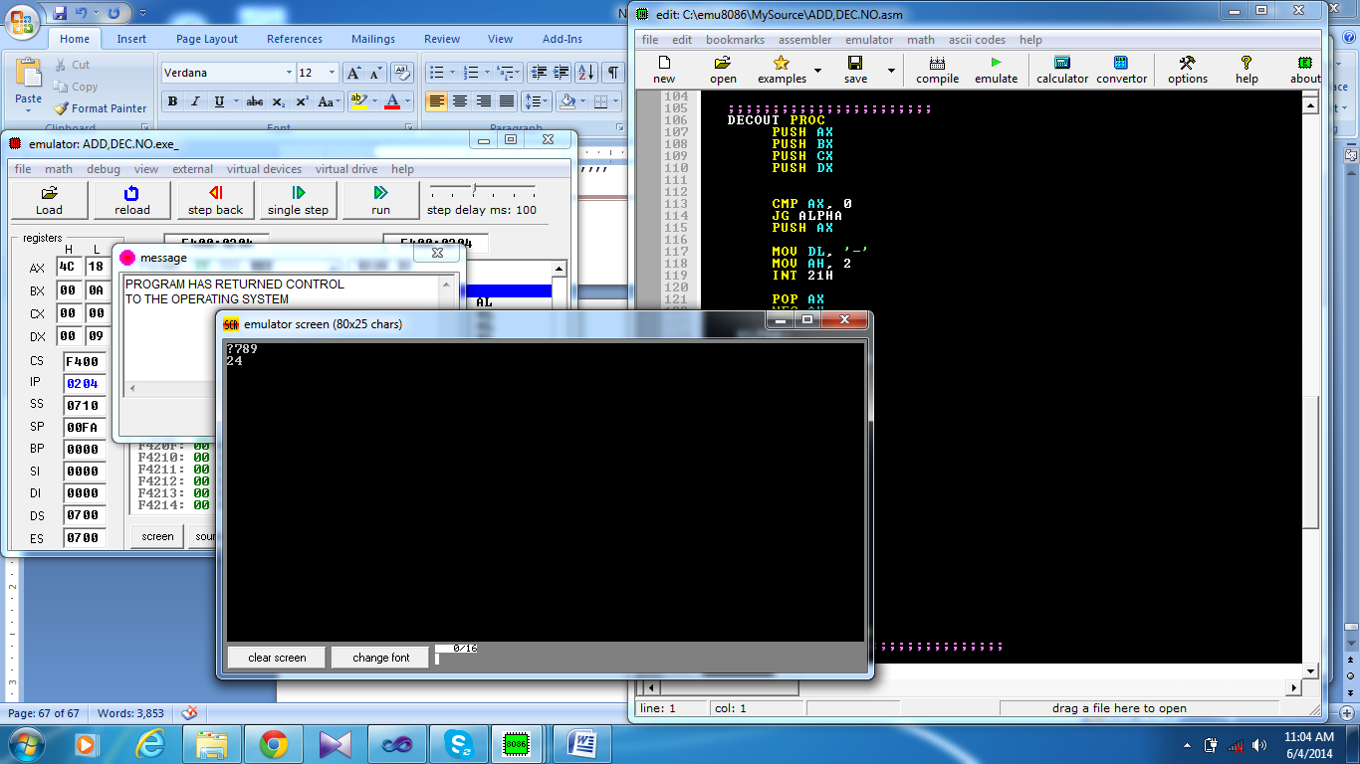

Time  Plan  (min) | Contents of Lecture | Lecture  Strategy  (Remarks)
10  mins | DIV BX  MOV BX, DX  MOV AX, CX  CMP BX, 0  JNE WHILEE_  MOV HCF, AX  MOV CX, AX  MOV AX, NUM1  MOV BX, NUM2  MUL BX  DIV CX  MOV LCM, AX  CALL DECOUT  MOV AH, 4CH  INT 21H  MAIN ENDP  END MAIN  GCD  .MODEL SMALL  .STACK 100H  .DATA  PROMPT_1 DB 'Enter the value of M = $'  PROMPT_2 DB 10,13,'Enter the value of N = $'  PROMPT_3 DB 10,13,'The GCD of M and N is = $'  .CODE  MAIN PROC  MOV AX, @DATA ; initialize DS  MOV DS, AX  LEA DX, PROMPT_1 ; load and display the string PROMPT_1  MOV AH, 9  INT 21H  CALL DECIN ; call the procedure DEC INPUT  PUSH AX ; push AX onto the STACK  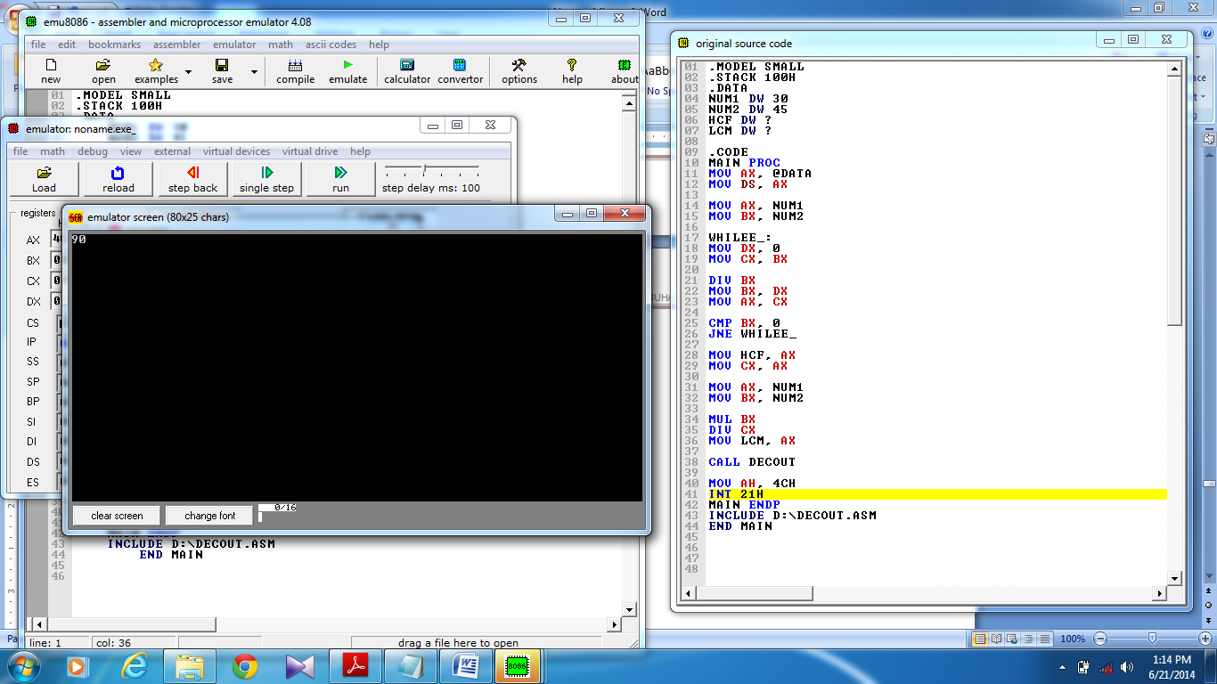

Time  Plan  (min) | Contents of Lecture | Lecture  Strategy  (Remarks)
LEA DX, PROMPT_2 ; load and display the string PROMPT_2
MOV AH, 9
INT 21H

CALL DECIN ; call the procedure INDEC

MOV BX, AX ; set BX=AX

POP AX ; pop a value from STACK into AX

@REPEAT: ; jump label
XOR DX, DX ; clear DX
DIV BX ; set AX=DX:AX\BX , AX=DX:AX%BX

CMP DX, 0 ; compare DX with 0
JE @END_LOOP ; jump to label @END_LOOP if CX=0
MOV AX, BX ; set AX=BX
MOV BX, DX ; set BX=DX
JMP @REPEAT ; jump to label @REPEAT

@END_LOOP: ; jump label

LEA DX, PROMPT_3 ; load and display the string PROMPT_3
MOV AH, 9
INT 21H

MOV AX, BX ; set AX=BX

CALL DECOUT ; call the procedure DEC OUTPUT

MOV AH, 4CH ; return control to DOS
INT 21H
MAIN ENDP
INCLUDE D:\DECIN.ASM
INCLUDE D:\DECOUT.ASM
END MAIN

