H. M. Faisal (03455275108) Computer Organization and Assembly Language (CS-530)

Lesson Plan 10

Objectives: The main objectives are: (a) Arrays; (b) Addressing Modes.

Content: This lecture will cover Arrays and Addressing Modes. To access an array in assembly language,
we use a pointer. A pointer is simply a register or variable that contains a memory address.
Most assembly language instructions require operands to be processed. When an instruction
requires two operands, the first operand is generally the destination, which contains data in a
register or memory location and the second operand is the source. Source contains either the
data to be delivered (immediate addressing) or the address (in register or memory) of the data.
Generally, the source data remains unaltered after the operation.

Methods: For every new topic, I will first provide the definition and the basic working, then I will request some student to come to the board and with the help of class discussion repeat that discussion. This process will not only give them confidence, but will also clear their idea and encourage them to openly discuss any complications with this topic.

Resources: Besides the lecture handout, this lesson will draw from the following Text books: Assembly Language Programming and Organization of the IBM-PC, Ytha Yu and Charles Marut.

Evaluation: In this lecture I will not be using any formal evaluation process. I will be using informal techniques to monitor if the students have absorbed the material or not: (i) By making the students step up to the board and solve some examples. (iii) By judging the class interaction, which is a clear indicator of their interest.

Assignment: Give them a home assignment on programming practices.

Time  Plan  (min) | Contents of Lecture | Lecture  Strategy  (Remarks)
10 mins  10  mins | - One-Dimensional Arrays:  A one-dimensional array is an ordered list of elements, all of the same type. By “ordered,” we mean that there is a first element, second element, third element, and so on. In mathematics, if A is an array, the elements are usually denoted by A[1], A[2], A[3] and so on. Figure shows a one dimensional array A with six elements.  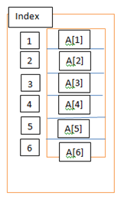  Example:  MSG DB ‘abcde’  W DW 10, 20, 30, 40, 50, 60  Or a word array of six integers, initialized to 10, 20, 30, 40, 50, 60ariable is called the base address of the array. If the offset address assigned to W is 0200h, the array looks like this in memory:  Offset address Symbolic address Decimal content  0200h W 10  0202h W+2h 20  0204h W+4h 30  0206h W+6h 40  0208h W+8h 50  020Ah W+Ah 60  The Dup Operator:  It is possible to define arrays whose elements share a common initial value by using the DUP (duplicate) operator. It has this form:  repeat_count Dup (value)

Time  Plan  (min) | Contents of Lecture | Lecture  Strategy  (Remarks)
This operator causes value to be repeated the number of times specified by repeat_count. For example:
GAMMA DW 100 DUP (0)

Sets up an array of 100 words, with each entry initialized to 0. Similarly,
DELTA DB 212 DUP (?)

Creates an array of 212 uninitialized bytes. DUPs may be nested. For Example:
LINE DB 5,4, 3 DUP (2,3 DUP (0),1)
Which is equivalent to:
LINE DB 5,4,2,0,0,0,1,2,0,0,0,1,2,0,0,0,1

Location of Array Elements:
The address of an array element may be specified by adding a constant to the base address. Suppose A is an array and S denotes the number of bytes in an element (S=1 for a byte array, S=2 for a word array). The position of the elements in array A can be determined as follows:

Position Location
- A
- A=1XS
- A=2XS
- .
- .
- .
N A=(N-1)XS

Example: Exchange the 10th and 25th elements in a word array W.
MOV AX, W+18
XCHG W+48, AX
MOV W+18, AX

In many applications we need to perform some operation on each element of an array. For example, suppose array is a 10-element array, and we want to add the elements. In a high-level language, we could do it like this:

SUM=0
N=1
REPEAT
SUM=SUM+A[N]
N=N+1
UNTIL N>10
To code this in assembly language, we need a way to move from one array element to the next one. In the next section, we’ll see how to accomplish this by direct addressing.

Time  Plan  (min) | Contents of Lecture | Lecture  Strategy  (Remarks)
10  mins | - Addressing Modes:  The way and operand is known as its addressing mode. The addressing modes we have used so far are:  - Register mode: which means that an operand is a register.  - Immediate mode: when an operand is a constant.  - Direct mode: when an operand is a variable.  - Register indirect Mode  In this mode, the offset address of the operand is contained in register. We say that the register acts a pointer to the memory location.  The register BX, SI, DI, or BP. For BX, SI, or DI, the operand’s segment number is contained in DS. For BP, SS has the segment numbers.  For example, suppose that SI contains 0100h, and the word at 0100h contains 1234h. To execute  MOV AX, SI  The CPU (1) examines SI and obtains the offset address 100h, (2) uses the address DS:0100h to obtain the value 1234h, and (3) moves 1234h to AX. This is not the same as:  MOV AX, SI  Example: Suppose that  BX contains 1000h Offset 1000h contains 1BACh  SI contains 2000h Offset 2000h contains 20FEh  DI contains 3000h Offset 3000h contains 031Dh  Where the above offsets are in the data segment addressed by DS.  Tell which of the following instructions are legal. If legal, give the source offset address and the result or number moved.  - MOV BX, [BX]  - MOV CX, [SI]  - MOV BX, [AX]  - ADD [SI], [DI]  - INC [DI]  Solution:  Source offset Result  - 1000h 1BACh  - 2000h 20FEh  - Illegal source register (must be BX, SI or DI)  - Illegal memory-memory Addition  - 3000h 031Eh

Time  Plan  (min) | Contents of Lecture | Lecture  Strategy  (Remarks)
10  mins | Now let’s return to the problem of adding the elements of an array.  Example: Write some code to sum in AX the elements of the 10-elements array W defined by  W DW 10, 20, 30, 40, 50, 60, 70, 80, 90, 100  Solution:  The idea is to set a pointer to the base of the array, and let it move up the array, summing elements as it goes.  XOR AX, AX  LEA SI, W  ADDNOS:  ADD AX, [SI]  ADD SI, 2  LOOP ADDNOS  Example: Write a procedure REVERSE that will reverse an array of N words. This means that the Nth word becomes the first, the (N-1)st word becomes the second, and so on, and the first word becomes the Nth word. The procedure is entered with SI pointing to the array, and BX has the number of words N.  Solution: The idea is to exchange the 1st and Nth words, the 2nd and (N-1)st word, and so on. The number of exchanges will be N/2 (rounded down to the nearest integer if N is odd). Recall from section 10.1 that the Nth element in a word array A has address A + 2 x (N - 1).  PUSH AX  PUSH BX  PUXH CX  PUSH SI  PUSH DI  ;make DI point to nth word  MOV DISI  MOV CX,BX  DEC BX  SHL BX, 1  ADD DI, BX  SHR CX,1  ;swap elements  XCHG_LOOP:  MOV AX, [SI]  XCHG AX, [DI]  MOV [SI], AX  ADD SI, 2  SUB DI, 2  LOOP XCHG_LOOP  POP DI  POP SI  POP CX  POP BX  POP AX  REVERSE ENDP

Time  Plan  (min) | Contents of Lecture | Lecture  Strategy  (Remarks)
10  mins | - Based and Indexed Addressing Modes:  In this modes, the operand’s offset address is obtained by adding a number called a displacement to the contents of a register. Displacement may be any of the following:  The offset address of a variable  A constant (positive or negative)  The offset address of a variable plus or minus a constant  If A is a variable, examples of displacements are:  A (offset address of a variable)  -2 (constant)  A+4 (offset address of a variable plus a constant)  Example:  Rework example 10.3 by using based mode.  Solution:  The idea is to clear base register BX, then add 2 to it on each trip through the summing loop.  XOR AX, AX  XOR BX, BX  MOV CX, 10  ADDNOS:  ADD AW, W [BX]  ADD BX, 2  LOOP ADDNOS  Example:  Suppose that ALPHA is declared as  ALPHA DW 0123h, 0456h, 0789h, 0ABCDh  In the segment addressed by DS. Suppose also that  BX contains 2 Offset 0002 contains 1084h  SI contains 4 Offset 0004 contains 2BACh  DI contains 1  Tell which of the following instructions are legal. If legal, give the source offset address and the number moved.  - MOV AX, [ALPHA+BX]  - MOV BX, [BX+2]  - MOV CX, ALPAH[SI]  - MOV AX, -2[SI]  - MOV BX, [ALPHA+3+DI]  - MOV AX, [BX]2  - ADD BX, [ALPHA+AX]

Time  Plan  (min) | Contents of Lecture | Lecture  Strategy  (Remarks)
5  Mins  5 min | Solution:  Source offset Number moved  - ALPHA+2 0456h  - 2+2=4 2BACh  - ALPHA+4 0789h  - -2+4=2 1084h  - ALPHA+3+1= ALPHA+4 0789h  - Illegal form of source operand  Illegal source register  Example:  Replace each lowercase letter in the following string by its upper case equivalent. Use index addressing mode.  Solution:  MOV CX, 17  XOR SI, SI  TOP:  CMP MSG[SI], ‘ ‘  JE NEXT  AND MSG[SI], 0DFh  NEXT:  INC SI  LOOP TOP  Exercise:  ARRAY (Addition)  .MODEL SMALL  .STACK 100H  .DATA  ARR DW 100, 200, 300, 400, 500, 600, 700  .CODE  MAIN PROC  MOV AX, @DATA  MOV DS, AX  LEA SI, ARR  MOV CX, 7  MOV AX, 0  ADDUP:  ADD AX,[SI]  ADD SI, 2  LOOP ADDUP  CALL DECOUT

Time  Plan  (min) | Contents of Lecture | Lecture  Strategy  (Remarks)
5 mins | MOV AH, 4CH  INT 21H  MAIN ENDP  INCLUDE D:\DECOUT.ASM  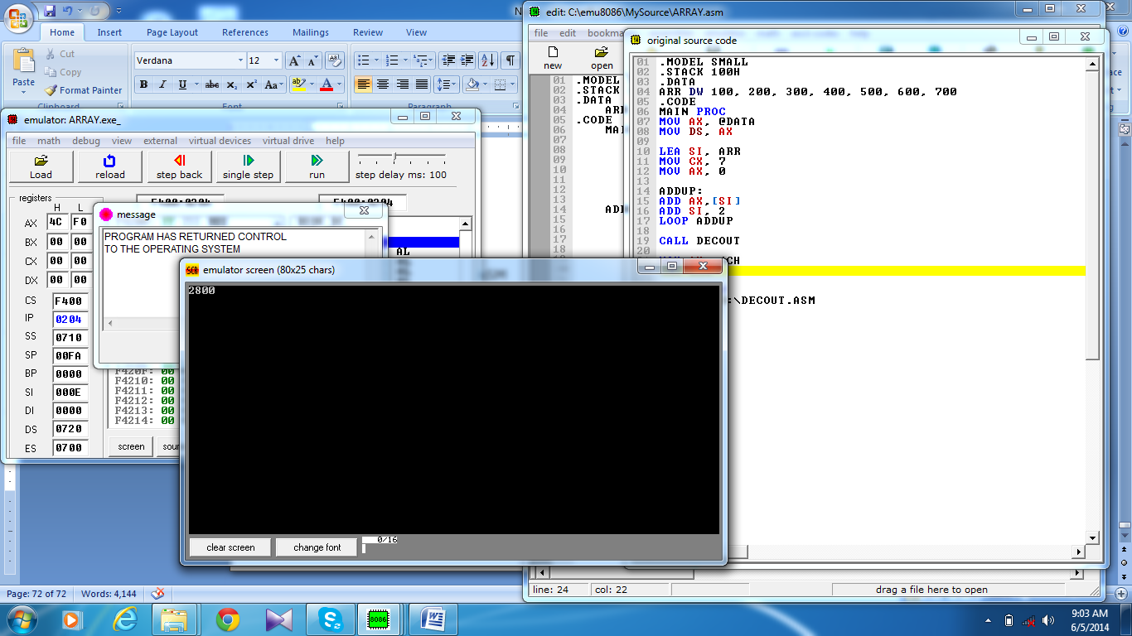  END MAIN  AVERAGE  .MODEL SMALL  .STACK 100H  .DATA  ARR DW 100, 200, 300, 400, 500, 600, 700  .CODE  MAIN PROC  MOV AX, @DATA  MOV DS, AX  LEA SI, ARR  MOV CX, 7  MOV AX, 0  ADDUP:  ADD AX,[SI]  ADD SI, 2  LOOP ADDUP  XOR DX, DX  MOV BX, 7  DIV BX  CALL DECOUT  MOV AH, 4CH  INT 21H  MAIN ENDP  INCLUDE D:\DECOUT.ASM  END MAIN  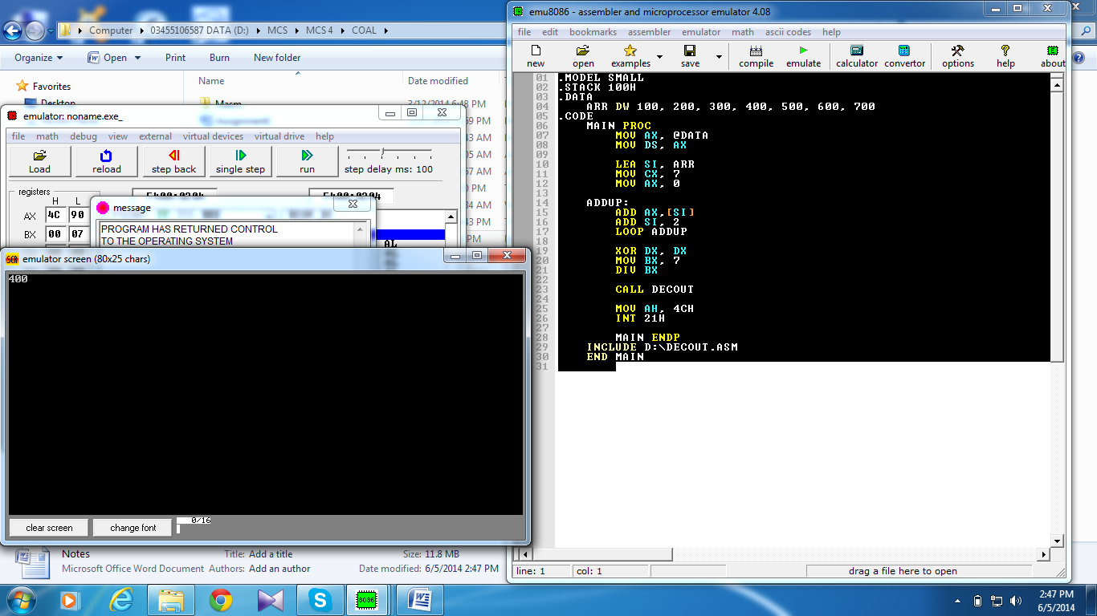

Time  Plan  (min) | Contents of Lecture | Lecture  Strategy  (Remarks)
10  mins | SEARCH NO  .MODEL SMALL  .STACK 100H  .DATA  MSG1 DB 10,13,"FOUND$"  MSG2 DB 10,13,"NOT FOUND$"  X DW 100  ARR DW 800, 200, 100, 400, 500, 600, 700  .CODE  MAIN PROC  MOV AX, @DATA  MOV DS, AX  LEA SI, ARR  MOV CX, 7  MOV AX, X  ADDUP:  CMP AX, [SI]  JE FOUND  ADD SI, 2  LOOP ADDUP  MOV AH, 9  LEA DX, MSG2  INT 21H  JMP EXIT  FOUND:  MOV AH, 9  LEA DX, MSG1  INT 21H  EXIT:  MAIN ENDP  END MAIN  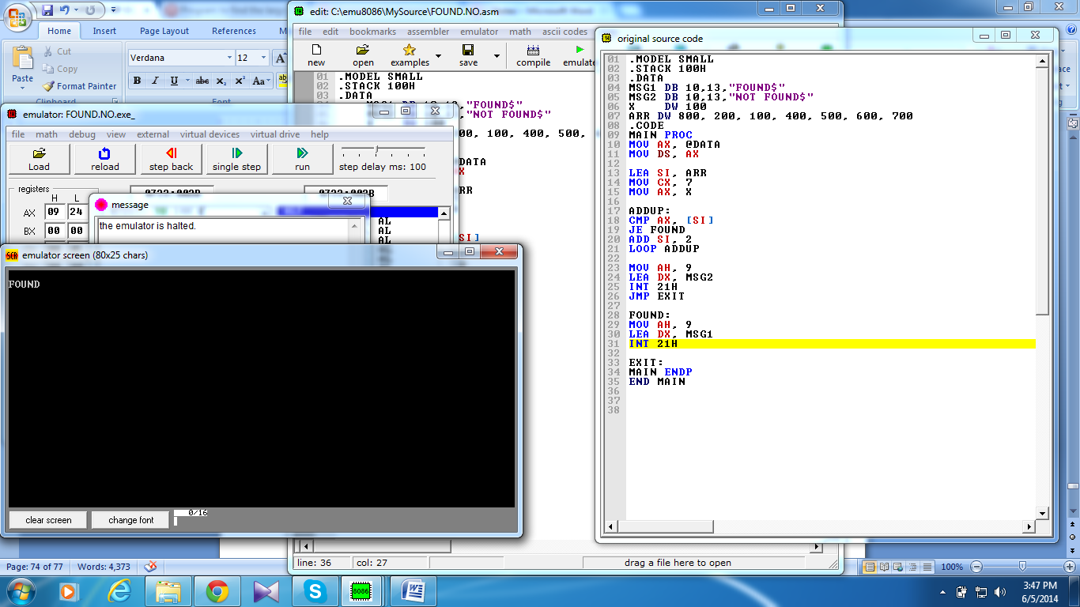

Time  Plan  (min) | Contents of Lecture | Lecture  Strategy  (Remarks)
5  mins | NO OF OCCURRENCE  .MODEL SMALL  .STACK 100H  .DATA  COUNT DW 0  X DW 100  ARR DW 800, 200, 100, 400, 500, 100, 700  .CODE  MAIN PROC  MOV AX, @DATA  MOV DS, AX  LEA SI, ARR  MOV CX, 7  MOV AX, X  ADDUP:  CMP AX, [SI]  JE PLUS  ADD SI, 2  LOOP ADDUP  JMP EXIT  PLUS:  INC COUNT  ADD SI, 2  JMP ADDUP  EXIT:  MOV AX, COUNT  CALL DECOUT  MOV AH, 4CH  INT 21H  MAIN ENDP  INCLUDE D:\DECOUT.ASM  END MAIN  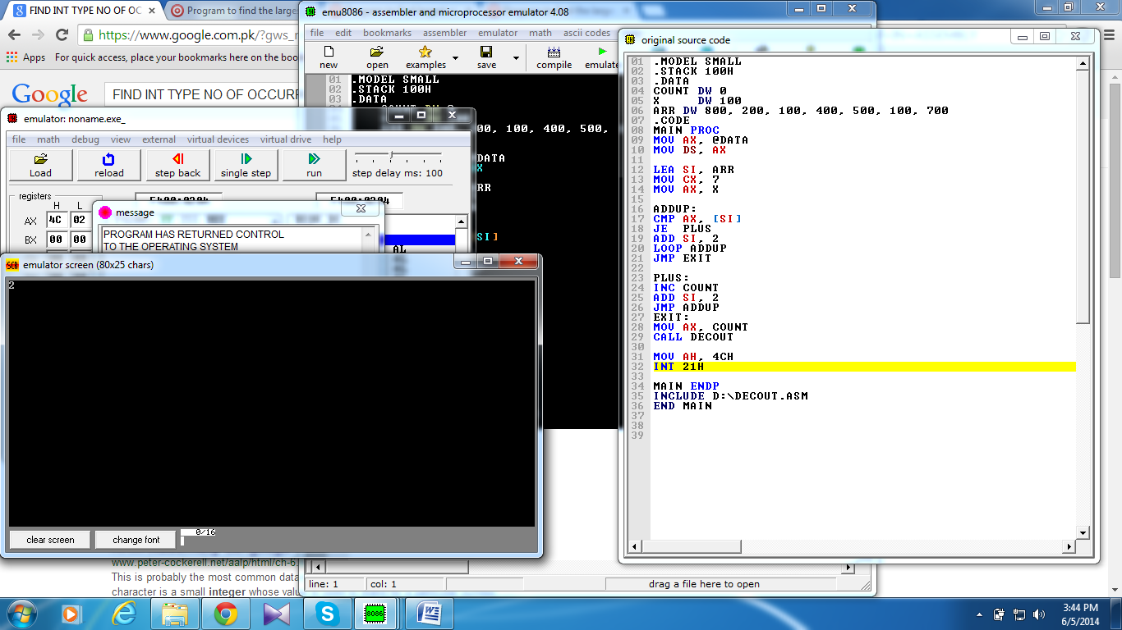

Time  Plan  (min) | Contents of Lecture | Lecture  Strategy  (Remarks)
5  mins | MIN NO  .MODEL SMALL  .STACK 100H  .DATA  ARR DW 800, 200, 700, 400, 900, 600, 100  .CODE  MAIN PROC  MOV AX, @DATA  MOV DS, AX  LEA SI, ARR  MOV BX, [SI]  MOV CX, 7  ADDUP:  CMP BX, [SI]  JG SWAP  ADD SI, 2  LOOP ADDUP  JMP EXIT  SWAP:  XCHG BX, [SI]  ADD SI, 2  LOOP ADDUP  EXIT:  MOV AX, BX  CALL DECOUT  MOV AH, 4CH  INT 21H  MAIN ENDP  INCLUDE D:\DECOUT.ASM  END MAIN  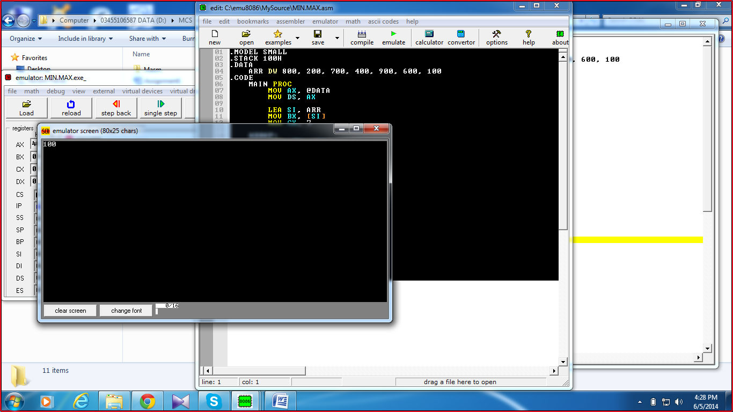

Time  Plan  (min) | Contents of Lecture | Lecture  Strategy  (Remarks)
5  mins | MAX NO  .MODEL SMALL  .STACK 100H  .DATA  ARR DW 800, 200, 700, 400, 900, 600, 100  .CODE  MAIN PROC  MOV AX, @DATA  MOV DS, AX  LEA SI, ARR  MOV BX, [SI]  MOV CX, 7  ADDUP:  CMP BX, [SI]  JL SWAP  ADD SI, 2  LOOP ADDUP  JMP EXIT  SWAP:  XCHG BX, [SI]  ADD SI, 2  LOOP ADDUP  EXIT:  MOV AX, BX  CALL DECOUT  MOV AH, 4CH  INT 21H  MAIN ENDP  INCLUDE D:\DECOUT.ASM  END MAIN  