H. M. Faisal (03455275108) Computer Organization and Assembly Language (CS-530)

Lesson Plan 11

Objectives: The main objectives are: (a) The Direction Flag; (b) Moving a String; (c) The REP Prefix; (d)
Store String; (e) Load String; (f) Scan String; (g) Compare String; (h) REPE and REPZ; (i)
Finding a substring of a substring; (j) General Form of the String Instructions.

Content: In this lecture we will firstly cover the direction flag. One of the control flags in the direction flag (DF). Its purpose is to determine the direction in which string operation will proceed. These operations are implemented the two index registers will proceed. These operations are implemented by the two index registers SI and DI. Then will proceed to load, store , compare and scan string along with different programming examples.

Methods: For every new topic, I will first provide the definition and the basic working, then I will request some student to come to the board and with the help of class discussion repeat that discussion. This process will not only give them confidence, but will also clear their idea and encourage them to openly discuss any complications with this topic.

Resources: Besides the lecture handout, this lesson will draw from the following Text books: Assembly Language Programming and Organization of the IBM-PC, Ytha Yu and Charles Marut.

Evaluation: In this lecture I will not be using any formal evaluation process. I will be using informal techniques to monitor if the students have absorbed the material or not: (i) By making the students step up to the board and solve some examples. (iii) By judging the class interaction, which is a clear indicator of their interest.

Assignment: Give them a home assignment on Programming practices.

Time  Plan  (min) | Contents of Lecture | Lecture  Strategy  (Remarks)
5  mins | - The Direction Flag  Previous, we saw that the FLAGS register contains six status flags and three control flags. We know that the status flags reflect the result of an operation that the processor has done. The control flags are used to control the processor’s operations.  One of the control flags in the direction flag (DF). Its purpose is to determine the direction in which string operation will proceed. These operations are implemented the two index registers will proceed. These operations are implemented by the two index registers SI and DI. Suppose, for example, that the following string has been declared:  STRING DB ‘ABCDE’  And this string is stored in memory starting at offset 0200h:  Offset address Content ASCII character  0200h 041h A  0201h 042h B  0202h 043h C  0203h 044h D  0204h 045h E  If DF=0, SI and DI proceed in the creation of increasing memory addresses from left to right across the string conversely, if DF=1, SI and DI proceed in the direction of decreasing memory addresses: from right to left.  In the DEBUG display DI=0 is symbolized by UP, and DF=1 by DN.  CLD and STD:  To make DF=0, use the CLD instruction:  CLD ; Clear direction flag  To make DF=1, use the STD instruction:  STD ;set direction flag  CLD and STD have no effect on the other flags  - Moving a String:  Suppose we have defined two strings as follows:  .DATA  STRING1 DB ‘HELLO’  STRING2 DB 5 DUP (?)  And we would like to move the contents of STRING 1 (the source string) into STRING2 (the destination string). This operation is needed for many string operations, such a) duplicating a string or concatenating strings (attaching one string to the end of another string).  The MOVSB instruction:  MOVSB ; move string byte

Time  Plan  (min) | Contents of Lecture | Lecture  Strategy  (Remarks)
5  mins | Copies the contents of the byte addressed by DS:SI, to the byte addressed by ES:DI. The contents of the source byte are unchanged. After the byte has been moved, both SI and DI are automatically incremented. If DF=0, or decremented If DF= I. For example, to move the first two bytes of STRING1 to STRING2, we execute the following Instructions:  .MOV AX,@DATA  MOV DS,AX  MOV ES,AX  LEA SI,STRING1  LEA DI,STRING2  CLD  MOVSB  MOVSB  MOVSB is the first instruction we have seen that permits a memory- memory operation. It is also the first instruction that involves the ES register.  - The REP Prefix:  MOVSB moves only a single byte from the source string to the destination string. To move the entire string, first initialize CX to the number N of bytes ln the source string and execute. The REP prefix causes MOVSB to be executed N times. After each MOVSB, CX is decremented until it becomes 0. For example, to copy STRING1 of the preceding section into STRING2, we execute:  CLD  LEA SI, STRING1  LEA DI, STRING2  MOV CX, 5 ; no. of chars in STRING1  REP MOVSB  Example: Write instructions to copy STRING 1 of the preceding section into STRING2 in reverse order.  Solution: The idea is to get SI pointing to the end of STRING 1, DI to the beginning of STRING2, then move characters as SI travels to the left across STRING1.  LEA SI, STRING1+4  LEA DI, STRING2  STD  MOV CX, 5  MOVE:  MOVSB  ADD DI, 2  LOOP MOVE  Here it is necessary to add 2 to DI after each MOVSB. Because we do this when OF = l, MOVSB automatically decrements both SI and DI, and we want to increment DI.  MOVSW  There is a word form of MOVSB. It is  MOVSW ; move string word

Time  Plan  (min) | Contents of Lecture | Lecture  Strategy  (Remarks)
5  mins  5  mins | MOVSW moves a word from the source string to the destination string. Like MOVSB, it expects DS:SI to point to a source string word, and ES:DI to point to a destination string word. After a string word has been moved, both SI and DI are increased by 2 if DF = 0, or are decreased by 2 if OF = 1. MOVSB and MOVSW have no effect on the flags.  Example: For the following array,  ARR DW 1o, 20, 40, 50, 60?  Write instructions to insert 30 between 20 and 40. (Assume DS and ES have been initialized to the data segment.)  Solution: The idea is to move 40, 50, and 60 forward one position in the array, then insert 30.  STD  LEA SI, ARR+8h  LEA DI, ARR+8h  MOV CX, 3  PTR MOVSW  MOV WORD PTR [DI], 30  - Store String:  The STOSB Instruction moves the contents of the AL register to the byte addressed b ES:DI. DI is incremented if DF=0 or decremented if DF=1. Similarly, the STOSW instruction moves the contents of AX to the word at address ES:DI and updates DI by 2, according to the direction flag setting.  STOSB and STOSW have no effect on the flags.  As an example of STOSB, the following instructions will store two “A”s in STRING1:  MOV AX, @DATA  MOV ES, AX  LEA DI, STRING1  CLD  MOV AL, ‘A’  STOSB  STOSB  Reading and Storing a Character String:  INT 21h, function 1 reads a character from the keyboard into AL. By repeatedly executing this interrupt with STOSB, we can read and store characters in a string, until a carriage return is typed. The procedure is entered with the string offset address in DI. It returns the string offset in DI and number of characters entered in BX. If the user makes a typing mistake and hits the backspace key, the previous character is removed from the string.

Time  Plan  (min) | Contents of Lecture | Lecture  Strategy  (Remarks)
5  Mins  5 mins | - Load String:  The LODSB instruction moves the byte addressed by DS:SI into AL.SI is then incremented if DF=O or decremented if DF=1. The word form is  LODSW. It moves the word addressed by DS:SI into AX;SI is incremented if By 2 if DF=O or decreased by 2 if DF=1.  LODSB can be used to examine to characters of a string, as shown later.  LODSB and LODSW have no effect on the flags.  - Scan String:  SCASB can be used to examine a string for a target byte. The target byte is contained in Al. SCASW in this case; the target word is in AX.  - Compare String:  The CMPSB Instruction CMPSB subtracts the byte with address ES:DI from the byte with address DS:SI, and sets the flags. CMPSW it subtracts the word with address ES:DI from the word whose address is DS:SI, and sets the flags.  Exercise:  String Input/output  .MODEL SMALL  .STACK 100H  .DATA  STR DB 20 DUP(?)  .CODE  MAIN PROC  MOV AX, @DATA  MOV DS, AX  MOV ES, AX  LEA DI, STR  MOV CX, 0  MOV AH, 1  CLD  INPUT:  INT 21H  CMP AL, 13  JE END_INP  INC CX  STOSB  JMP INPUT

Time  Plan  (min) | Contents of Lecture | Lecture  Strategy  (Remarks)
5 mins | END_INP:  MOV DL, 10  MOV AH, 2  INT 21H  MOV DL, 13  MOV AH, 2  INT 21H  LEA SI, STR  CLD  MOV AH, 2  PRINT:  LODSB  MOV DL, AL  INT 21H  LOOP PRINT  MOV AH, 4CH  INT 21H  MAIN ENDP  END MAIN  String Reverse  .MODEL SMALL  .STACK 100H  .DATA  STR1 DB "HELLOWORLD"  STR2 DB 10 DUP(?)  .CODE  MAIN PROC  MOV AX,@DATA  MOV DS, AX  MOV ES, AX  LEA SI, STR1  LEA DI, STR2  ADD DI, 9  CLD  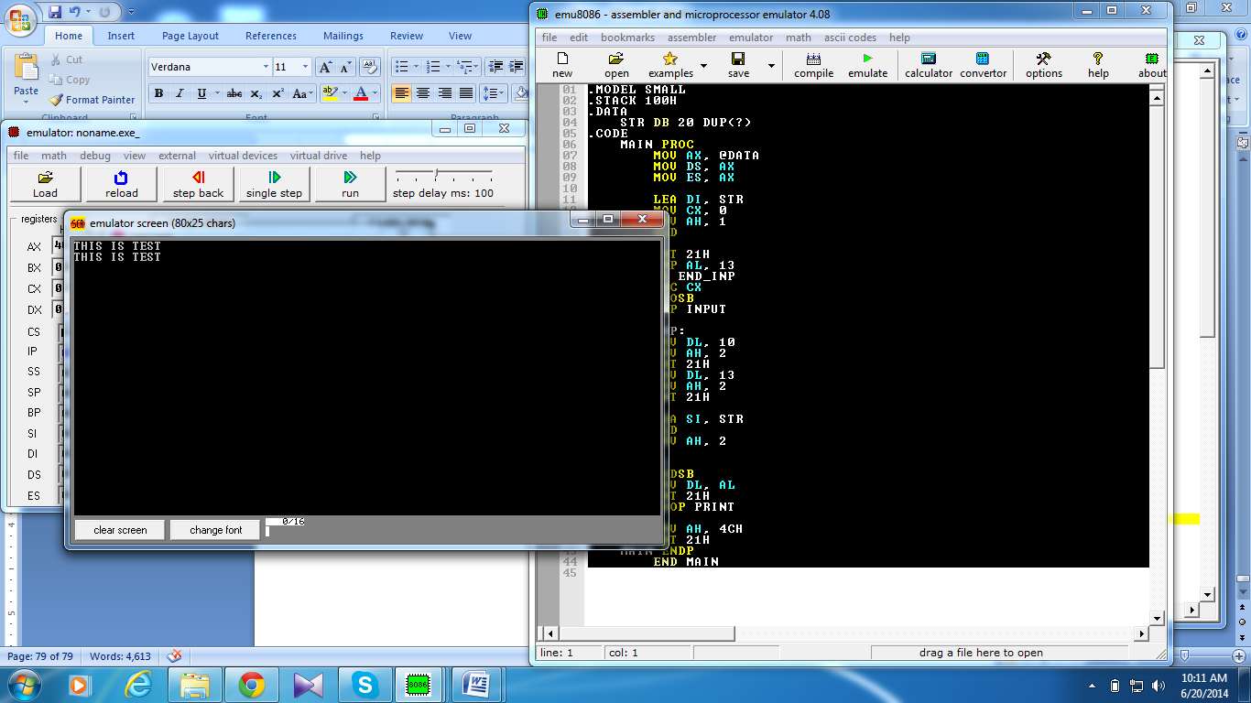

Time  Plan  (min) | Contents of Lecture | Lecture  Strategy  (Remarks)
5 mins | MOV CX, 10  SWAP:  MOVSB  SUB DI, 2  LOOP SWAP  LEA SI, STR2  CLD  MOV AH, 2  MOV CX, 10  PRINT:  LODSB  MOV DL, AL  INT 21H  LOOP PRINT  MOV AH, 4CH  INT 21H  MAIN ENDP  END MAIN  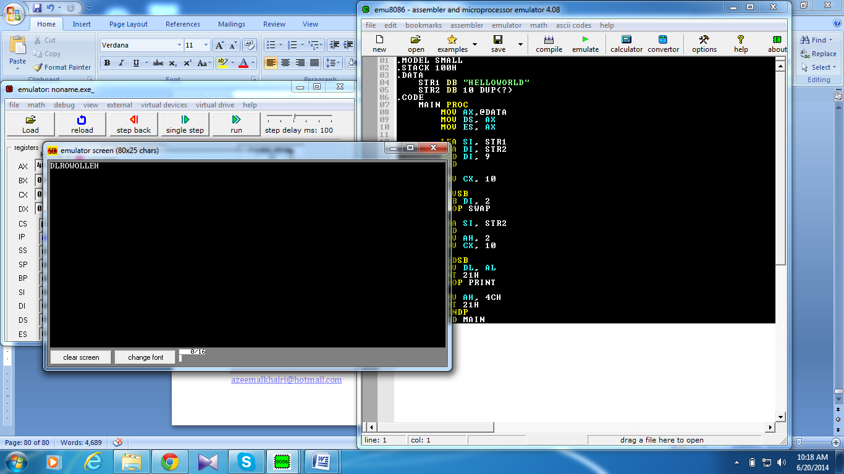  String Reverse 2  .MODEL SMALL  .STACK 100H  .DATA  STR1 DB "HELLOWORLD"  STR2 DB 10 DUP(?)  .CODE  MAIN PROC  MOV AX,@DATA  MOV DS, AX  MOV ES, AX  LEA SI, STR1  LEA DI, STR2  ADD SI, 9  CLD  MOV CX, 10

Time  Plan  (min) | Contents of Lecture | Lecture  Strategy  (Remarks)
5  mins | SWAP:  MOVSB  SUB SI, 2  LOOP SWAP  LEA SI, STR2  CLD  MOV AH, 2  MOV CX, 10  PRINT:  LODSB  MOV DL, AL  INT 21H  LOOP PRINT  MOV AH, 4CH  INT 21H  MAIN ENDP  END MAIN  COPY IN SAME STRING  .MODEL SMALL  .STACK 100H  .DATA  STR1 DB "HELLO"  .CODE  MAIN PROC  MOV AX,@DATA  MOV DS, AX  MOV ES, AX  LEA SI, STR1  LEA DI, STR1  ADD DI, 5  CLD  MOV CX, 5  REP MOVSB  LEA SI, STR1  CLD  MOV AH, 2  MOV CX, 10

Time  Plan  (min) | Contents of Lecture | Lecture  Strategy  (Remarks)
5 mins | PRINT:  LODSB  MOV DL, AL  INT 21H  LOOP PRINT  MOV AH, 4CH  INT 21H  MAIN ENDP  END MAIN  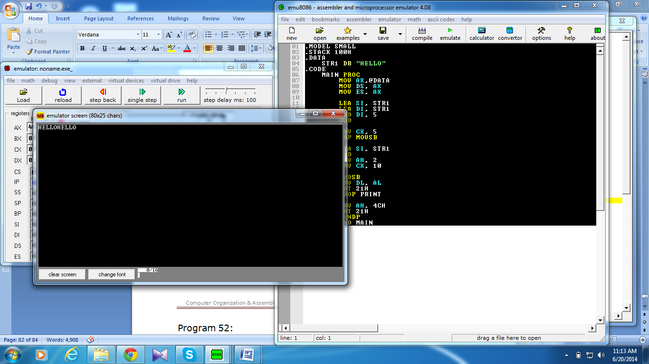  REVERSE IN SAME STRING  .MODEL SMALL  .STACK 100H  .DATA  STR1 DB "HELLO"  .CODE  MAIN PROC  MOV AX,@DATA  MOV DS, AX  MOV ES, AX  LEA SI, STR1  LEA DI, STR1  ADD DI, 9  CLD  MOV CX, 5  SWAP:  MOVSB  SUB DI, 2  LOOP SWAP  LEA SI, STR1  CLD  MOV AH, 2  MOV CX, 10  PRINT:  LODSB  MOV DL, AL  INT 21H  LOOP PRINT

Time  Plan  (min) | Contents of Lecture | Lecture  Strategy  (Remarks)
5  mins | MOV AH, 4CH  INT 21H  MAIN ENDP  END MAIN  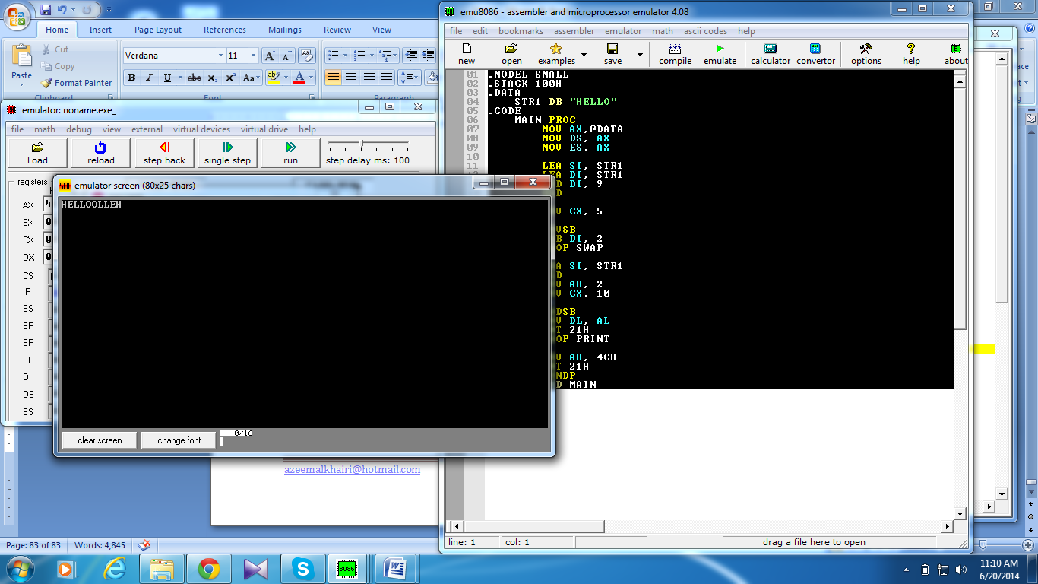  STRING APPEND  .MODEL SMALL  .STACK 100H  .DATA  STR1 DB "FGHIJ"  STR2 DB "ABCDE"  .CODE  MAIN PROC  MOV AX,@DATA  MOV DS, AX  MOV ES, AX  LEA SI, STR1  LEA DI, STR2  ADD DI, 5  CLD  MOV CX, 10  SWAP:  MOVSB  LOOP SWAP  LEA SI, STR2  CLD  MOV AH, 2  MOV CX, 10  PRINT:  LODSB  MOV DL, AL  INT 21H  LOOP PRINT  MOV AH, 4CH  INT 21H  MAIN ENDP  END MAIN  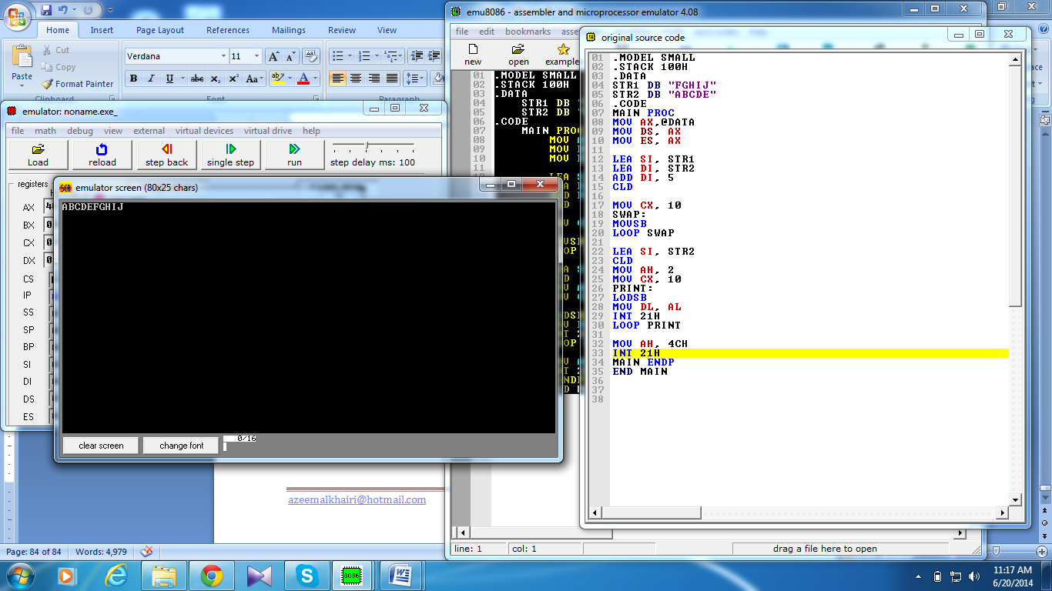

Time  Plan  (min) | Contents of Lecture | Lecture  Strategy  (Remarks)
5  Mins  5 mins | FIND STRING LENGTH  .MODEL SMALL  .STACK 100H  .DATA  STR1 DB "THIS IS AN ASCIIZ STRING",0  .CODE  MAIN PROC  MOV AX,@DATA  MOV DS, AX  LEA SI, STR1  LEA DI, STR1  CLD  MOV DL, 0  WILE_:  LODSB  INC DL  CMP AL, 0  JNE WILE_  DEC DL  MOV AX, DX  CALL DECOUT  MOV AH, 4CH  INT 21H  MAIN ENDP  INCLUDE D:\DECOUT.ASM  END MAIN  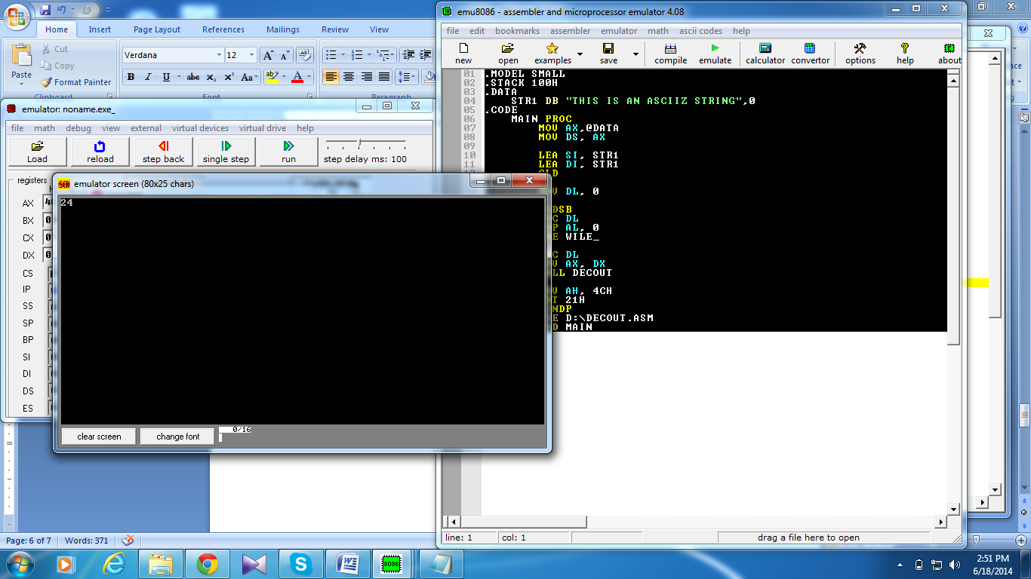  REMOVE SPACES IN A STRING  .MODEL SMALL  .STACK 100H  .DATA  STR1 DB "T H I S I S A T E S T"  STR2 DB 11 DUP(?)  .CODE  MAIN PROC  MOV AX,@DATA  MOV DS, AX  MOV ES, AX

Time  Plan  (min) | Contents of Lecture | Lecture  Strategy  (Remarks)
15 mins | LEA SI, STR1  LEA DI, STR2  CLD  MOV CX, 11  SWAP:  MOVSB  ADD SI, 1  LOOP SWAP  LEA SI, STR2  CLD  MOV AH, 2  MOV CX, 11  PRINT:  LODSB  MOV DL, AL  INT 21H  LOOP PRINT  MOV AH, 4CH  INT 21H  MAIN ENDP  END MAIN  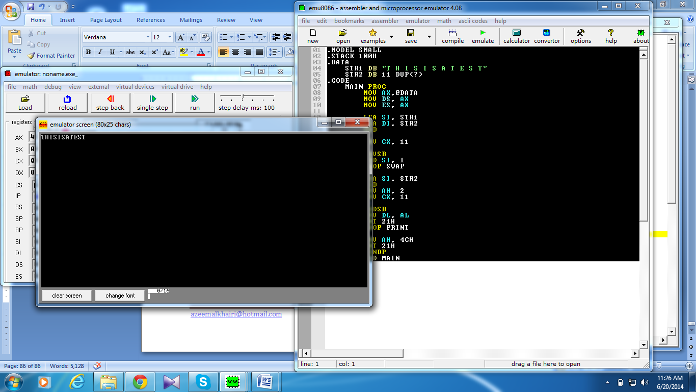  FIND SUBSTRING  .MODEL SMALL  .STACK 100H  .DATA  MSG1 DB "ENTER sUB STRING",10,13,"$"  MSG2 DB 10,13,"ENTER MAIN STRING ",10,13,"$"  MAINST DB 80 DUP (0)  SUBST DB 80 DUP (0)  STOP DW ? ;LAST PLACE TO BEGIN SEARCH  START DW ? ;PLACE TO RESUME SEARCH  SUB_LEN DW ?  YESMSG DB 10,13,"SUBSTRING IS IN MAIN STRING $"  NOMSG DB 10,13,"SUBSTRING IS NOT IN MAIN STRING $"  .CODE  MAIN PROC  MOV AX,@DATA  MOV DS,AX  MOV ES,AX

Time  Plan  (min) | Contents of Lecture | Lecture  Strategy  (Remarks)
MOV AH,9
LEA DX, MSG1
INT 21H

LEA DI,SUBST
CALL READSTR
MOV SUB_LEN,BX

LEA DX,MSG2
INT 21H

LEA DI,MAINST
CALL READSTR

OR BX,BX
JE NO
CMP SUB_LEN,BX
JG NO
LEA SI,SUBST
LEA DI,MAINST
CLD
MOV STOP,DI
ADD STOP,BX
MOV CX,SUB_LEN
SUB STOP,CX

MOV START,DI
REPEAT:
;MOV CLEN
MOV DI,START
LEA SI,SUBST
REPE CMPSB
JE YES

INC START

MOV AX,START
CMP AX,STOP
JNLE NO
JMP REPEAT
YES:
LEA DX,YESMSG
JMP DISPLAY
NO:
LEA DX,NOMSG
DISPLAY:
MOV AH,9
INT 21H

Time  Plan  (min) | Contents of Lecture | Lecture  Strategy  (Remarks)
MOV AH,4CH
INT 21H
MAIN ENDP

READSTR PROC
PUSH AX
PUSH DI

CLD
XOR BX,BX
MOV AH,1
INT 21H

WHILE:
CMP AL,13
JE END_WHILE

CMP AL,8
JNE ELSE

DEC DI
DEC BX
JMP READ

ELSE:
STOSB
INC BX

READ:
INT 21H
JMP WHILE

END_WHILE:
POP DI
POP AX
RET

READSTR ENDP
END MAIN

Time  Plan  (min) | Contents of Lecture | Lecture  Strategy  (Remarks)
10  mins | 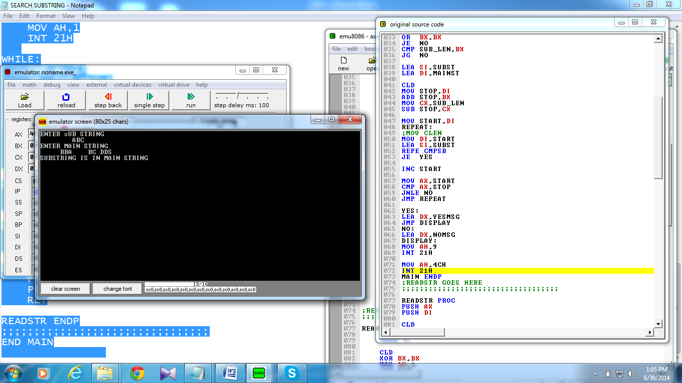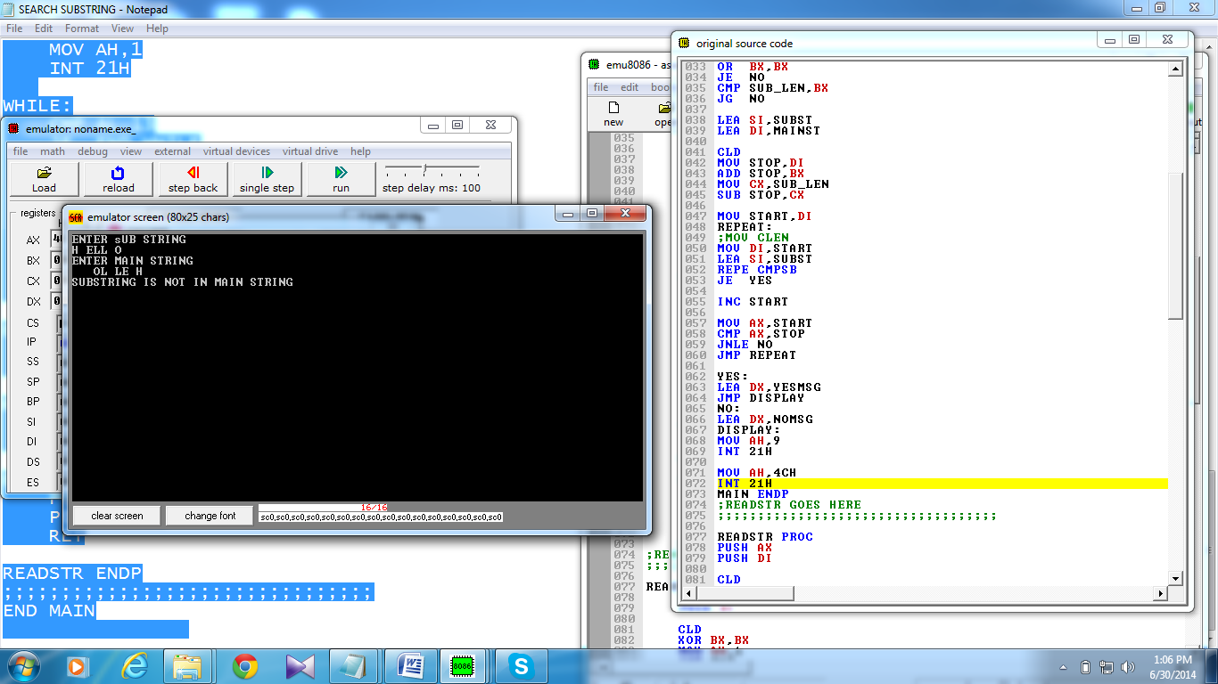  NO OF CONSONENTS AND VOWELS  .MODEL SMALL  .STACK 100H  .DATA  PROMPT_1 DB 'Enter a string : $'  PROMPT_2 DB 0DH,0AH,'No. of Vowels = $'  PROMPT_3 DB 0DH,0AH,'No. of Consonants = $'  STRING DB 50 DUP (?)  C_VOWELS DB 'AEIOU'  S_VOWELS DB 'aeiou'  C_CONSONANTS DB 'BCDFGHJKLMNPQRSTVWXYZ'  S_CONSONANTS DB 'bcdfghjklmnpqrstvwxyz'  .CODE  MAIN PROC  MOV AX, @DATA ; initialize DS and ES  MOV DS, AX  MOV ES, AX  LEA DX, PROMPT_1 ; load and display the string PROMPT_1  MOV AH, 9  INT 21H

Time  Plan  (min) | Contents of Lecture | Lecture  Strategy  (Remarks)
20  mins | LEA DI, STRING ; set DI=offset address of variable STRING  CALL READ_STR ; call the procedure READ_STR  XOR DX, DX ; clear DX  LEA SI, STRING ; set SI=offset address of variable STRING  OR BX, BX ; check BX for 0  JE @EXIT ; jump to label @EXIT if BX=0  @COUNT: ; jump label  LODSB ; set AL=DS:SI  LEA DI, C_VOWELS  MOV CX, 5 ; set CX=5  REPNE SCASB ; check AL is capital vowel or not  JE @INCREMENT_VOWELS  LEA DI, S_VOWELS  MOV CX, 5 ; set CX=5  REPNE SCASB ; check AL is small vowel or not  JE @INCREMENT_VOWELS  LEA DI, C_CONSONANTS ; set DI=offset address of variable  MOV CX, 21 ; set CX=21  REPNE SCASB ; check AL is capital consonant or not  JE @INCREMENT_CONSONANTS  LEA DI, S_CONSONANTS  MOV CX, 21 ; set CX=21  REPNE SCASB ; check AL is small consonant or not  JE @INCREMENT_CONSONANTS  JMP @NEXT ; otherwise, jump to label @NEXT  @INCREMENT_VOWELS: ; jump label  INC DL ; increment DL  JMP @NEXT ; jump to label @NEXT  @INCREMENT_CONSONANTS: ; jump label  INC DH ; increment DH  @NEXT: ; jump label  DEC BX ; decrement BX  JNE @COUNT ; jump to label @COUNT while BX!=0  @EXIT: ; jump label

Time  Plan  (min) | Contents of Lecture | Lecture  Strategy  (Remarks)
MOV CX, DX ; set CX=DX
LEA DX, PROMPT_2 ; load and display the string PROMPT_2
MOV AH, 9
INT 21H

XOR AX, AX ; clear AX
MOV AL, CL ; set AL=CL
CALL DECOUT ; call the procedure OUTDEC

LEA DX, PROMPT_3 ; load and display the string PROMPT_3
MOV AH, 9
INT 21H

XOR AX, AX ; clear AX
MOV AL, CH ; set AL=CH

CALL DECOUT ; call the procedure OUTDEC

MOV AH, 4CH ; return control to DOS
INT 21H
MAIN ENDP
INCLUDE D:\READ_STR.ASM
INCLUDE D:\DECOUT.ASM
END MAIN

