H. M. Faisal (03455275108) Computer Organization and Assembly Language (CS-530)

Lesson Plan 12

Objectives: The main objectives are: (a) Macros; (b) Macro Definition and Invocation; (c) Label Conflict;
(d) Macros and Procedures.

Content: This lecture will cover Macros and label conflict along with different examples. A macro is a
block of text that has been given a name when MASM encounters the name during assembly, it
inserts the block into the program. The text may consist of instructions, pseudo-ops, comments,
or references to other macros.

Methods: For every new topic, I will first provide the definition and the basic working, then I will request some student to come to the board and with the help of class discussion repeat that discussion. This process will not only give them confidence, but will also clear their idea and encourage them to openly discuss any complications with this topic.

Resources: Besides the lecture handout, this lesson will draw from the following Text books: Assembly Language Programming and Organization of the IBM-PC, Ytha Yu and Charles Marut.

Evaluation: In this lecture I will not be using any formal evaluation process. I will be using informal techniques to monitor if the students have absorbed the material or not: (i) By making the students step up to the board and solve some examples. (iii) By judging the class interaction, which is a clear indicator of their interest.

Assignment: Give them a home assignment on programming practices.

Time  Plan  (min) | Contents of Lecture | Lecture  Strategy  (Remarks)
20 mins | - Macro Definition and Invocation  A macro is a block of text that has been given a name. when MASM encounters the name during assembly, it inserts the block into the program. The text may consist of instructions, pseudo-ops, comments, or references to other macros.  The syntax of macro definition is:  Macro_name MACRO d1, d2, . . . dn  Statements  ENDM  Example:  Define a macro to move a word into a word.  Solution:  MOVW WORD1, WORD2  PUSH WORD2  POP WORD1  ENDM  To use a macro in a program, we invoke it. The syntax is  Macro_name a1, a2, … an  Where a1, a2, … an is a list of actual arguments. When MASM encounters the macro name, it expands the macro; that is, it copies the macro statements into the program at the position of invocation, just as if the user had typed them in. as it copies the statements, MASM replaces each dummy argument di by the corresponding actual argument ai and creates the machine code for any instructions.  Example:  Invoke the macro MOVW to move B to A, where A and B are word variables.  Solution:  MOV A, B  To expand this macro, MASM would copy the macro statements into the program at the position of the call, replacing each occurrence of WORD1 by A, and WORD2 by B. The result is:  PUSH B  POP A  In expanding a macro, the assembler simply substitutes the character strings defining the actual arguments for the corresponding dummy ones. For example, the following calls to the MOVW macro:  MOVW A, DX and MOVW A+2, B

Time  Plan  (min) | Contents of Lecture | Lecture  Strategy  (Remarks)
20  Mins  10  mins | Cause the assembler to insert this code into the program:  PUSH DX and PUSH B  POP A POP A+2  - Label conflict:  A macro with a loop or decision structure contains one or more labels. If such a macro is Invoked more than once In a program, a duplicate label appears, resulting in an assembly error: This problem can be avoided by using local labels In the macro. To declare them, we use the LOCAL pseudo-op, whose syntax is:  LOCAL list_of _ labels  Where list_of_labels is a list of labels, separated by commas. Every time the macro is expanded, MASM assigns different symbols to the lab('!s in the list.  The LOCAL directive must appear on the next line after the MACRO statement.  - Macros and Procedures:  - Procedures are called while Macros are expanded.  - Procedure call generates a jump statement. (Branch with saving return address), while there is no jump in Macros.  - In Macros, program size may increase while Procedure this is not the case.  It is recommended that small codes should be handled by Macro while large code may by handled by Procedures.  Exercise:  MACROS  .MODEL SMALL  PRINT MACRO A,B  MOV CX, A  MOV DL, B  MOV AH, 2  DISP:  INT 21H  LOOP DISP  ENDM  .STACK 100H  .CODE  MAIN PROC  MOV BX, 10  MOV AH, '*'  PRINT BX, AH  MOV AH, 4CH  INT 21H  MAIN ENDP  END MAIN  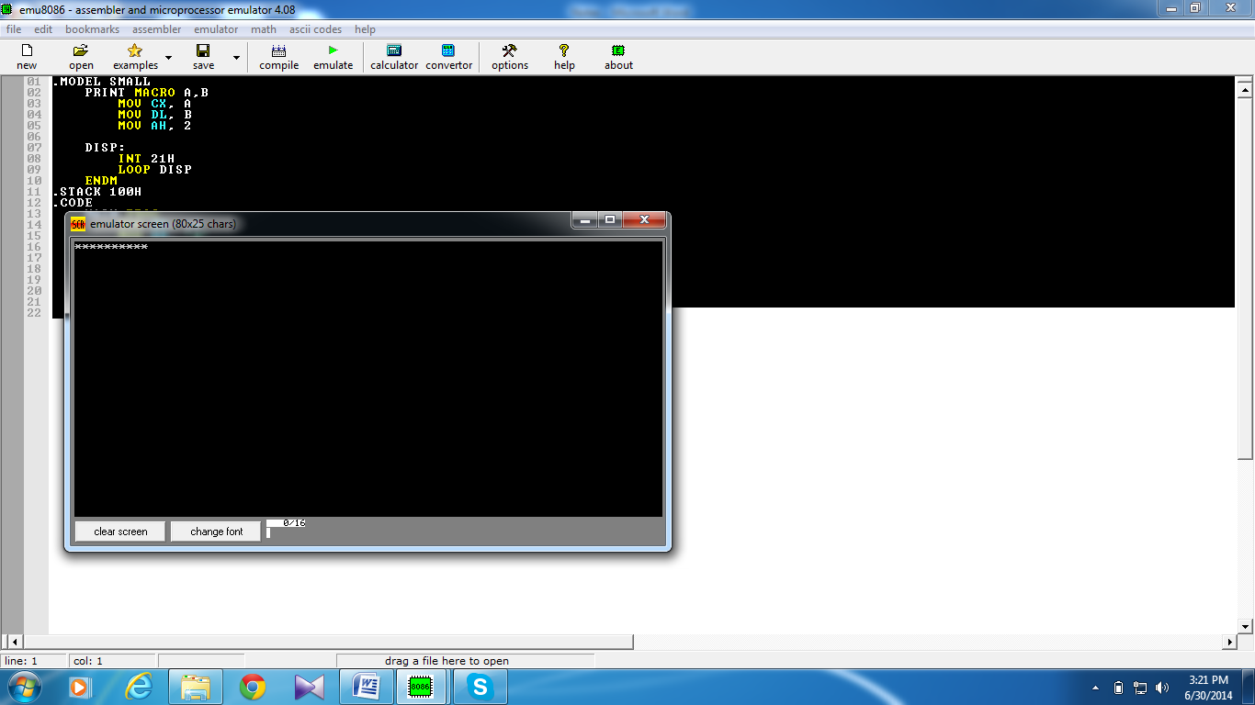

Time  Plan  (min) | Contents of Lecture | Lecture  Strategy  (Remarks)
20  mins  20  mins | MACROS 1  .MODEL SMALL  PRINT MACRO A,B  MOV CX, A  MOV DL, B  MOV AH, 2  DISP:  INT 21H  LOOP DISP  ENDM  .STACK 100H  .CODE  MAIN PROC  PRINT 10, '*'  MOV AH, 4CH  INT 21H  MAIN ENDP  END MAIN  LABEL CONFLICT (MACROS)  .MODEL SMALL  MAX MACRO WORD1,WORD2  LOCAL EXIT  MOV AX, WORD1  CMP AX, WORD2  JG EXIT  MOV AX, WORD2  EXIT:  ENDM  .STACK 100H  .DATA  MSG DB "OK$"  .CODE  MAIN PROC  MOV AX, @DATA  MOV DS, AX

Time  Plan  (min) | Contents of Lecture | Lecture  Strategy  (Remarks)
MOV BX, 10
MOV AH, '*'
MAX 30, 25
JMP EXIT

EXIT:
LEA DX, MSG
MOV AH, 9
INT 21H

MOV AH, 4CH
INT 21H
MAIN ENDP
END MAIN
