H. M. Faisal (03455275108) Computer Organization and Assembly Language (CS-530)

Lesson Plan 13

Objectives: The main objectives are: (a) Inline Assembly.

Content: The inline assembler is a feature of some compilers that allows very low level code written
in assembly to be embedded in a high level language. In this lecture inline assembly along with
different programming examples will be covered.

Methods: For every new topic, I will first provide the definition and the basic working, then I will request some student to come to the board and with the help of class discussion repeat that discussion. This process will not only give them confidence, but will also clear their idea and encourage them to openly discuss any complications with this topic.

Resources: Besides the lecture handout, this lesson will draw from the following Text books: Assembly Language Programming and Organization of the IBM-PC, Ytha Yu and Charles Marut.

Evaluation: In this lecture I will not be using any formal evaluation process. I will be using informal techniques to monitor if the students have absorbed the material or not: (i) By making the students step up to the board and solve some examples. (iii) By judging the class interaction, which is a clear indicator of their interest.

Assignment: Give them a home assignment on programming practices.

Time  Plan  (min) | Contents of Lecture | Lecture  Strategy  (Remarks)
20 mins | The inline assembler is a feature of some compilers that allows very low level code written in assembly to be embedded in a high level language.  Exercise:  Factorial  #include "stdafx.h"  #include <windows.h>  #include <iostream>  using namespace std;  int fact(int num);  int _tmain(int argc, _TCHAR* argv[])  {  int n;  char c='y';  do{  system("cls");  cout<<"Enter Number for factorial : ";  cin>>n;  cout<<endl<<fact(n)<<endl;  cout<<"Enter Again (y/n) ? : ";  cin>>c;  }  while(c=='y' || c=='Y');  system("pause");  return 0;  }  int fact( int num)  {  int x;  __asm  {  mov eax, 1  mov ecx,num  z:  mul ecx  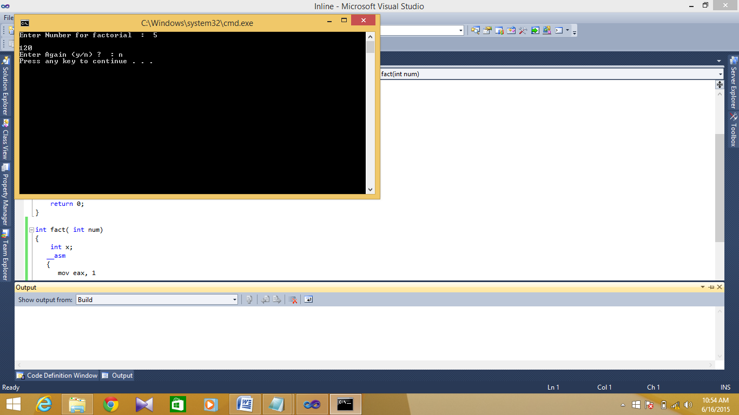  loop z  mov x,eax  }  return x;  }

Time  Plan  (min) | Contents of Lecture | Lecture  Strategy  (Remarks)
25  mins | Power of a number  #include "stdafx.h"  #include <windows.h>  #include <iostream>  using namespace std;  int power(int az,int bz);  int _tmain(int argc, _TCHAR* argv[])  {  int a,b;  char c='y';  do{  system("cls");  cout<<"Number = ";  cin>>a;  cout<<"power = ";  cin>>b;  cout<<a<<"^"<<b<<" = "<<power(a,b)<<endl;  cout<<"\n\nEnter Again (y/n) ? : ";  cin>>c;  }  while(c=='y' || c=='Y');  system("pause");  return 0;  }  int power(int az,int bz)  {  int x;  __asm  {  mov eax, az  mov ebx,az  mov ecx,bz  dec ecx  z:  mul ebx;  loop z  mov x,eax  }  return x;  }  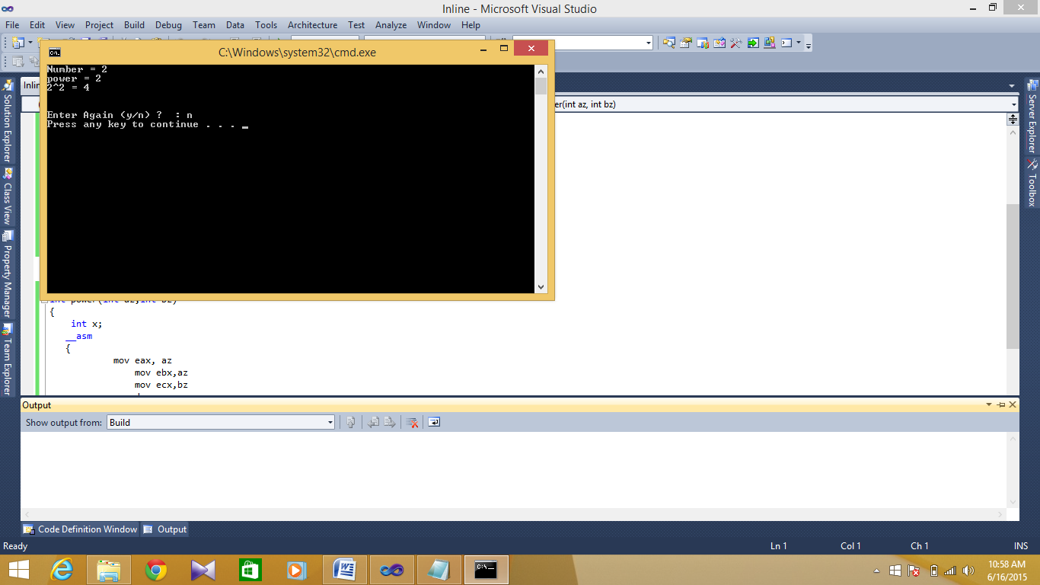

Time  Plan  (min) | Contents of Lecture | Lecture  Strategy  (Remarks)
25  mins | Arithmetic Operations (Inline Assembly)  #include "stdafx.h"  #include <windows.h>  #include <iostream>  using namespace std;  int addition(int a,int b);  int subtraction(int a,int b);  int multiplication(int a,int b);  int division(int a,int b);  int _tmain(int argc, _TCHAR* argv[])  {  int choice, fn,sn;  char a='y';  do  {  system("cls");  cout<<"Enter 1 for addition\nEnter 2 for Subtraction\nEnter 3 for Multiplication\nEnter 4 for Division\n";  cout<<"Enter your choice : ";  cin>>choice;  cout<<"\n\nEnter 1st number : ";  cin>>fn;  cout<<"Enter 2nd number : ";  cin>>sn;  switch(choice)  {  case 1:  cout<<"Addition of "<<fn<<" and "<<sn<<" is = "<<addition(fn,sn);  break;  case 2:  cout<<"Subtraction of "<<fn<<" and "<<sn<<" is = "<<subtraction(fn,sn);  break;  case 3:  cout<<"Multiplication of "<<fn<<" and "<<sn<<" is = "<<multiplication(fn,sn);  break;  case 4:  cout<<"Division of "<<fn<<" and "<<sn<<" is = "<<division(fn,sn);  break;  default:  cout<<"You enter wrong Operator";  break;  }  cout<<"\n\nDo you want to try again (Y/N) ? : ";

Time  Plan  (min) | Contents of Lecture | Lecture  Strategy  (Remarks)
10  mins | cin>>a;  }  while(a=='y' || a=='Y');  return 0;  }  int addition(int a,int b)  {  int x;  __asm  {  mov eax,a  add eax,b  mov x,eax  }  return x;  }  int subtraction(int a,int b)  {  int x;  __asm  {  mov eax,a  sub eax,b  mov x,eax  }  return x;  }  int multiplication(int a,int b)  {  int x;  __asm  {  mov eax,a  mov ebx,b  mul ebx  mov x,eax  }  return x;  }

Time  Plan  (min) | Contents of Lecture | Lecture  Strategy  (Remarks)
10  mins | int division(int a,int b)  {  int x;  __asm  {  xor edx, edx  mov eax, a  div b  mov x,eax  }  return x;  }  