H. M. Faisal (03455275108) Computer Organization and Assembly Language (CS-530)

Lesson Plan 14

Objectives: The main objective is: (a) Recursion.

Content: In this lecture recursion will be covered. A recursive procedure is one that calls itself. There are
two kind of recursion: direct and indirect. In direct recursion, the procedure calls itself and in
indirect recursion, the first procedure calls a second procedure, which in turn calls the first
procedure.

Methods: For every new topic, I will first provide the definition and the basic working, then I will request some student to come to the board and with the help of class discussion repeat that discussion. This process will not only give them confidence, but will also clear their idea and encourage them to openly discuss any complications with this topic.

Resources: Besides the lecture handout, this lesson will draw from the following Text books: Assembly Language Programming and Organization of the IBM-PC, Ytha Yu and Charles Marut.

Evaluation: In this lecture I will not be using any formal evaluation process. I will be using informal techniques to monitor if the students have absorbed the material or not: (i) By making the students step up to the board and solve some examples. (iii) By judging the class interaction, which is a clear indicator of their interest.

Assignment: Give them a home assignment on programming practices.

Time  Plan  (min) | Contents of Lecture | Lecture  Strategy  (Remarks)
25 mins | A recursive procedure is a procedure that calls itself. Recursive procedures are important in high-level languages, but the way the system uses the stack to implement these procedures is hidden from the programmer. In - assembly language, the programmer must actually program the stack operations. So this provides, an opportunity to see how recursion really works.  Example:  Addition of positive natural numbers  - 1 + 2 + 3 + . . . + n  .MODEL SMALL  .STACK 100H  .CODE  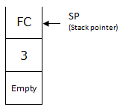  MAIN PROC  ;CALL DECIN  MOV AX, 3  PUSH AX  CALL ADDITION  CALL DECOUT  MOV AH, 4CH  INT 21H  MAIN ENDP  ADDITION PROC  PUSH BP  MOV BP, SP  CMP WORD PTR[BP + 4], 1  JG END_IF  MOV AX, 1  JMP RETURN  END_IF:  MOV CX, [BP + 4]  DEC CX  PUSH CX  CALL ADDITION  ADD AX, WORD PTR[BP + 4]

Time  Plan  (min) | Contents of Lecture | Lecture  Strategy  (Remarks)
10  mins | 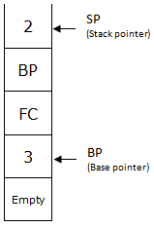  First Pass  RETURN:  POP BP  RET 2  ADDITION ENDP  INCLUDE D:\DECIN.ASM  INCLUDE D:\DECOUT.ASM  MAIN ENDP  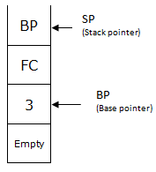  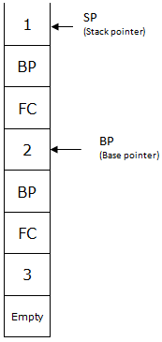

Time  Plan  (min) | Contents of Lecture | Lecture  Strategy  (Remarks)
20  mins | Examples:  Factorial  .MODEL SMALL  .STACK 100H  .CODE  MAIN PROC  ;CALL DECIN  MOV AX, 5  PUSH AX  CALL FACTORIAL  CALL DECOUT  MOV AH, 4CH  INT 21H  MAIN ENDP  FACTORIAL PROC  PUSH BP  MOV BP, SP  CMP WORD PTR[BP + 4], 1  JG END_IF  MOV AX, 1  JMP RETURN  END_IF:  MOV CX, [BP + 4]  DEC CX  PUSH CX  CALL FACTORIAL  ADD AX, WORD PTR[BP + 4]  ;MUL WORD PTR[BP + 4]  RETURN:  POP BP  RET 2  FACTORIAL ENDP  INCLUDE D:\DECIN.ASM  INCLUDE D:\DECOUT.ASM  MAIN ENDP

Time  Plan  (min) | Contents of Lecture | Lecture  Strategy  (Remarks)
20  mins | Searching  .MODEL SAMLL  .STACK 100H  .DATA  Max DW 3, 5, 2, 4  .CODE  MAIN PROC  MOV AX, @DATA  MOV DS, AX  MOV AX, 4  PUSH AX  CALL Find_Max  CALL DECOUT  MOV AH, 4CH  INT 21H  MAIN ENDP  Find_Max PROC  PUSH BP  MOV BP, SP  CMP WORD PTR[BP+4], 1  JG ELSE_  MOV AX, Max  JMP END_IF  ELSE_:  MOV CX, [BP+4]  DEC CX  PUSH CX  CALL Find_Max  MOV BX, [BP+4]  SHL BX, 1  SUB BX, 2  CMP Max[BX], AX  JGE END_IF  MOV AX, Max[BX]  END_IF:  POP BP  RET 2  Find_Max ENDP  INCLUDE D:\DECOUT.ASM  MAIN ENDP

