H. M. Faisal (03455275108) Computer Organization and Assembly Language (CS-530)

Lesson Plan 3

Objectives: (a) Register (b) Data Register (c) Segment Register (d) Pointer and index Register
(e) Flag Register

Content: In this lecture we will study detailed working of these topics: Register, Data Register, Address Registers and status Registers.

A register is a small bit of memory that sits inside the CPU and is used by assembly language to perform various tasks.

The 8086 has four general data registers the address registers are divided into segment, pointer
And index registers and the status register is called the FLAGS register.

Methods: For every new topic, I will first provide the definition and the basic working, then I will request some student to come to the board and with the help of class discussion repeat that discussion. This process will not only give them confidence, but will also clear their idea and encourage them to openly discuss any complications with this topic.

Resources: Besides the lecture handout, this lesson will draw from the following Text books: Assembly Language Programming and Organization of the IBM-PC, by Ytha Yu and Charles Marut.

Evaluation: In this lecture I will not be using any formal evaluation process. I will be using informal techniques to monitor if the students have absorbed the material or not: (i) By making the students step up to the board and solve some examples. (iii) By judging the class interaction, which is a clear indicator of their interest.

Assignment: Give them a home assignment questions related to physical address and segment numbers.

Time  Plan  (min) | Contents of Lecture | Lecture  Strategy  (Remarks)
15 mins | - Registers  The registers are classified according to the functions they perform In general data registers hold data for an operation, address registers hold the address of an instruction or data and status registers keeps the current status of the processor.  The 8086 has four general data registers the address registers are divided into segment, pointer and index registers and the status register is called the FLAGS register.  - Data Registers:  Four register are available to the programmer for general data Manipulation. The high and low bytes of the data registers can be accessed separately. The high byte of AX is called AH and the low byte is AL. Similarly, the high and low bytes of BX, CX, and DX are BH and BL, CH and CL, DH and DL respectively.  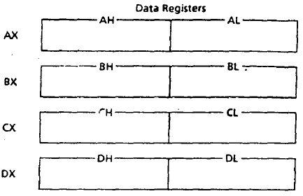

Time  Plan  (min) | Contents of Lecture | Lecture  Strategy  (Remarks)
10  Mins  10  Mins | AX (Accumulator Register):  AX is the preferred register to use in arithmetic, logic, and transfer instructions. In multiplication and division operations, one of the numbers involved must be in AX or AL. AX is 16 bit register.  BX (Base Register):  BX also serves as an address register; an example is a table look-up Instruction called XLAT (translate).  CX (Count Register):  CX serves as a loop counter. Another example of using CX as counter is REP (repeat), which controls a special class of instructions called string operation.  DX (Data Register):  DX Is used in multiplication and division. It is also used in I/0 Operations.  - Segment Registers:  In assembly 4 segments are:  CS (code segment)  DS (data segment)  SS (stack segment)  ES (extra segment)  The registers CS, DS, SS and ES. A typical machine language program consists of instructions (code) and data. There is also a data structure called the stack used by the processor to implement procedure calls. The program's code, data, and stack are loaded into different memory segments, we call them the code segment, data segments, and stack segment.  The CS, DS, and SS registers contain the code, data, and stack Segment numbers, respectively. If a program needs to access a second data segment, it can use the ES (extra segment) register.

Time  Plan  (min) | Contents of Lecture | Lecture  Strategy  (Remarks)
15  mins | 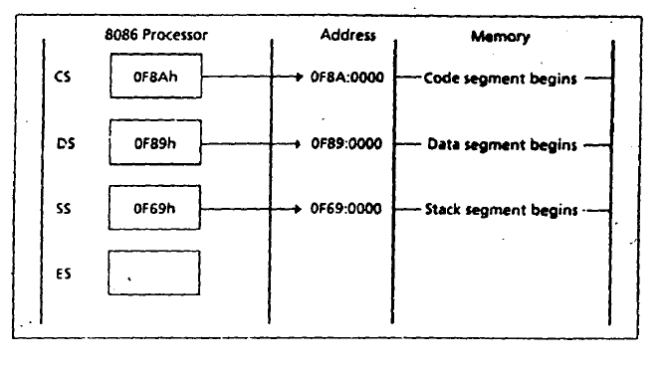  - Pointer and Index Registers:  The registers SP, BP, SI, and DI normally point to (contain the offset addresses of) memory locations.  SP (Stack Pointer):  The SP (stack pointer) register is used in conjunction with SS for accessing the stack segment.  BP (Base Pointer):  The BP (base pointer) register is used primarily to access data on the stack. However, unlike SP, we can also use BP to access data in the other segments.  SI (Source index):  The SI (source index) register is used to point to memory locations in the data segment addressed by DS. By incrementing the contents of SI, We can easily access Consecutive memory locations.  DI (Destination Index):  The DI (destination Index) register performs the same functions as SI. There is a class of instructions, called string operations that use DI to access memory locations addressed by ES.

Time  Plan  (min) | Contents of Lecture | Lecture  Strategy  (Remarks)
20  mins | - Memory Segment:  A memory segment is a block of (or 64k) consecutive memory Bytes. Each segment is identified by a segment number, starting with 0. A segment number is 16 bits, so the highest segment number is FFFFh.  Segment: Offset Address:  A memory location may be specified by providing a segment number and an offset, written in the form Segment: Offset; this is known as a logical address.  For example: A4FB:4872h means offset 4872h within segment A4FBh.To obtain a 20-bit physical address. The 8086 microprocessor first shifts the segment address 4 bits to the left (this is equivalent to multiplying by l0h), and then adds the offset. Thus the physical address for A4FB:4872 is:  A4FB0h  + 4872h  A9822h (20-bit physical address)  Example: For the memory location, whose physical address is specified by 1256Ah, give the address in segment: offset form for segments 1256h and 1240h.  Solution: Let X be the offset in segment 1256h and Y the offset in segment 1240h. We have:  1256Ah = 12560h + X and 1256Ah = l2400h + y  And so  X = l256Ah - 12560h = Ah and Y = 1256Ah - 12400h = l6Ah  Thus  1256Ah =1256:000A = 1240:016A

Time  Plan  (min) | Contents of Lecture | Lecture  Strategy  (Remarks)
20  mins | Exercise:  - For the memory location whose physical address is specified 1256Ah, give the address in segment: offset form or segments 1256h and 1240h.  Ans: 1256Ah=1256:0000A=1240:0016A  - A memory location has physical address 80FD2h. In what segment does it have offset BFD2h?  Ans: 7500h  - Determine the physical address of a memory location given by 0A51:CD90h.  Ans: physical address= 172A0  - A memory location has physical address 4A37Bh. Compute  - The offset address if the segment number is 40FFh.  Ans: offset= 0938B  - The segment number if the offset address is 123Bh.  Ans: Segment number=4914h
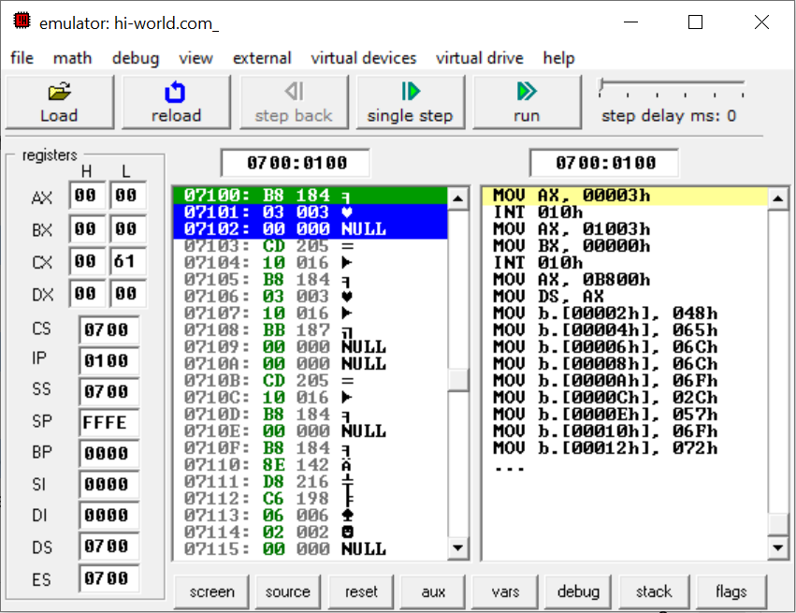
Load
- Loads an .ASM / .COM program into memory.
Reload
- Reloads the same program from the beginning.
Single Step
- Executes one instruction at a time.
- Best for learning how CPU executes instructions step-by-step.
Run
- Runs the whole program continuously.
Step Delay
- Adds delay between instructions (for observation).
Left Panel – Registers (CPU State)
This shows CPU registers (small storage inside CPU).
General Purpose Registers
Register | Meaning | Use
AX | Accumulator | Math, I/O
BX | Base | Addressing
CX | Counter | Loops
DX | Data | I/O, math
Each has H (high byte) and L (low byte).

Segment Registers
Register | Purpose
CS | Code segment (where instructions are)
DS | Data segment (where data is)
SS | Stack segment
ES | Extra segment

Pointer & Index Registers
Register | Purpose
IP | Instruction Pointer (current instruction)
SP | Stack Pointer
BP | Base Pointer
SI | Source Index
DI | Destination Index
These values show current CPU condition, like a live X-ray.

Middle Panel – Memory View (Hex + ASCII)
Example:
07100: B8 03 00
- 07100 → Memory address
- B8 → Machine code (opcode)
- 03 00 → Operand (data)
- Rightmost shows ASCII if printable, else NULL
This is actual RAM content.

Right Panel – Disassembled Instructions
This is the human-readable version of memory.
Example:
MOV AX, 0003h
INT 10h
Meaning:
- Load value 0003h into AX
- Call BIOS interrupt 10h (screen services)
This shows what CPU understands and executes

Highlighted Instruction (Green / Yellow)
- Green: Current instruction being executed
- Yellow: Decoded instruction view
Together they answer:
“What instruction is CPU executing right now?”

Bottom Tabs
Tab | Purpose
Screen | Output screen (text mode display)
Source | Assembly source code
Reset | Restart execution
Aux | Emulator utilities
Vars | Variables
Debug | Breakpoints
Stack | Stack memory
Flags | CPU flags

- General-Purpose Registers (16-bit)
Used for data manipulation, math, and addressing
Register | Type | Why it is used | Example (Usage)
AX | Accumulator | Fast arithmetic, I/O, BIOS calls | mov ax, 3 (video mode)
BX | Base | Base address for memory access | mov bx, 0 (BIOS parameter)
CX | Counter | Loop counter | mov cx, 12 / loop c
DX | Data | Extra data, I/O ports | mov dx, 03F8h (COM port)

Split Registers (8-bit)
Register | Use
AH / AL | High / Low byte of AX
BH / BL | High / Low byte of BX
CH / CL | High / Low byte of CX
DH / DL | High / Low byte of DX

Why split?
Allows byte-level operations.
Example:
mov ah, 0
int 16h

- Segment Registers (16-bit)
Used to divide memory into segments
Register | Type | Why it is used | Example
CS | Code Segment | Holds program instructions | Auto used by CPU
DS | Data Segment | Points to data memory | mov ds, ax
SS | Stack Segment | Stack operations | Used by push/pop
ES | Extra Segment | Extra data access | String operations

Example from code
mov ax, 0b800h
mov ds, ax
Makes DS point to video memory

- Pointer Registers
Used to track locations in memory or stack
Register | Type | Why it is used | Example
IP | Instruction Pointer | Address of next instruction | Auto updated
SP | Stack Pointer | Top of stack | Used by push
BP | Base Pointer | Stack frame access | Function parameters

Example:
push ax
pop ax

- Index Registers
Used for arrays, loops, string operations
Register | Type | Why it is used | Example
SI | Source Index | Source pointer | String copy
DI | Destination Index | Destination pointer | VGA memory loop
From Ref. Base Hello-World program
mov di, 03h
add di, 2
Used to jump between color bytes.

- Flag Register (Status Register)
Controls program decisions and CPU state
Flag | Purpose | Set When
ZF | Zero Flag | Result = 0
CF | Carry Flag | Carry/borrow
SF | Sign Flag | Negative result
OF | Overflow Flag | Overflow
IF | Interrupt Enable | Interrupts enabled
DF | Direction | String direction
Example:
loop c
Uses ZF & CX internally.

- Control / Special Registers (Internal)
Register | Purpose
IP | Controls instruction flow
Flags | Controls CPU behavior
(Not directly editable like others)

- Register Usage in Assembly Program (Ref. Base Hello World Example)
Register | How used
AX | Video mode, color control
BX | BIOS configuration
CX | Loop counter
DI | VGA memory pointer
DS | Video memory segment

- One-Page Exam Summary (Very Important)
8086 registers are divided into general-purpose, segment, pointer, index, and flag registers.
They enable data processing, memory addressing, program control, and decision making in assembly programs.

