H. M. Faisal (03455275108) Computer Organization and Assembly Language (CS-530)

Lesson Plan 4

Objectives: The main objectives are: (a) Field; (b) Program Data; (c) Variables; (d) A Few Basic Instructions.

Content: These are important topic in COAL. Nearly all problems that student face about such topics will clear in this lecture by detailed studying.
In this lecture we will study detailed working of these topics: Field, Program Data, Variables, A Few Basic Instructions.
I will provide information about fields like name field, operation field, operand field and comment field. Then we will discuss about Variables (Byte, Word) and Basic Instructions.

Methods: For every new topic, I will first provide the definition and the basic working, then I will request some student to come to the board and with the help of class discussion repeat that discussion. This process will not only give them confidence, but will also clear their idea and encourage them to openly discuss any complications with this topic.

Resources: Besides the lecture handout, this lesson will draw from the following Text books: Assembly Language Programming and Organization of the IBM-PC, Ytha Yu and Charles Marut.

Evaluation: In this lecture I will not be using any formal evaluation process. I will be using informal techniques to monitor if the students have absorbed the material or not: (i) By making the students step up to the board and solve some examples. (iii) By judging the class interaction, which is a clear indicator of their interest.

Assignment: Give them a home assignment related to instructions.

Time  Plan  (min) | Contents of Lecture | Lecture  Strategy  (Remarks)
10 mins | Fields:  - Name Field:  The name field is used for instruction labels, procedure names, and variable names. The assembler translates names into memory addresses.  Names can be from 1 to 31 characters long. And may commits of letters, digits, and the special character ? . @ _ $ %. Embedded blanks are not allowed. If a period is used, it must be the first char. Names may not begin with a digit. The assembler does not differentiate between upper and lower case in a name.  Examples of legal names  COUNTER1  @CHARACTER  SUM_OF_DIGITS  $1000  DONE?  .TEST  Examples of illegal names  TWO WORDS contain a blank  2ABC begin with a digit  A45.28 . not first character  YOU&ME contains an illegel character  Operation Field:  The assembler translates a symbolic opcode into a machine language opcode. Opcode symbols often describe the operation's function;  For example:  MOV, ADD, SUB.  Operand Field:  The operand field specifies the data that are to be acted on by the operation. An instruction may have zero, one, or two operands. For example:  NOP no operands. Does nothing  INC AX one operand. Adds, 1 to the contents  of AX  ADD WORDl,2 Two operands; adds 2 to the contents  of memory word WORDl  In a two, operand instruction, the first operand is the destination operand. It is the register or memory location where the result is stored (note: some instructions don't store the result). The second operand is the source operand.

Time  Plan  (min) | Contents of Lecture | Lecture  Strategy  (Remarks)
10  mins | Comment Field:  A semicolon marks the beginning of this field, and the assembler ignores anything typed after the semicolon. Comments are optional, but because assembly language is so low-level, it is almost impossible to understand an assembly language program without comments.  MOV CX, 0 ; move 0 to CX  Instead, use comments to put the instruction into the context of the program:  MOV CX.0 ; CX counts terms, initially 0  It is also permissible to make an entire line a comment, and use them to create space in a program:  ;  ; initialize registers  ;  MOV AX, 0  MOV BX, 0  - Program Data:  In an assembly language program, we may express data as binary, decimal, or hex numbers, and even as characters.  Numbers:  A binary number is written as a bit string followed by the letter "R" or "b"; for example: 1010B.  A decimal number is a string of decimal digits, ending with an optional "D" or "d".  A hex number must begin with a decimal digit and end with the letter "H" or "h"; for example, 0ABCH (the reason for this is that the assembler would be unable to tell whether a symbol such as "ABCH" represents the variable name "ABCH" or the hex number ABC). Any of the preceding numbers may have an optional sign.  Here are examples of legal and illegal numbers for MASM:  Number Type  11011 decimal  11011B binary  64223 decimal  -21843D decimal  1,234 illegal – contains a non digit  Character  1B4DH hex  1B4D illegal hex number–doesn’t end in  H  FFFFH illegal hex number – doesn’t being  with a decimal digit  0FFFFH hex

Time  Plan  (min) | Contents of Lecture | Lecture  Strategy  (Remarks)
10  mins | - Character:  Characters and character strings must be enclosed in single or double quotes: for example, "A" or 'hello'.  - Variables:  Byte Variables:  The assembler directive that defines a byte variable takes the following form:  name DB initial_value  Where the pseudo-op DB stands for "Define Byte".  For example:  ALPHA DB 4  This directive causes the assembler to associate a memory byte with the name ALPHA, and initialize it to 4. A question mark (“?") used in place of an initial value sets aside an uninitialized byte; for example:  BYT DB ?  Word Variables:  The assembler directive for defining a word variable has the following form:  name DW initial_value  The pseudo-op DW means "Define Word." For example:  WRD DW -2  The decimal range of Initial values that can be specified is -32768 to 32767 for a signed interpretation, or 0 to 65535 for an unsigned interpretation.  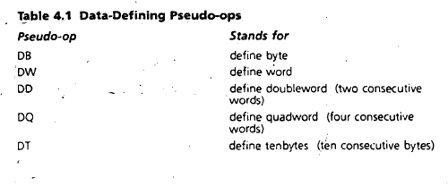

Time  Plan  (min) | Contents of Lecture | Lecture  Strategy  (Remarks)
5  mins | Array:  An array is just a sequence of memory bytes or words. For example, to define a three-byte array called B_ARRAY, whose initial values are 10h, 20h, and 30h, we can write:  B_ARRAY DB 10H, 20H, 30H  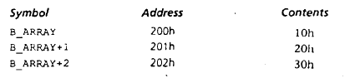  - A Few Basic Instructions:  MOV and XCHG:  The MOV Instruction is used to transfer data between register, between a register and a memory location, or to move a number directly into a register or memory location. The syntax is:  MOV destination, source  Here are some examples:  MOV AX, WORDl  MOV AX, ’A’  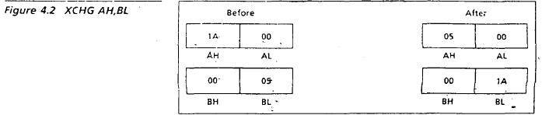

Time  Plan  (min) | Contents of Lecture | Lecture  Strategy  (Remarks)
10  mins | 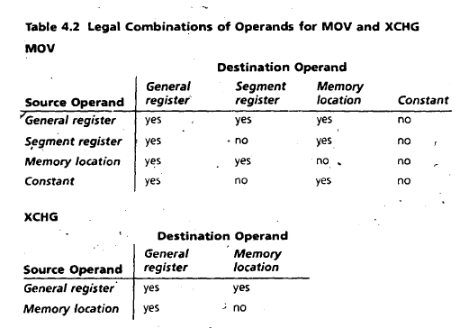  The XCHG (exchange) operation is used to exchange the contents of two registers, or a register and a memory location. The syntax is:  XCHG destination, source  An example is:  XCHG AH, BL  Restrictions on MOV and XCHG:  For technical reasons, there may a few restrictions on the use of MOV and XCHG. Table 4.2 shows the allowable combinations. For example,  ILLEGAL: MOV WORD1, WORD2  But we can get around this restriction by using a register:  MOV AX, WORD2  MOV WORD1, AX

Time  Plan  (min) | Contents of Lecture | Lecture  Strategy  (Remarks)
5  mins | Programming Practice  - Write instructions (not a complete program) to do the following.  - Read a character, and display it at the next position on the same line.  MOV AH, 1  INT 21H  MOV DL, AL  INT 21H  - Read an uppercase letter (omit error checking), and display it at the next position on the same line in lower case.  MOV AH, 1  INT 21H  MOV BL, AL  ADD BL, 32  MOV AH, 2  MOV DL, BL  INT 21H

Time  Plan  (min) | Contents of Lecture | Lecture  Strategy  (Remarks)
5  mins | - Write a Program to (a) display a “?”, (b) read two decimal digits whose sum is less than 10, (c) display them and their sum on the next line, with an appropriate message.  Sample execution:  ?27  THE SUM OF 2 AND 7 IS 9  .MODEL SMALL  .STACK 100H  .DATA  MSG1 DB "?$"  MSG2 DB 10,13,"THE SUM OF $"  MSG3 DB " AND $"  MSG4 DB " IS $"  .CODE  MAIN PROC  MOV AX, @DATA  MOV DS, AX  MOV AH, 9  LEA DX, MSG1  INT 21H  MOV AH, 1  INT 21H  MOV BL, AL  MOV AH, 1  INT 21H  MOV CL, AL  MOV AH, 9  LEA DX, MSG2  INT 21H

Time  Plan  (min) | Contents of Lecture | Lecture  Strategy  (Remarks)
5  mins | MOV AH, 2  MOV DL, BL  INT 21H  MOV AH, 9  LEA DX, MSG3  INT 21H  MOV AH, 2  MOV DL, CL  INT 21H  MOV AH, 9  LEA DX, MSG4  INT 21H  ADD BL, CL  SUB BL, 48  MOV AH, 2  MOV DL, BL  INT 21H  MOV AH, 4CH  INT 21H  ENDP MAIN  END MAIN  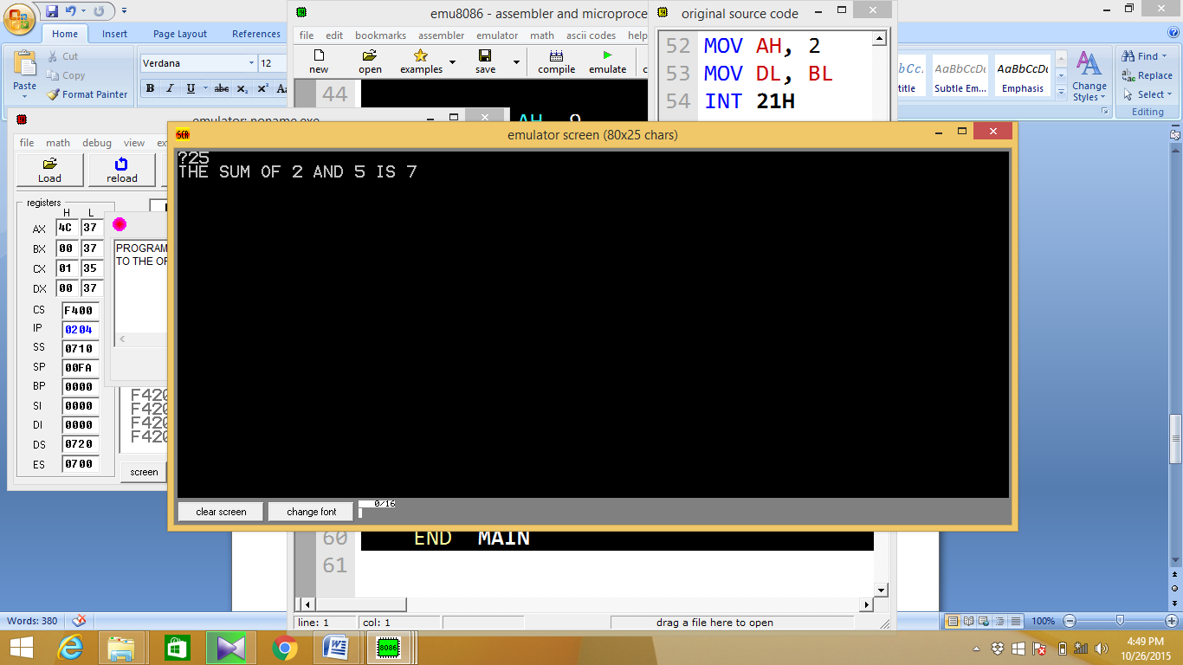

Time  Plan  (min) | Contents of Lecture | Lecture  Strategy  (Remarks)
5  mins | - Write a program to (a) prompt the user, (b) read first, middle, and last initials of a person’s name, and (c) display them down the left margin.  Sample execution:  ENTER THREE INITIALS: JFK  J  F  K  .MODEL SMALL  .STACK 100H  .DATA  MSG1 DB "ENTER THREE INITIALS: $"  MSG2 DB 10,13,"$"  .CODE  MAIN PROC  MOV AX, @DATA  MOV DS, AX  MOV AH, 9  LEA DX, MSG1  INT 21H  MOV AH, 1  INT 21H  MOV BL, AL  MOV AH, 1  INT 21H  MOV CL, AL  MOV AH, 1  INT 21H  MOV CH, AL

Time  Plan  (min) | Contents of Lecture | Lecture  Strategy  (Remarks)
5  Mins | MOV AH, 9  LEA DX, MSG2  INT 21H  MOV AH, 2  MOV DL, BL  INT 21H  MOV AH, 9  LEA DX, MSG2  INT 21H  MOV AH, 2  MOV DL, CL  INT 21H  MOV AH, 9  LEA DX, MSG2  INT 21H  MOV AH, 2  MOV DL, CH  INT 21H  MOV AH, 4CH  INT 21H  ENDP MAIN  END MAIN  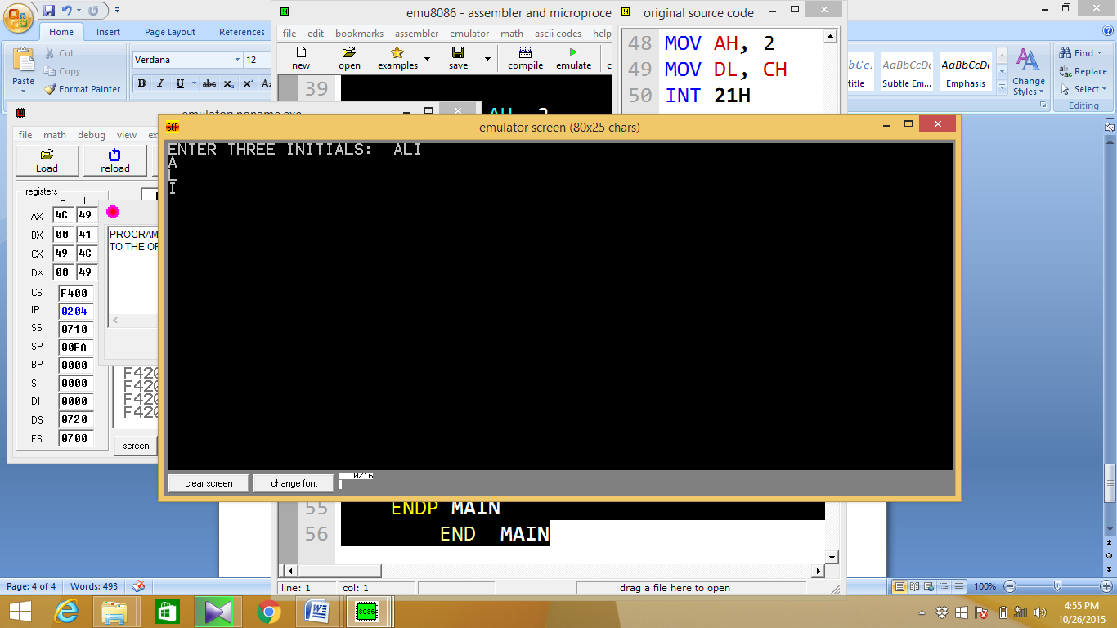

Time  Plan  (min) | Contents of Lecture | Lecture  Strategy  (Remarks)
5  mins | - Write a program to read one of the hex digits A-F; and display it on the next line in decimal. Sample execution:  ENTER A HEX DIGIT: C  IN DECIMAL IT IS 12  .MODEL SMALL  .STACK 100H  .DATA  MSG1 DB "ENTER A HEX DIGIT: $"  MSG2 DB 10,13,"IN DECIMAL IT IS 1$"  .CODE  MAIN PROC  MOV AX, @DATA  MOV DS, AX  MOV AH, 9  LEA DX, MSG1  INT 21H  MOV AH, 1  INT 21H  MOV BL, AL  SUB BL, 17  MOV AH, 9  LEA DX, MSG2  INT 21H  MOV AH, 2  MOV DL, BL  INT 21H  MOV AH, 4CH  INT 21H  ENDP MAIN  END MAIN  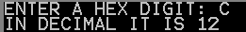

Time  Plan  (min) | Contents of Lecture | Lecture  Strategy  (Remarks)
5  mins | - Write a program to display at 10 x 10 solid box of asterisks.  Hint: declare a string in the data segment that specifies the box, and display it with INT 21h, function 9h.  .MODEL SMALL  .STACK 100H  .DATA  MSG1 DB "**********$"  MSG2 DB 10,13,"**********$"  .CODE  MAIN PROC  MOV AX, @DATA  MOV DS, AX  MOV AH, 9  LEA DX, MSG1  INT 21H  LEA DX, MSG2  INT 21H  INT 21H  INT 21H  INT 21H  INT 21H  INT 21H  INT 21H  INT 21H  INT 21H  MOV AH, 4CH  INT 21H  ENDP MAIN  END MAIN  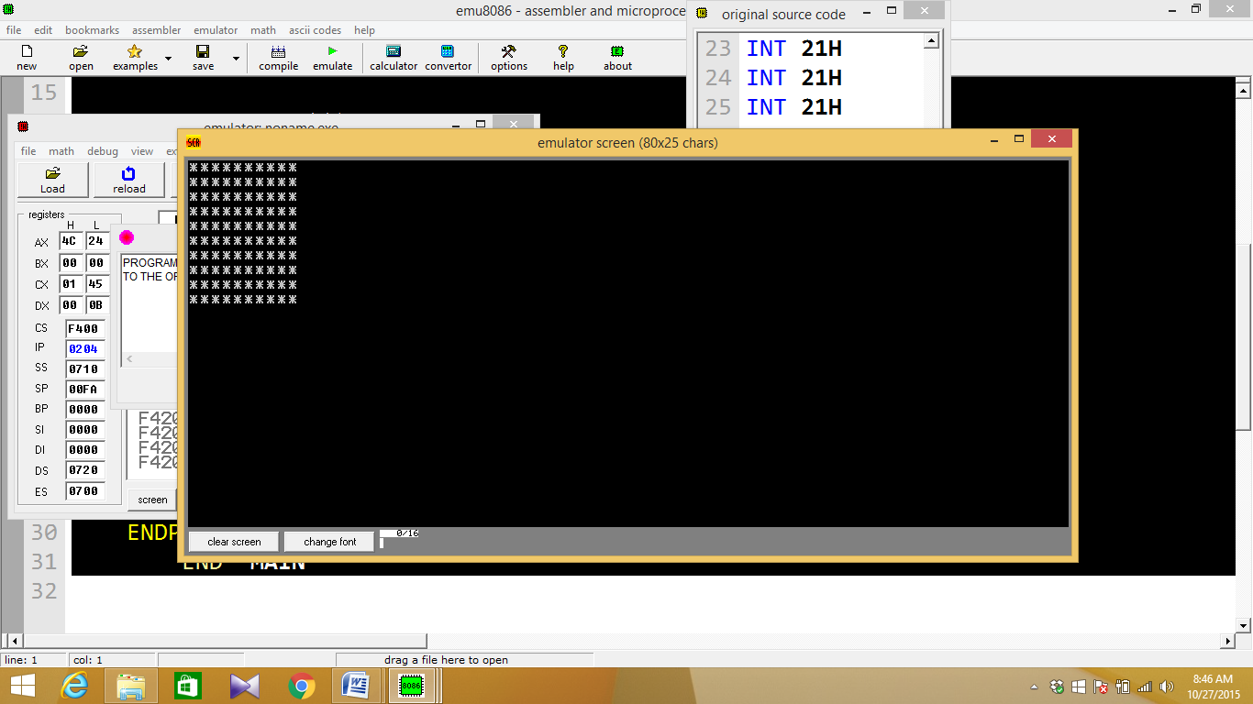

Time  Plan  (min) | Contents of Lecture | Lecture  Strategy  (Remarks)
5  mins | - Write a program to (a) display “?”, (b) read three initials, (c) display them in the middle of an 11 x 11 box of asterisks, and (d) beep the computer.  .MODEL SMALL  .STACK 100H  .DATA  MSG1 DB 10,13,"***********$"  MSG2 DB 10,13,"$"  MSG3 DB "?$"  MSG4 DB "****$"  .CODE  MAIN PROC  MOV AX, @DATA  MOV DS, AX  MOV AH, 9  LEA DX, MSG3  INT 21H  MOV AH, 1  INT 21H  MOV BL, AL  INT 21H  MOV CL, AL  INT 21H  MOV CH, AL  MOV AH, 9  LEA DX, MSG1  INT 21H  INT 21H  INT 21H  INT 21H  INT 21H  MOV AH, 9  LEA DX, MSG2  INT 21H  LEA DX, MSG4  INT 21H

Time  Plan  (min) | Contents of Lecture | Lecture  Strategy  (Remarks)
5  mins | MOV AH, 2  MOV DL, BL  INT 21H  MOV DL, CL  INT 21H  MOV DL, CH  INT 21H  MOV AH, 9  LEA DX, MSG4  INT 21H  LEA DX, MSG1  INT 21H  INT 21H  INT 21H  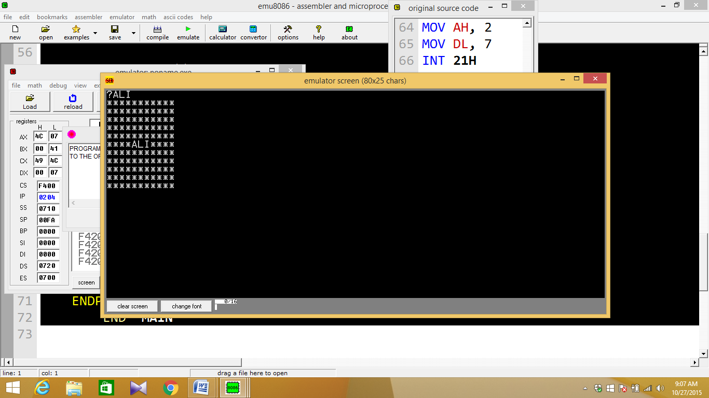  INT 21H  INT 21H  MOV AH, 2  MOV DL, 7  INT 21H  MOV AH, 4CH  INT 21H  ENDP MAIN  END MAIN

Time  Plan  (min) | Contents of Lecture | Lecture  Strategy  (Remarks)
5  mins | Print the followings patterns with and without using data segment.  PROGRAM NO 1  .MODEL SMALL  .STACK 100H  .DATA  N DB "*"  .CODE  MAIN PROC  MOV AX,@DATA  MOV DS,AX  MOV DL,'*'  MOV AH,2  INT 21H  MOV DL,'*'  MOV AH,2  INT 21H
  ******  ******  ****** | *  **  *** | *  **  *** | *  **  ***

Time  Plan  (min) | Contents of Lecture | Lecture  Strategy  (Remarks)
5  mins | MOV DL,'*'  MOV AH,2  INT 21H  MOV DL,'*'  MOV AH,2  INT 21H  MOV DL,'*'  MOV AH,2  INT 21H  MOV DL,'*'  MOV AH,2  INT 21H  MOV DL,'*'  MOV AH,2  INT 21H  MOV AH,2  MOV DL,10  INT 21H  MOV AH,2  MOV DL,13  INT 21H  MOV AH,2  MOV DL,10  INT 21H  MOV AH,2  MOV DL,13  INT 21H

Time  Plan  (min) | Contents of Lecture | Lecture  Strategy  (Remarks)
5  mins | MOV DL,'*'  MOV AH,2  INT 21H  MOV DL,'*'  MOV AH,2  INT 21H  MOV DL,'*'  MOV AH,2  INT 21H  MOV DL,'*'  MOV AH,2  INT 21H  MOV DL,'*'  MOV AH,2  INT 21H  MOV DL,'*'  MOV AH,2  INT 21H  MOV AH,2  MOV DL,10  INT 21H  MOV AH,2  MOV DL,13  INT 21H  MOV AH,2  MOV DL,10  INT 21H  MOV AH,2  MOV DL,13  INT 21H  MOV DL,'*'  MOV AH,2  INT 21H

Time  Plan  (min) | Contents of Lecture | Lecture  Strategy  (Remarks)
MOV AH,2
INT 21H

MOV DL,'*'
MOV AH,2
INT 21H

MOV DL,'*'
MOV AH,2
INT 21H

MOV DL,'*'
MOV AH,2
INT 21H

MOV AH,4CH

INT 21H

MAIN ENDP
END MAIN

OUTPUT:

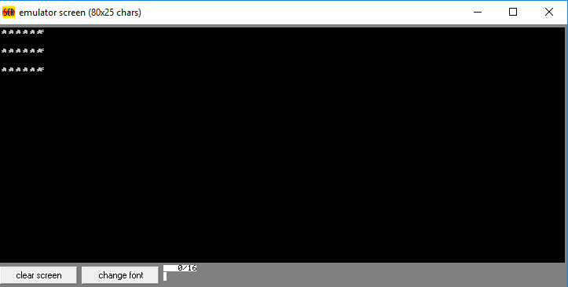

Time  Plan  (min) | Contents of Lecture | Lecture  Strategy  (Remarks)
PROGRAM NO 2
.MODEL SMALL
.STACK 100H
.DATA
N DB "*"

.CODE
MAIN PROC
MOV AX,@DATA
MOV DS,AX

MOV DL,'*'
MOV AH,2
INT 21H

MOV AH,2
MOV DL,10
INT 21H

MOV AH,2
MOV DL,13
INT 21H

MOV AH,2
MOV DL,10
INT 21H

MOV AH,2

Time  Plan  (min) | Contents of Lecture | Lecture  Strategy  (Remarks)
MOV DL,'*'
MOV AH,2
INT 21H

MOV DL,'*'
MOV AH,2
INT 21H

MOV AH,2
MOV DL,10
INT 21H

MOV AH,2
MOV DL,13
INT 21H

MOV AH,2
MOV DL,10
INT 21H

MOV AH,2
MOV DL,13
INT 21H

MOV DL,'*'
MOV AH,2
INT 21H

MOV DL,'*'
MOV AH,2
INT 21H

MOV DL,'*'
MOV AH,2
INT 21H

MOV AH,4CH
INT 21H

MAIN ENDP
END MAIN

Time  Plan  (min) | Contents of Lecture | Lecture  Strategy  (Remarks)
OUTPUT:

PROGRAM NO 3
.MODEL SMALL
.STACK 100H
.DATA
N DB "*"
.CODE
MAIN PROC
MOV AX,@DATA
MOV DS,AX

MOV AH,2
MOV DL,'*'
INT 21H

Time  Plan  (min) | Contents of Lecture | Lecture  Strategy  (Remarks)
MOV AH,2
MOV DL,10
INT 21H

MOV AH,2
MOV DL,10
INT 21H

MOV AH,2
MOV DL,'*'
INT 21H

MOV AH,2
MOV DL,'*'
INT 21H

MOV AH,2
MOV DL,10
INT 21H

MOV AH,2
MOV DL,10
INT 21H

MOV AH,2
MOV DL,'*'
INT 21H

MOV AH,2
MOV DL,'*'
INT 21H

MOV AH,2
MOV DL,'*

Time  Plan  (min) | Contents of Lecture | Lecture  Strategy  (Remarks)
MOV AH,2
MOV DL,'*'
INT 21H

MOV AH,2
MOV DL,'*'
INT 21H

MOV AH,2
MOV DL,'*'
INT 21H

MOV AH,4CH
INT 21H

MAIN ENDP
END MAIN

OUTPUT:

