H. M. Faisal (03455275108) Computer Organization and Assembly Language (CS-530)

Lesson Plan 5

Objectives: The main objectives are: (a) The Flag Register; (b) Over Flow; (c) How instructions affect the flags; (d) The Debug Program.

Content: This lecture will cover the flag registers, Overflow and Debug Program. The FLAGS register is the status register in Intel x86 microprocessors that contains the current state of the processor. The DEBUG program provides an environment in which a program may be tested. The user can step through a program and display and change the registers and memory. After status, parity, carry, auxiliary, zero flag and overflow (signed, unsigned) we will proceed to some examples.

Methods: For every new topic, I will first provide the definition and the basic working, then I will request some student to come to the board and with the help of class discussion repeat that discussion. This process will not only give them confidence, but will also clear their idea and encourage them to openly discuss any complications with this topic.

Resources: Besides the lecture handout, this lesson will draw from the following Text books: Assembly Language Programming and Organization of the IBM-PC, Ytha Yu and Charles Marut.

Evaluation: In this lecture I will not be using any formal evaluation process. I will be using informal techniques to monitor if the students have absorbed the material or not: (i) By making the students step up to the board and solve some examples. (iii) By judging the class interaction, which is a clear indicator of their interest.

Assignment: Give them a home assignment related to flags.

Time  Plan  (min) | Contents of Lecture | Lecture  Strategy  (Remarks)
10 mins | - FLAGS REGISTER :  The status flags are located in bits 0, 2, 4, 6, 7, and 11 and the control flags are located in bit 8, 9, and 10. The other bits have no significance.  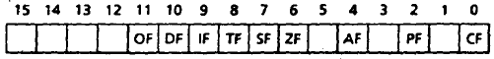  The Status Flags:  As stated earlier, the processor uses the status flags to reflect the result of an operation. For example, If SUB AX, AX is executed, the zero flag becomes 1, thereby Indicating that a zero result was produced. Now let's get to know the status flags.  Carry Flag (CF):  CF = 1 if there is a carry out from the most significant bit (MSB) on addition, or there is a borrow into the MSB on subtraction; otherwise, it is 0. CF is also affected by shift and rotates instructions.  Parity Flag (PF):  PF = 1 If the low byte of a result has an even number of one bits (even parity). It Is 0 if the low byte has, odd parity. For example, if the result of a word addition is FFFEh, then the low byte contains 7 one bits, so PF = 0.  Auxiliary Carry Flag (AF):  AF = 1 if there is a carry out from bit 3 on addition, or a borrow into bit 3 on subtraction. AF is used in binary-coded decimal (BCD) operations.  Zero Flag (ZF):  ZF = 1 for a zero result, and ZF = 0 for a nonzero result.  Sign Flag (SF):  SF = 1 if the MSB of a result is 1; it means the result is negative if you are giving a signed interpretation. SF = 0 if the MSB is 0.

Time  Plan  (min) | Contents of Lecture | Lecture  Strategy  (Remarks)
5  mins | 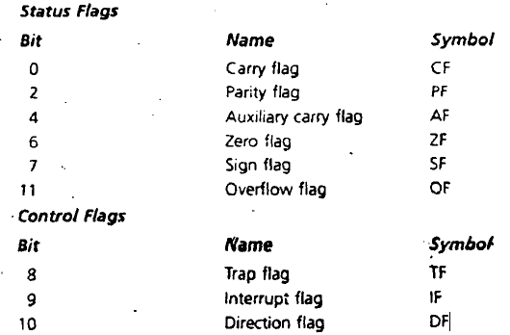  Overflow Flag (OF):  OF = 1 if signed overflow occurred, otherwise it is 0. The meaning of overflow is discussed next.  Examples of Overflow:  Signed and unsigned overflows are independent phenomena. When we perform an arithmetic operation such as addition, there are four possible outcomes: (1) no overflow, (2) signed overflow only, (3) unsigned overflow only, and (4) both signed and unsigned overflows.  As an example of unsigned overflow but not signed overflow, suppose AX contains FFFFh, BX contains 0001 h, and ADD AX, BX is executed.  The binary result is  1111 1111 1111 1111  + 0000 0000 0000 0001  1 0000 0000 0000 0000  If we-are giving an unsigned interpretation, the correct answer is 1000h = 65536, but this is out of range for a word operation. A 1 is carried out of the MSB and the answer stored in AX, 0000h, is wrong, so unsigned overflow occurred. But the stored answer is correct as a signed number, for FFFFh = -10001h = 1, and FFFFh + 0001h = -1 + 1 = 0, so signed overflow did not occur.

Time  Plan  (min) | Contents of Lecture | Lecture  Strategy  (Remarks)
10  mins | Unsigned Overflow:  On addition, unsigned overflow occurs when there is a carry out of the MSB. This means that the correct answer is larger than the biggest unsigned number that is, FFFFh for a word and FFh for a byte. On subtraction, unsigned overflow occurs when there is a borrow into the MSB. This means that the correct answer is smaller than 0.  Signed Overflow:  On addition of numbers with the same sign, signed overflow occurs when the sum has a different sign. This happened in the preceding example when we were adding 7FFFh. and 7FFFh (two positive numbers), but got FFFEh. (a negative result)  Subtraction of numbers with different signs is like adding numbers of the same sign. For example, A - ( -B) = A + B and -A -(+B) = -A + -B. Signed overflow occurs if the result has a different sign than expected.  - How Instructions Affect the Flags:  In general, each time the processor executes an instruction, the flags are altered to reflect the result. However, some instructions don't affect any of the flags, affect only some of them, or may leave them undefined. The flags affected as follows:  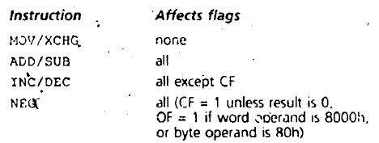  - The DEBUG Program:  The DEBUG program provides an environment in which a program may be tested. The user can step through a program and display and change the registers and memory. It is also possible to enter assembly code directly, which DEBUG converts to machine code and stores in memory.

Time  Plan  (min) | Contents of Lecture | Lecture  Strategy  (Remarks)
5  mins | 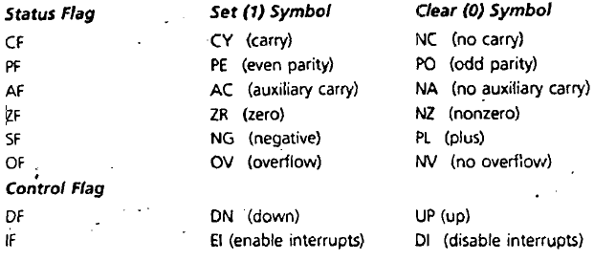  Exercise:  - For each of the following instructions, give the new destination contents and the new setting of CF, SF, ZF, PF, and OF. Suppose that the flags are initially 0 in each part of this question.  - ADD AX, BX Where AX contains 7FFFh and BX contains 0001h  0111 1111 1111 1111  + 0000 0000 0000 0001  ──────────────────────  1000 0000 0000 0000  AF=1,CF=0,PF=1,SF=1,ZF=0,OF=1  - SUB AL, BL Where AL contains 01h and BL contains FFh  0111 0111  - 0000 0001  ─────────────  0111 0110  AF=0, PF=0,SF=0,ZF=0,CF=0,OF=0  - DEC AL Where AL contains 00h  00, +(-1)=>  TAKE 2`S COMPLIMENT:1111 1111  ADD:0000 0000 + 1111 1111  =1111 1111  AF=1,CF=0,ZF=0,SF=1,OF=0,PF=1

Time  Plan  (min) | Contents of Lecture | Lecture  Strategy  (Remarks)
10  mins | - NEG AL Where AL contains 7Fh  0111 1111  TAKE 2`S COMPLIMENT  1000 0000+0000 0001=>1000 0001  AF=1, PF=1, CF=1,SF=1,OF=0,ZF=0  - XCHG AX, BX Where AX contains 1ABCh and BX contains 712Ah  After xchange operation:  AX=712Ah, BX=1ABCh  AX=0111 0001 0010  AF=0,PF=0,ZF=0,SF=0,OF=0,CF=0  NO EFFECT ON STATUS FLAGS  - ADD AL, BL Where AL contains 80h and BL contains FFh  1000 0000  +1111 1111  ─────────  10111 1111  AF=0,PF=0,ZF=0,SF=0,OF=1,CF=1  - SUB AX, BX Where AX contains 0000h and BX contains 8000h  AX+(-BX)  TAKING 2`S COMPLIMENT:  1000 0000 0000 0000:  0111 1111 1111 1111+0000 0000 0000 0001  =1000 0000 0000 0000  ADD it with 00h: 1000 0000 0000 0000  AF=0,CF=1,PF=1,SF=1,ZF=0,OF=1,

Time  Plan  (min) | Contents of Lecture | Lecture  Strategy  (Remarks)
10  mins | 2.  a. Suppose that AX and BX both contains positive numbers; and ADD AX, BX is executed. Show that there is a carry into the msb but no carry out of the msb if, and only if, signed overflow occurs.  LET AX=0110,BX=0011  ADD:  0110  +0011  ─────  1001  Here there is a carry in msb but no carry out of the msb.  b. Suppose AX and BX both contain negative numbers, and ADD AX,BX is executed. Show that there is a carry out of the msb but no carry into the msb if, and only if, signed overflow occurs.  LET AX=1011,BX=1000  ADD:  1011  +1000  ─────  10011  Here there is NO carry in msb but Acarry out of the msb.  - Suppose ADD AX, BX is executed. In each of the following parts, the first number being added is the contents of AX, and the second number is the contents of BX. Give the resulting value of AX and tell whether signed or unsigned overflow occurred.  a. 512Ch + 4185h  0101 0001 0010 1100  + 0100 0001 1000 0101  ──────────────────  1001 0000 1011 0001  OF=1 because two positive numbers are adding to give a negative number here.

Time  Plan  (min) | Contents of Lecture | Lecture  Strategy  (Remarks)
10  mins | b. FE12h + 1ACBh  1111 1110 0001 0010  +0001 1010 1100 1011  ───────────────────  1┘0001 1000 1101 1101  Unsigned Overflow Occurred  No Signed Overflow  c.E1E4h + DAB3h  1110 0001 1110 0101  +1101 1010 1011 0011  ───────────────────────  1┘1011 1100 1001 1000  OF=0 because two negative numbers are added give a negative number.  No Signed Overflow  Unsigned Overflow Occured  d.7132h + 7000h  0111 0001 0011 0010  +0111 0000 0000 0000  ──────────────────  1110 0001 0011 0010  OF=1 because two positive numbers add to give positive not a negative number.  Signed Overflow Occured  No Unsigned Overflow  e.6389h + 1176h  0110 0011 1000 1001  + 0001 0100 1111 1111  0111 0100 1111 1111  OF=0 because two positive numbers give positive number by addition.  No signed Overflow  No unsigned Overflow

Time  Plan  (min) | Contents of Lecture | Lecture  Strategy  (Remarks)
10  mins | 4. Suppose SUB AX, BX is executed. In each of the following parts, the first number is the initial contents of AX and the second number is the contents of BX. Give the resulting value of AX and tell whether signed or unsigned overflow occurred.  - 2143h – 1986h  0010 0001 0100 0011  - 0001 1001 1000 0110  ──────────────────  0000 1111 1011 1101  OF=0, because the greater number is positive and the answer has msb 0  No Signed Overflow  No Unsigned Overflow  - 81FEh – 1986h  1000 0001 1111 1110  -0001 1001 1000 0110  ─────────────────  0111 1000 0111 1000  OF =1 because answer was supposed to be negative as –A+(-B)=-C,here its positive.  Signed Overflow Occurred  No Unsigned Overflow  c. 19BCh – 81FEh  19BCh+(-81FEh)  Take compliment of 81FEh and then add. Both numbers  81FEh=1000 0001 1111 1110  Taking 2;s compliment :0111 1110 0000 0010  Now add:  0001 1001 1011 1100  +0111 1110 0000 0010  ──────────────────  1001 0111 1011 1110  OF=1 because two positive numbers add to give positive number
Time  Plan  (min) | Contents of Lecture | Lecture  Strategy  (Remarks)
10  mins | Signed Overflow Occured  No Unsigned Overflow  d.0002h – FE0Fh  FE0Fh=1111 1110 0000 1111  Taking 2;s compliment:  0000 0001 1111 0001  Add:  0000 0000 0000 0010  +0000 0001 1111 0001  ───────────────────  0000 0001 1111 0011  OF=0 because both are positive  No Unsigned Overflow  No Signed Overflow  e.8BCDh – 71Abh  1000 1011 1100 1101  -1111 0001 1010 1011  ──────────────────  0001 1010 0010 0010  OF=1 because both are negative and gives positive number  Signed Overflow  No Unsigned Overflow  5.  ADD AX, BX , where AX contains FFFFh, BX contains FFFFh.  (SF, PF, ZF, CF, OF = ?)  1111 1111 1111 1111  +1111 1111 1111 1111  ────────────────────  1┘1111 1111 1111 1110  ZF=0,PF=0,CF=1,OF=0,SF=1  6.  ADD AL, BL, where AL contains 80h, BL contains 80h.  (SF, PF, ZF, CF, OF = ?)  1000 0000  +1000 0000  ──────────  1┘0000 0000  Sf=0,PF=1,ZF=1,CF=1,OF=1
Time  Plan  (min) | Contents of Lecture | Lecture  Strategy  (Remarks)
10  mins | 7.  SUB AX, BX, where AX contains 8000h and BX contains 0001h.  (SF, PF, ZF, CF, OF = ?)  1000 0000 0000 0000  -0000 0000 0000 0001  ──────────────────  0111 1111 1111 1111  CF=0,ZF=0,SF=0,OF=1,PF=1  8.  INC Al, where AL contains FFh.  (SF, PF, ZF, CF, OF = ?)  1111 1111  +0000 0001  ─────────  1┘0000 0000  CF=0(Carry is unaffected by INC),ZF=1,SF=0,PF=1,OF=0  9.  MOV AX, -5.  (SF, PF, ZF, CF, OF = ?)  Taking 2s compliment:  0101-> 1010+1=1011  CF=0,PF=0,SF=0,ZF=0,OF=0  10.  NEG AX, where AX contains 8000h.  (SF, PF, ZF, CF, OF = ?)  TAKING 2S COMPLIMENT:  1000 0000 0000 0000=> 0111 1111 1111 +1 = 1000 0000 0000 0000  IT’S THE SAME NUMBER so  OF=1,PF=1,CF=1,SF=1,ZF=0

