H. M. Faisal (03455275108) Computer Organization and Assembly Language (CS-530)

Lesson Plan 6

Objectives: The main objectives are: (a) Flow Control; (b) Conditional jumps; (c) The JMP Instruction.

Content: This lecture will cover Flow control, Conditional jump. The jump and loop instructions transfer control to another part of the program. This transfer can be unconditional or can depend on a particular combination of status flag settings. We will cover different programming practices as well.

Methods: For every new topic, I will first provide the definition and the basic working, then I will request some student to come to the board and with the help of class discussion repeat that discussion. This process will not only give them confidence, but will also clear their idea and encourage them to openly discuss any complications with this topic.

Resources: Besides the lecture handout, this lesson will draw from the following Text books: Assembly Language Programming and Organization of the IBM-PC, Ytha Yu and Charles Marut.

Evaluation: In this lecture I will not be using any formal evaluation process. I will be using informal techniques to monitor if the students have absorbed the material or not: (i) By making the students step up to the board and solve some examples. (iii) By judging the class interaction, which is a clear indicator of their interest.

Assignment: Give them a home assignment on programming practices.

Time  Plan  (min) | Contents of Lecture | Lecture  Strategy  (Remarks)
10 mins | - Flow controls:  The jump and loop instructions transfer control to another part of the program. This transfer can be unconditional or can depend on a particular combination of status flag settings.  - Conditional Jumps :  JNZ is an example of a conditional jump instruction.  The syntax is:  JNZ destination_label  - The JMP Instruction:  The JMP (jump) instruction causes an unconditional transfer of control. (Unconditional jump)  The syntax is:  JMP destination  JMP can be used to get around the range restriction of a conditional Jump. For example, suppose we want to implement the following loop:  TOP:  ; body of the loop  DEC CX ; decrement counter  JNZ TOP ; keep looping if CX > 0  MOV AX,BX  IF-THEN-ELSE:  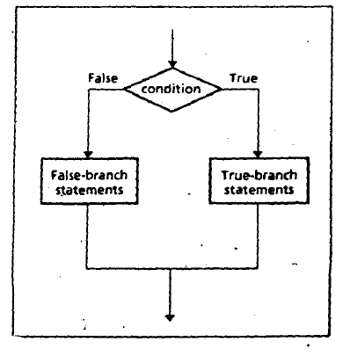

Time  Plan  (min) | Contents of Lecture | Lecture  Strategy  (Remarks)
5  mins | 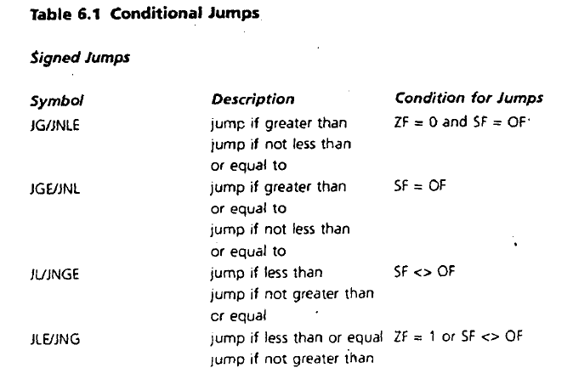  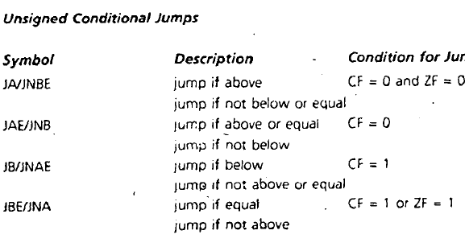

Time  Plan  (min) | Contents of Lecture | Lecture  Strategy  (Remarks)
5  mins | 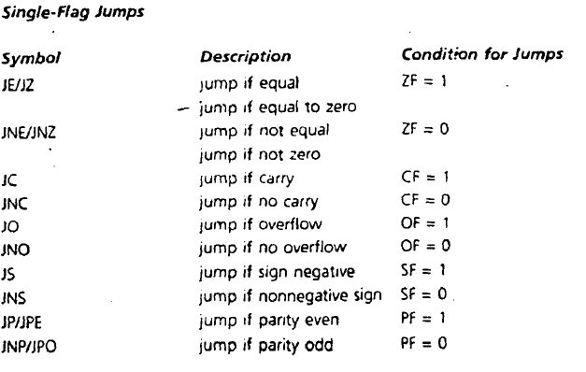

Time  Plan  (min) | Contents of Lecture | Lecture  Strategy  (Remarks)
10  mins | EXAMPLES:  - Read a character, and if it's an uppercase letter, display it.  .MODEL SMALL  .STACK 100H  .CODE  MAIN PROC  MOV AH, 2  MOV DL, "?"  INT 21H  MOV AH, 1  INT 21H  MOV BL, AL  MOV AH,2  MOV DL,10  INT 21H  MOV DL,13  INT 21H  CMP BL,41H  JL ABC  CMP BL,5BH  JGE ABC  MOV AH,2  MOV DL,BL  INT 21H  ABC:  MOV AH,4CH  INT 21H  MAIN ENDP  END MAIN  

Time  Plan  (min) | Contents of Lecture | Lecture  Strategy  (Remarks)
10  mins | - Read a character. If it's "y" or "Y", display it; otherwise, terminate the program.  .MODEL SMALL  .STACK 100H  .CODE  MAIN PROC  MOV AH,2  MOV DL,"?"  INT 21H  MOV AH,1  INT 21H  MOV BL,AL  MOV AH,2  MOV DL,10  INT 21H  MOV DL,13  INT 21H  CMP BL,79H  JE ABC  CMP BL,59H  JE ABC  JMP E  ABC:  MOV AH,2  MOV DL,BL  INT 21H  E:  MOV AH,4CH  INT 21H  MAIN ENDP  END MAIN  

Time  Plan  (min) | Contents of Lecture | Lecture  Strategy  (Remarks)
10  mins | - Write a count-controlled loop to display a row of 80 stars.  .MODEL SMALL  .STACK 100H  .CODE  MAIN PROC  MOV CX,80  MOV AH,2  ABC:  MOV DL,'*'  INT 21H  LOOP ABC  MOV AH,4CH  INT 21H  ENDP MAIN  END MAIN  - Write some code to count the number of characters in n input line.  .MODEL SMALL  .STACK 100H  .DATA  VAR DB 1  .CODE  MAIN PROC  MOV AX,0  MOV AH,1  INT 21H  WHILE_:  CMP AL,13  JE END_WHILE  INC VAR  INT 21H  JMP WHILE_

Time  Plan  (min) | Contents of Lecture | Lecture  Strategy  (Remarks)
10  mins | END_WHILE:  MOV AH,2  MOV DL,10  INT 21H  MOV DL,13  INT 21H  MOV BL,VAR  ADD BL,48  MOV DL,BL  INT 21H  MOV AH,4CH  INT 21H  ENDP MAIN  END MAIN    - Write some code to read characters until a blank is read.  .MODEL SMALL  .STACK 100H  .CODE  MAIN PROC  MOV AH,1  WHILE_:  CMP AL,' '  JE END_WHILE  INT 21H  JMP WHILE_  END_WHILE:  MOV AH,4CH  INT 21H  ENDP MAIN  END MAIN

Time  Plan  (min) | Contents of Lecture | Lecture  Strategy  (Remarks)
10  mins | - Write a program to display the extended ASCII characters (ASCII codes 80h to FFh). Display 10 characters per line, separated by blanks. Stop after the extended characters have been displayed once  .MODEL SMALL  .STACK 100H  .DATA  C10 DB 0D  .CODE  MAIN PROC  MOV AH,2  MOV BL,80H  MOV CL,10  JMP WH  AC:  MOV CL,10  MOV DL,10  INT 21H  MOV DL,13  INT 21H  WH:  MOV DL,BL  INT 21H  INC BL  DEC CL  CMP CL,0  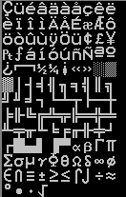  JE AC  CMP BL,0FFH  JE END_WHILE  JMP WH  END_WHILE:  MOV AH,4CH  INT 21H  ENDP MAIN  END MAIN

Time  Plan  (min) | Contents of Lecture | Lecture  Strategy  (Remarks)
10  mins | - Write a program that will prompt the user to enter a hex digit character ("0"· ... "9" or "A" ... "F"), display it on the next line in decimal, and ask the user if he or she wants to do it again. If the user types "y" or "Y", the program repeats; if the user types anything else, the program terminates. If the user enters an illegal character, prompt the user to try again.  Sample execution:  ENTER A HEX DIGIT: 9  IN DECIMAL IS IT 9  DO YOU WANT TO DO IT AGAIN? Y  ENTER A HEX DIGIT: c  ILLEGAL CHARACTER - ENTER 0 - 9 OR A - F: C  IN DECIMAL IT IS 12 DO YOU WANT TO DO IT AGAIN? N  .MODEL SMALL  .STACK 100H  .DATA  MS1 DB "ENTER A HEX DIGIT:$"  MS2 DB 10,13,"IN DECIMAL IT IS: $"  MS5 DB 10,13,"IN DECIMAL IT IS:1 $"  MS3 DB 10,13,"DO YOU WANT TO DO IT AGAIN?: $"  MS4 DB 10,13,"ILLEGAL CHARACTER - ENTER 0 … 9 OR A ... F:$"  COT DB 0  .CODE  MAIN PROC  MOV AX,@DATA  MOV DS,AX  ST:  MOV AH,9  LEA DX,MS1  INT 21H  MOV AH,1  INT 21H  MOV BL,AL  CMP BL,'9'  JLE AA  CMP BL,'A'  JGE BB  JMP CC

Time  Plan  (min) | Contents of Lecture | Lecture  Strategy  (Remarks)
10  mins | AA:  MOV AH,9  LEA DX,MS2  INT 21H  MOV AH,2  MOV DL,BL  INT 21H  JMP EXIT  BB:  CMP BL,'G'  JGE CC  SUB BL,17  MOV AH,9  LEA DX,MS5  INT 21H  MOV AH,2  MOV DL,BL  INT 21H  JMP EXIT  CC:  MOV AH,9  LEA DX,MS4  INT 21H  MOV DL,COT  CMP DL,3  JE END  INC DL  MOV COT,DL  EXIT:  MOV AH,9  LEA DX,MS3  INT 21H  MOV AH,1  INT 21H  MOV CL,AL

Time  Plan  (min) | Contents of Lecture | Lecture  Strategy  (Remarks)
CMP CL,'N'
JE END
JMP ST

END:
MOV AH,4CH
INT 21H
ENDP MAIN
END MAIN

