H. M. Faisal (03455275108) Computer Organization and Assembly Language (CS-530)

Lesson Plan 7

Objectives: The main objectives are: (a) AND, OR and XOR Instructions; (b) NOT Instruction;
(c) TEST instruction; (d) Shift Instructions; (e) Rotate Instructions; (f) Binary and Hex I/O.

Content: This lecture will cover the logical instructions (AND, OR, XOR, NOT). We will see truth tables as well as perform these logic instructions on different examples. Then will proceed to Shift and Rotate instructions with examples. Binary and Hex I/O programming practices will be solved.

Methods: For every new topic, I will first provide the definition and the basic working, then I will request some student to come to the board and with the help of class discussion repeat that discussion. This process will not only give them confidence, but will also clear their idea and encourage them to openly discuss any complications with this topic.

Resources: Besides the lecture handout, this lesson will draw from the following Text books: Assembly Language Programming and Organization of the IBM-PC, Ytha Yu and Charles Marut.

Evaluation: In this lecture I will not be using any formal evaluation process. I will be using informal techniques to monitor if the students have absorbed the material or not: (i) By making the students step up to the board and solve some examples. (iii) By judging the class interaction, which is a clear indicator of their interest.

Assignment: Give them a home assignment on programming practices.

Time  Plan  (min) | Contents of Lecture | Lecture  Strategy  (Remarks)
5 mins | - Logic Instruction:  The truth tables for the logic operators AND, OR, XOR (exclusive OR), and NOT.  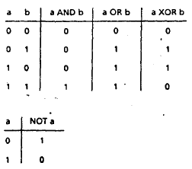  When a logic operation is applied to 8- or 16-bit operands, the result is obtained by applying the logic operation at each bit position.  Example 7.1 Perform the following logic operations:  1. 10101010 AND 11110000  2. 10101010 OR 11110000  3. 10101010 XOR 11110000  4. NOT 101010.10  Solutions:  - 10101010 AND 11110000 = 10100000  2. 10101010 OR 11110000 = 11111010  3. 10101010 XOR 11110000 =01011010  4. NOT 10101010 = 01010101  - AND,OR, and XOR INSTRUCTION:  The AND, OR, and XOR instructions perform the named logic operations.  THE formats are:  AND destination, source  OR destination, source  XOR destination, source  The result of the operation-is stored in the destination, which must be a register or memory location. However, memory-to-memory operations are not allowed.  Effect on Flags:  SF, ZF, PF reflect the result  AF is undefined  CF, OF= 0  If b represents a bit (0 or 1)  b AND 1 = b, b OR 0 = b, b XOR 0 = b  b AND 0 = 0, b OR 1 = 1, b XOR 1 = -b (complement of b)

Time  Plan  (min) | Contents of Lecture | Lecture  Strategy  (Remarks)
5  mins | From these, we may conclude that:  1. The AND instruction can be used to clear specific destination bits while preserving the others. A 0 mask bit clears the corresponding destination bit; a 1 mask bit preserves the corresponding destination bit.  Example:  Clear the sign bit of AL while leaving the other bits unchanged.  Solution:  Use the AND instruction with 01111111b = 7Fh as the mask.  Thus:  AND AL,7Fh  2. The OR instruction can be used to set specific destination bits while preserving the others. A 1 mask bit sets the corresponding destination bit; a 0 mask bit preserves the corresponding destination bit.  Example:  Set the most significant and least significant bits of AL while preserving the other bits.  Solution:  Use the OR instruction with 10000001b = 81h as the mask. Thus:  OR AL, 81h  3. The XOR instruction· can be used to complement specific destination bits while preserving the others. A 1 mask bit complements the corresponding destination bit; a 0 mask bit preserves the corresponding destination bit.  Example:  Change the sign bit of DX.  Solution:  Use the XOR instruction with a mask of 8000h. Thus:  XOR DX, 8000h  - Test Instruction:  The TEST Instruction performs an AND operation of the destination with the source but does not change the destination contents. The purpose of the TEST instruction is to set the status flags. The format is TEST destination, source.  Effect on flags  SF, ZF, PF reflect the result  AF is undefined  CF, OF= 0

Time  Plan  (min) | Contents of Lecture | Lecture  Strategy  (Remarks)
5  mins | Examining Bits:  The TEST instruction can be used to examine individual bits in an operand. The mask should contain 1's In the bit positions to be tested and 0's elsewhere. Because 1 AND b = b, 0 AND b = 0, the result of TEST destination, mask will have l's in the tested bit positions if and only if the destination has l's in these positions; it will have 0's elsewhere. If destination has 0's in all the tested position, the result will be 0 and so ZF = 1.  Example:  Jump to label BELOW if AL contains an even number.  Solution:  Even numbers have a 0 in bit 0. Thus, the mask is 00000001b= 1.  TEST AL, 1 ; is AL even?  JZ BELOW ; yes, go to BELOW  - Shift Instructions:  - Shift Left (SHL):  The SHL (shift left) instruction shifts the bits in the destination to the left. The format for a single shift is SHL destination, 1  A 0 is shifted into the rightmost bit position and the msb is shifted into CF.  Effect on Flags:  SF, PF, ZF reflect the result  AF is undefined  CF= last bit shifted out  OF= 1 if result changes sign on last shift  Example:  Suppose DH contains 8Ah and CL contains 3. What are the values of DH and of CF after the instruction SHL DH, CL is executed?  Solution:  The binary value of DH Is 10001010. After 3 left shifts, CF will contain 0. The new contents of DH may be obtained by erasing the leftmost three bits and adding three zero bits to the right end, thus:  01010000b = 50h.  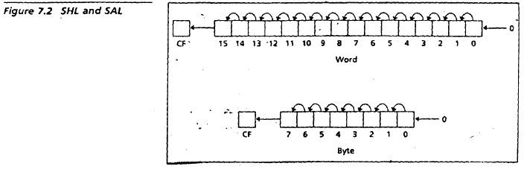

Time  Plan  (min) | Contents of Lecture | Lecture  Strategy  (Remarks)
5  mins | - Shift Arithmetic Left (SAL):  Same as SHL  Example:  Write some code to multiply the value of AX by 8. Assume that overflow will not occur.  Solution:  To multiply by 8, we need to do three left shifts.  MOV CL, 3 ;number of shifts to do  SAL AX, CL ;multiply by 8  - Shift Right (SHR):  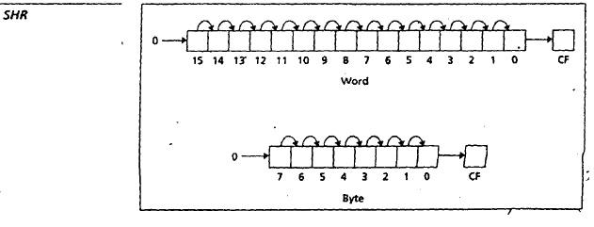  The instruction SHR (shift right) performs right shifts on the destination operand. The format for a single shift is  SHR destination, 1  A 0 Is shifted Into the msb position, and the rightmost bit Is shifted into CF. See Figure. If the shift count N is different from 1, the instruction takes the form  SHR destination, CL  Where CL contains N. In this case N single right shifts are made. The effect on the flags is the same as for SHL.  - Shift Arithmetic Right (SAR):  The SAR Instruction (shift arithmetic right) operates like SHR, with one difference: the msb retains its original value. See Figure. The syntax is  SAR destination, 1  And SAR destination, CL  The effect on flags is the same as for SHR.

Time  Plan  (min) | Contents of Lecture | Lecture  Strategy  (Remarks)
5  mins | 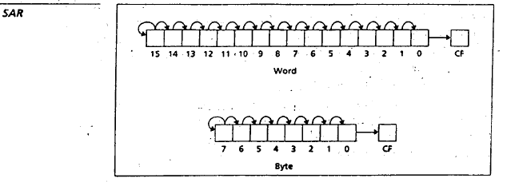  - Rotate Instructions:  - Rotate Left (ROL):  The instruction ROL (rotate left) shifts bits to the left. The msb is shifted into the rightmost bit. The CF also gets the bit shifted out of the msb. You can think of the destination bits forming a circle, with the least significant bit following the msb in the circle. See Figure. The syntax is:  ROL destination, 1  and ROL destination, CL  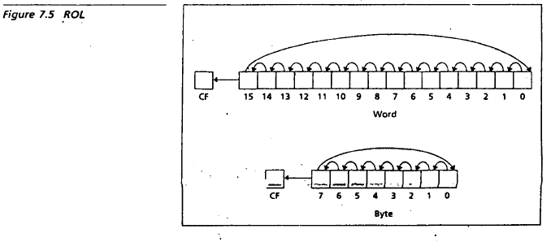  - Rotate Right (ROR):  The instruction ROR (rotate right) works just like ROL, except that the bits are rotated to the right. The rightmost bit is shifted into the msb, and also into the CF. See Figure. The syntax is:  ROR destination, 1  And ROR destination, CL

Time  Plan  (min) | Contents of Lecture | Lecture  Strategy  (Remarks)
5  mins | 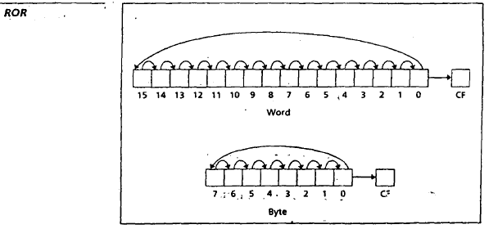  - Rotate Carry Left (RCL):  The Instruction RCL (Rotate through Carry Left) shifts the bits of the destination to the left. The msb is shifted Into the CF, and the previous value of CF is shifted into the rightmost bit. In other words, RCL works like just like ROL, except that CF is part of the circle of bits being rotated. See Figure. The syntax is:  RCL destination, 1  and RCL destination, CL  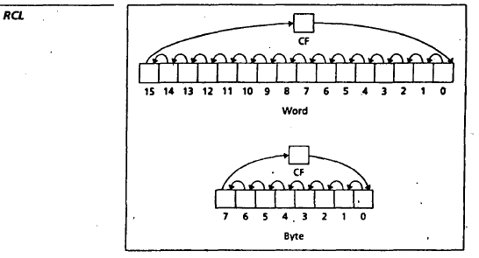  - Rotate Carry Right (RCR):  The instruction RCR (Rotate through Carry Right) works just like RCL, except that the bits are rotated to the right See Figure. The syntax is:  RCR destination, 1  And RCR destination, CL

Time  Plan  (min) | Contents of Lecture | Lecture  Strategy  (Remarks)
5  mins | 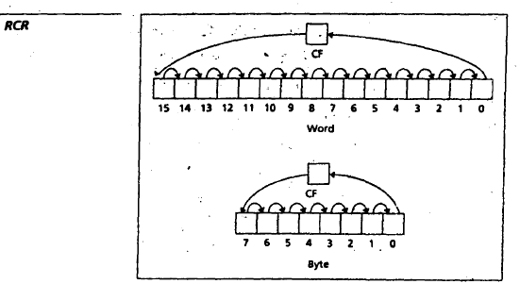  Exercise:  Positive Negative Even Odd (SHIFT)  .MODEL SMALL  .STACK 100H  .DATA  MSG1 DB "PLEASE ENTER CHARACTER $"  MSG2 DB 10,13,"NUMBER IS EVEN POSITIVE $"  MSG3 DB 10,13,"NUMBER IS EVEN NEGATIVE $"  MSG4 DB 10,13,"NUMBER IS ODD POSTIVE $"  MSG5 DB 10,13,"NUMBER IS ODD NEGATIVE $"  .CODE  MAIN PROC  MOV AX, @DATA  MOV DS, AX  MOV AH, 9  LEA DX, MSG1  INT 21H  MOV AH, 1  INT 21H  MOV BL, AL  SHR BL, 1  JC ODD  JMP EVEN

Time  Plan  (min) | Contents of Lecture | Lecture  Strategy  (Remarks)
5  mins | EVEN:  SHL BX, 1  JC ENEG  JMP EPOS  EPOS:  MOV AH, 9  LEA DX, MSG2  INT 21H  JMP EXIT  ENEG:  MOV AH, 9  LEA DX, MSG3  INT 21H  JMP EXIT  ODD:  SHL BX, 1  JC ONEG  JMP OPOS  OPOS:  MOV AH, 9  LEA DX, MSG4  INT 21H  JMP EXIT  ONEG:  MOV AH, 9  LEA DX, MSG5  INT 21H  JMP EXIT  EXIT:  MOV AH, 4CH  INT 21H  MAIN ENDP  END MAIN  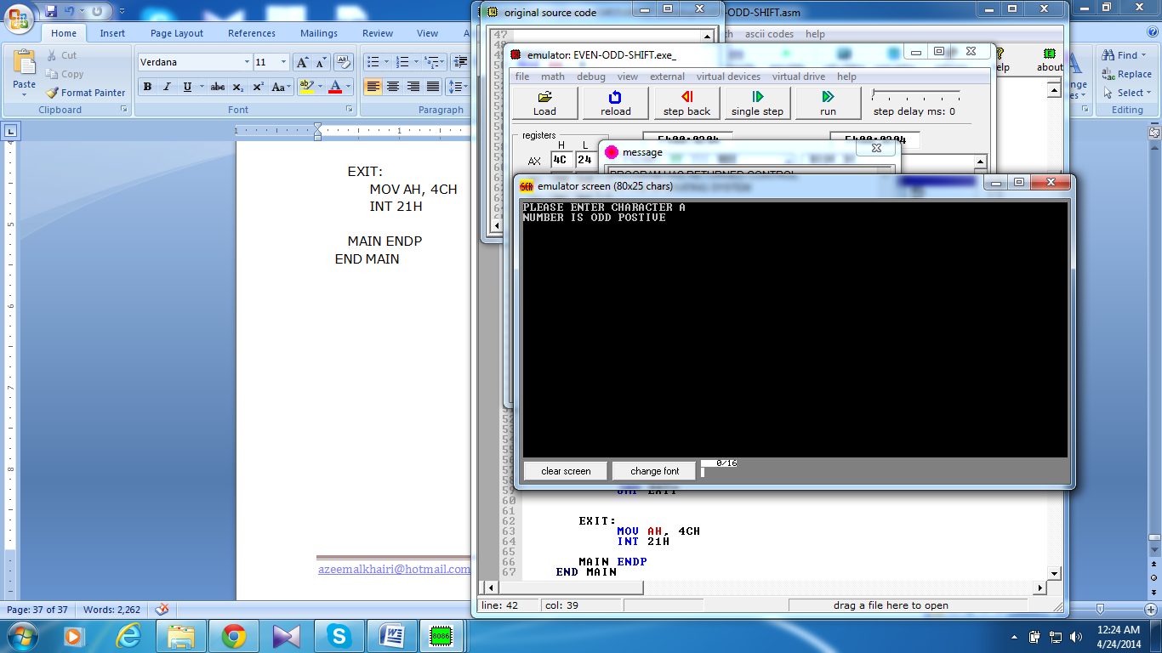  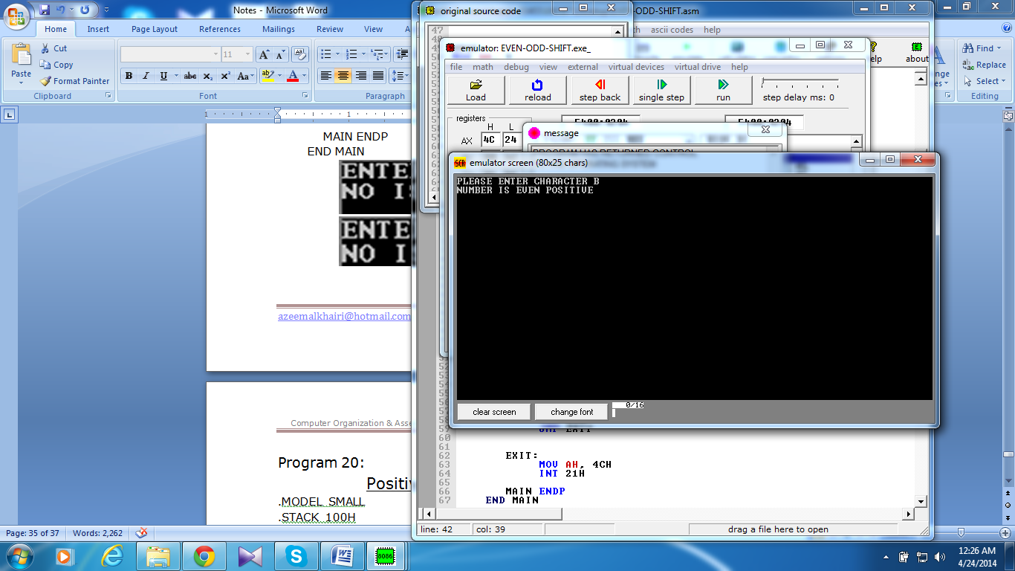

Time  Plan  (min) | Contents of Lecture | Lecture  Strategy  (Remarks)
5  mins | Count 0 & 1 (Rotate)  .MODEL SMALL  .STACK 100H  .DATA  MSG1 DB "PLEASE ENTER CHARACTER: $"  MSG2 DB 10,13,"THE NUMBER OF 1 ARE: $"  MSG3 DB 10,13,"THE NUMBER OF 0 ARE: $"  CONT DB 0  .CODE  MAIN PROC  MOV AX, @DATA  MOV DS, AX  MOV AH, 9  LEA DX, MSG1  INT 21H  MOV AH, 1  INT 21H  MOV BL, AL  MOV CX, 8  CHECK:  ROL BL, 1  JC ADDON  LOOP CHECK  JMP EXIT  ADDON:  INC CONT  LOOP CHECK  EXIT:  MOV AH, 9  LEA DX, MSG2  INT 21H  MOV DL, CONT  ADD DL, 48  MOV AH, 2  INT 21H

Time  Plan  (min) | Contents of Lecture | Lecture  Strategy  (Remarks)
5  mins | MOV AH, 9  LEA DX, MSG3  INT 21H  MOV CL, CONT  MOV BL, 8  SUB BL, CL  MOV DL, BL  ADD DL, 48  MOV AH, 2  INT 21H  MOV AH, 4CH  INT 21H  MAIN ENDP  END MAIN  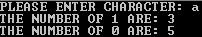  Binary Input  .MODEL SMALL  .STACK 100H  .CODE  MAIN PROC  XOR BX, BX  MOV AH, 1  INPUT:  INT 21H  CMP AL, 13  JE END_INPUT  SHL BX, 1  SUB AL, 48  OR BL, AL  JMP INPUT

Time  Plan  (min) | Contents of Lecture | Lecture  Strategy  (Remarks)
5  mins | END_INPUT:  MOV AH, 4CH  INT 21H  MAIN ENDP  END MAIN  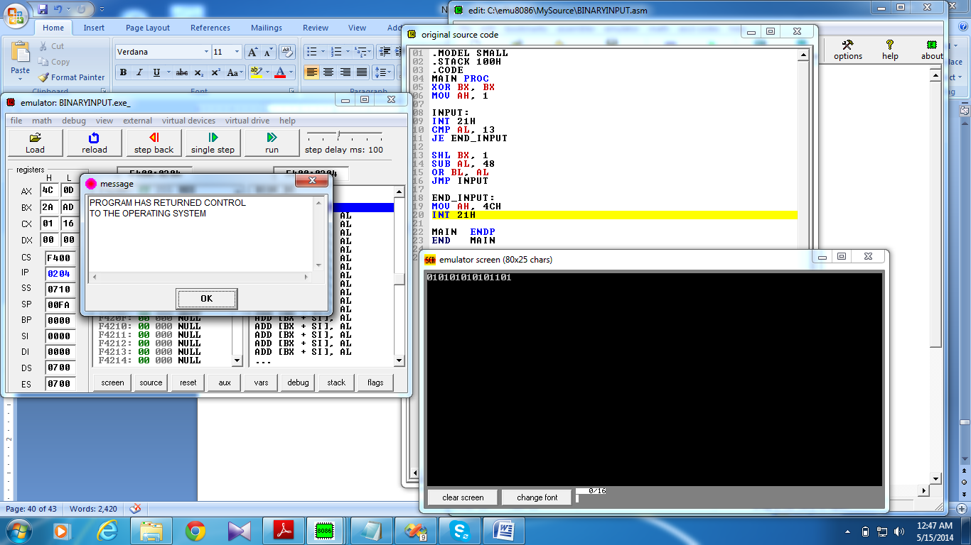  Binary Output  .MODEL SMALL  .STACK 100H  .CODE  MAIN PROC  MOV BX, 5  MOV CX, 16  MOV AH, 2  PRINT:  ROL BX, 1  JC DISPONE  MOV DL, '0'  INT 21H  LOOP PRINT  JMP EXIT  DISPONE:  MOV DL, '1'  INT 21H  LOOP PRINT  EXIT:  MOV AH, 4CH  INT 21H  MAIN ENDP  END MAIN  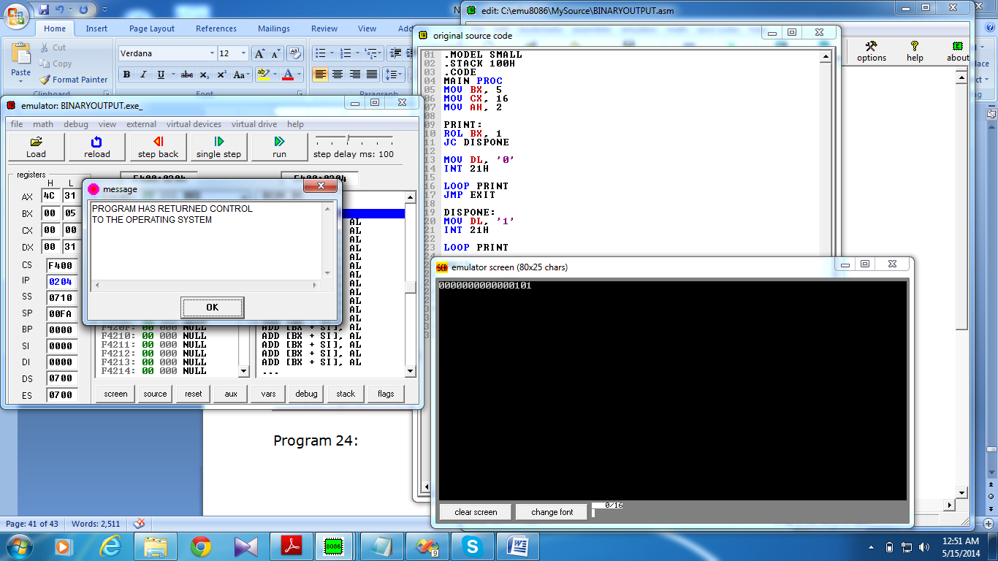

Time  Plan  (min) | Contents of Lecture | Lecture  Strategy  (Remarks)
5  mins | Hexa Input  .MODEL SMALL  .STACK 100H  .CODE  MAIN PROC  XOR BX, BX  MOV CL, 4  MOV AH, 1  INPUT:  INT 21H  CMP AL,13  JE END_INPUT  SHL BX, CL  CMP AL, '9'  JLE NUMBER  SUB AL, 55  JMP INSERT  NUMBER:  SUB AL, 48  INSERT:  OR BL, AL  JMP INPUT  END_INPUT:  MOV AH, 4CH  INT 21H  MAIN ENDP  END MAIN  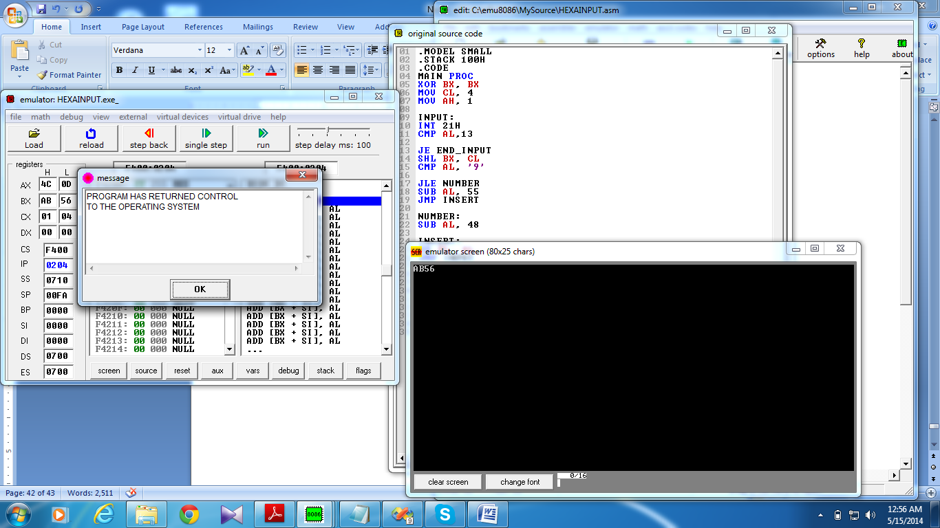

Time  Plan  (min) | Contents of Lecture | Lecture  Strategy  (Remarks)
5  mins | Hexa Output  .MODEL SMALL  .STACK 100H  .CODE  MAIN PROC  MOV BX, 9ABFh  MOV CX, 4  MOV AH, 2  PRINT:  MOV DL, BH  SHR DL, 1  SHR DL, 1  SHR DL, 1  SHR DL, 1  CMP DL, 9  JLE DISPNUM  ADD DL,55  JMP DISP  DISPNUM:  ADD DL, 48  DISP:  INT 21H  ROL BX,1  ROL BX,1  ROL BX,1  ROL BX,1  LOOP PRINT  MOV AH, 4CH  INT 21H  MAIN ENDP  END MAIN  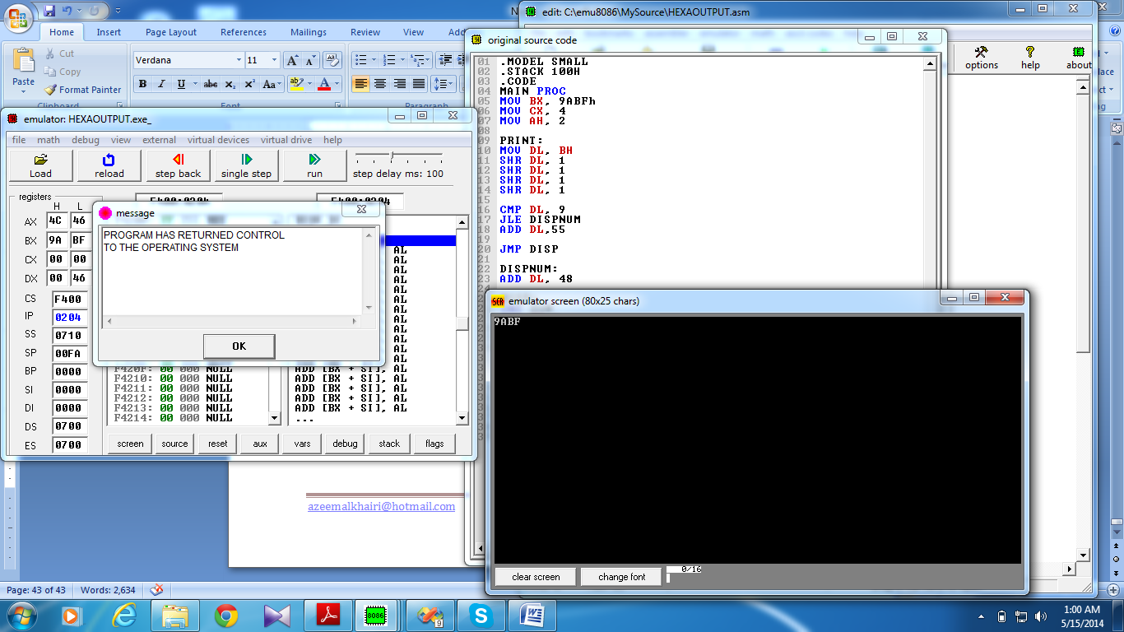

Time  Plan  (min) | Contents of Lecture | Lecture  Strategy  (Remarks)
5  mins | Hexa Input Binary Output  .MODEL SMALL  .STACK 100H  .DATA  MSG DB 10,13,"IN BINARY IT IS: $"  .CODE  MAIN PROC  MOV AX, @DATA  MOV DS, AX  XOR BX, BX  MOV CL, 4  MOV AH, 1  INPUT:  INT 21H  CMP AL, 13  JE END_INPUT  SHL BX, CL  CMP AL, '9'  JLE NUMBER  SUB AL, 55  JMP INSERT  NUMBER:  SUB AL, 48  INSERT:  OR BL, AL  JMP INPUT  END_INPUT:  MOV AH, 9  LEA DX, MSG  INT 21H  MOV CX, 16  PRINT:  ROL BX, 1  JC DISPONE  MOV DL, '0'  MOV AH, 2  INT 21H

Time  Plan  (min) | Contents of Lecture | Lecture  Strategy  (Remarks)
5  mins | LOOP PRINT  JMP EXIT  DISPONE:  MOV DL, '1'  MOV AH, 2  INT 21H  LOOP PRINT  EXIT:  MOV AH, 4CH  INT 21H  MAIN ENDP  END MAIN  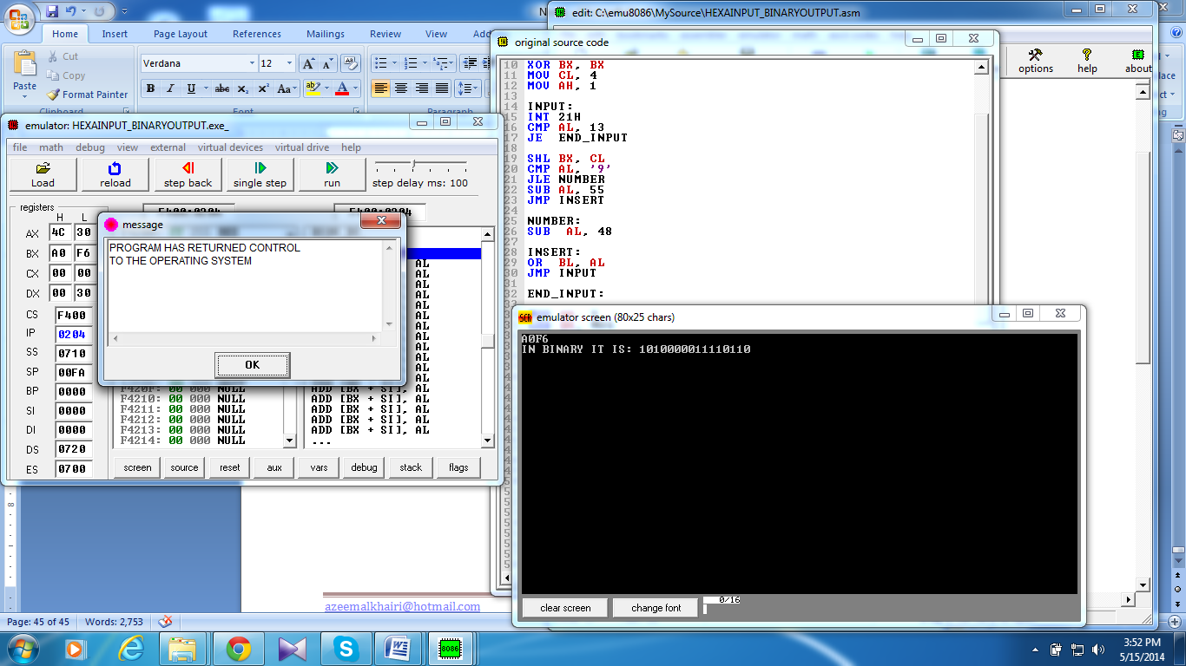  Binary Input Hexa Output  .MODEL SMALL  .STACK 100H  .DATA  MSG DB 10,13,"IN HEX IT IS: $"  .CODE  MAIN PROC  MOV AX, @DATA  MOV DS, AX  XOR BX, BX  MOV AH, 1  INPUT:  INT 21H  CMP AL, 13  JE END_INPUT  SHL BX, 1  SUB AL, 48  OR BL, AL  JMP INPUT  END_INPUT:  MOV AH, 9  LEA DX, MSG  INT 21H

Time  Plan  (min) | Contents of Lecture | Lecture  Strategy  (Remarks)
5  mins | MOV CX, 4  MOV AH, 2  PRINT:  MOV DL, BH  SHR DL, 1  SHR DL, 1  SHR DL, 1  SHR DL, 1  CMP DL, 9  JLE NUMBER  ADD DL, 55  JMP DISPLAY  NUMBER:  ADD DL, 48  DISPLAY:  INT 21H  ROL BX, 1  ROL BX, 1  ROL BX, 1  ROL BX, 1  LOOP PRINT  MAIN ENDP  END MAIN  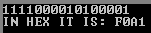

Time  Plan  (min) | Contents of Lecture | Lecture  Strategy  (Remarks)
5  mins | Hexa Input Hexa Output  .MODEL SMALL  .STACK 100H  .DATA  MSG DB 10,13,"YOU HAVE TYPED: $"  .CODE  MAIN PROC  MOV AX, @DATA  MOV DS, AX  XOR BX, BX  MOV CL, 4  MOV AH, 1  INPUT:  INT 21H  CMP AL, 13  JE END_INPUT  SHL BX, CL  CMP AL, '9'  JLE NUMBER  SUB AL, 55  JMP INSERT  NUMBER:  SUB AL, 48  INSERT:  OR BL, AL  JMP INPUT  END_INPUT:  MOV AH, 9  LEA DX, MSG  INT 21H  MOV CX, 4  MOV AH, 2  PRINT:  MOV DL, BH  SHR DL, 1  SHR DL, 1  SHR DL, 1  SHR DL, 1

Time  Plan  (min) | Contents of Lecture | Lecture  Strategy  (Remarks)
5  mins | CMP DL, 9  JLE DISPNUMBER  ADD DL, 55  JMP DISP  DISPNUMBER:  ADD DL, 48  DISP:  INT 21H  ROL BX, 1  ROL BX, 1  ROL BX, 1  ROL BX, 1  LOOP PRINT  MOV AH, 4CH  INT 21H  MAIN ENDP  END MAIN  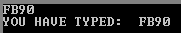  Binary Input Binary Output  .MODEL SMALL  .STACK 100H  .DATA  MSG DB 10,13,"YOU HAVE ENTERED $: "  .CODE  MAIN PROC  MOV AX, @DATA  MOV DS, AX  XOR BX, BX  MOV AH, 1  INPUT:  INT 21H  CMP AL, 13  JE END_INPUT  SHL BX, 1  SUB AL, 48

Time  Plan  (min) | Contents of Lecture | Lecture  Strategy  (Remarks)
OR BL, AL
JMP INPUT
END_INPUT:

MOV CX, 16

MOV AH, 9
LEA DX, MSG
INT 21H

PRINT:
ROL BX, 1
JC DISPONE
MOV DL, '0'
MOV AH, 2
INT 21H

LOOP PRINT
JMP EXIT
DISPONE:
MOV DL, '1'
MOV AH, 2
INT 21H
LOOP PRINT

EXIT:
MOV AH, 4CH
INT 21H

MAIN ENDP
END MAIN

