H. M. Faisal (03455275108) Computer Organization and Assembly Language (CS-530)

Lesson Plan 8

Objectives: The main objectives are: (a) The Stack; (b) A Stack Application; (c) Procedures.

Content: In this lecture detailed explanation and implementation of Stack and Procedures with different programming practices will be covered. A stack is one-dimensional data structure. Items are added and removed from one end of the structure; that is, it is processed in a "last-in, first-out" manner.

Procedures or subroutines are very important in assembly language, as the assembly language programs tend to be large in size. Procedures are identified by a name. Following this name, the body of the procedure is described which performs a well-defined job. End of the procedure is indicated by a return statement.

Methods: For every new topic, I will first provide the definition and the basic working, then I will request some student to come to the board and with the help of class discussion repeat that discussion. This process will not only give them confidence, but will also clear their idea and encourage them to openly discuss any complications with this topic.

Resources: Besides the lecture handout, this lesson will draw from the following Text books: Assembly Language Programming and Organization of the IBM-PC, Ytha Yu and Charles Marut.

Evaluation: In this lecture I will not be using any formal evaluation process. I will be using informal techniques to monitor if the students have absorbed the material or not: (i) By making the students step up to the board and solve some examples. (iii) By judging the class interaction, which is a clear indicator of their interest.

Assignment: Give them a home assignment on programming practices.

Time  Plan  (min) | Contents of Lecture | Lecture  Strategy  (Remarks)
15 mins | - Introduction of stack:  A stack is one-dimensional data structure. Items are added and removed from one end of the structure; that is, it is processed in a "last-in, first-out" manner. The most recent addition to the stack is called the top of the stack. A familiar example is a stack of dishes; the last dish to go on the stack is the top one, and it's the only one that can be removed easily.  A program must set aside a block of memory to hold the stack. we have been doing this by declaring a stack segment:  For example:  .STACK 100H  When the program is assembled and loaded in memory, SS will contain the segment number of the stack segment. For the preceding Stack Declaration, SP, the stack pointer, is initialized to 100p. This represents the empty stack position: When the stack is not empty, SP contains the offset address of the top of the stack.  PUSH:  To add a new word to the stack we PUSH it on,  The syntax is:  PUSH Source  Where source is a 16-bit register or memory word.  For example:  PUSH AX after PUSH AX  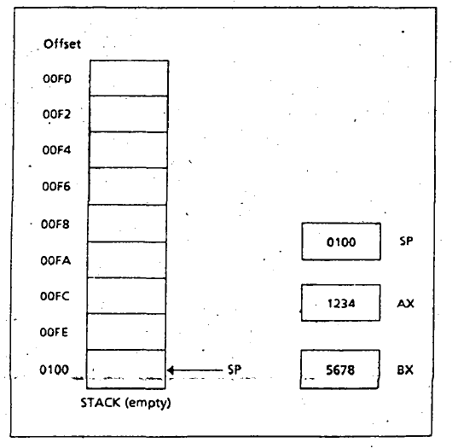

Time  Plan  (min) | Contents of Lecture | Lecture  Strategy  (Remarks)
10  mins | 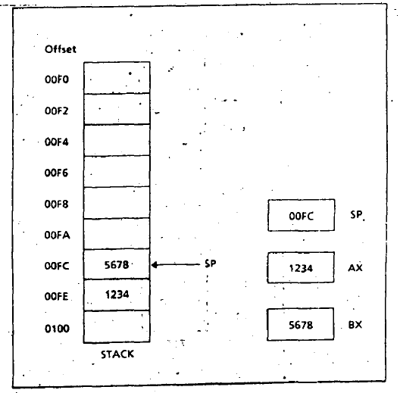  POP:  To remove the top item from the stack, we POP It.  The syntax is:  POP destination  Where destination is a 16-bit register (except IP) or memory word.  For example:  POP BX  Before POP After POP CX  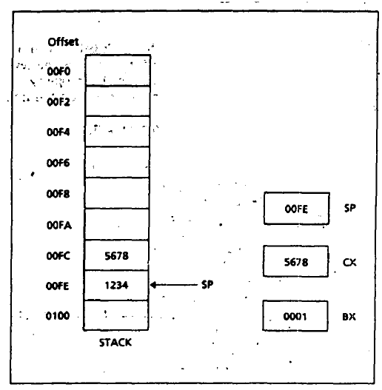

Time  Plan  (min) | Contents of Lecture | Lecture  Strategy  (Remarks)
10  mins | 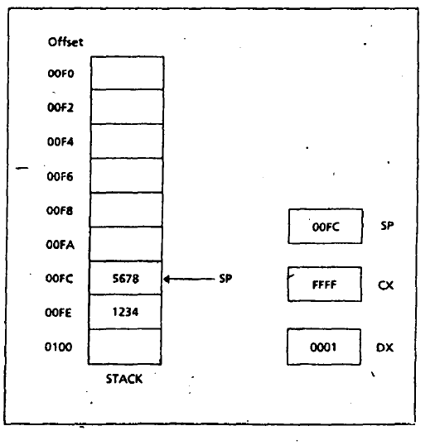  After POP DX  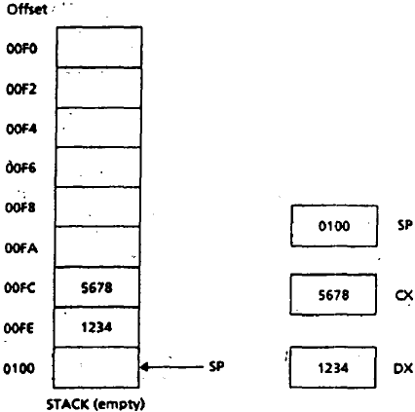

Time  Plan  (min) | Contents of Lecture | Lecture  Strategy  (Remarks)
10  mins | Stack (A String Reversal Application)  .MODEL SMALL  .STACK 100H  .DATA  MSG1 DB "ENTER A STRING: $"  MSG2 DB 10,13,"REVERSE STRING: $"  .CODE  MAIN PROC  MOV AX, @DATA  MOV DS, AX  MOV AH, 9  LEA DX, MSG1  INT 21H  MOV CX, 0 ;TO COUNT THE CHARACTER  MOV AH, 1  INPUT:  INT 21H  CMP AL, 13  JE END_INPUT  PUSH AX  INC CX  JMP INPUT  END_INPUT:  MOV AH, 9  LEA DX, MSG2  INT 21H  MOV AH, 2  PRINT:  POP DX  INT 21H  LOOP PRINT  MOV AH, 4CH  INT 21H  MAIN ENDP  END MAIN  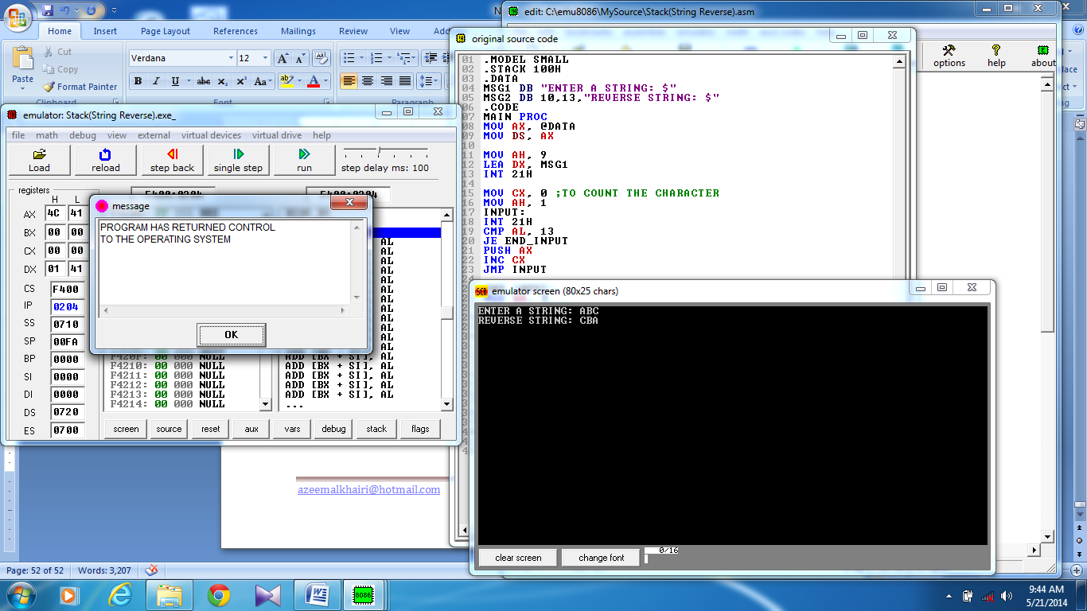

Time  Plan  (min) | Contents of Lecture | Lecture  Strategy  (Remarks)
15  mins | - Procedures:  One of the procedures is the main procedure, and it contains the entry point to the program. To carry out a task, the main procedure calls one of the other procedures. It is also possible for these procedures to call each other, or for a procedure to call itself.  When one procedure calls another, control transfers to the called procedure and its instructions are executed; the called procedure usually returns control to the caller at the next instruction after the call statement.  Procedure Declaration:  The syntax of procedure declaration is the following:  Name PROC type  ; Body of the procedure  RET  Name ENDP  Procedure Call and Return:  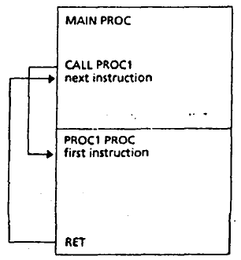  RET:  The RET (return) instruction causes control to transfer back to the calling procedure. Every procedure (except the main procedure) should have a RET someplace; usually it's the last statement in the procedure.

Time  Plan  (min) | Contents of Lecture | Lecture  Strategy  (Remarks)
10  mins | Exercise:  Procedures  .MODEL SMALL  .STACK 100H  .CODE  MAIN PROC  CALL PRINTSTAR  MOV AH, 4CH  INT 21H  MAIN ENDP  PRINTSTAR PROC  MOV CX, 10  MOV AH, 2  MOV DL, '*'  PRINT:  INT 21H  LOOP PRINT  RET  PRINTSTAR ENDP  END MAIN  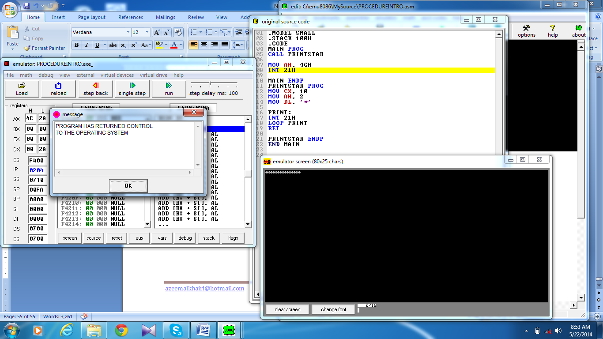

Time  Plan  (min) | Contents of Lecture | Lecture  Strategy  (Remarks)
10  mins | Procedures (RETURN + ARGUMENT)  .MODEL SMALL  .STACK 100H  .CODE  MAIN PROC  MOV CX, 10;FEEL LIKE ARGUMENT PASS  CALL PRINTSTAR  PRINT: ;FEEL LIKE RETURN VALUE  INT 21H  LOOP PRINT  MOV AH, 4CH  INT 21H  MAIN ENDP  PRINTSTAR PROC  MOV AH, 2  MOV DL, '*'  RET  PRINTSTAR ENDP  END MAIN  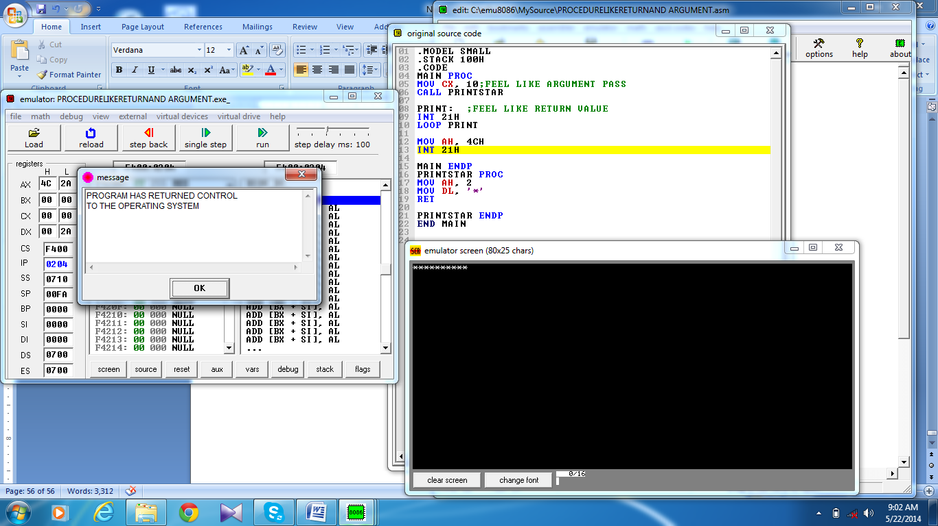

Time  Plan  (min) | Contents of Lecture | Lecture  Strategy  (Remarks)
10  mins | Procedures (Get From File)  .MODEL SMALL  .STACK 100H  .CODE  MAIN PROC  CALL PRINTSTAR  MOV AH, 4CH  INT 21H  MAIN ENDP  INCLUDE D:\ PRINTSTAR.ASM  END MAIN

