NETWORK DESIGN FOR HOTEL MANAGEMENT SYSTEM
1. Introduction
This project involves the design and implementation of a computer network for Modern Hotel as part of my end-of-semester networking project. The objective of the project is to design a secure, scalable, and well-structured network that supports communication between different departments located on multiple floors of the hotel. The network was designed using industry-standard networking concepts such as VLANs, OSPF routing, DHCP, and wireless networking to ensure efficiency and reliability.

2. Hotel Structure Overview
Vic Modern Hotel consists of three floors, each hosting different departments:
- First Floor: Reception, Store, and Logistics
- Second Floor: Finance, Human Resource (HR), and Sales/Marketing
- Third Floor: IT and Administration
Each department operates independently but must still communicate with other departments across the hotel network.

3. Network Design Architecture
3.1 Router Configuration
Three routers were used in the network design, with one router logically assigned to each floor. All routers are physically located in the server room within the IT department for centralized management and security.
The routers are interconnected using serial DCE cables to ensure reliable point-to-point communication. The inter-router networks were assigned the following IP address ranges:
- 10.10.10.0/30
- 10.10.10.4/30
- 10.10.10.8/30
These /30 networks were selected to efficiently utilize IP addresses for router-to-router communication.

3.2 Switching and LAN Design
Each floor is equipped with one access switch, which connects all wired devices within that floor. The switch handles traffic segmentation using Virtual Local Area Networks (VLANs) to separate departments logically, improve security, and reduce broadcast traffic.

4. VLAN and IP Addressing Scheme
Each department was assigned a unique VLAN ID and IP network, as shown below:
First Floor
- Reception: VLAN 80 – 192.168.8.0/24
- Store: VLAN 70 – 192.168.7.0/24
- Logistics: VLAN 60 – 192.168.6.0/24
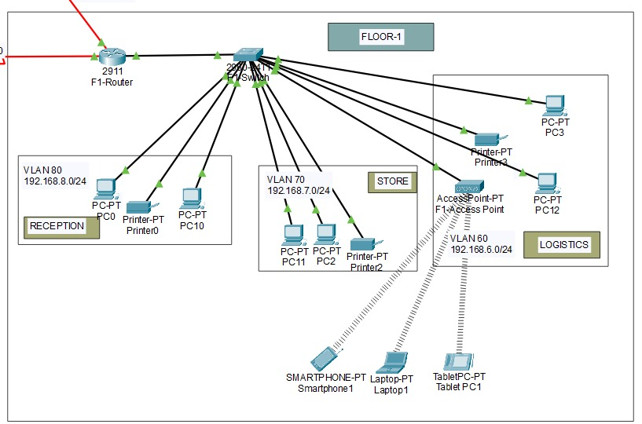

Second Floor
- Finance: VLAN 50 – 192.168.5.0/24
- Human Resource (HR): VLAN 40 – 192.168.4.0/24
- Sales/Marketing: VLAN 30 – 192.168.3.0/24
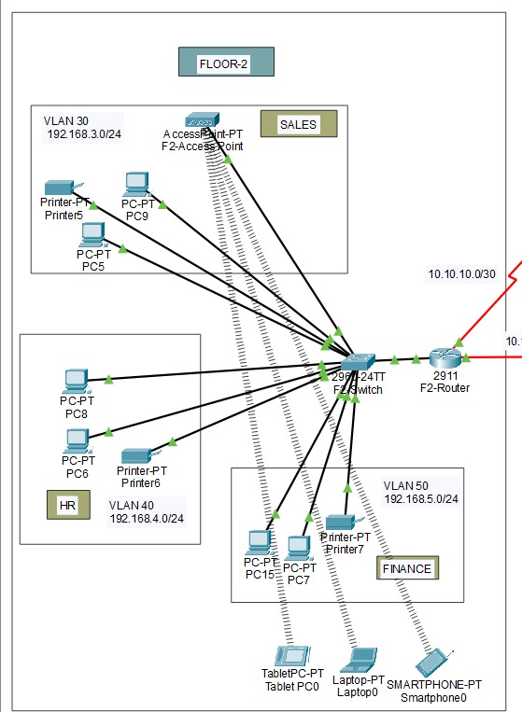

Third Floor
- Administration: VLAN 20 – 192.168.2.0/24
- IT Department: VLAN 10 – 192.168.1.0/24
This VLAN-based segmentation ensures that each department has its own broadcast domain while still allowing controlled inter-department communication.

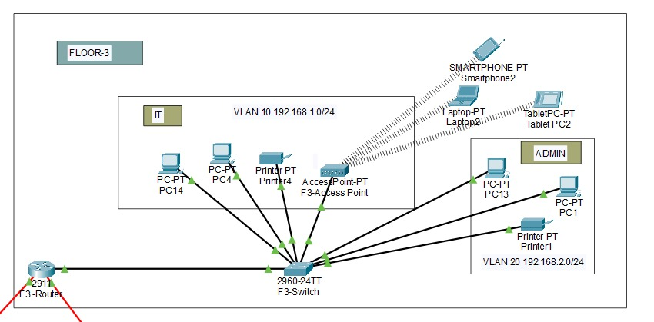

5. Wireless Network Implementation
Each floor includes a wireless network (Wi-Fi) to support laptops and mobile phones used by staff. The wireless access points are connected to the floor switches and mapped to the appropriate VLANs to maintain network segmentation and security.

6. Peripheral Devices
Every department was provided with at least one network printer, connected to the local switch and assigned an IP address dynamically. This allows users within the same VLAN to easily access shared printing resources.

7. Dynamic IP Address Allocation (DHCP)
All end devices in the network obtain IP addresses dynamically using DHCP. Each router is configured as a DHCP server for the VLANs under its control. This approach simplifies network management and reduces configuration errors.

8. Routing Protocol
The Open Shortest Path First (OSPF) routing protocol was implemented across all routers. OSPF was chosen because it is a scalable and efficient dynamic routing protocol that allows all networks to be advertised automatically, ensuring full connectivity between departments on different floors.

9. Network Communication and Testing
The network was tested to ensure that:
- Devices within the same VLAN can communicate successfully
- Devices across different VLANs and floors can communicate via routing
- Wireless and wired devices receive IP addresses correctly
- Printers and shared resources are accessible
All tests confirmed that full network connectivity was achieved as required.
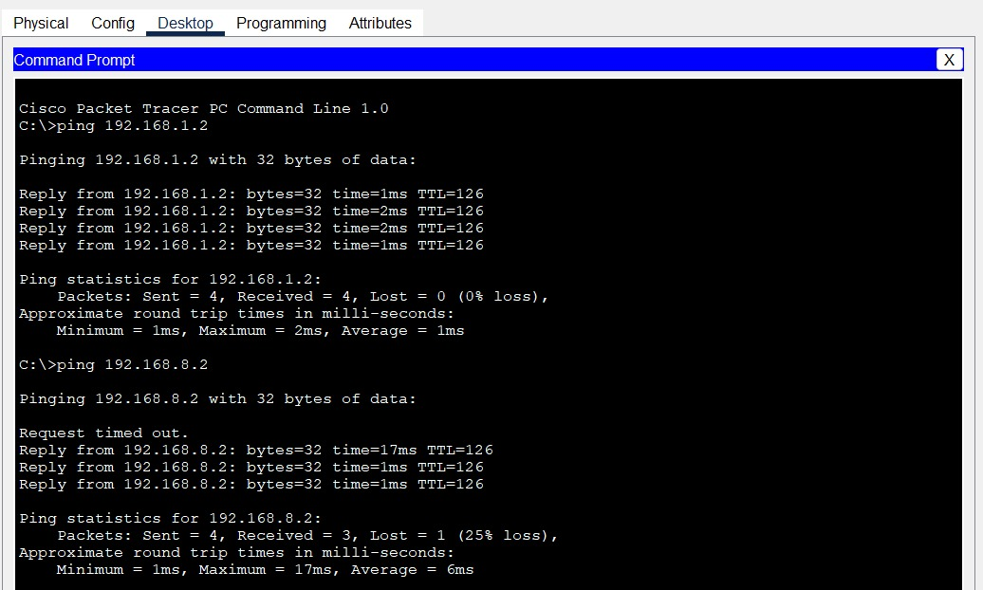

10. Conclusion
The Vic Modern Hotel network was successfully designed and implemented according to the given requirements. The use of VLANs improved security and organization, OSPF ensured efficient routing, and DHCP simplified IP management. This project demonstrates practical application of networking concepts and provides a reliable and scalable network solution suitable for a modern hotel environment.

