Progress Report — Weeks 1–2 (Foundation Phase)
Project | Classification of Malignant Melanoma in Canines (CATCH dataset)
Project Code | DAIM2025A_088
Student | Muhammad Tayyab Abbas
Supervisor | Dr Claire Cashmore
Reporting period | Week 1–2 (26 May – 8 June 2026)
Meeting | First fortnightly supervisor meeting

1. Summary
The Foundation phase is on schedule. The computational environment is fully configured inside an isolated virtual environment, the literature review has been refined, and the data acquisition and preprocessing pipeline (Macenko stain normalisation → patch extraction → stratified split) has been implemented and validated end-to-end. The pipeline was verified on synthetic H&E slides while the CATCH dataset download from TCIA is being finalised; it is ready to run unchanged on the real slides.

2. Planned vs. actual (Gantt chart)
Gantt task | Planned weeks | Status | Evidence
Environment Setup & Framework | W1 | Complete | .venv, requirements.txt, requirements-lock.txt, setup_env scripts
Literature Review & Refinement | W1–W2 | Complete | docs/literature/literature_review_notes.md
Data Acquisition & Preprocessing | W1–W3 | In progress (~60%) | code + QA/split reports + figures

3. What was completed

3.1 Environment setup (Week 1)
- Python 3.12 in an ISOLATED virtual environment (.venv) so project packages never affect other projects or the global interpreter.
- Dependencies: OpenCV, scikit-image, scikit-learn, OpenSlide, NumPy, pandas, matplotlib (PyTorch + Albumentations added for Week 3 model development).
- Reproducible setup: requirements.txt, environment.yml, pinned requirements-lock.txt, and one-command installers (setup_env.ps1 / .sh).
- Git repository with a clean, modular src/ package structure.

3.2 Literature review refinement (Weeks 1–2)
- Consolidated the key references underpinning the methodology (U-Net, Attention U-Net, ResNet, EfficientNet, Macenko, Grad-CAM, canine comparative-oncology papers).
- Method and finding summaries recorded in docs/literature/literature_review_notes.md.

3.3 Data acquisition and preprocessing (Weeks 1–3, in progress)
Implemented and validated the complete preprocessing chain:
- Acquisition helper (download_catch.py) — documents the TCIA / NBIA Data Retriever workflow and verifies downloaded slides.
- Quality assessment (quality_check.py) — per-slide checks for size, blur, brightness and tissue fraction; flags/excludes poor slides with a reason.
- Macenko stain normalisation (stain_normalization.py) — maps slides onto a common H&E colour appearance to remove scanner/lab variation.
- Patch extraction (patch_extraction.py) — tiles slides into 256×256 patches, keeping only tissue-bearing tiles (≥50% tissue).
- Stratified split (dataset_split.py) — 70/15/15 train/val/test split preserving class distribution.
Validation run (synthetic slides): 2 slides → both passed QA → 26 tissue patches extracted → split 18/4/4. Confirms the pipeline runs end-to-end and is ready for the real CATCH slides.

4. Artefacts produced (shown in this meeting)
Artefact | Location
Before/after stain normalisation figures | outputs/figures/stain_normalization_*.png
Sample extracted patches (grids) | outputs/figures/patches_*.png
Quality assessment report | outputs/logs/quality_report.csv
Train/val/test split summary | outputs/logs/split_summary.json
Source code (modular package) | src/

Figure: Macenko stain normalisation (before / after).
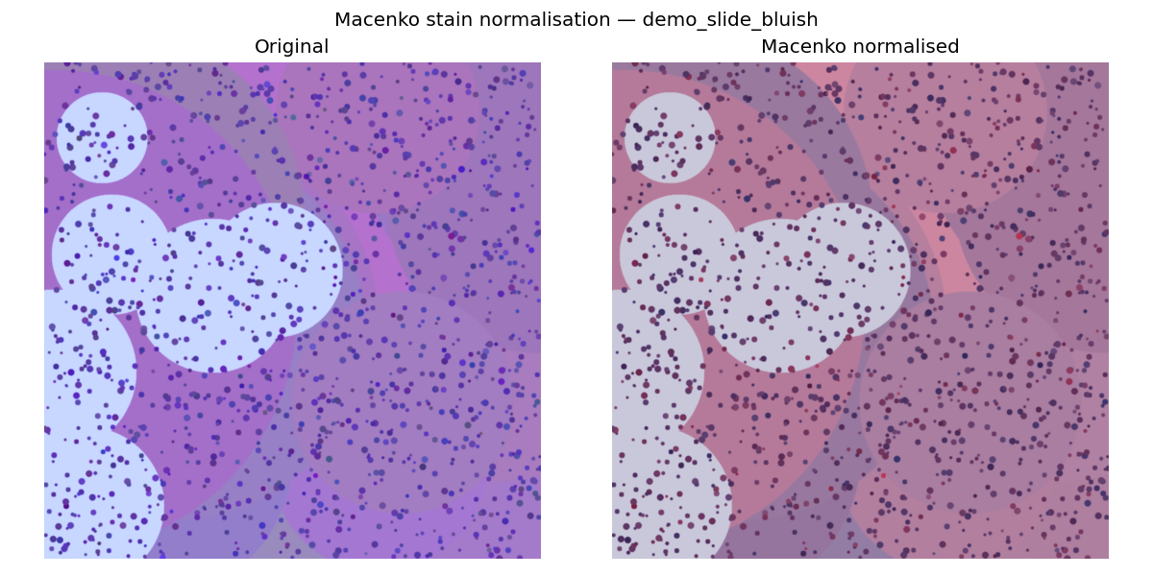

5. Risks & issues (current)
Risk | Status | Mitigation in place
CATCH download (TCIA account / large files) | Active | Pipeline validated on synthetic data; runs unchanged on real slides once downloaded. NBIA Data Retriever workflow documented.
GPU resources for upcoming training | Watching | Google Colab Pro + university HPC identified as fallback.
Class imbalance across tumour subtypes | Anticipated | Stratified split implemented; class-weighted loss + augmentation planned for Week 3+.

6. Plan for next fortnight (Weeks 3–5)
- Complete CATCH download and run the validated pipeline on all real slides.
- Finalise patch dataset and class distribution statistics.
- Begin U-Net segmentation model (baseline → ResNet-34 encoder), with TensorBoard monitoring of loss convergence.

7. Questions for supervisor
- Is the QA exclusion threshold (≥10% tissue, blur ≥ 50) appropriate, or should it be agreed with a veterinary pathologist?
- Confirm the final list of tumour subtypes to include as classification classes.
- Any preference on patch magnification priority (5×/10×/20×) for the first segmentation experiments?

