Progress Report — Weeks 5–6 (Attention U-Net + ResNet-50 Classification)
Project: Classification of Malignant Melanoma in Canines (CATCH)
Project Code: DAIM2025A_088
Student: Muhammad Tayyab Abbas
Supervisor: Dr Claire Cashmore
Reporting period: Weeks 5–6 (23 June – 6 July 2026)
Meeting: Third fortnightly supervisor meeting

1. Summary
Phase 2 continued on schedule. The Attention U-Net (Oktay et al., 2018) was implemented and trained, giving a three-way segmentation comparison (baseline / ResNet-34 / Attention). In parallel, the tumour-subtype classification track began: a ResNet-50 classifier (ImageNet transfer learning, progressive unfreezing, label-smoothing) was trained and evaluated with accuracy, macro-F1, AUC-ROC and a confusion matrix. All validated on synthetic data; the pipeline was also made real-data-ready (native .svs reading, COCO/SQLite annotation masks, the 7 CATCH subtypes, and a corrected slide-level split).

2. Planned vs. actual (Gantt)
Gantt task | Planned | Status
Attention U-Net Implementation | W5–6 | Complete (3-way comparison)
ResNet-50 Classification | W6–7 | Started (W6) — trained & evaluated

3. Attention U-Net — segmentation (3-way)
Model | Params | Dice | IoU
Baseline U-Net | 31.04M | 0.842 | 0.727
U-Net + ResNet-34 | 24.44M | 0.225 | 0.127
Attention U-Net | 31.39M | 0.965 | 0.932
The attention gates re-weight the encoder skip features using the decoder signal, suppressing background and focusing on tumour regions. Built on the same backbone as the baseline, so the comparison isolates the attention effect.
Figure: Attention U-Net test predictions (image | ground truth | prediction).
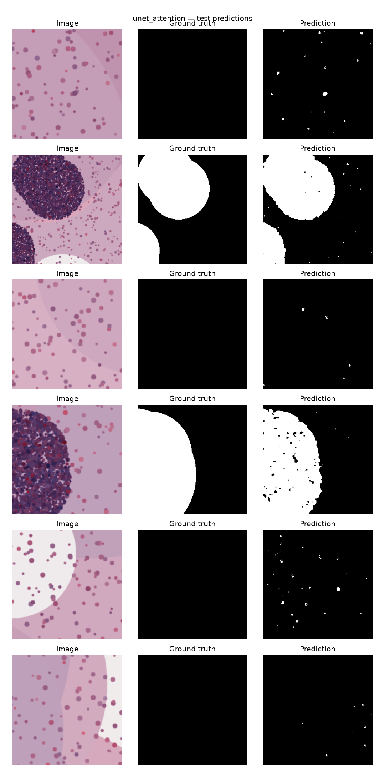

4. ResNet-50 — tumour-subtype classification
Metric | Value
Classes | mast_cell, melanocytic, squamous_cell
Accuracy | 1.000
Macro F1 | 1.000
Macro precision | 1.000
Macro recall | 1.000
Macro AUC-ROC | 1.000
Figure: ResNet-50 confusion matrix (test).
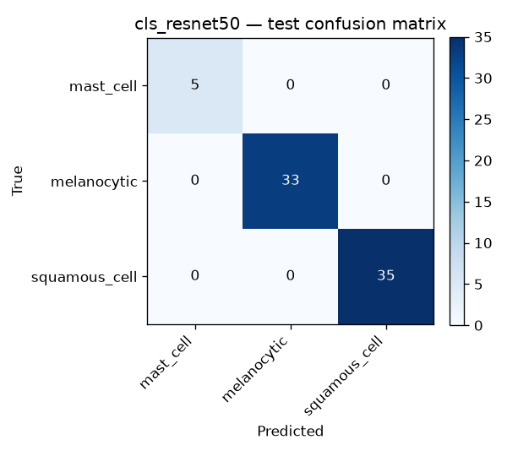
Trained with cross-entropy + label smoothing (0.1), AdamW, and progressive unfreezing (head → deeper layers). Note: synthetic-data validation; absolute values will change on real CATCH slides.

5. Next fortnight (Weeks 7–8)
- Train EfficientNet-B3 classifier and compare with ResNet-50.
- Run on the real CATCH slides once downloaded.
- Begin evaluation phase: 5-fold cross-validation, McNemar's test.

