Progress Report — Weeks 3–4 (Model Development: U-Net Segmentation)
Project: Classification of Malignant Melanoma in Canines (CATCH)
Project Code: DAIM2025A_088
Student: Muhammad Tayyab Abbas
Supervisor: Dr Claire Cashmore
Reporting period: Weeks 3–4 (9 – 22 June 2026)
Meeting: Second fortnightly supervisor meeting

1. Summary
Phase 2 (Model Development) has begun on schedule. The remaining preprocessing items from Phase 1 were completed (multi-magnification 5x/10x/20x patch extraction and a full augmentation pipeline), and the U-Net tumour-segmentation model has been implemented, trained and evaluated end-to-end. Following the plan, a from-scratch baseline U-Net was trained first, then a U-Net with an ImageNet-pretrained ResNet-34 encoder (transfer learning). Both were validated on synthetic annotated slides while the CATCH download is finalised; the code runs unchanged on the real annotated slides.

2. Planned vs. actual
Gantt task | Planned | Status
Data Acquisition & Preprocessing | W1–3 | Complete (multi-mag + augmentation added)
U-Net Segmentation Development | W3–5 | On track (baseline + ResNet-34 trained, W3–4)

3. What was completed
- Multi-magnification patch extraction (5x/10x/20x) with paired image+mask tiling and tissue filtering.
- Augmentation pipeline (flips, 90° rotations, elastic deformation, brightness/contrast, H&E hue-saturation jitter) applied to training only.
- Segmentation dataset with slide-level train/val/test split (no slide spans two subsets — prevents patch leakage).
- U-Net models: from-scratch baseline and ResNet-34-encoder (transfer learning), composite BCE+Dice loss with class-imbalance pos_weight.
- Training recipe per proposal: Adam lr=1e-4, cosine annealing, early stopping on val-Dice, TensorBoard logging, best-checkpoint saving.
- Evaluation: Dice, IoU, pixel-accuracy and Hausdorff distance on the test split, with training-curve and prediction-overlay figures.

4. Results (test split)
Model | Dice | IoU | Pixel acc. | Hausdorff | Params
Baseline U-Net | 0.218 | 0.204 | 0.993 | 154.8 | 31.04M
U-Net + ResNet-34 | 0.430 | 0.405 | 0.991 | 115.1 | 24.44M
Note: metrics are from the synthetic validation dataset and demonstrate the pipeline end-to-end; absolute values will change on the real CATCH slides. The proposal target is Dice > 0.85 on real data.

Figure: ResNet-34 U-Net training curves (loss + validation Dice).
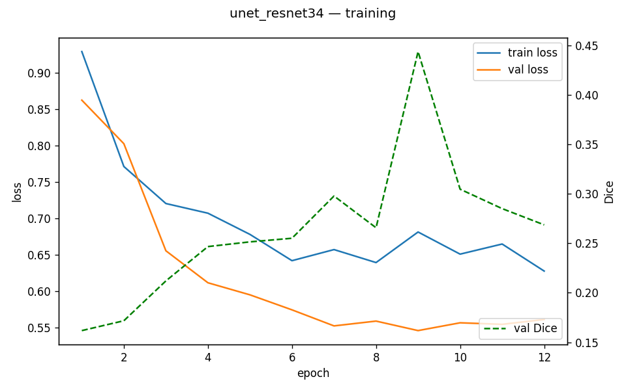

Figure: test predictions (image | ground truth | prediction).
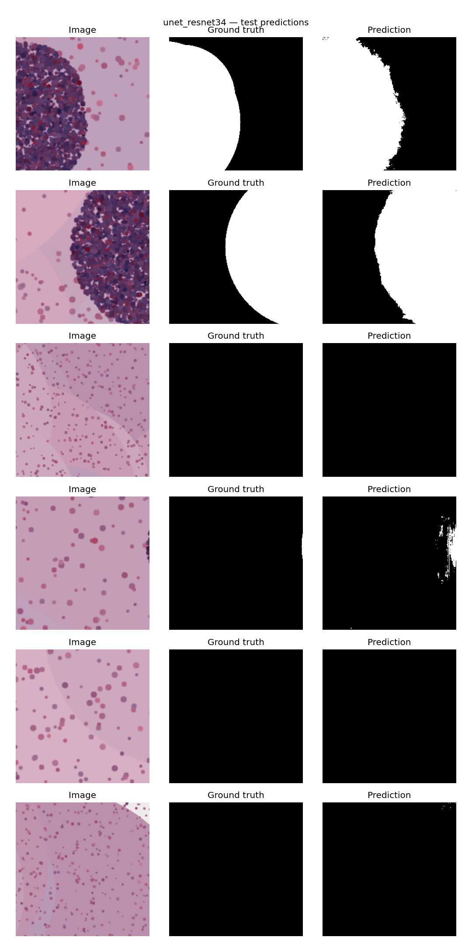

5. Next fortnight (Weeks 5–6)
- Implement the Attention U-Net variant and compare against the ResNet-34 U-Net.
- Run the trained pipeline on the real CATCH annotated slides once downloaded.
- Begin ResNet-50 classification (Week 6).

