FATIMA JINNAH WOMEN UNIVERSITY
Department of Software Engineering



COURSE TITLE:
CLOUD COMPUTING

SUBMITTED TO:
WAQAS SALEEM

SUBMITTED BY:
TAYYABA NOOR

SECTION:
B

REGISTRATION NO:
FA24B1-SE-068

Assignment 01
Git, Gitea, GitHub, Git LFS, and GitHub Pages


Task 1:
Install Gitea and Push a Repository (Ubuntu Server)
Install & Run Gitea
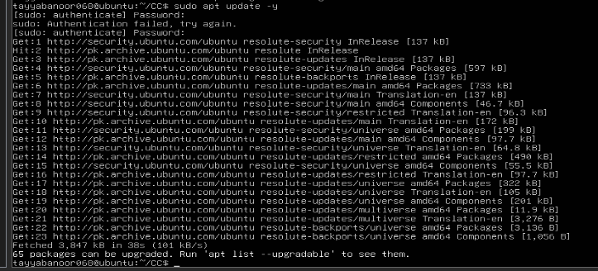
Docker Install:
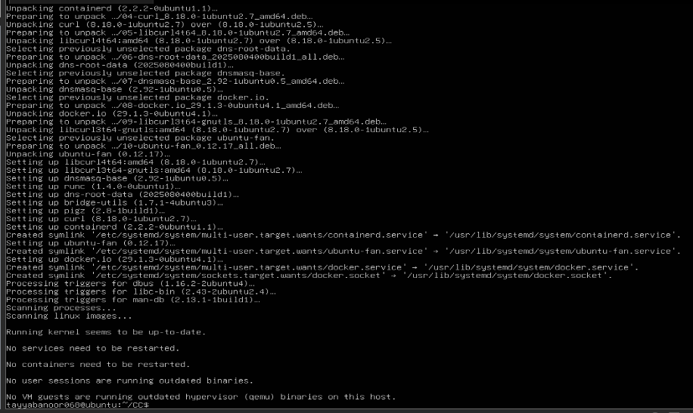
- Create the system-wide Docker CLI plug-in directory and download the Docker Compose plug-in for an x86_64 Ubuntu server:
- Verify the Git, Docker, and Docker Compose installations:
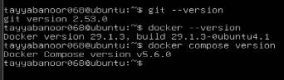
- Clone the instructor-provided Gitea setup repository on the Ubuntu server:
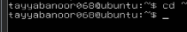
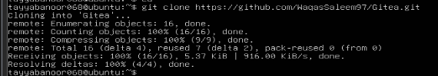
- Use the existing compose.yaml without changing its server URL or port settings. Start Gitea and PostgreSQL:
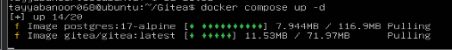
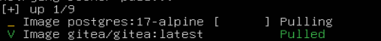
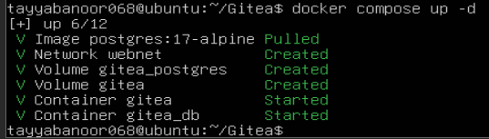
- Confirm that both containers are running:
- Confirm that Gitea responds locally on port 3000:
- Display the Ubuntu server's IP address:
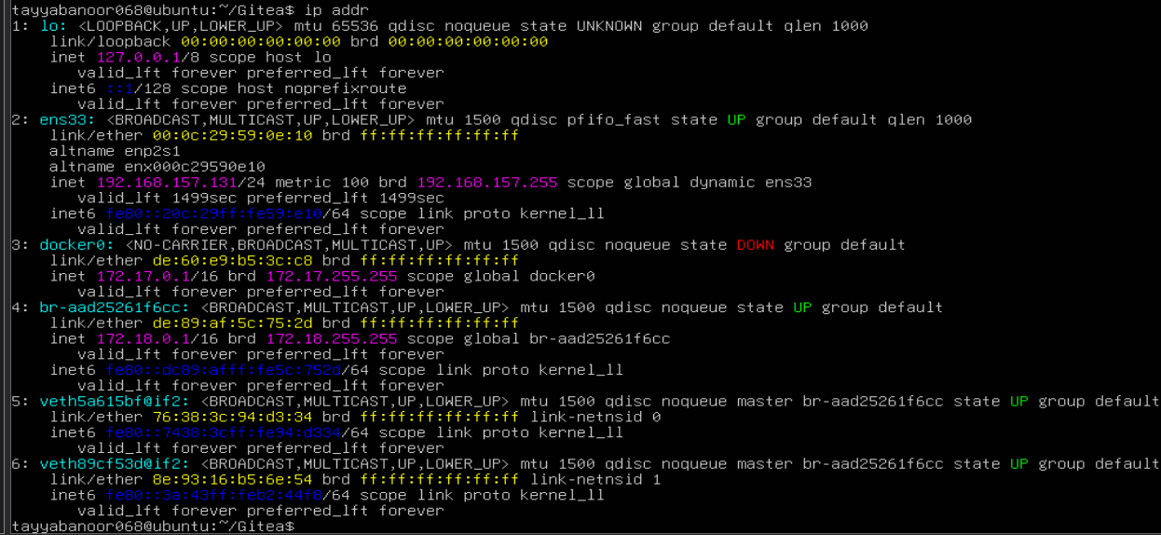
- Open Gitea in a web browser using the server address provided for your lab:
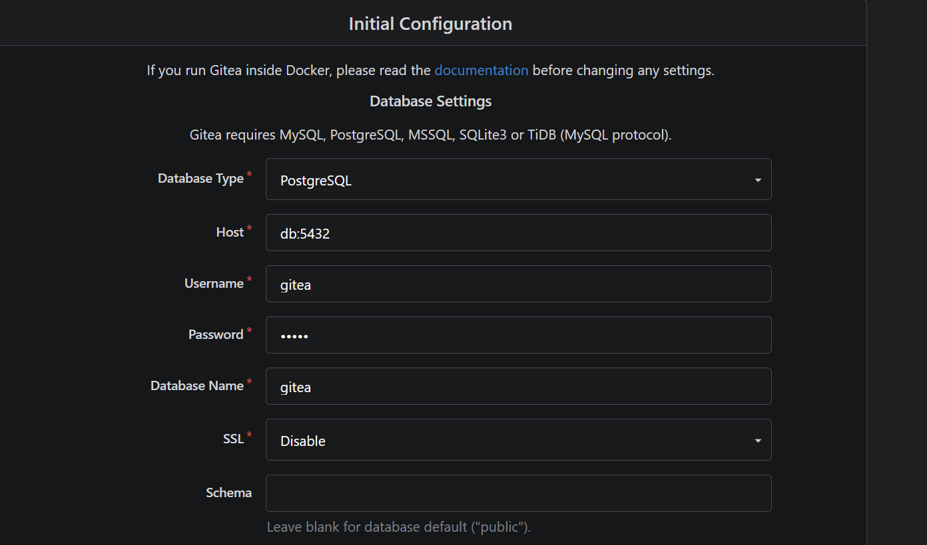
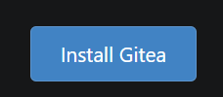

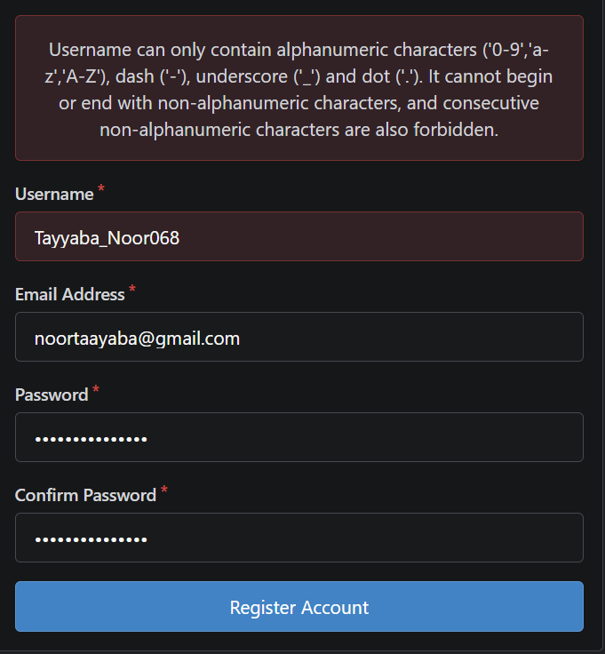
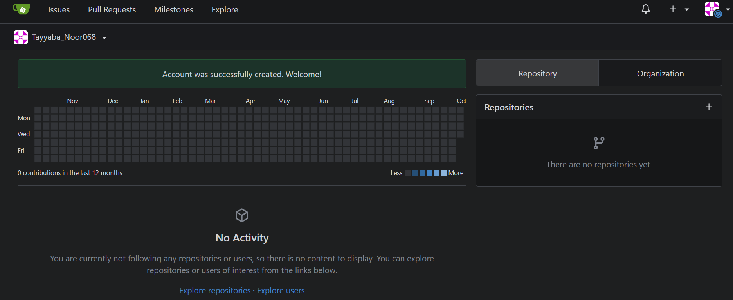
- Create and Push the Initial Repository:
In Gitea, create an empty public repository named exactly Assignment01.
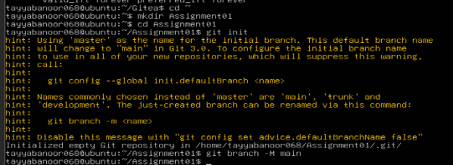

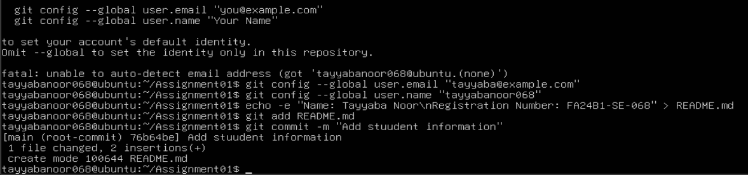
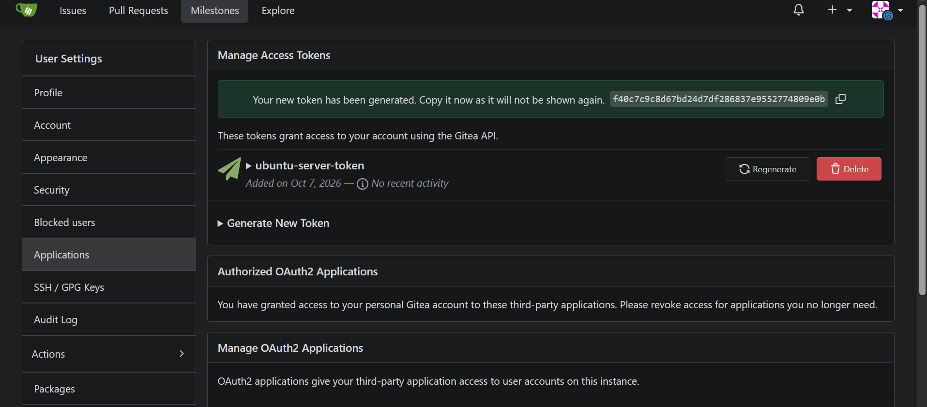
- Verifi the Git Repository:
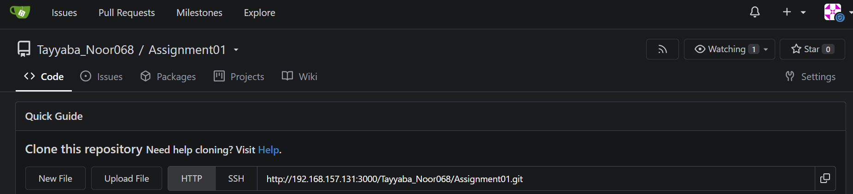
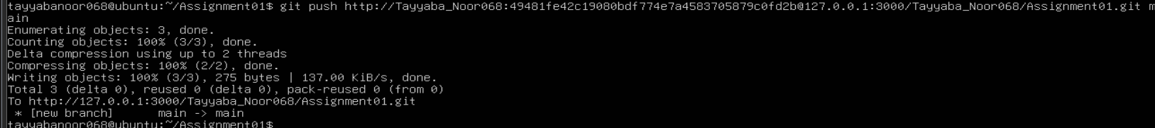

Task 2:
Push the Same Repository to GitHub
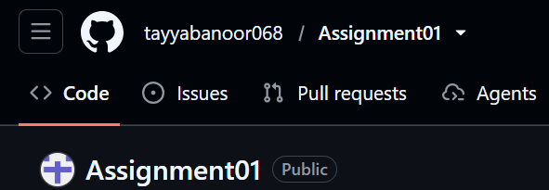
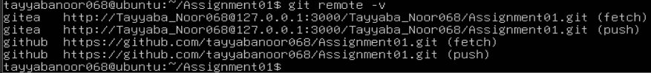
- Push to GitHub
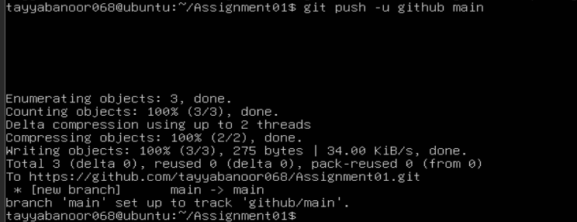
- Verify the GitHub Repository
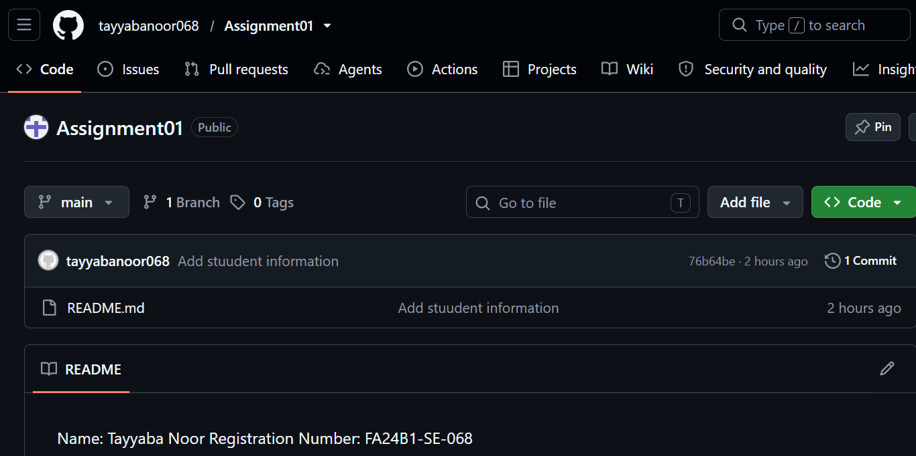

Task 3:
Track Three Large Files with Git LFS
Configure Git LFS On the Ubuntu server, open the local Assignment01 repository, initialize Git LFS, confirm its version, and configure tracking for.bin files:

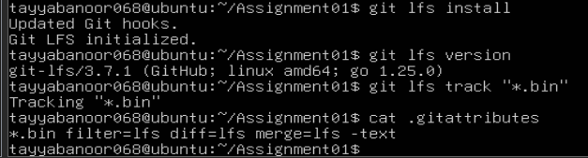
- Create and Verify Three LFS Files
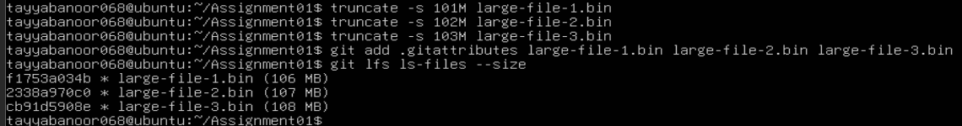
- Commit and Push the LFS Files
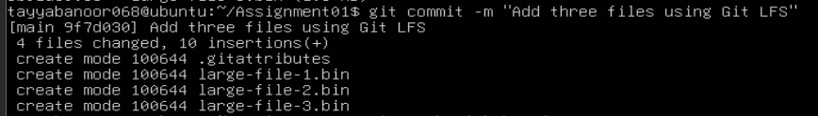
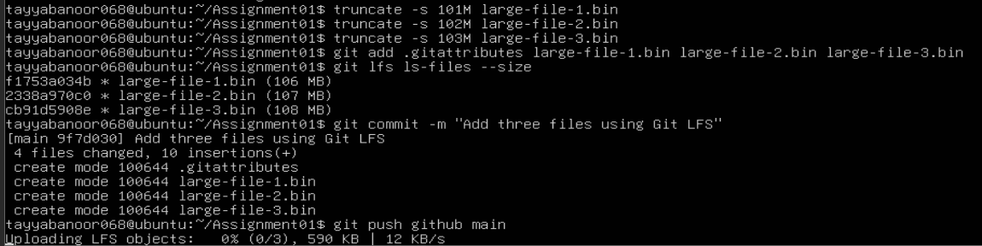
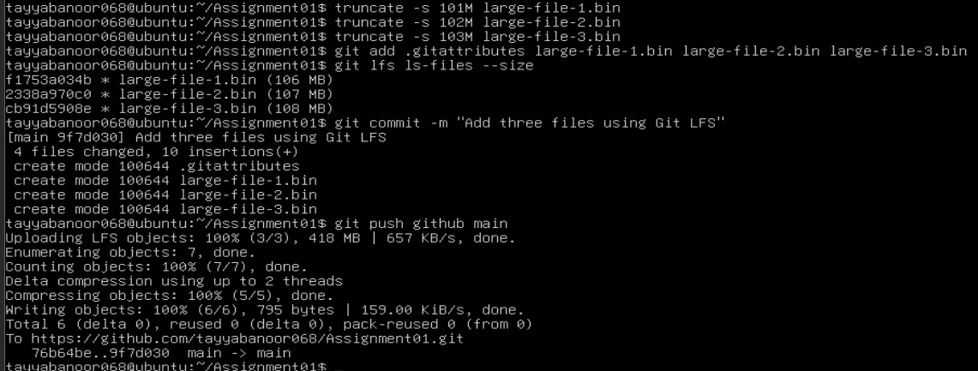

Task 4:
- Create a Portfolio or CV with GitHub Pages
Create and Push the Portfolio Repository
1. Create a new public GitHub repository named:
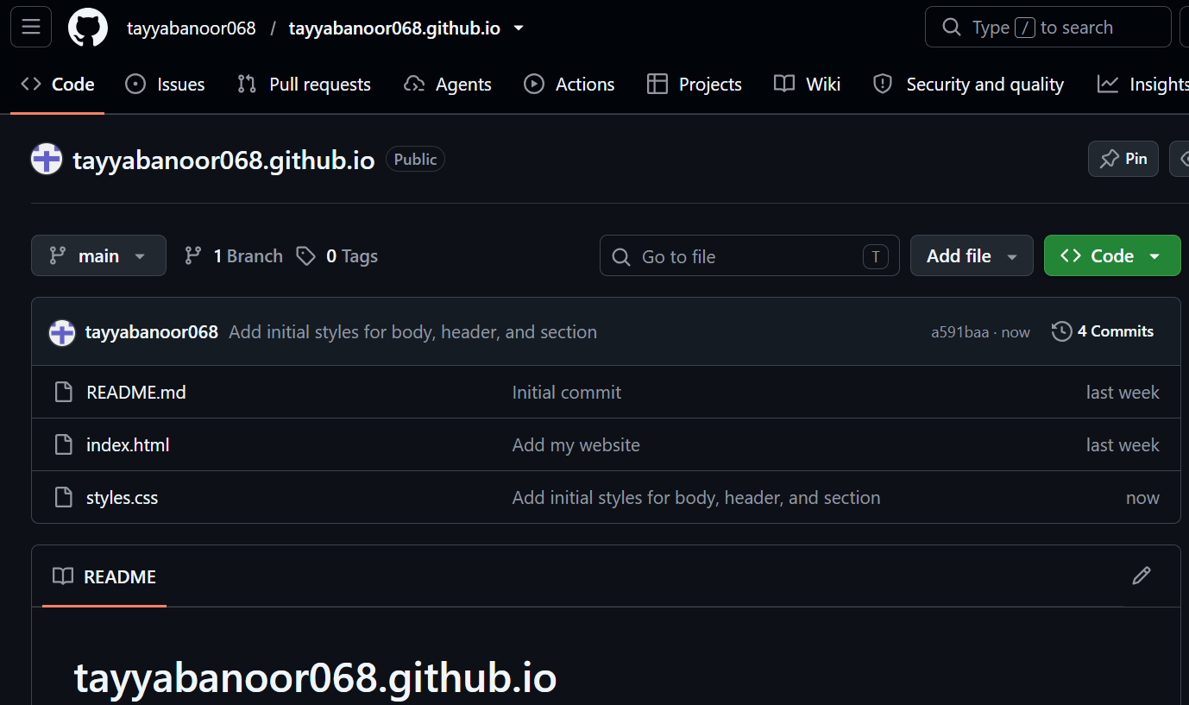
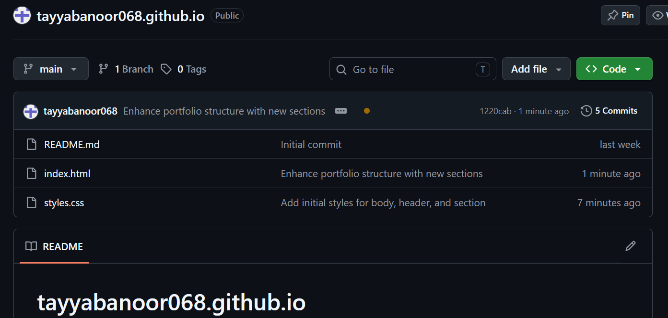

- Publish with GitHub Pages
Open the portfolio repository on GitHub.
2. Go to Settings → Pages.
3. Under Build and deployment, select Deploy from a branch.
4. Select the main branch and the / (root) folder, then save.
5. Wait until GitHub reports that the site is published or live. The page must show GitHub Pages, a successful published or live status, and your .github.io URL.
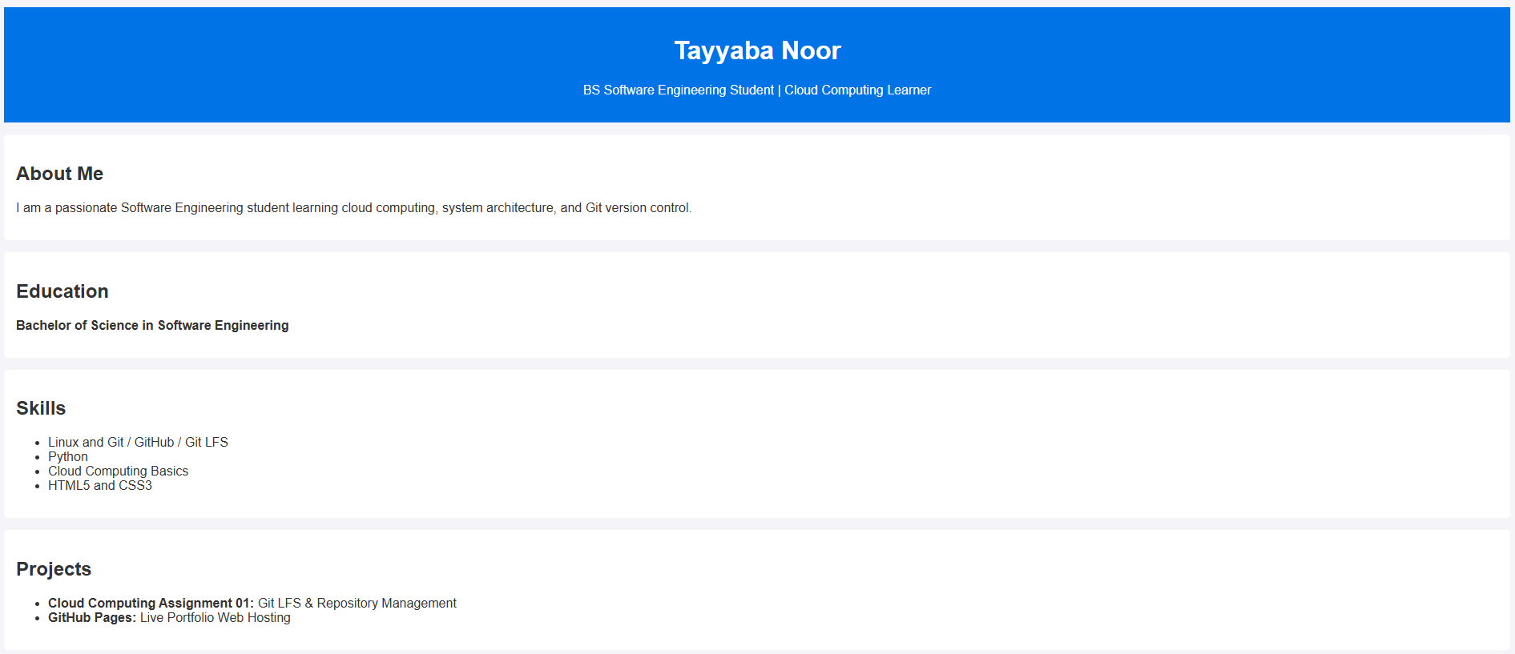
- Verify the Live Portfolio

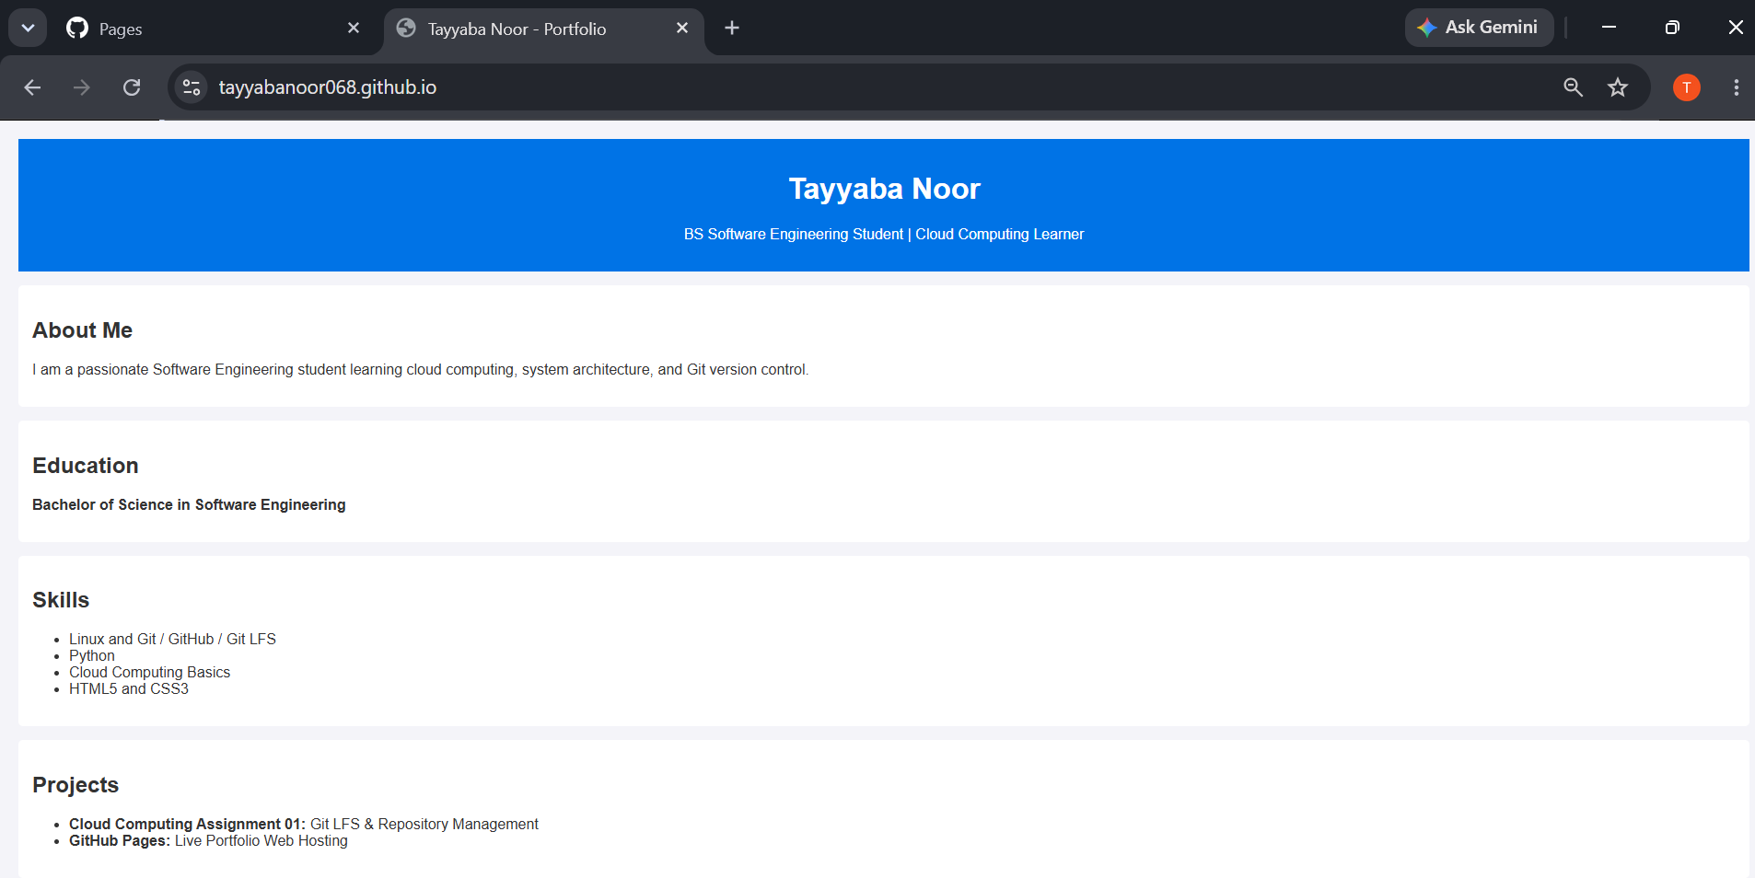

Complete Assignment 01

