

Assignment 01
Name: Tayyaba Ziafat
Registration No: FA24B1-SE-018
Section: B
Course Name: Cloud Computing
Topic: Git, Gitea, GitHub, Git LFS, and GitHub Pages

Task 1: Install Gitea and Push a Repository from the Ubuntu Server
Step 1.1: Install and Run Gitea on the Ubuntu Server
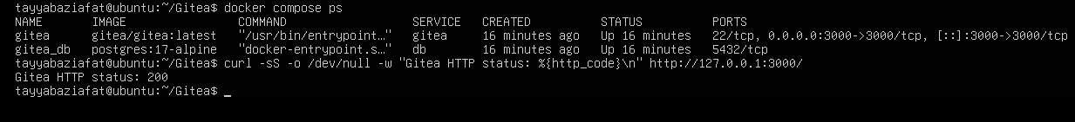
Step 1.2: Create and Push the Initial Repository
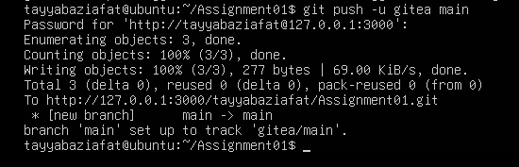
Step 1.3: Verify the Gitea Repository
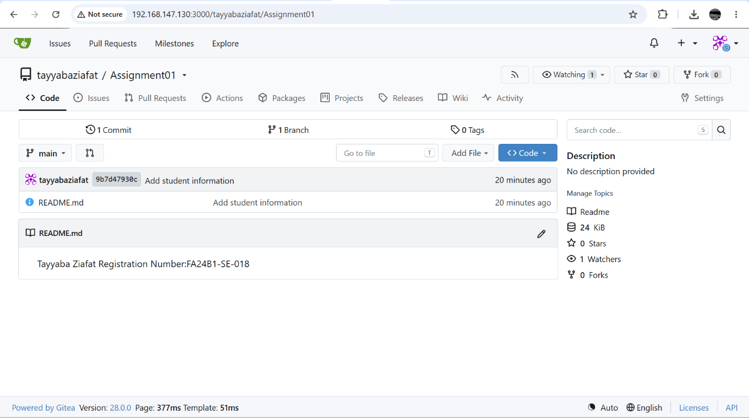

Task 2: Push the Same Repository to GitHub
Step 2.1: Create the GitHub Repository and Verify Both Remotes
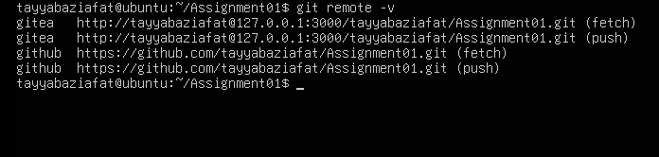
Step 2.2: Push to GitHub
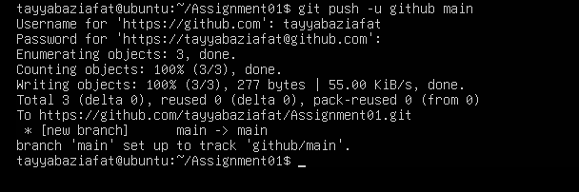
Step 2.3: Verify the GitHub Repository
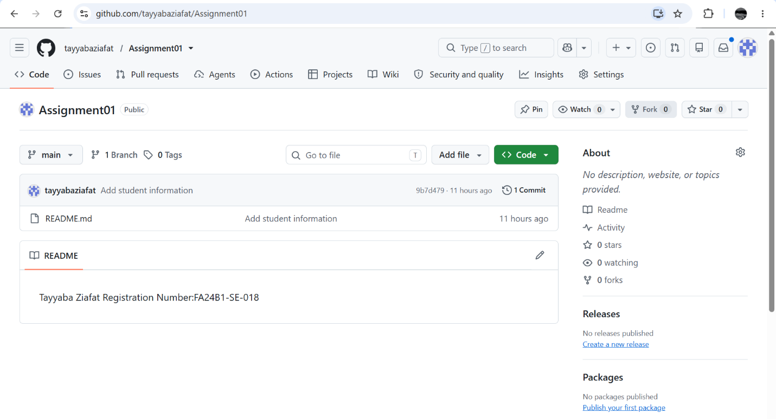
Task 3: Track Three Large Files with Git LFS
Step 3.1: Configure Git LFS
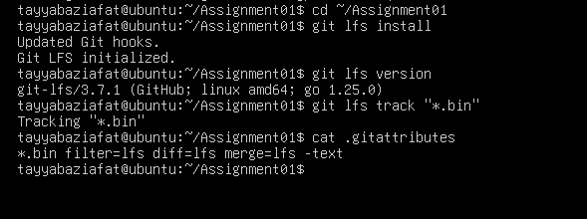
Step 3.2: Create and Verify Three LFS Files
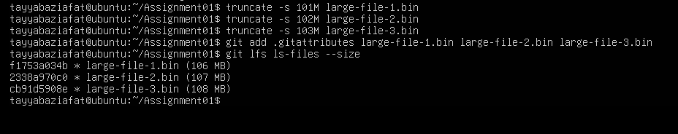
Step 3.3: Commit and Push the LFS Files
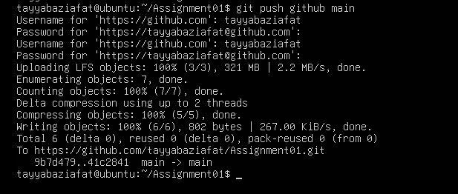
Task 4: Create a Portfolio or CV with GitHub Pages
Step 4.1: Create and Push the Portfolio Repository
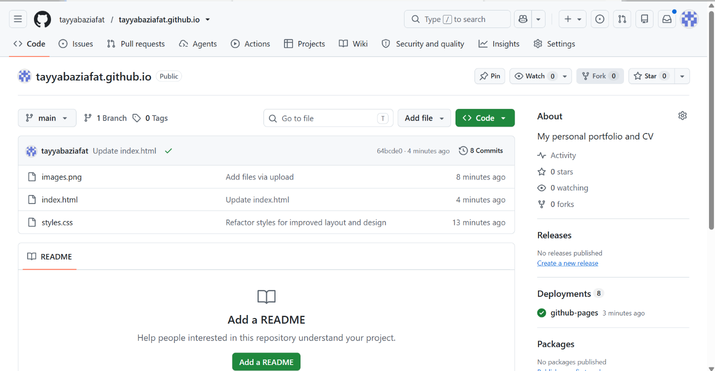
Step 4.2: Publish with GitHub Pages

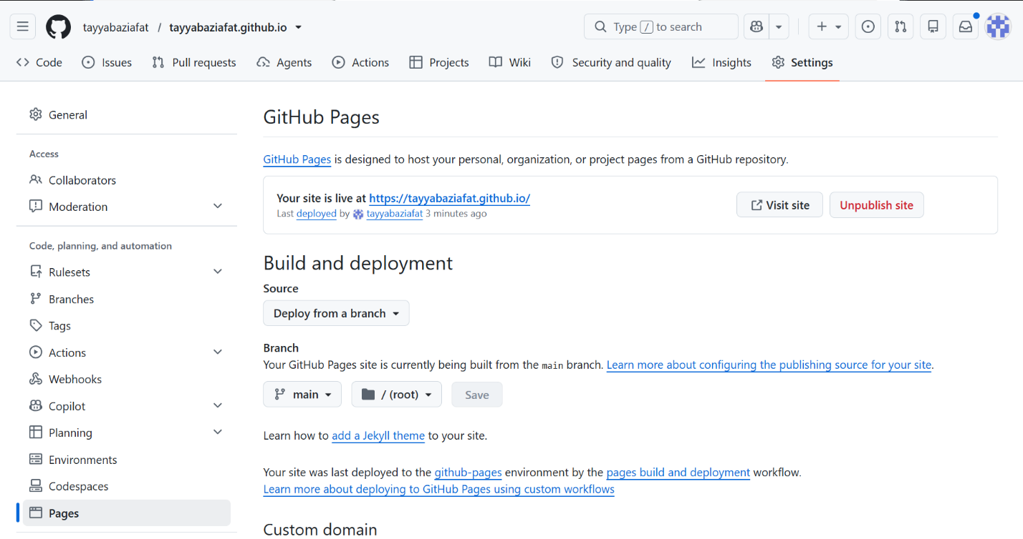
Step 4.3: Verify the Live Portfolio
