Internship Daily Report
ProSensia Cyber Security Task Force — Day 6
Intern Name | Tayyab
Date | July 13
Task | Parameter Tampering & Burp Suite Proxy (OWASP Juice Shop)
Status | Completed
Objective
Today's goal was to move a step higher in the stack — from the network layer we were poking at earlier in the week, to the actual application layer. The idea was to route my browser traffic through Burp Suite, catch a real request going out to the Juice Shop sandbox, and mess with a hidden parameter before it reached the server, basically to see whether the app blindly trusts whatever the client sends it.
Action 1 — Proxy Configuration
First step was getting Burp Suite actually sitting in the middle of my traffic. I set my browser's proxy to route everything through 127.0.0.1:8080, then installed the Burp CA certificate so HTTPS requests to the Juice Shop sandbox wouldn't throw certificate warnings. Once that was done I could see every request leaving the browser before it actually hit the server.
Action 2 — Traffic Interception
With the proxy live, I logged into the Juice Shop sandbox as a normal test user and just browsed around to generate traffic — login, product pages, adding stuff to the basket. I turned on intercept in Burp and watched the requests come through one by one, then started sending the interesting ones (mainly the basket/cart request) over to the Repeater tab so I could replay and edit them freely without having to redo the whole flow in the browser every time.
Action 3 — Parameter Manipulation
- Picked the basket/cart request as my target since it carries a quantity value that directly decides the total price at checkout — a good example of a hidden parameter the client controls.
- In the intercepted request I changed the quantity field from a normal positive number to a negative value (-5) and forwarded it instead of dropping it.
- The server accepted it without any re-validation and recalculated the total — the basket total flipped to a negative amount (-9.95), which on a real e-commerce backend would basically mean crediting money instead of charging for it.
- Going through the same session I also ended up clearing a few of the app's built-in challenges along the way — Login Admin, Password Strength, and View Basket (viewing another user's basket) — a nice bonus confirming the account/session handling has its own separate gaps.
Evidence
Screenshot below is taken straight from the Juice Shop basket page after the tampered request went through. You can see the negative quantity (-5) sitting next to the Apple Juice item and the total price line at the bottom showing -9.95, which is the proof that the price/quantity coming from the client was never re-validated on the server side.
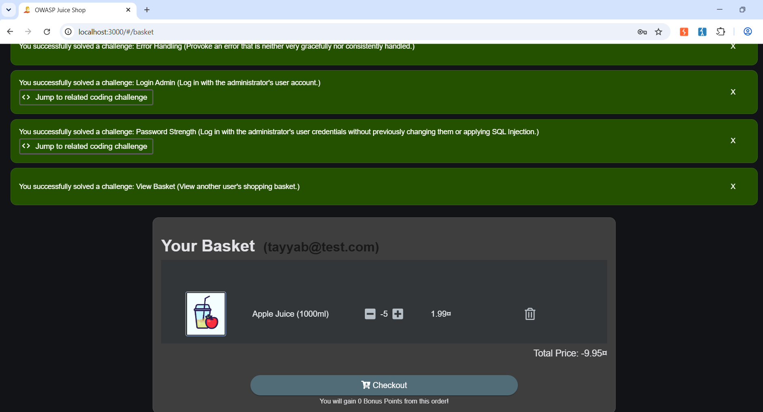
Fig 1 — Tampered basket showing negative quantity and negative total price
Why This Actually Matters
This is basically the textbook argument for why you can never trust anything coming from the client, no matter how it's packaged — a hidden form field, a cookie, or a query parameter, it's all still just text that a user can open in dev tools or a proxy like Burp and rewrite before it ever reaches your server. The moment a backend uses that value directly for something that affects money, permissions, or roles without checking it again server-side, it's handing control of that decision to whoever's on the other end of the request. Today's basket example is a mild version of it — a negative quantity turning into a negative total — but the exact same gap is what lets people push a role field from 'user' to 'admin' or knock a product's price down to zero right before checkout.
Reflection
Up until now most of what I'd tried felt like it was happening 'behind the scenes' — network scans, that kind of thing. This one felt different because I could actually watch cause and effect: change one number in Repeater, hit forward, and watch the total price on the actual page flip into the negatives in real time. It made the whole 'never trust client input' rule click in a way that just reading about it in the OWASP docs didn't.

