**Project Documentation**

**Nature Wonders Website**

**Web Engineering**

**Submitted to:**

MS Aqsa Ejaz

**Submitted by:**  
 Tayyab Mehmood

**BSCS (6-C)**

**Project Overview**

The **Nature Wonders** website is a visually appealing, interactive platform designed to showcase the beauty of nature through a collection of images and informative content. The website features a responsive gallery of famous natural wonders from around the world and provides a seamless user experience with easy navigation and interactivity.

**Features**

* **Interactive Gallery**: A responsive image gallery displaying nature-related images such as forests, mountains, and oceans, with hover effects for enhanced user interaction.
* **Informative Tables**: A table presenting famous natural wonders along with their locations and interesting facts.
* **External Links**: Quick access to external resources for further exploration on nature and wildlife conservation.
* **Responsive Design**: The website is fully optimized for mobile and desktop devices, providing an excellent viewing experience across different screen sizes.
* **Visual Effects**: Modern design elements such as smooth hover transitions and image scaling for an engaging user interface.

**Technology Stack**

* **HTML5**: Used to structure the content of the website.
* **CSS3**: Employed for styling, layout design, and responsive features. Modern CSS techniques such as flexbox and media queries are used for flexible layout adjustments.
* **JavaScript**: Provides interactive functionality, specifically for the gallery lightbox effect where images expand when clicked.
* **Responsive Web Design**: Ensures that the website adjusts its layout according to the screen size, enhancing usability on mobile devices.

**Code Explanation**

**HTML Structure**

* **Header**: Contains a welcoming message and the website title. The header uses a green background color to align with the theme of nature.
* **Main Content**: Includes a short introduction to nature’s wonders, a table listing famous natural landmarks (with information on location and interesting facts), and a gallery showcasing various images of natural landscapes.
* **Gallery Section**: Displays images such as forests, mountains, waterfalls, oceans, and wildlife. The gallery is designed with a responsive layout to look great on both large and small screens.
* **Footer**: Provides navigation links to other sections of the website, such as "Home," "About Us," "Gallery," and "Contact," along with copyright information.

**CSS Styling**

* **General Styling**: The website utilizes a clean and simple design with a soothing green and white color scheme, representing the theme of nature. Typography is set to Arial, providing a modern and easy-to-read layout.
* **Gallery Styling**: The images in the gallery are styled with rounded corners and hover effects. The layout is responsive, adjusting based on the screen size.
* **Footer Styling**: The footer matches the header in color and layout, ensuring consistency. It contains links to other pages of the site, providing easy navigation.

**JavaScript Functionality**

* **Gallery Light box Effect**: JavaScript adds interactivity to the gallery. When a user clicks on an image, a modal (light box) appears, displaying a larger version of the image. Clicking on the modal closes it.
* **Smooth Transitions**: JavaScript is also used to handle transitions in the gallery, enhancing the overall user experience by making interactions more dynamic.

**Responsive Design**

The website is designed to be responsive using **CSS media queries**. This ensures that:

* On mobile devices, the layout adjusts to fit the screen size, stacking elements vertically.
* On larger screens, the gallery and other sections are displayed side by side for a more spacious and user-friendly layout.

**Screenshots**

* **Gallery View**: A clean and organized layout showcasing nature-related images in a grid format.

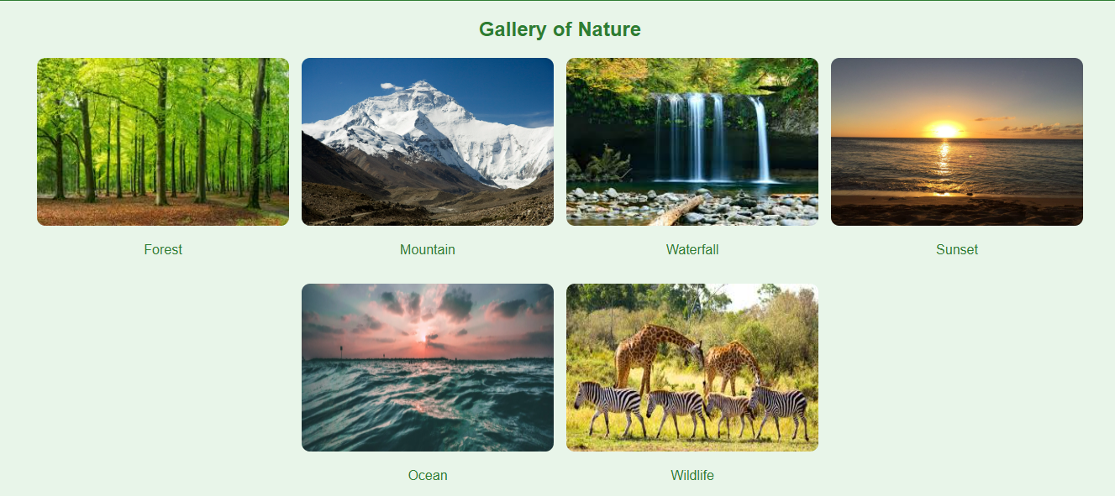

* **Mobile View**: The responsive design ensures the website looks great on smaller screens, with elements stacked vertically for easier reading and navigation.

**Future Enhancements**

* **Interactive Map**: Future versions of the website could include an interactive map where users can click on regions to learn more about specific natural wonders in that area.
* **User-Generated Content**: Allow users to upload their own photos of nature or share their experiences visiting natural wonders.
* **Additional Features**: Integration of videos or educational content like nature documentaries to further enrich the website’s offerings.

**Conclusion**

The **Nature Wonders** website is a simple yet effective platform for exploring the beauty of nature. With its responsive design, interactive gallery, and informative content, it offers an enjoyable experience for nature enthusiasts and casual visitors alike. The website can easily be expanded with additional features, such as user-generated content or multimedia resources, to make it even more engaging and informative.