**Name: Muneeb Ullah Asif Khan**

**Reg No: SP20-BSE-040**

**Use case Diagram:**

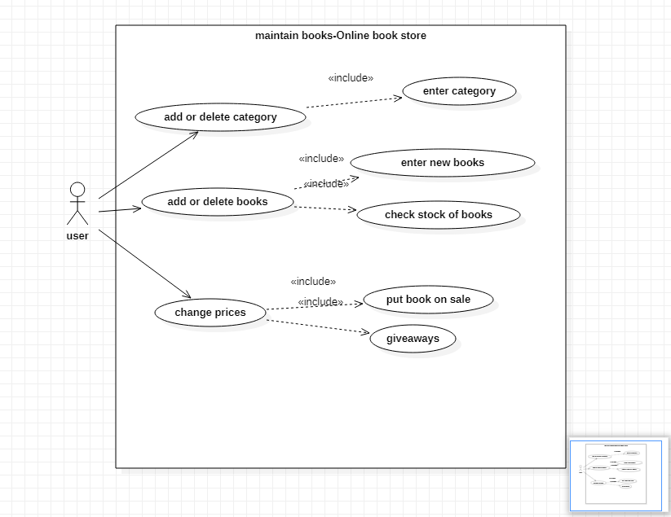

**Brief Level Points:**

Maintain books

**Brief case:**

In online book store we have use case of maintain books. In that usecase there is sub usecases like add or delete category of books like according to subjects. There is also another category that is add or delete books according to their availability and in that seller can sell books by entering books, editions and their author names into system and by checking seller can assure that book is in stock. And the other usecase is the price of book. The price of book is set by its seller and he can charge buyer by credit card or other payment methods offer by seller.

**Fully Dressed Use Case:**

|  |  |
| --- | --- |
| Use case | comments |
| Use case name | Maintain books |
| Scope | Online book store |
| Level | User goal |
| Primary actor | buyer |
| Stakeholders and interests | Seller: wants to seller books.  Buyer: wants to buy books. |
| Preconditions | Buyer and seller must be logged in. |
| postconditions | Record of seller and buyer must be added. |
| Main success scenario | Buyer places an order and admin will validate the order if all the details are correct or not. |
| Extensions | If the provided details are correct order will be cancelled. |
| Special requirements | Reliability, maintainability and usability. |

**Domain Model:**

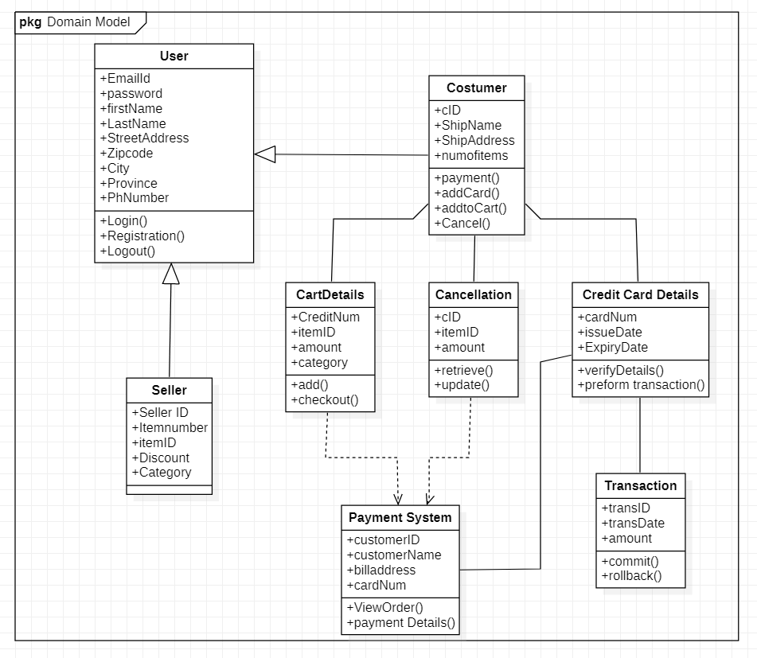

**System Sequential Diagram:**

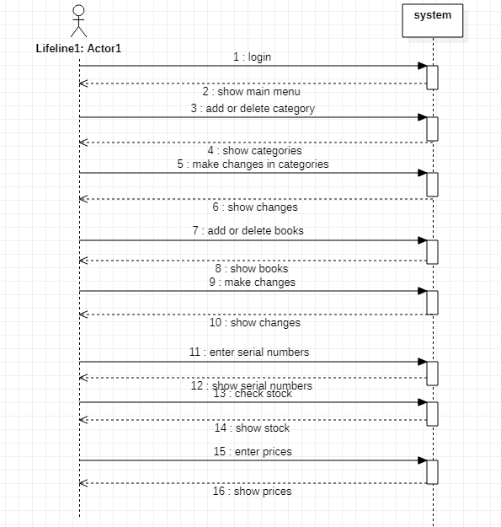

**Operation Contract:**

|  |  |
| --- | --- |
| **Operation** | Add or delete category, add or delete books and change prices |
| **Cross References** | Use Case: Maintain books |
| **Preconditions:** | Seller added the books. |
| **Postconditions:** | seller was entered the name or title of book.  Result had been displayed. |