**Name: Abdur Rehman**

**Registration number: SP20-BSE-047**

**Subject: Object Oriented Software Engineering**

**Online Book Store**

**Use Case Diagram:**

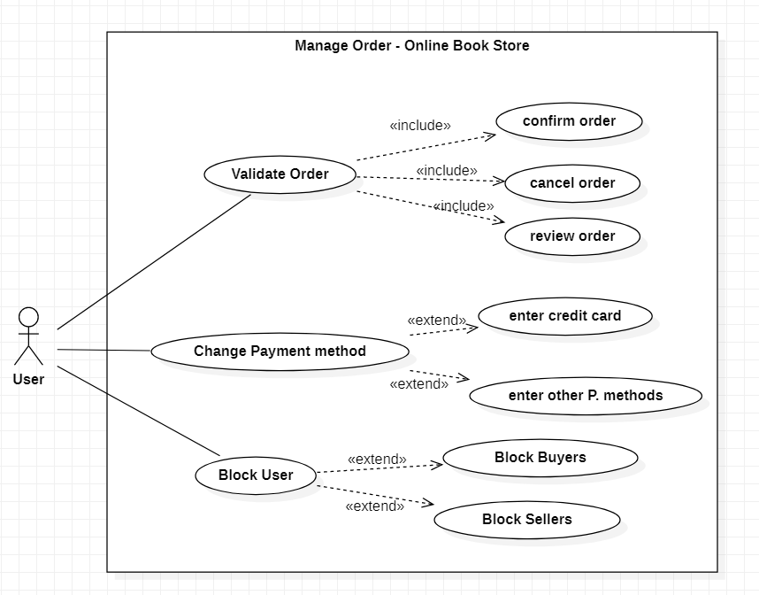

**Brief Level Points: Abdur Rehman**

Manage Order

**Brief Case:**

The buyer will search the book and will put it in the cart, then he will make a purchase and the admin will validate the payment details, if the payments details are not correct, the order will go into pending and system will notify the user to replace his/her order.

**Fully Dressed Use Case: Abdur Rehman**

|  |  |
| --- | --- |
| Name | Manage Order |
| Scope | Online Book Store |
| Level | Main use case |
| Primary Actor | Buyer |
| Stakeholders and Interests | Buyer: want to place an order.  Seller: provide the order to buyers.  Admin: Manage accounts and other details of users. |
| Preconditions | The buyer will place an order and admin will pass it to the seller, so he can provide the buyer his books. |
| Postconditions | After buyer place an order the admin will make sure to review provided details by buyer and will notify seller. |
| Main Success Scenario | Buyer places an order and admin will validate the order if all the details are correct or not. |
| Extensions | If the provided details are correct, the deal will continue or else order will be cancelled. |
| Special Requirements | Security, Reliability, Data Integrity, Availability. |
| Variations in Technology and Data | step number: possible change in technology or data format |
| Frequency of Occurrence | Continues |
| Miscellaneous | Who can join the app?  Which sellers will be allowed to sell?  What will be the stock availability? |

**Domain Model:**

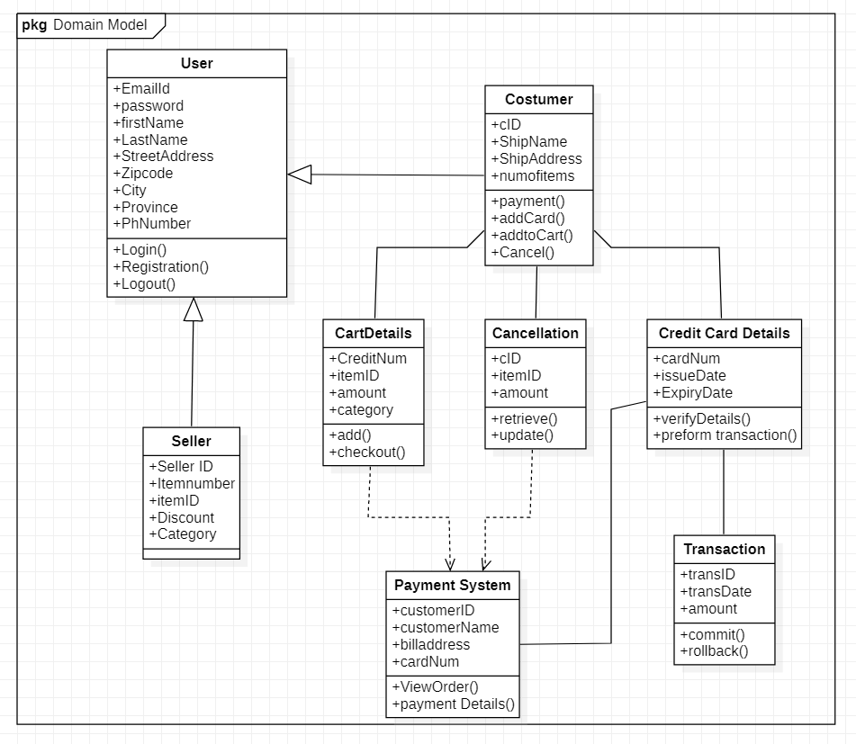

**System Sequential Diagram: Abdur Rehman**

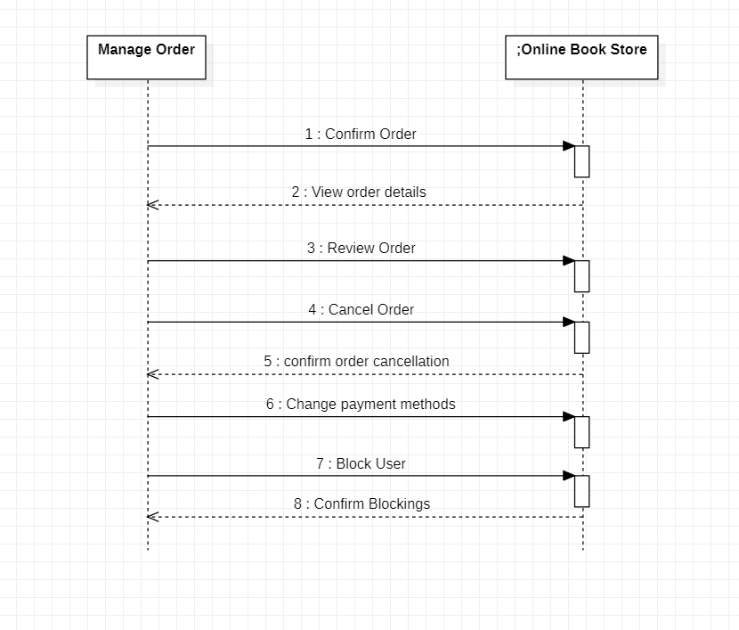

**Operation Contracts: Abdur Rehman**

|  |  |
| --- | --- |
| **Operation** | validateOrder, ChangePaymentMethod, BlockUser |
| **Cross References** | Use Case: Manage Order |
| **Preconditions:** | The buyer places an order. |
| **Postconditions:** | The admin will validate the details of buyer and the payment details, if they are correct the admin will pass the order to seller and the deal will go forward. |