Instructions:
Please read the following instructions carefully before submitting assignment:
- Check the link given below about Microsoft Visual Studio Project Creation Guidance.
https://vulms.vu.edu.pk/CourseResources/OpenFile.aspx?File=Instruction.docx.
- Check the link given below about how to run and compile a program in C#.
https://vulms.vu.edu.pk/CourseResources/OpenFile.aspx?File=C_sharp_first_program.doc
- You need to use MS word document to prepare and submit the assignment on VU-LMS.
It should be clear that your assignment will not get any credit if:
- The assignment is submitted after due date.
- The assignment is not in the required format (doc or docx)
- The submitted assignment does not open or file is corrupt.
- Assignment is copied (partial or full) from any source (websites, forums)

Objectives:
- To develop a simple WPF application in C#
- To design Graphical User interface (GUI) in XAML
- To implement ( can write code for the form’s button(s) )
- To enable to keep separate the interface design and its implementation.

If you have any confusion, you can send your query at CS411@vu.edu.pk

Lecture Topics
Lecture 12 to 15

Problem Statement:

Develop a simple Window Presentation Foundation (WPF) application containing a Graphical User Interface (FORM). This application will have two files, i.e. .XAML and .CS

Requirements:

1. .XAML file:
  - Draw three labels dictating for entering three values for Bank balance, Cash in Hand and Gold amount respectively.
  - Draw three text boxes for reading Bank balance, Cash in hand and Gold amount from users.
  - Draw a button label as “Calculate Zakat”
  - A TextBlock element (or Tag) mention the purpose of the Form
2. .CS file:
  - Declare a partial class derived from Window class
  - Default constructor of partial class which calls InitializeComponent() method
These both will declare automatically when you open a new WPF application project in C#
  - A private member method for the button that calculate the Zakat.
Hint: The zakat can be calculated by the formula (Total-amount * 2.5)/100 or dividing total amount by 40.
You need to submit a single MS Word (.doc or docx) file through LMS containing the code of both .xaml and .cs files.

Note: Do not include output screenshots in your solution.

Sample Output (Before entering data)

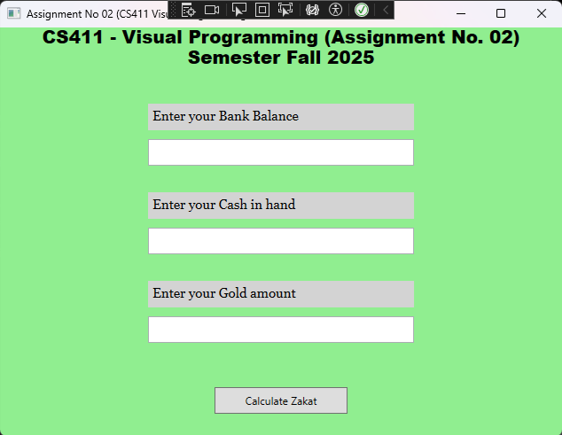

Note: Do not include output screenshots in your solution.

Sample Output (After entering data and button clicked)

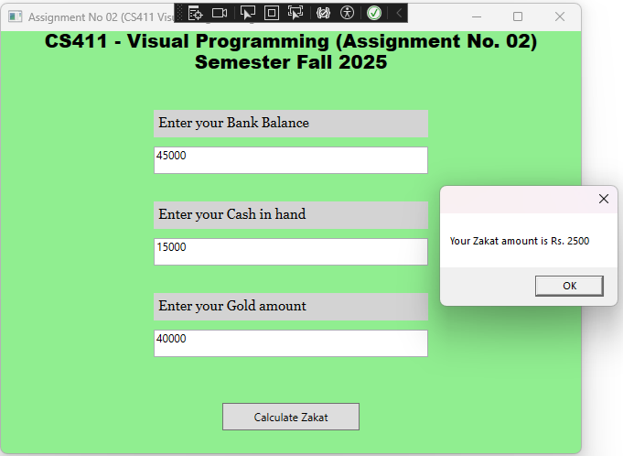

Note: Do not include output screenshots in your solution.

<============================END ==================================>

