**EDIT 1:**

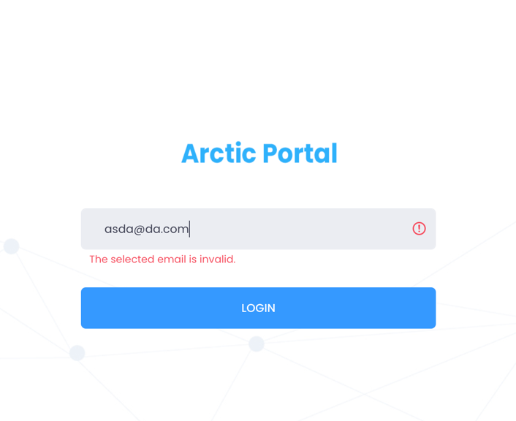

**Error message should be:**

Please enter correct email address.

**EDIT 2:**

What remember me will do??? Is there anything associated with that??

**EDIT 3:**

Dashboard needs to be dynamic

**EDIT 4:**

Although while creating project image is mandatory but validation is not shown so we can understand that its mandatory.

**EDIT 5:**

Creating project and updating is giving 500 error.

**EDIT 6:**

Errors and success message should be in sweet popups

**EDIT 7:**

* View button tracking is not added in Access logs
* Wrong email address tracking is not added in Access logs
* SMTP needs to be configured

**Messages**

<https://pixinvent.com/modern-admin-clean-bootstrap-4-dashboard-html-template/html/ltr/vertical-modern-menu-template/ex-component-toastr.html>

* **Project Update Success:**

Title: Success

Message: Project has been updated successfully.

* **User create:**

Title: Success

Message: User created successfully.

* **Email exists:**

Title: Error

Message: Please enter unique email.

* **User update:**

Title: Success

Message: User updated successfully.

**EDIT Last:**

* Email design needs to be implemented
* Needs to be migrated to live server
* SMTP needs to be configured