Fake News Detection Using AI
Software Requirements Specification

Version 1.0



Group Id: F25PROJECTB0FB6
Supervisor Name: Huma Mumtaz

Revision History
Date (dd/mm/yyyy) | Version | Description | Author
5/11/2025 | 1.0 | Introduction of the project | BC220201723

Table of Contents

- Scope (of the project)
- Functional Requirements and Non Functional requirements
- Use Case Diagram
- Usage Scenarios
- Adopted Methodology
- Work Plan (Use MS Project to create Schedule/Work Plan)

SRS Document

Scope of Project:

In this vast, digital, and interconnected world, fake news has become a significant issue, spreading misinformation and influencing public opinion, and sometimes it can create unnecessary panic in society, which is a very serious issue.
This project aims to build an AI-based solution in order to detect fake news by using Natural Language Processing (NLP) and classical supervised machine learning algorithms for classification, such as logistic regression, naive Bayes, etc. This solution will be beneficial for all, including the general public, media organizations, and researchers, to reduce the impact of fake news.
ML algorithm training will be done on publicly available datasets, and then the model will be deployed on a web-based interface where a user can enter the headline or the article paragraph to check its authenticity, and based on the user's input, the model will predict if the news is real or fake.
The system will offer two roles: User and Admin.
Users can register or log in and submit a news headline or article paragraph in order to get a Real/Fake prediction along with a confidence score, and can also view their past prediction history.
Admin is responsible for user account management, uploading new datasets, retraining the ML model, reviewing performance metrics including accuracy, precision, recall, and F1-score, and managing stored history entered by the user.
Due to time, resource, and project scope limitations, the following techniques and features are not included in this project.
- Deep learning based models
- Real-time news crawling and live data updates
- Multilingual support (English only)
- Batch predictions for users

Functional Requirements:
Admin Panel Features:
- The system shall allow access to the admin panel only to those with the correct administrative credentials in order to access the admin panel features.
- The system shall allow the admin to manage user accounts, such as add, update, and delete user accounts.
- The system shall allow the admin to upload new training datasets in CSV format only and update existing datasets with a newly uploaded dataset.
- The system shall allow the admin to retrain the ML model using uploaded datasets.
- The system shall allow the admin to view system performance metrics such as accuracy, precision, recall, and F1-score after model training is completed.
- The system shall allow the admin to generate usage reports, such as the number of analyses done per day, and export them in CSV format.
- The system shall allow the admin to view, manage, or delete the selected or all the history of analyzed articles.
- To ensure data security and privacy, the system shall ensure that only an admin can access the admin panel, and users' passwords will be hashed.
User Panel Functionalities:
- The system shall allow the user to register a new account with a unique username, and the password must be greater than 8 characters and contain at least one special character, or the admin can manually register (add) the user in the system.
- The system shall allow the user to log in securely using their credentials after registration.
- The system shall provide an interface that allows the user to input news articles or headlines for analysis.
- The system shall provide the user with the result as Real or Fake after the input of new articles or headlines, and receive classification results with a confidence score.
- The system shall allow the user to view their previously analyzed articles or headlines in history.
- The system shall allow the user to test the system using the sample datasets/text (some articles or headlines as text, not in CSV format). This sample will also be provided to the user by the system.
- The system shall allow the user to view results of the analysis, either Real or Fake, in graphical form (charts, graphs).
- The system shall allow the user to export the results of their analysis in CSV or Excel format.
- The system shall display error messages if input is invalid or unsupported, which could result from invalid language entered or if the input text is very short, less than the minimum length.
Non-Functional Requirements:
Performance:
- The system shall classify the standard-length news articles or paragraphs within 2-7 seconds.
Usability:
- The UI must be intuitive and user-friendly for both technical and non-technical users and provide consistent navigation and layout across all pages.
Compatibility:
- The system should be accessible through most major web browsers (Chrome, Edge, Firefox) on desktop.
Security:
- Admin functionalities must be protected by role-based access control.
- Password hashing must be implemented for both admin and user.
Maintainability:
- Best Practices of software engineering will be followed during the implementation in order to increase the maintainability of the system.
- A modular code structure will be practiced for easier updates and debugging.

Use Case Diagram(s):

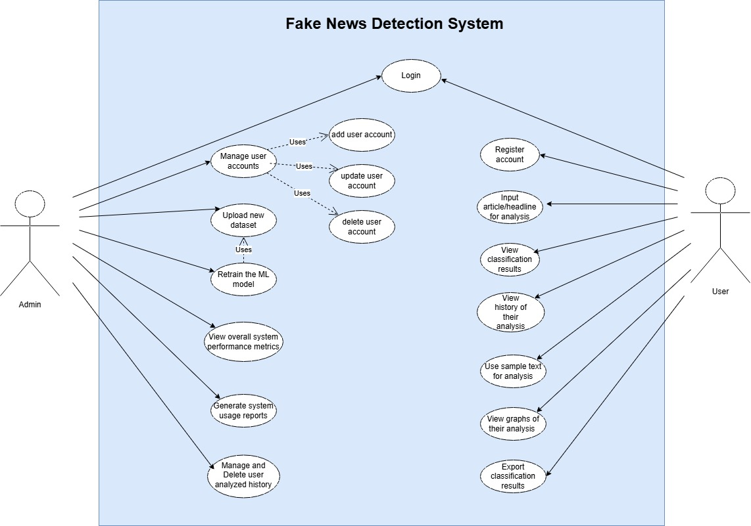
Usage Scenarios:

Use Case Title | Manage user accounts
Use Case ID | UC-01
Actors | Admin
Description | The admin will be able to add, edit or delete user accounts for the system.
Precondition | Admin must be logged in first in the system.
Actions | - The admin logs into the system.  - The admin clicks on Manage user accounts tab.  - The admin selects Add user/Edit user/Delete user  If the admin selects Add user or Edit user then they fill a form to add or edit the user account in the system.  - Save changes.
Postcondition | User data is updated in the system
Alternative Paths | The system shows an error if the user already exists.
Exception | Database is unavailable.
Author | Muhammad Tayyar Hussain BC220201723

Use Case Title | Upload new dataset
Use Case ID | UC-02
Actors | Admin
Description | The admin uploads a new CSV dataset file for model retraining in the system.
Precondition | The file must be in CSV format
Actions | - The admin logs into the system.  - The admin selects a file for model retraining.  - The admin uploads the file in the system.  - The system validates whether the uploaded file is in CSV format.  - If it is in CSV format then it is stored in the system.
Postcondition | Data is successfully stored for model retraining.
Alternative Paths | If format validations fails, then an error message will be shown to the admin to re-upload the dataset file in CSV format.
Exception | Incorrect or corrupted file format uploaded.
Author | Muhammad Tayyar Hussain BC220201723

Use Case Title | Retrain the ML model
Use Case ID | UC-03
Actors | Admin
Description | The admin retrains the machine learning model on the system using the dataset uploaded by him in UC-02.
Precondition | The dataset must be uploaded and stored in the system before model retraining.
Actions | - The admin logs into the system.  - The admin navigates to Model retraining tab.  - The admin clicks on Retrain model button.  - The system will start the retraining process and display a progress or a message indicating that the model is being retrained.
Postcondition | The system generates and updates performance metrics after retraining completes, saves the updated model for future predictions  and then displays a message to show that model retraining was successful.
Alternative Paths | If model retraining takes too much time then system will show a message.
Exception | Model retraining failed.
Author | Muhammad Tayyar Hussain BC220201723

Use Case Title | View overall system performance metrics
Use Case ID | UC-04
Actors | Admin
Description | The admin views the overall system performance metrics after retraining.
Precondition | The dataset must be uploaded and stored in the system before model retraining.
Actions | - The admin logs into the system.  - The admin navigates to performance metrics tab and clicks it.  - The system loads the performance metrics and shows it.
Postcondition | The system will show performance metrics to admin.
Alternative Paths | If there are no metrics available the system will show “No performance data available” message.
Exception | The system fails to load performance metrics.
Author | Muhammad Tayyar Hussain BC220201723

Use Case Title | Generate system usage reports
Use Case ID | UC-05
Actors | Admin
Description | The admin will generate system usage report such as daily prediction count, active users, etc.
Precondition | The system should maintain a record in a database or activity log.
Actions | - The admin logs into the system.  - The admin navigates to Generate System Usage Report tab.  - The system will export the reports in CSV format.
Postcondition | The system produces system usage reports.
Alternative Paths | The admin selects wrong date range.
Exception | Failed to export the reports.
Author | Muhammad Tayyar Hussain BC220201723

Use Case Title | Manage and Delete user analyzed history
Use Case ID | UC-06
Actors | Admin
Description | The admin deletes selected or all user analysis history.
Precondition | User analysis history should exist in the database or log.
Actions | - The admin logs into the system.  - The admin navigates to Manage user history tab.  - The admin can then select a few entries to delete or select all entries of the user analyzed history.
Postcondition | The system updates the history in database.
Alternative Paths | The admin can cancel the deletion process.
Exception | Database write error.
Author | Muhammad Tayyar Hussain BC220201723

Use Case Title | Register account
Use Case ID | UC-07
Actors | User
Description | The user can register a new account with username and password.
Precondition | The selected username must be unique and password must meet the criteria.
Actions | - The user navigates to user register account button and clicks it.  - The user will enter the details.  - The system will validate these details.  - After validation the system will save these details in the database.  - The user receives a confirmation message.
Postcondition | The user account is created successfully.
Alternative Paths | The system shows a message that your selected password is weak.
Exception | The system shows a message that username is already taken.
Author | Muhammad Tayyar Hussain BC220201723

Use Case Title | Login
Use Case ID | UC-08
Actors | Admin and User
Description | Both admin and user can log in into the system using their valid credentials.
Precondition | - User must be registered in the system.  - Admin must be registered with administrative privileges.
Actions | - Admin or User navigate to login page and enter their credentials.  - The system takes these credentials and authenticates them.  - After the authentication the system loads their respective page/dashboard.
Postcondition | The admin or user is logged in.
Alternative Paths | The admin or user enters incorrect username.
Exception | The admin or user enters incorrect password.
Author | Muhammad Tayyar Hussain BC220201723

Use Case Title | Input article/headline for analysis
Use Case ID | UC-09
Actors | User
Description | The user enters article/headline for fake-news detection.
Precondition | Input must satisfy the required length to use fake-news detection system.
Actions | - The user logs into the system.  - The user navigates to input text form and enters the input.  - The user clicks the Analyze button.  - The system takes the input and processes it.
Postcondition | The ML model will predict whether the article/headline is real or fake.
Alternative Paths | If the user enters a very long article.  - The system shows an error that the input text is too long and instruct the user to shorten it.  - Or The system automatically trims the input text.
Exception | The user entered empty text or an unsupported language.
Author | Muhammad Tayyar Hussain BC220201723

Use Case Title | View classification results
Use Case ID | UC-10
Actors | User
Description | The user can see classification/prediction results and confidence score.
Precondition | The user has entered the input and submitted it.
Actions | - The user navigates to Classification/Prediction result tab and clicks it.  - The system fetches the latest prediction and displays it.
Postcondition | The system displays results as Real or Fake along with the confidence score.
Alternative Paths | No results to show.
Exception | The ML model is not loaded in the system.
Author | Muhammad Tayyar Hussain BC220201723

Use Case Title | View history of their analysis
Use Case ID | UC-11
Actors | User
Description | The user can see a list of all the previously analyzed input.
Precondition | The user must be logged in.
Actions | - The user navigates to analysis history tab and clicks it.
Postcondition | The system displays the history of their analysis.
Alternative Paths | The system shows a message that history is empty for the user.
Exception | Database fetching error occurred.
Author | Muhammad Tayyar Hussain BC220201723

Use Case Title | Use sample text for analysis
Use Case ID | UC-12
Actors | User
Description | The user tests the system using built-in sample text provided.
Precondition | - The user logs into the system.  - Sample dataset/text should be provided.
Actions | - The user navigates to test the system tab and clicks it.  - The user selects article or headline to test it.
Postcondition | The system displays the prediction result (Real/Fake) with the confidence score.
Alternative Paths | The sample text list is empty then system shows a message No sample text available.
Exception | ML model fails to load.
Author | Muhammad Tayyar Hussain BC220201723

Use Case Title | View graphs of their analysis
Use Case ID | UC-13
Actors | User
Description | The user views the graphs/charts of their predictions. (of all the previously analyzed input)
Precondition | At least one prediction should exist in the system.
Actions | - The user logs into the system.  - The user navigates to View graphs tab.  - The system fetches the data from the database and generates charts/graphs.  - The system displays these to the user.
Postcondition | The system displays the graphs/charts of their analysis.
Alternative Paths | The system shows a message that no data is available or no graph to show.
Exception | The system throws an error if a graph cannot be generated.
Author | Muhammad Tayyar Hussain BC220201723

Use Case Title | Export classification results
Use Case ID | UC-14
Actors | User
Description | The user exports prediction/classification results to CSV or Excel format.
Precondition | Prediction/Classification history should exist in the system.
Actions | - The user logs into the system.  - The user navigates to the Export results tab and clicks it.  - The system shows the available export options (CSV/Excel).  - The user selects any of the options given.  - The system generates the file in the selected format and downloads to the user’s device.
Postcondition | Exported file is downloaded successfully.
Alternative Paths | The user cancels the export file.
Exception | The system throws file export error.
Author | Muhammad Tayyar Hussain BC220201723

Adopted Methodology:
The adopted methodology for this project is the VU Process Model, it is a combination of the Waterfall Model and Spiral Model

Waterfall Model:
It provides a structured, sequential flow for a project where requirements are well.
understood and does not change, which ensures that from Requirements to Deployment
follow a disciplined order.
Each phase of the waterfall model is heavily documented before going to the next phase.

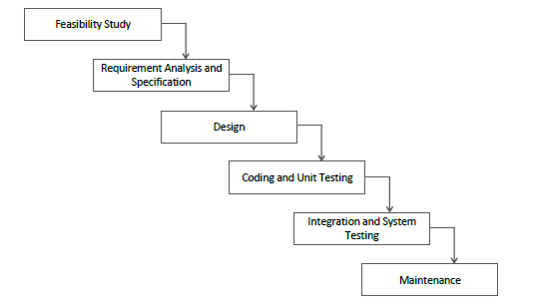
Waterfall Model

Spiral Model:
The spiral model is a risk-driven software development process model.
It adds risk assessment, allows cyclic refinement, and provides frequent feedback loops.
All of the mentioned characteristics above are suitable for the Machine Learning model development, where experimentation is required.

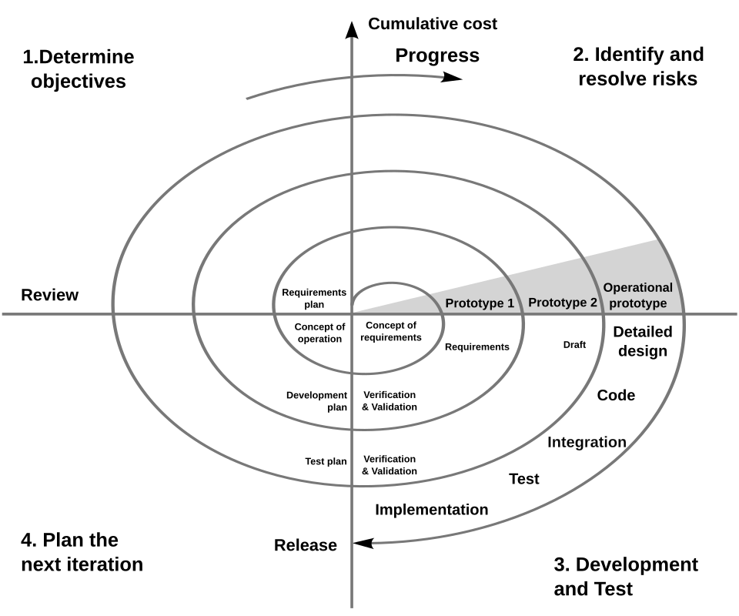
Spiral Model
VU Processes Model:
For the development of this project VU Process Model is followed.
The Waterfall Model component will provide a clear sequence of phases.
Feasibility study, Requirements analysis, Design, Coding, Testing, Integration, Deployment, and Maintenance, which ensures that each stage is completed with proper deliverables.
The Spiral Model component will provide a loop in the whole project lifecycle, which allows early identification and mitigation of risks, in our case, continuous evaluation of the ML model’s performance, and improvement of it through feedback from the prototypes.
By combining these process models, it ensures a balance between systematic project development and the flexibility required for experimentation, especially in Machine learning model training.

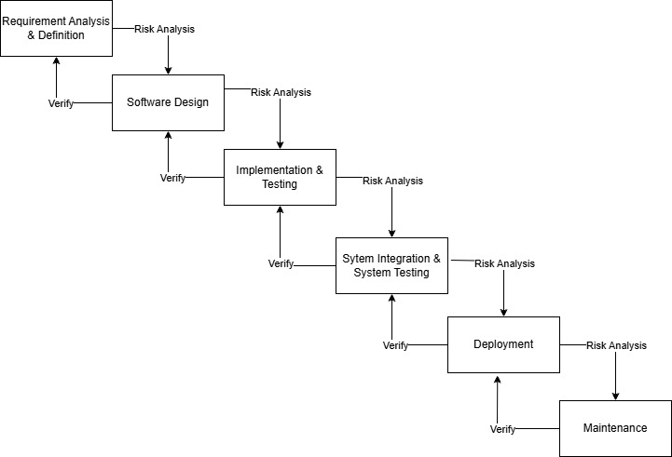
VU Process Model

Work Plan:

Weekend days are considered off in this graph
