

A

MINI PROJECT REPORT

On

# “Reader space”

# SUBMIITED BY

# ABDUL TAYYEB (1132190324)

# DEEPAK KUMAR (1132190033)

# RONAK GOHIL (1132190377)

**IN PARTIAL FULFILLMENT OF MASTER OF COMPUTER APPLICATIONS (MCA)**

**THROUGH**

**FACULTY OF SCIENCE**

**SCHOOL OF COMPUTER SCIENCE**

**2020-2021**

**TO DR. VISHWANATH KARAD MIT- World Peace University**

# CERTIFICATE

This is to certify that Mr. / Ms. / Mrs. **Abdul Tayyeb**

Of **MIT-WPU School of Computer Science** has successfully completed the Mini project work titled

# “Reader space”

In partial fulfilment of requirement of the award of **MCA** prescribed by the **MIT World Peace University, Pune**.

This project is the record of authentic work carried out by him / her out during the academic year **2020-2021**

|  |  |  |  |
| --- | --- | --- | --- |
| **Dr. Anuradha Kanade Internal Project Guide Faculty of Science** | **Dr. Rajeshree khande**  **AHOS**  **School of Computer Science** | **Dr. C. H. Patil Head of**  **School Faculty of Science** | **Dr. Shubhalaxmi Joshi Associate**  **Dean Faculty**  **of Science** |

# CERTIFICATE

This is to certify that Mr. / Ms. / Mrs. **Deepak Kumar**

Of **MIT-WPU School of Computer Science** has successfully completed the Mini project work titled

# “Reader space”

In partial fulfilment of requirement of the award of **MCA** prescribed by the **MIT World Peace University, Pune**.

This project is the record of authentic work carried out by him / her out during the academic year **2020-2021.**

|  |  |  |  |
| --- | --- | --- | --- |
| **Dr. Anuradha Kanade Internal Project Guide Faculty of Science** | **Dr. Rajeshree khande**  **AHOS**  **School of Computer Science** | **Dr. C. H. Patil Head of**  **School Faculty of Science** | **Dr. Shubhalaxmi Joshi Associate**  **Dean Faculty**  **of Science** |

# CERTIFICATE

This is to certify that Mr. / Ms. / Mrs. **Ronak Gohil**

Of **MIT-WPU School of Computer Science** has successfully completed the Mini project work titled

# “Reader space”

In partial fulfilment of requirement of the award of **MCA** prescribed by the **MIT World Peace University, Pune**.

This project is the record of authentic work carried out by him / her out during the academic year **2020-2021**

|  |  |  |  |
| --- | --- | --- | --- |
| **Dr. Anuradha Kanade Internal Project Guide Faculty of Science** | **Dr. Rajeshree khande**  **AHOS**  **School of Computer Science** | **Dr. C. H. Patil Head of**  **School Faculty of Science** | **Dr. Shubhalaxmi Joshi Associate**  **Dean Faculty**  **of Science** |

# CERTIFICATE OF COMPLETION

This is to certify that Mr. / Ms. / Mrs.___ __**Abdul Tayyeb**_______ **___**Of **MIT-WPU**

**School of Computer Science** has successfully completed the Mini project work titled

# “Reader space”

In partial fulfilment of requirement of the award of **MCA** prescribed by the **MIT World Peace University, Pune.**

This project is the record of authentic work carried out by him / her out during the academic

year **2020-2021**.

**Authorized signature with stamp**

# CERTIFICATE OF COMPLETION

This is to certify that Mr. / Ms. / Mrs.___ **___Deepak Kumar**_**_________**

Of **MIT-WPU School of Computer Science** has successfully completed the Mini project work titled

# “Reader space”

In partial fulfilment of requirement of the award of **MCA** prescribed by the **MIT World Peace University, Pune.**

This project is the record of authentic work carried out by him / her out during the academic year **2020-2021**.

**Authorized signature with stamp**

# CERTIFICATE OF COMPLETION

This is to certify that Mr. / Ms. / Mrs.___ __**Ronak Gohil**________**____**

Of **MIT-WPU School of Computer Science** has successfully completed the Mini project work titled

# “Reader space”

In partial fulfilment of requirement of the award of **MCA** prescribed by the **MIT World Peace University, Pune.**

This project is the record of authentic work carried out by him / her out during the academic year **2020-2021**.

**Authorized signature with stamp**

# DECLARATION

I, Mr./Ms./Mrs. . **Abdul tayyeb** hereby declare that this project is the record of authentic work carried out by me during the academic year **2020-2021**. This project is **plagiarism-free** and has not been submitted to any other university or institute toward the award of any degree.

**Signature of the student**

(Abdul tayyeb)

**PRN No**: 1132190324

# DECLARATION

I,Mr./Ms./Mrs. . **Deepak Kumar** hereby declare that this project is the record of authentic work carried out by me during the academic year **2020-2021**. This project is **plagiarism-free** and has not been submitted to any other university or institute toward the award of any degree.

**Signature of the student**

(Deepak Kumar)

**PRN No**: 1132190033

# DECLARATION

I, Mr./Ms./Mrs. . **Ronak Gohil** hereby declare that this project is the record of authentic work carried out by me during the academic year **2020-2021**. This project is **plagiarism-free** and has not been submitted to any other university or institute towards the award of any degree.

**Signature of the student**

(Ronak Gohil)

**PRN No**: 1132190377

**ACKNOWLEDGMENT**

In the accomplishment of this project successfully, many people have best owned upon me their blessings and the heart pledged support, this time I am utilizing to thank all the people who have been concerned with project.

The success and final outcome of this project required a lot of guidance and assistance from many people and I am extremely privileged to have got this all along the completion of my project. All that I have done is only due to such supervision and assistance.

My sincere thanks also goes to **Dr. C.H. Patil** for supporting the Mini Project from the college in this pandemic situation.

I owe my deep gratitude to our Mini project guide **Dr. Anuradha Kanade** who took keen interest on our project work and guided us all along, till the completion of our project work by providing all the necessary information.

# TABLE OF CONTENTS

|  |  |  |
| --- | --- | --- |
| **Sr .No** | **Title** | **Page No.** |
| **1** | **Introduction** | **13-17** |
| 1.1 | Problem Statement | 13 |
| 1.2 | Proposed system | 14 |
| 1.3 | Product Description | 14 |
| 1.4 | Scope of Work | 15 |
| 1.5 | Operating Environment | 16 |
| 1.6 | Description of technology Used | 17 |
|  |  |  |
| **2** | **Analysis & Design** | **19-39** |
| 2.1 | Data Flow Diagram (DFD) | 19 |
| 2.2 | ER Diagrams | 21 |
| 2.3 | Activity diagram | 22 |
| 2.4 | Use case diagram | 23 |
| 2.5 | Class diagram | 24 |
| 2.6 | Sequence diagram | 24 |
| 2.7 | Table Specification | 37 |
| 2.8 | Test procedures and implementation (screens etc.) | 39 |
| 2.9 | Test Cases | 41 |
|  |  |  |
| **3** | **Drawbacks and limitations** | **42** |
| **4** | **Future enhancement** | **43** |
| **5** | **Conclusions** | **44** |
| **6** | **Bibliography** | **45** |

# Introduction

#### **1.1 Problem Statement**

* The world of literature is booming. Through the internet, millions of books are made available to readers.
* These evolutions in the literature confused the readers that which book is most relevant with their interests.
* That's why a common platform is necessary through which the readers can see thousands of books as well as a short description. Also, users can see the reviews given by other readers and can provide their own opinion to the books which they have read.

#### **1.2 Proposed System**

The proposed system is a globalized website that contains reviews of new books. It will also help the user to know the book details and review of the books given by the users who have already read the book.

#### **1.3 Product Description**

* Reader Space is an online book review website which facilitates the reader to browse the books and check the book detail such as title, description, author name, etc. Also, the user will be able to give the review of the book which the user has already read.
* The system also provides REST API for the developers containing data of book and user review etc. The proposed system is a globalized-website that contains reviews of new books.
* It will also help the user to know the book details and review of the books given by the users who have already read the book.

#### **1.4 Scope of Work**

Scope of this project is very broad in terms of other manually checking yourself. Few of them are :-

* The main purpose of this project is to provide a platform for the readers to help them find the perfect book for their next reading journey.
* The API from Goodreads makes it a more powerful platform to get to know about the user's opinion on the book by having data like average ratings and total ratings.
* This Project also provides a facility to user for giving there reviews and rating on a particular book.
* Along with the ratings from Goodreads the user will also be able to see the reviews of other users of the system.
* The system is fully responsive keeping into the mind of various device compatibility. It is a Web-based application so can be accessed by any browser.
* For the developer community, this system also provides a REST API available for everyone.
* Bulk insertion is also made possible through CSV file.

#### **1.5 Operating Environment**

#### **Hardware Requirements :**

* + **Processor:** Intel Pentium and above
  + **RAM:** 1GB and above
  + **HDD:** 64GB and above

#### **Software Requirements :**

* + **Web Browser :** Google Chrome, Mozilla Firefox
  + **OS:** Windows, Linux, MacOS
  + **Database:** PostgreSQL

#### **Tools and Environment :**

* + **Front-End:** Html 5, SASS, Bootstrap 4, jQuery
  + **Back End :** Python
  + **Framework :** Flask
  + **Library :** SQL Alchemy
  + **Web Server :** Flask
  + **Database Server :** Heroku_Postgres
  1. **Description of Technology Used**

#### **Python**

* Python is a general-purpose interpreted, interactive, object-oriented, and high-level programming language. It was created by Guido van Rossum during 1985- 1990. Like Perl, Python source code is also available under the GNU General Public License (GPL). This tutorial gives enough understanding on Python programming language.

#### **Flask**

* Flask is a web application framework written in Python. It is developed by **Armin Ronacher**, who leads an international group of Python enthusiasts named Pocco. Flask is based on the Werkzeug WSGI toolkit and Jinja2 template engine.

#### **SQLAlchemy**

* SQLAlchemy is a popular SQL toolkit and Object Relational Mapper. It is written in Python and gives full power and flexibility of SQL to an application developer. It is an open source and cross-platform software released under MIT license. SQLAlchemy is famous for its object-relational mapper (ORM), using which classes can be mapped to the database, thereby allowing the object model and database schema to develop in a cleanly decoupled way from the beginning.

#### **HTML**

* Hypertext Markup Language (HTML) is the standard markup language for creating web pages and web applications. With Cascading Style Sheets (CSS) and JavaScript, it forms a triad of cornerstone technologies for the World Wide Web.
* Web browsers receive HTML documents from a web server or from local storage and render the documents into multimedia web pages. HTML describes the structure of a web page semantically and originally included cues for the appearance of the document.

#### **SASS**

* SASS (Syntactically Awesome Stylesheet) is a CSS pre-processor, which helps to reduce repetition with CSS and saves time. It is more stable and powerful CSS extension language that describes the style of a document cleanly and structurally.
* It was initially designed by Hampton Catlin and developed by Natalie Weizenbaum in 2006. Later, Weizenbaum and Chris Eppstein used its initial version to extend the Sass with SassScript.

**Postgres**

* PostgreSQL is a powerful, open source object-relational database system. It has more than 15 years of active development phase and a proven architecture that has earned it a strong reputation for reliability, data integrity, and correctness.

**2. Analysis of the system**

**2.1 Data Flow Diagram (DFD)**

**Context Level Data Flow Diagram (DFD)**

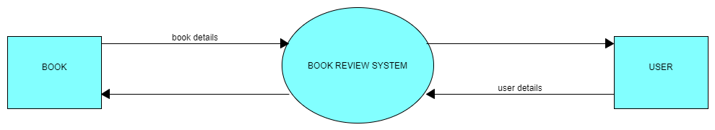

**First Level Data Flow Diagram (DFD)**

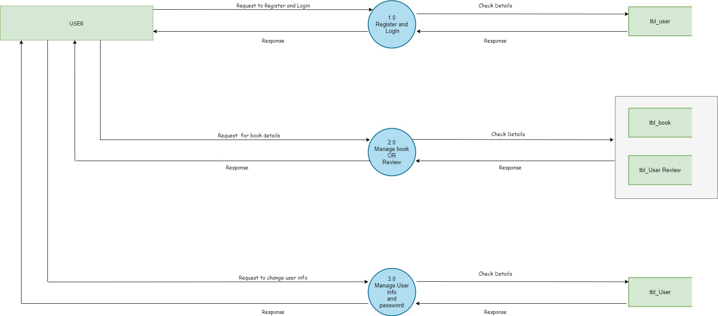

**Second Level Data Flow Diagram (DFD)**

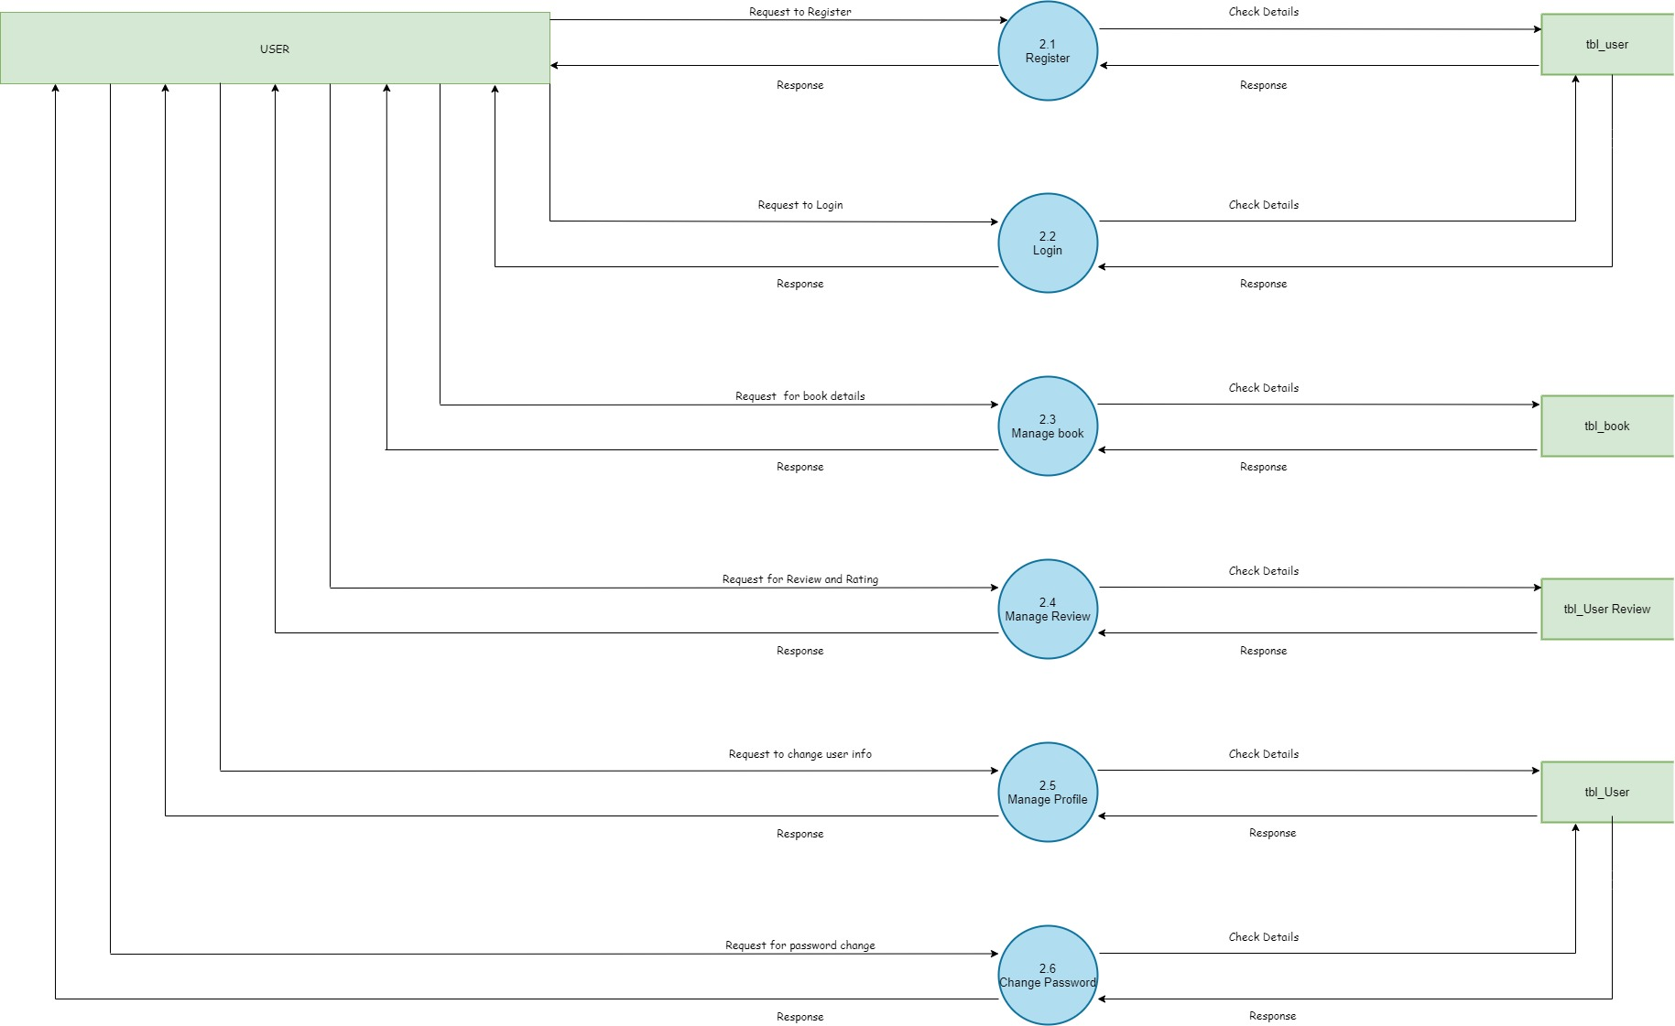

**2.2 ER Diagram**

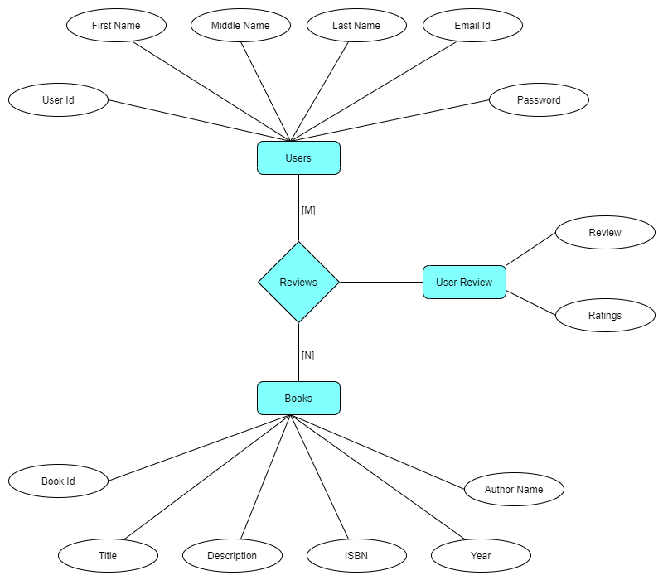

**Design**

**2.3 Activity Diagram**

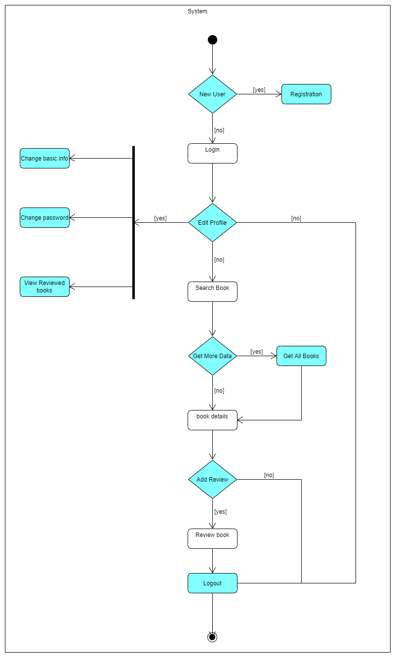

**2.4 Use Case Diagram**

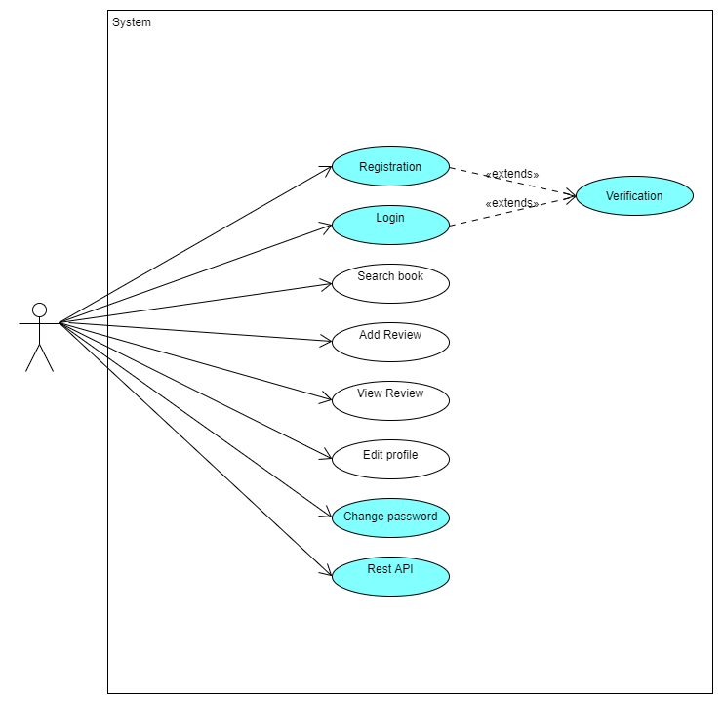

**2.5 Class Diagram**

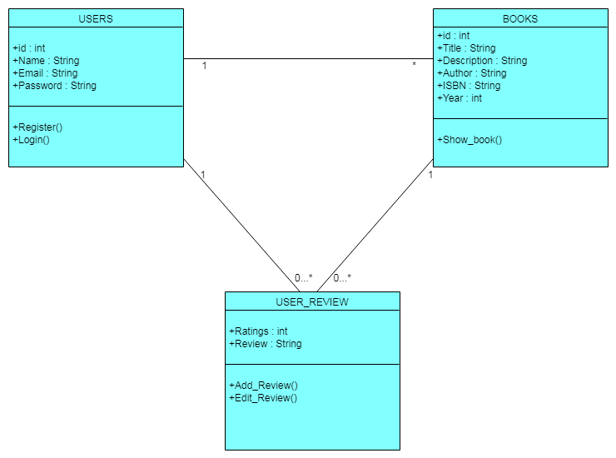

**2.6 Sequence Diagram**

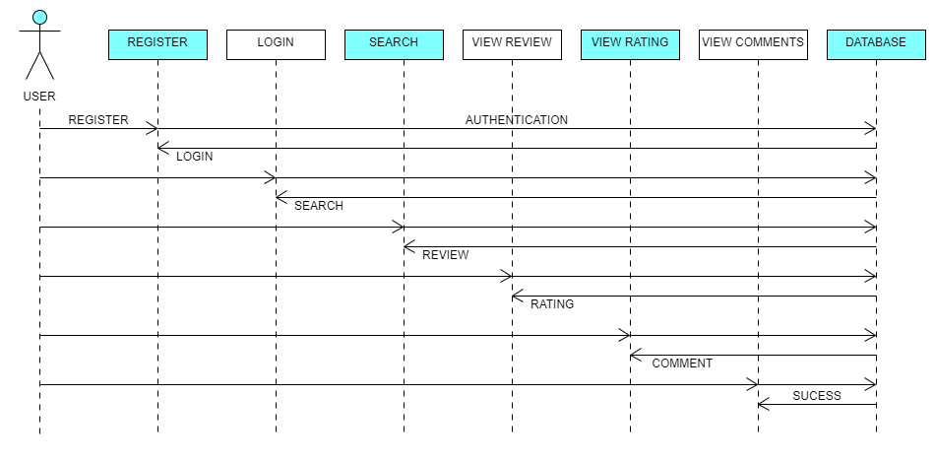

**Signup**

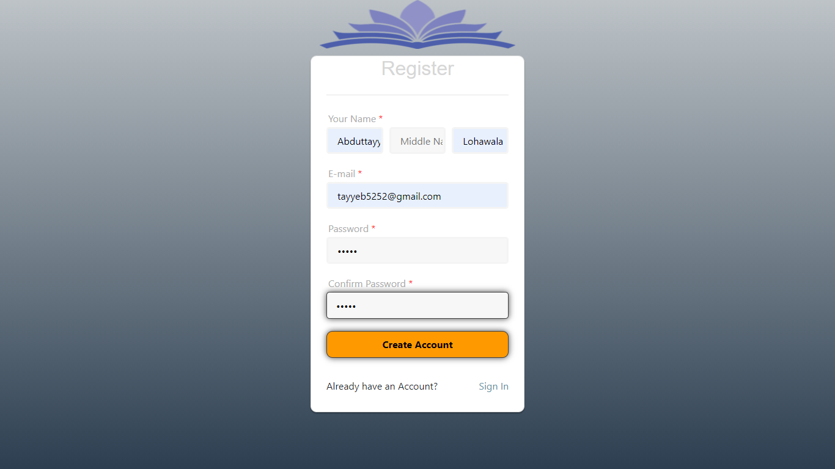

**Sign In**

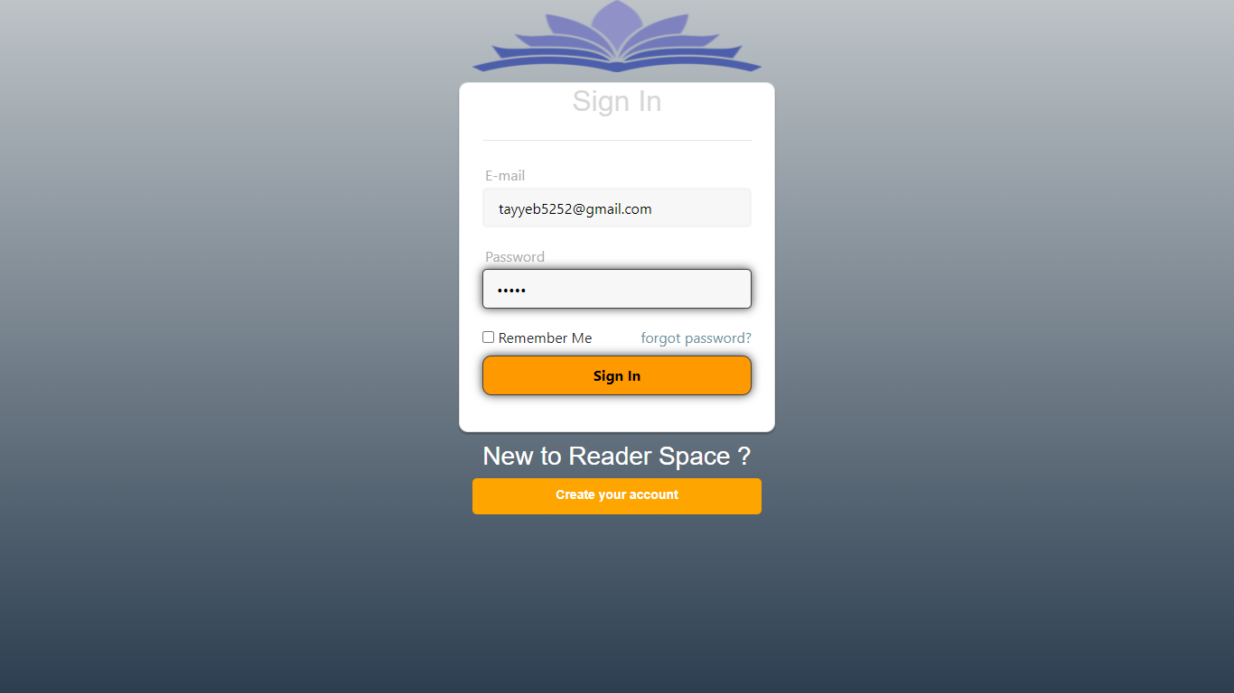

**Home Page**

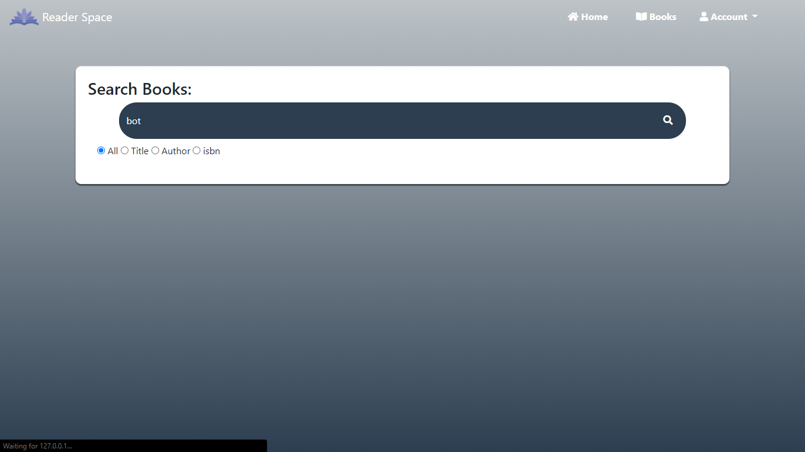

**Profile Page**

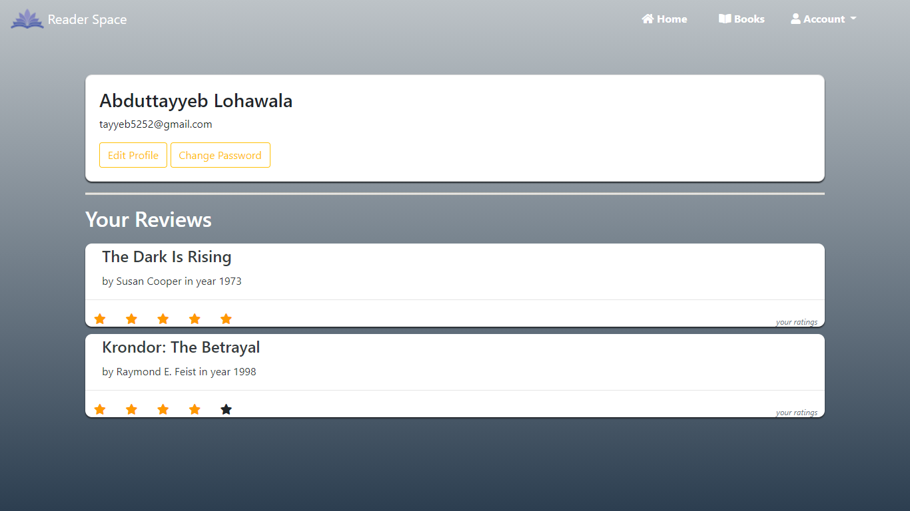

**Edit Profile**

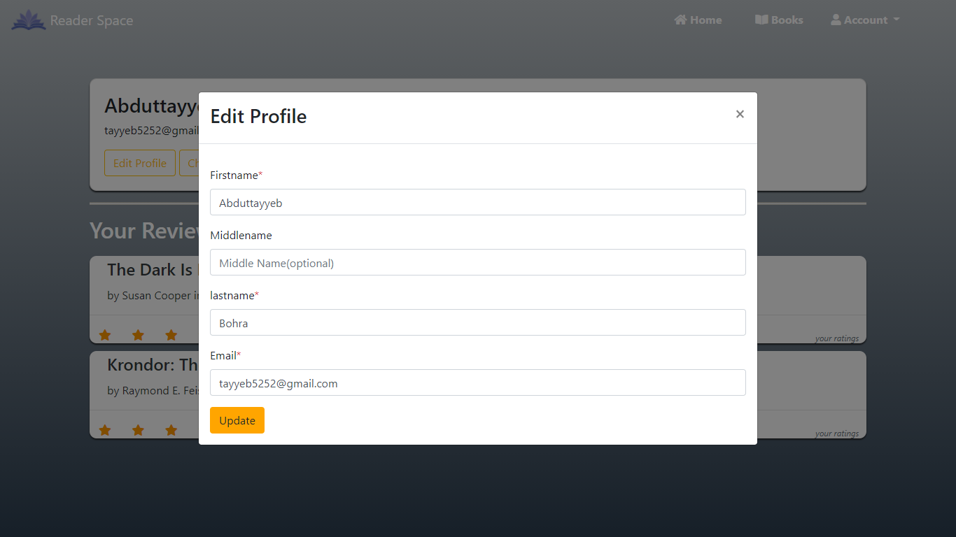

**Change Password**

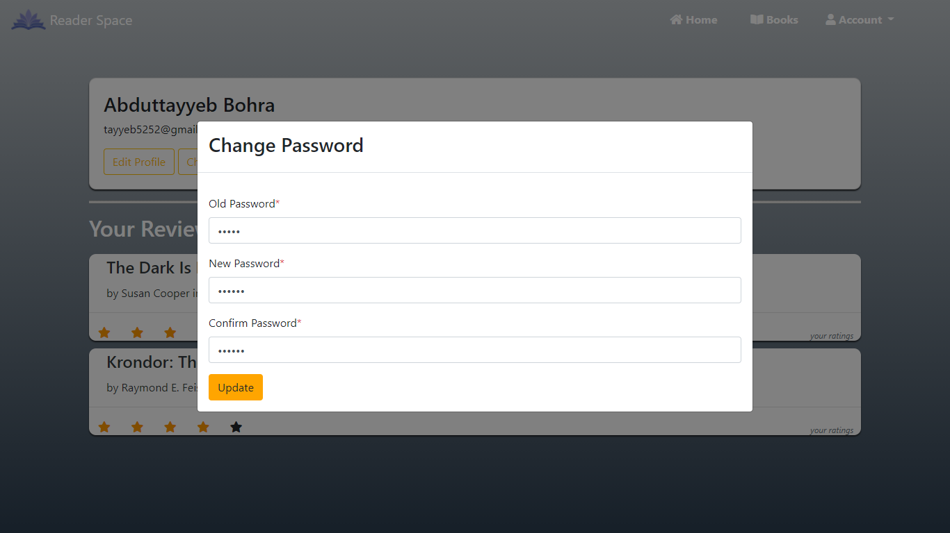

**Search Result**

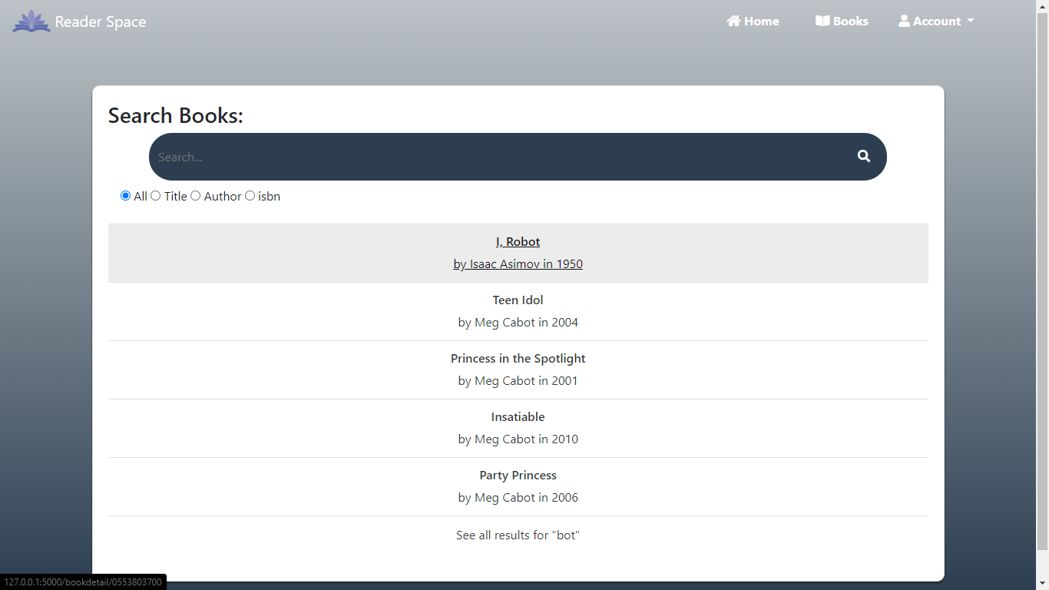

**Book Page**

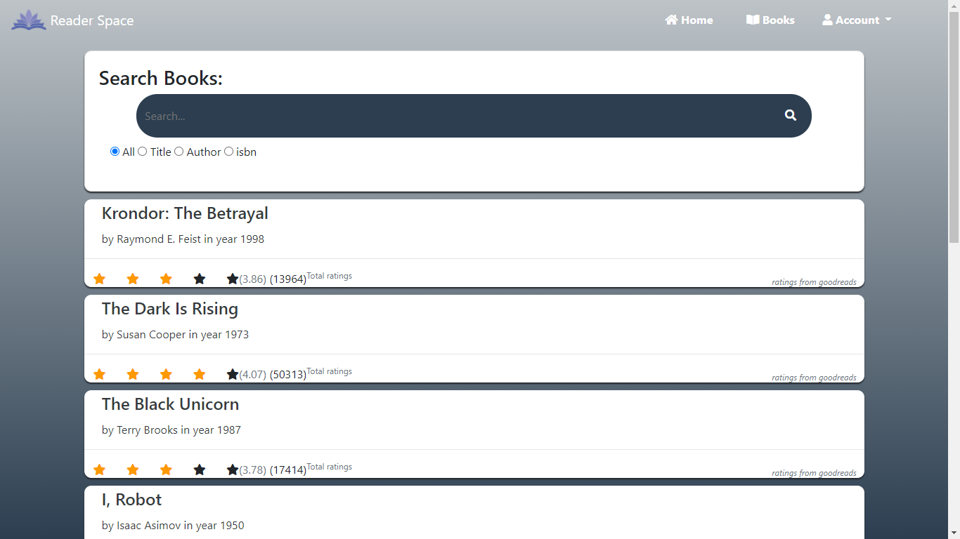

**Book Review**

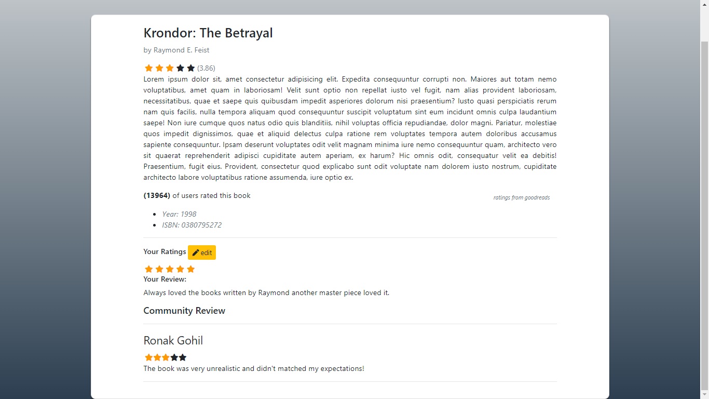

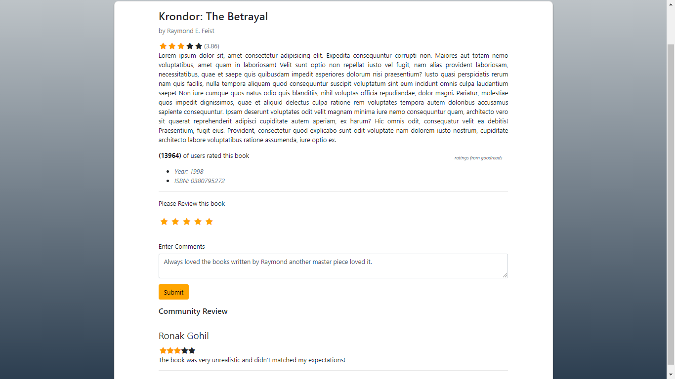

**Edit Review**

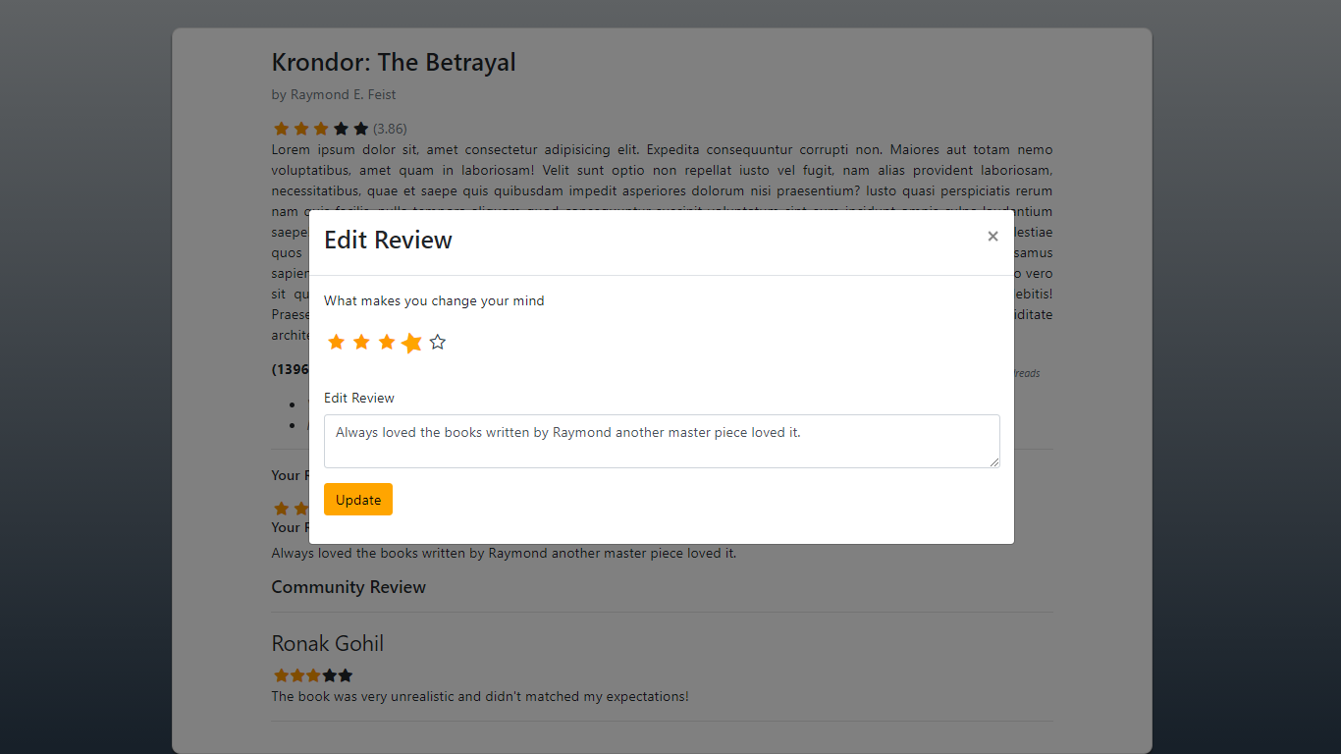

**API DATA**

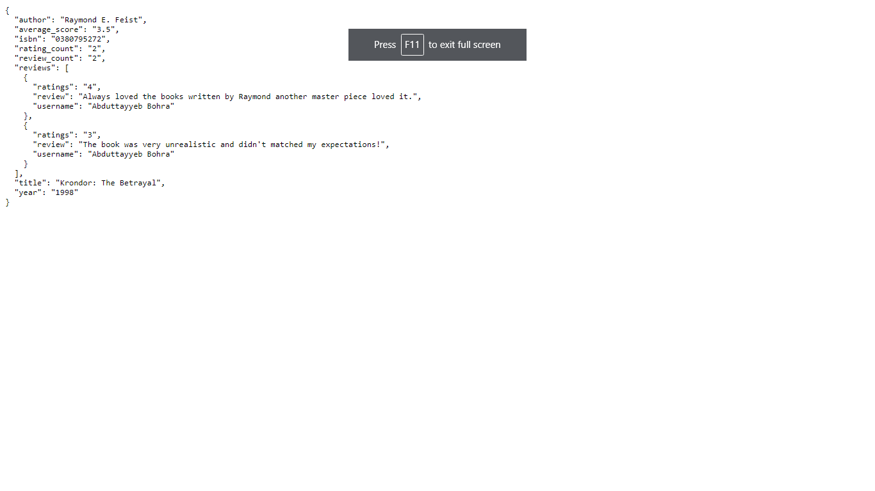

**2.7 table specification**

**TABLE 1: Book**

|  |  |  |
| --- | --- | --- |
| **Field name** | **Field type** | **Description** |
| Id | Integer | (Primary key) |
| Title | Character varying(50) | Not null |
| Description | Text | Not null |
| Isbn | Character varying(20) | Not null |
| Year | Integer | Not null |
| Authorname | Character varying(50) | Not null |

**TABLE 2: Userrview**

|  |  |  |
| --- | --- | --- |
| **Field name** | **Field type** | **Description** |
| User_id | Integer | Null |
| Book_id | Integer | Null |
| Rating | Integer) | Not null |
| review | text | Null |

**TABLE 3: User**

|  |  |  |
| --- | --- | --- |
| **Field name** | **Field type** | **Description** |
| Id | Integer | (Primary key) |
| Firstname | Character varying(20) | Not null |
| Middlename | Character varying(20) | Null |
| Lastname | Character varying(20) | Not null |
| Email | Character varying(120) | Not null |
| Password | Character varying(24) | Not null |

**2.8 Test Procedures and Implementation**

Testing is a process of executing a program with the intent of finding an error or bugs. Testing is a crucial element of software quality assurance and presents ultimate review of specification, design and coding. System Testing is an important phase. Testing represents an interesting anomaly for the software. Thus, a series of testing are performed for the proposed system before the system is ready for user acceptance testing.

Testing is a set of activities that can be planned in advance and conducted systematically testing requires that the developer discard preconceived notations of the correctness of the software just developed and overcome a conflict of interest that occurs when errors are encountered. Testing is a process of technical investigation, performed on behalf of stakeholder. Testing can be stated as the process of validating and verifying of a software program/application/product.

### **Testing Objectives :**

* Testing is a process of executing a program with the intent of finding an error.
* A good test case is one that has a probability of finding an as yet undiscovered error.
* A successful test is one that uncovers an undiscovered error.

### **Testing Principles :**

* All tests should be traceable to end user requirements.
* Tests should be planned long before testing begins.
* Testing should begin on a small scale and progress towards testing in large.
* Exhaustive testing is not possible.
* To be most effective testing should be conducted by a independent third party.

Test configuration includes test plan and test cases and test tools. Tests are conducted and all the results are evaluated. That is test results are compared with expected results. When erroneous data are uncovered, an error is implied and debugging commences.

The primary objective for test case design is to derive a set of tests that has the highest livelihood for uncovering defects in software. To accomplish this objective two different categories of test case design techniques are used. They are

* White box testing.
* Black box testing.

### **White-box testing :**

* White box testing focus on the program control structure. Test cases are derived to ensure that all statements in the program have been executed at least once during testing and that all logical conditions have been executed.

### **Block-box testing :**

* Black box testing is designed to validate functional requirements without regard to the internal workings of a program. Black box testing mainly focuses on the information domain of the software, deriving test cases by partitioning input and output in a manner that provides through test coverage. Incorrect and missing functions, interface errors, errors in data structures, error in functional logic are the errors falling in this category

**2.9 Test Cases:**

|  |  |  |  |
| --- | --- | --- | --- |
| Test Case ID | Objective | Description | Expected Output |
|  | Register Page | If not, all fields are filled except middle name field. | * All fields are compulsory |
|  | Register Page | If email is already registered | User already exist |
|  | Register Page | If new password and confirm password doesn’t match. | Password mismatch |
|  | Register Page | If valid data given by the user | Redirect login page with message “Account created please login to continue” |
|  | Login Page | If invalid credentials given by the user | Invalid email or password |
|  | Login Page | If valid Credentials | Redirect to home page |
|  | Home Page | Search bar is not filled. | This field is required |
|  | Edit Profile | If email is already exist | Email is taken |
|  | Edit Profile | If valid data is provided. | Information updated |
|  | Change Password | If old password doesn’t match | Wrong Password |
|  | Change Password | If new password and confirm password doesn’t match | Password mismatch |
|  | Change Password | If valid Password | Password changed successfully |
|  | Book Details | If already reviewed | Show review |
|  | Book Details | If not reviewed | Show review form |

**3. Drawbacks and Limitations**

Due to the time constraints and new technology following limitations are encountered by our team, which are as follows:

* GUI for adding and managing the books is not provided because of time constraints and security considerations.
* Due to time constraints we were not able to find the description for the 5000 books initially stored in database
* Along with description image for the books is also not provided because of time constraints and huge records

**4. Future Enhancement**

The future considerations of reader space project are as following:

* Adding Admin panel with user roles.
* Adding forget password feature through sending temporary link to provided email.
* Adding a feature for adding user as a friend for building a community.
* Adding feature for users to request for adding books to the system.
* More API support for developer’s community. (i.e. Authentication API etc.)

**5. Conclusions**

* **Reader space** provides facility to conduct all book detail review and rating. It saves time as it allows number of user to appear for book at a time and display book detail as gets over. online book review website which facilitates the reader to browse the books and check the book detail such as title, description, author name, etc. Also, the user will be able to give the review of the book which the user has already read. Also, the user will be able to give the review of the book which the user has already read.

**6. Bibliography**

* [**docs.python.org**](http://www.python.org)**/**
* [**https://flask.palletsprojects.com/en/1.1.x/**](https://flask.palletsprojects.com/en/1.1.x/)
* [**https://www.sqlalchemy.org/**](https://www.sqlalchemy.org/)
* [**https://www.w3schools.com/**](https://www.w3schools.com/)
* [**https://www.geekforgeeks.com/**](https://www.geekforgeeks.com/)
* [**https://www.youtube.com/**](https://www.youtube.com/)