Mini Project Report

On

# “Reader space”

MCA

**[2020-2021]**

Under the Guidance of

Dr. Anuradha Kanade

**Submitted To**



In partial fulfillment of the requirement for the award of Degree of Master in Computer Application (MCA)

**Submitted Through**

**MIT-WPU School of Computer Science, Pune.**

**Submitted By**

Abdul tayyeb

Deepak Kumar

Ronak Gohil

# DECLARATION

I, Mr./ Ms./ Mrs. . **_________ ______**hereby declare that

This project is the record of authentic work carried out by me during the academic year **2020-2021**. This project is **plagiarism-free** and has not been submitted to any other University or Institute towards the award of any degree.

**Signature of the student**

**ACKNOWLEDGMENT**

In the accomplishment of this project successfully, many people have best owned upon me their blessings and the heart pledged support, this time I am utilizing to thank all the people who have been concerned with project.

The success and final outcome of this project required a lot of guidance and assistance from many people and I am extremely privileged to have got this all along the completion of my project. All that I have done is only due to such supervision and assistance.

My sincere thanks also goes to **Dr. C.H. Patil** for supporting the Mini Project from the college in this pandemic situation.

I owe my deep gratitude to our internal project guide **Dr. Anuradha Kanade** who took keen interest on our project work and guided us all along, till the completion of our project work by providing all the necessary information.

**TABLE OF CONTENTS**

|  |  |  |
| --- | --- | --- |
| **Sr.No** | **Title** | **Page No.** |
| **1** | Introduction |  |
| **2** | Scope of Work |  |
| **3** | Operating Environment |  |
| **4** | Analysis Report |  |
| **5** | Description of technolodgy Used |  |
| **6** | Data Flow Diagram |  |
| **7** | ER Diagrams |  |
| **8** | Analysis & Design |  |
| **9** | Database Table Specification |  |
| **10** | Future enhancement |  |
| **11** | Bibolographys |  |

**SCOPE OF WORK**

Scope of this project is very broad in terms of other manually checking yourself. Few of them are :-

* The main purpose of this project is to provide a platform for the readers to help them find the perfect book for there next reading journey.
* The API from Goodreads makes it a more powerful platform to get to know about the user's opinion on the book by having data like average ratings and total ratings.
* This Project also provides a facility to user for giving there reviews and rating on a particular book.
* Along with the ratings from Goodreads the user will also be able to see the reviews of other users of the system.
* The system is fully responsive keeping into the mind of various device compatibility.It is a Web-based application so can be accessed by any browser.
* For the developer community, this system also provides a REST API available for everyone.
* Bulk insertion is also made possible through CSV file.

**Operating Environment**

#### **Hardware Requirements:**

* + **Processor:** Intel Core i5 and above
  + **Ram:** 8GB and above
  + **HDD:** 256GB and above

#### **Software Requirements:**

* + **Web Browser:** Google Chrome, Mozilla Firefox
  + **Os:** Windows, Linux
  + **Database:** Postgres

#### **Tools and Environment:**

* + **Front End:** Html 5, SASS , Bootstrap 4, JQuery
  + **Back End:** Python
  + **Framework:** Flask
  + **Library:** SQL Alchemy
  + **Web Server:** Flask Development
  + **Database Server:** Heroku_Postgres

**Analysis Report**

#### **Time-Line Chart**

|  |  |  |  |  |  |  |  |  |  |
| --- | --- | --- | --- | --- | --- | --- | --- | --- | --- |
| **Work Tasks** | **May** | | | | **June** | | | | |
| **Week** | **1** | **2** | **3** | **4** | **1** | **2** | **3** | **4** |
| **1. Requirements Gathering** |  |  |  |  |  |  |  |  |
| 1.1 Collected details from developed sites |  |  |  |  |  |  |  |  |
| 1.2 Analyzed gathered information |  |  |  |  |  |  |  |  |
| 1.3 Determine the scope of the system |  |  |  |  |  |  |  |  |
| **Milestone:** Requirements Gathering Completed |  |  |  |  |  |  |  |  |
| **2. Planning** |  |  |  |  |  |  |  |  |
| 2.1 Basic flow and structure |  |  |  |  |  |  |  |  |
| 2.2 Determined different modules |  |  |  |  |  |  |  |  |
| **Milestone:** Planning Completed. |  |  |  |  |  |  |  |  |
| **3. Designing** |  |  |  |  |  |  |  |  |
| 3.1 Basic interface design |  |  |  |  |  |  |  |  |
| 3.2 Database design |  |  |  |  |  |  |  |  |
| 3.3 Admin Side design |  |  |  |  |  |  |  |  |
| 3.4 Client Side design |  |  |  |  |  |  |  |  |
| 3.5 Design web forms and modules |  |  |  |  |  |  |  |  |
| **Milestone:** Design completed |  |  |  |  |  |  |  |  |
| **4. Coding and Integrating modules** |  |  |  |  |  |  |  |  |
| 4.1 Admin Side coding |  |  |  |  |  |  |  |  |
| 4.2 Client Side coding |  |  |  |  |  |  |  |  |
| **Milestone:** Finalized |  |  |  |  |  |  |  |  |
| **5. Finalize the developed system** |  |  |  |  |  |  |  |  |
| **Milestone:** Finalized |  |  |  |  |  |  |  |  |
| **6. Documentation** |  |  |  |  |  |  |  |  |
| **Milestone:** Documentation completed |  |  |  |  |  |  |  |  |

**Description of Technolodgy Used**

#### **Python**

* Flask is considered more [Pythonic](http://blog.startifact.com/posts/older/what-is-pythonic.html) than the [Django](https://www.fullstackpython.com/django.html) web framework because in common situations the equivalent Flask web application is more explicit. Flask is also easy to get started with as a beginner because there is little boilerplate code for getting a simple app up and running.

#### **Flask**

* Flask is a web application framework written in Python. It is developed by **Armin Ronacher**, who leads an international group of Python enthusiasts named Pocco. Flask is based on the Werkzeug WSGI toolkit and Jinja2 template engine.

#### **SQL Alchemy**

* SQLAlchemy is a popular SQL toolkit and Object Relational Mapper. It is written in Python and gives full power and flexibility of SQL to an application developer. It is an open source and cross-platform software released under MIT license. SQLAlchemy is famous for its object-relational mapper (ORM), using which classes can be mapped to the database, thereby allowing the object model and database schema to develop in a cleanly decoupled way from the beginning.

#### **HTML**

* Hypertext Markup Language (HTML) is the standard markup language for creating web pages and web applications. With Cascading Style Sheets (CSS) and JavaScript, it forms a triad of cornerstone technologies for the World Wide Web.
* Web browsers receive HTML documents from a web server or from local storage and render the documents into multimedia web pages. HTML describes the structure of a web page semantically and originally included cues for the appearance of the document.

#### **SASS**

* SASS (Syntactically Awesome Stylesheet) is a CSS pre-processor, which helps to reduce repetition with CSS and saves time. It is more stable and powerful CSS extension language that describes the style of a document cleanly and structurally.
* It was initially designed by Hampton Catlin and developed by Natalie Weizenbaum in 2006. Later, Weizenbaum and Chris Eppstein used its initial version to extend the Sass with SassScript.

**Postgres**

* PostgreSQL is a powerful, open source object-relational database system. It has more than 15 years of active development phase and a proven architecture that has earned it a strong reputation for reliability, data integrity, and correctness.

**ER Diagram**

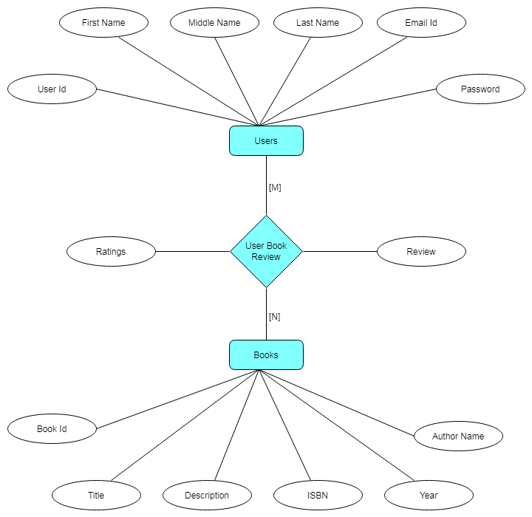

**Analysis & Design**

**Activity Diagram**

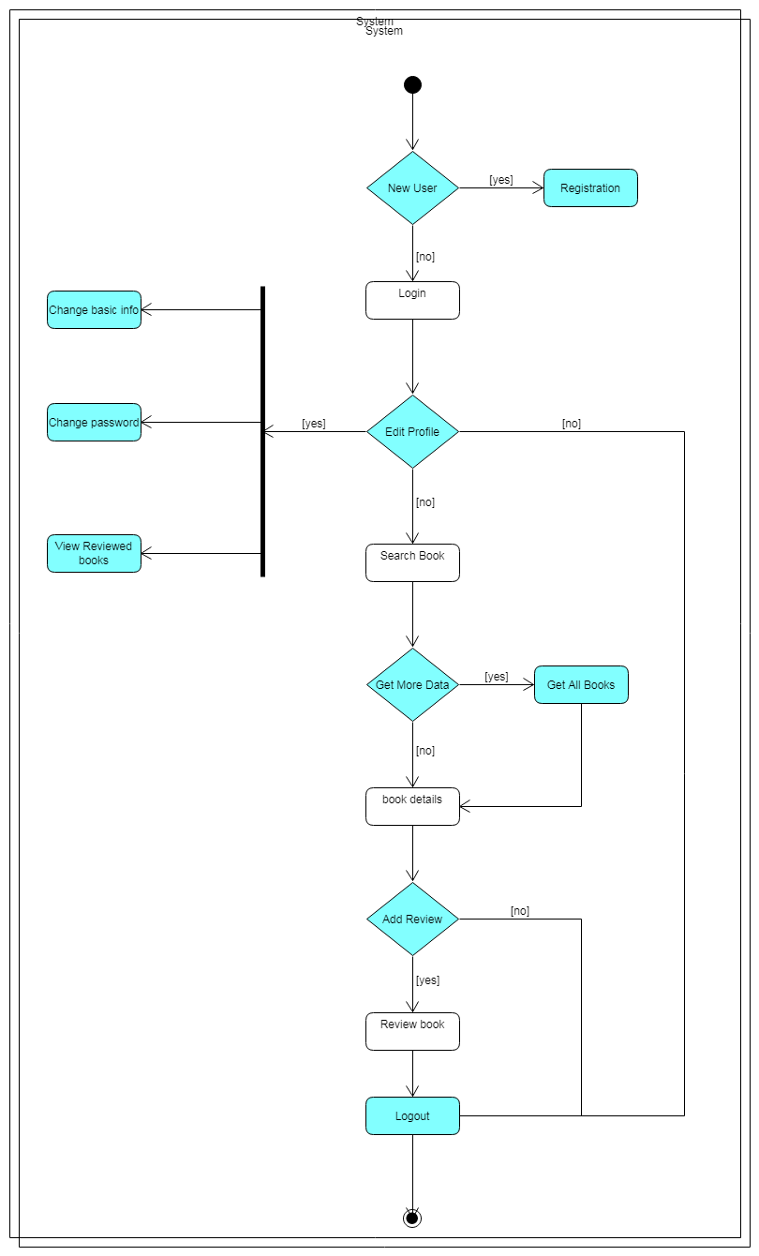

**Use Case Diagram**

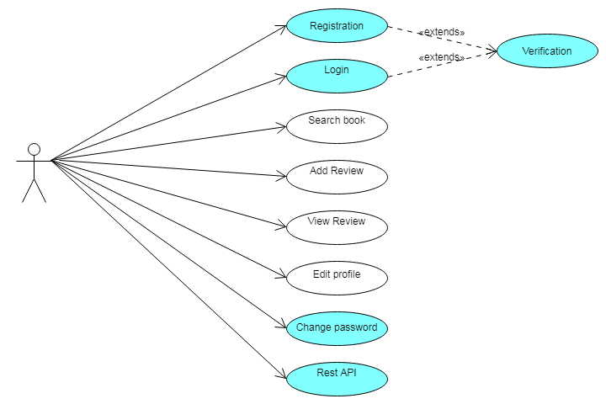

**Class Diagram**

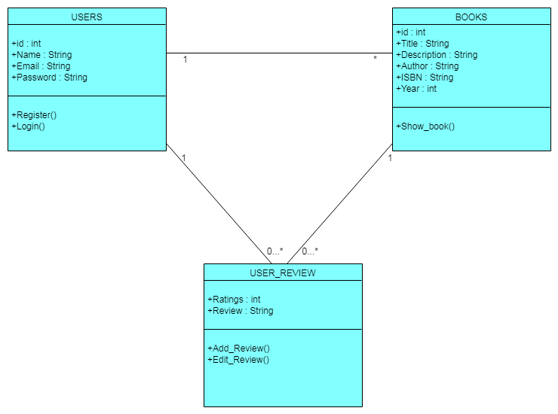

**Database Table Specification**

**TABLE 1: Book**

|  |  |  |
| --- | --- | --- |
| **Field name** | **Field type** | **Description** |
| Id | Integer | (Primary key) |
| Title | Character varying(50) | Not null |
| Description | Text | Not null |
| Isbn | Character varying(20) | Not null |
| Year | Integer | Not null |
| Authorname | Character varying(50) | Not null |

**TABLE 2: Userview**

|  |  |  |
| --- | --- | --- |
| **Field name** | **Field type** | **Description** |
| Id | Integer | (Primary key) |
| User_id | Integer | Null |
| Book_id | Integer | Null |
| Rating | Integer) | Not null |
| review | text | Null |

**TABLE 3: User**

|  |  |  |
| --- | --- | --- |
| **Field name** | **Field type** | **Description** |
| Id | Integer | (Primary key) |
| Firstname | Character varying(20) | Not null |
| Middlename | Character varying(20) | Null |
| Lastname | Character varying(20) | Not null |
| Email | Character varying(120) | Not null |
| Password | Character varying(24) | Not null |

**Future Enhancement**

**Bibilography**