LAB#14

Tayyeba Muhammad khan

Image detected

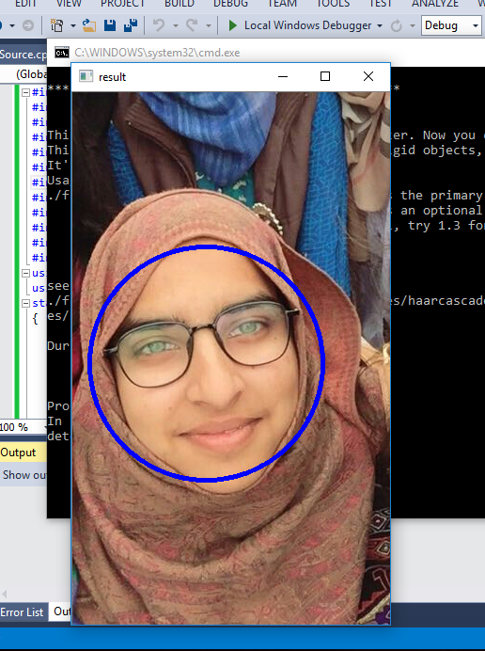

Image not detected

Because of the side pose

