Test Project
WSC2019_TP09_01_EN

Submitted by:
Name: Mohammad R. Tayyebi
Member country or region: IR

Notes:
This is a preperation campus test project designed for IRI competitor assesments. This is not going to exactly match WorldSkills standards.
Please let us know if you have a copy of this test project.

Overall Introduction
You have to follow style guide, use logo anywhere needed, validate links and buttons, etc … .

Contents
This Test Project proposal consists of the following documentation/files:
- graph01.gif
- map.gif
- map-chart.gif
- style-guide.html
- logo.png

Introduction
Manucipality of AmadaPolis, a city with about 7000 citizen (2500 families), wants to develop their software systems that will help them to increase people life quality. They want to improve their abilities on energy usage monitor, health care services, insurance, and etc.

Task 1. Generate Data
Because of citizens privacy, no data is provided. You have to generate data which is needed to test system. Your random data must fit consumption pattern.
You are asked to store your preferred schema and generated data as a script file named ‘residential_load.sql’.
Note: name the table: ‘WaterUsageTransactions’
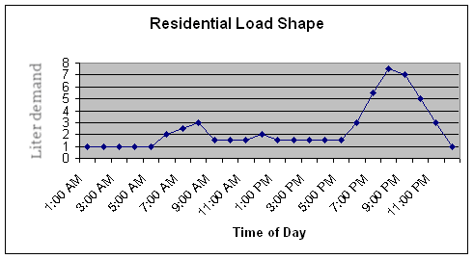

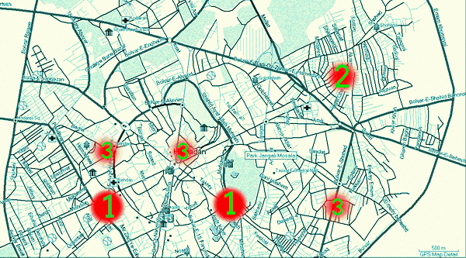
Task 2. Visualize the output
Create a single form application ‘visualizer.exe’ regarding following wireframe that will output charts based on data stored in database ‘manu_amada’ and same schema name as Task 1.
Place a button on your form that allows operator to import from and another button that will allow operator to export to CSV format. Use slash as separator and first line must be column headers.
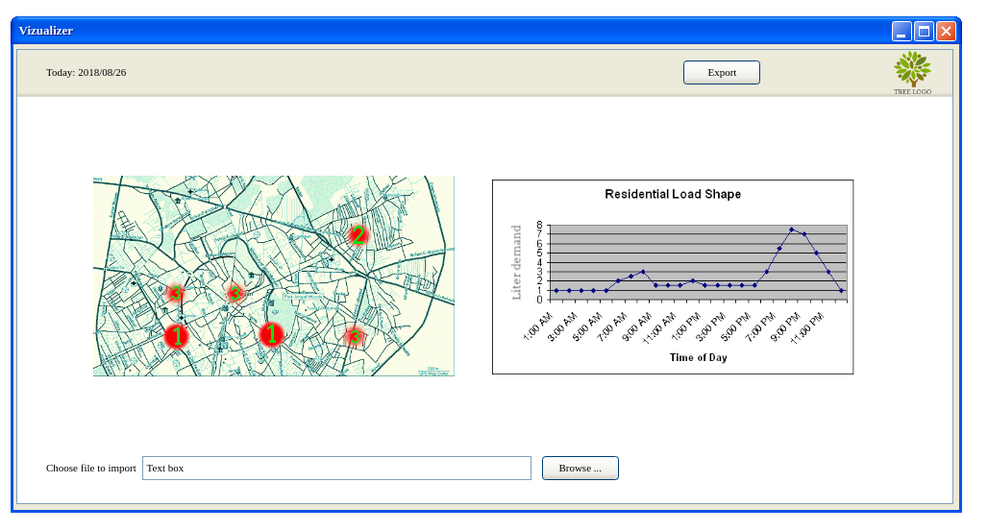
You must validate data before import. If it was valid, only keep new imported data.

Instructions to the Competitor
Save the fiels in directory C:\output\Session1

