Test Project
WSC2019_TP09_02_EN

Submitted by:
Name: Mohammad R. Tayyebi
Member country or region: IR

Notes:
This is a preperation campus test project designed for IRI competitor assesments. This is not going to exactly match WorldSkills standards.
Please let us know if you have a copy of this test project.

Overall Introduction
You have to follow style guide, use logo anywhere needed, validate links and buttons, etc … .

Contents
This Test Project proposal consists of the following documentation/files:
- List of Feeling Words by www.psychpage.com.html
- Emoji-Anger-icon.png
- Emoji-Disgust-icon.png
- Emoji-Fear-icon.png
- Emoji-Joy-icon.png
- Emoji-Sadness-icon.png
- Emoji-Suprised-icon.png
- Emoji-Trust-icon.png

Introduction
Municipality of AmadaPolis, wants to create a feedback system. Citizens can have account on this system so they can follow their requests.

Task 3. Mobile Interface
You can develop mobile app based on your preferred database management system.
Users are able to register for a new account. Each user has a Username, Fullname and Password submitted for authentication.
User can login with registered username and password.
Login form: Register button redirects user to register activity. Login buttons, validates the logins and if it was successful, redirects user to feedback list that he/she already sent.
Regsiter form: Cancel button discards current activity and redirects to Login. Register button stores new user to the database. We use e-mail as username; so validating is required: unique and in the form aaa@bbb.ccc.
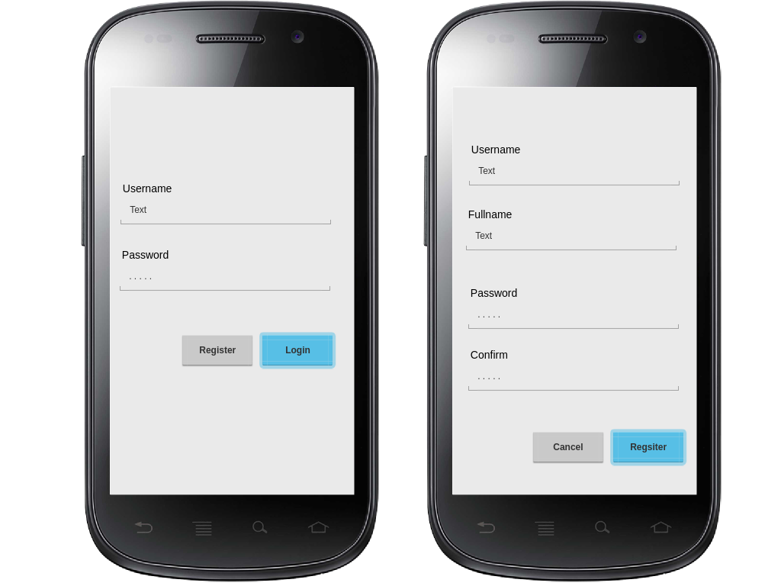
User can view his/her previously submitted data to the system. Items will be listed for this case. Listed items must style light theme on count 2k and dark theme in count 2k + 1.
Each list item is clickable and it will redirect user to detailed view of the feedback. Detailed view will be discarded by mobile’s back button.
There is a floating button which will redirect user to Draft a new FeedBack Activity.
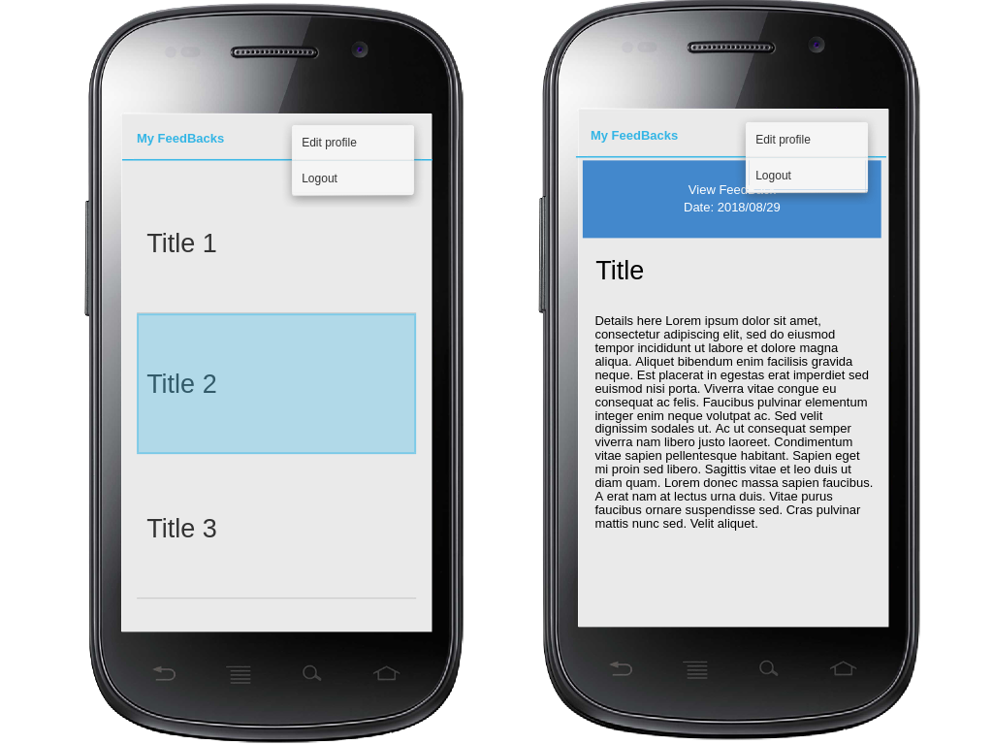
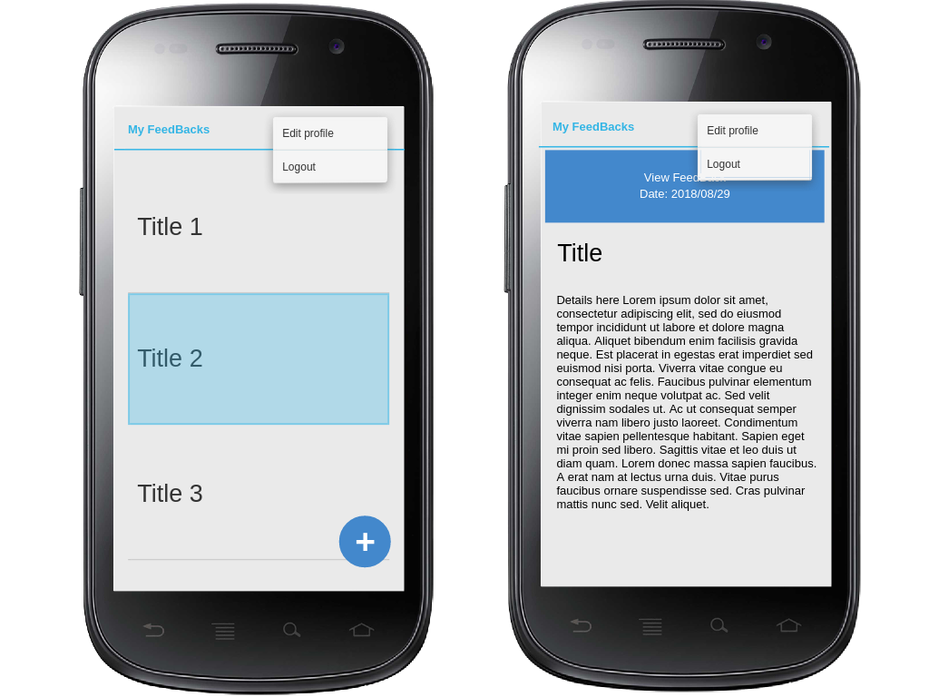
FeedBacks List activity, Edit Login, and Detailed View of FeedBacks are all using same ActionBar with menu items that are accessible from all mentioned forms.
Menu functionalities: Logout Button will Logout user and restarts the application from Login activity. It’s clear that if user was logged in and user enters application anytime, login form will not be displayed.
User can edit his/user profile. There is an exception for password fields: if it was filled with data, password must be confirmed and updated, else old password will be kept. In this activity, Save button will commit changes and cancel button will discard current form.

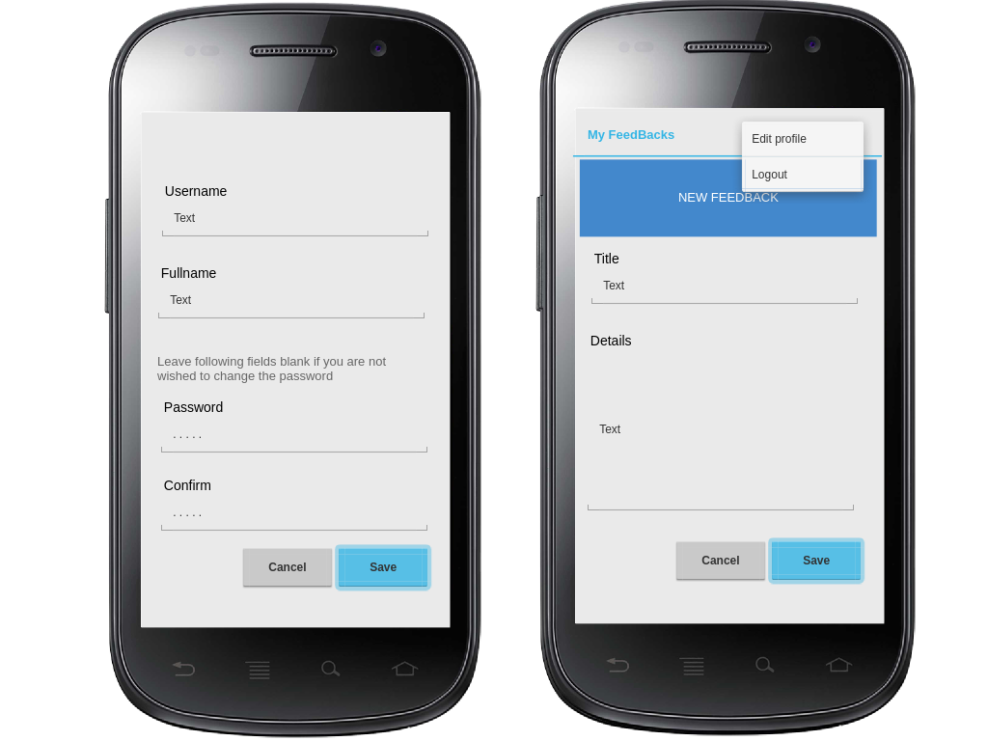
Draft a new FeedBack form functionalities: Save button will store the feedback and cancel button will discard current form.

Task 4. Admins Artificial Intelligence Bot Panel
Handling huge amount of feedback daily sent by users is weird. Municipality operators prefer to use an automated mechanism to analyze data and report the result daily.
They need a Natural Language Processing (NLP) algorithm that will allow them to classify each comment in four groups of emotions based on Robert Plutchik's theory:
- Fear → feeling of being afraid, frightened,scared .
- Anger → feeling angry. A stronger word for anger is rage
- Sadness → feeling sad. Other words are sorrow, grief (a stronger feeling, for example when someone has died)
- Joy → feeling happy. Other words are happiness, gladness
- Disgust → feeling something is wrong or nasty
- Surprise → being unprepared for something
- Trust → a positive emotion; admiration is stronger; acceptance is weaker.
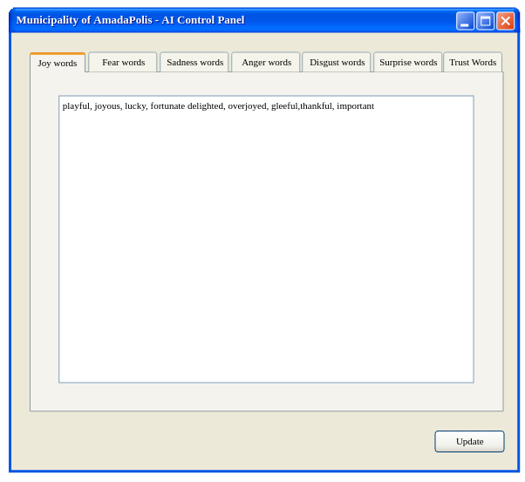
A list of words is provided to you. Feel free to use them as sample. The sample file can be found as ‘List of Feeling Words by www.psychpage.com.html ’.
Keep It Simple Stupid! You can change the control panel UI/UX if needed but keep the main functionalities: There will be an Update Button that will calculate new results based on inputs. Remember that two results are required on next Task (Public Web View): Yesterday’s overall result and today’s overall.
Output executable filename: AmadaPolis_AI.exe

Task 5. Public Web View
You can generate the HTML output using software developed in previous task regarding the wire frame.
Output filename generated each timet: AmadaOpenDataProject.html
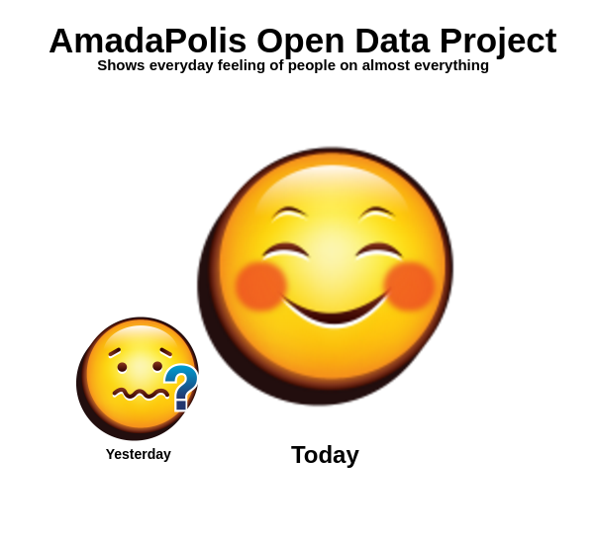

Instructions to the Competitor
Save the files in directory C:\output\Session2

