“In his name”

Airport Management System **v1.0.0.0**

Technical Description, System Analysis, Database Design and User Manual

Provider: MReza Tayyebi

Company: Hamedan

# The principals of system access and use case

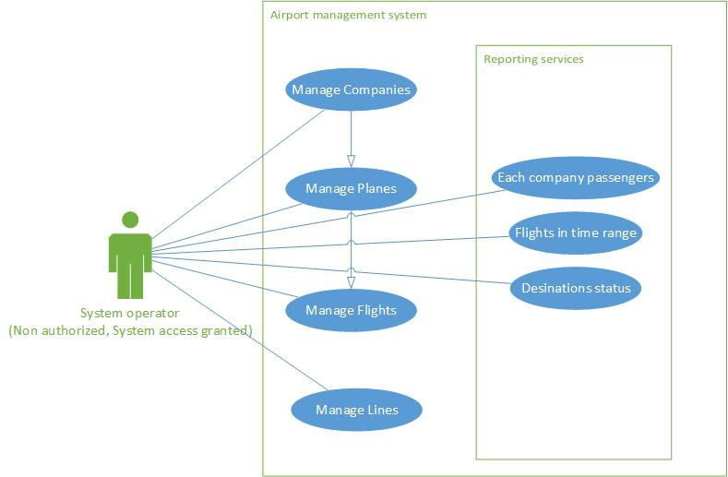

# Installation:

## Minimum software requirements:

* Microsoft .NET Framework version 4.5
* Microsoft SQL Server 2014
* Microsoft Windows 7 SP1

Fire on the database, configure the client and then run the windows executable file (.exe)

## Minimum hardware requirements:

* 2GB of RAM
* 20GB of hard disk or network storage
* Network (Optional: If in emergency support service)

# Applied database solutions:

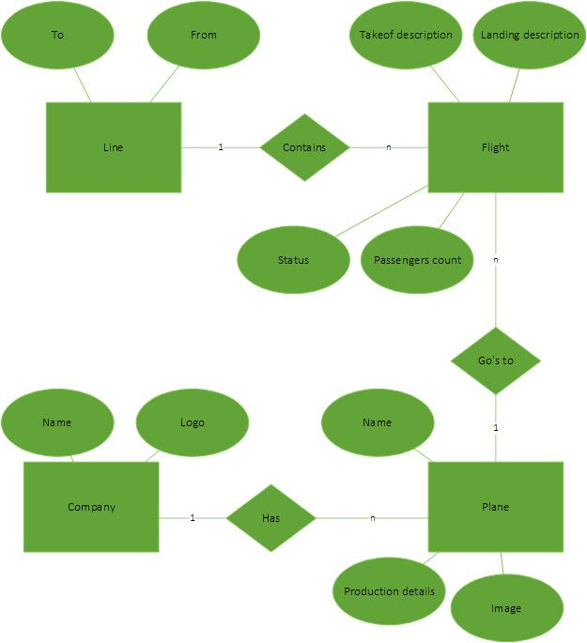

# Analysis:

No users, no database layer; This was the rule. Regarding to the project description provided by the airlines, we don’t need to analysis any type of authentication for the airline project; so this section was skipped from development.

Our suggestion to the UI was Mdi container. Simple and shortcut access to different parts of system is one of the benefits of this UI/UX Design. In another way, user can view and manage multiple parts parallelly through this UI.

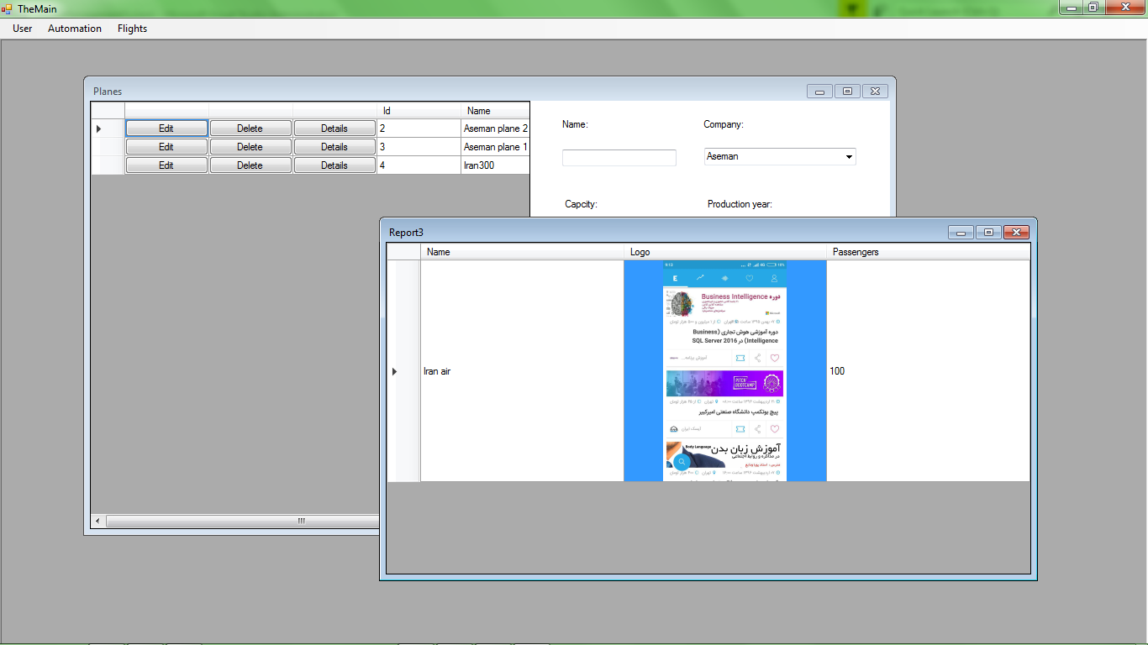

Second rule: If you don’t define a father, so there will not be any child.

As you know, there wasn’t any force to prevent user from entering invalid data; but there is always this force to keep database integration. All error will be handled on messages, so user can find out if data wasn’t submitted in database and he/she must retry to enter those data with having validations in his/her view.

Regards

Tayyebi, MohammadReza

Mail: rexa@gordarg.com