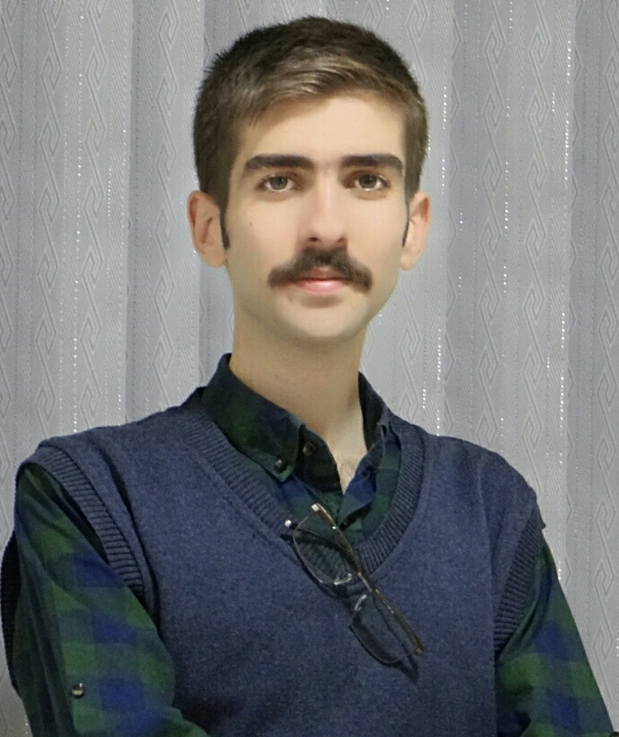 | Mohammad R. Tayyebi
 | Mobile  E-Mail | +98 912 098 22 76  primary:  smile@tyyi.net  backup:  tayyebi_mohammadreza@hotmail.com | Website  Address | http://www.tyyi.net  No. 107, Nastaran, Pasdaran, Hamedan, Iran, Postal Code: 6517648758
Note: some of the organizations and media, also wrote ‘Tayyebi’ as ‘Tayebi’ / ‘Mohammad’ as ‘Mohamad’ / ‘..dReza’ as ‘..d Reza’ which is also accepted.
This document is updated on Jul 04 2021, please download newer version from http://kouy.ir/cv

Professional Profile
An international competitor, national champion and undergraduate of computer engineering with professional experience in software development and team management. Seriously eager to learn, enjoy artistic problem solving and overcoming challenges with a view of achieving academic and scientific experience and certification. Fully energetic in working in teams and highly skilled in fundamental knowledge and skills of software engineering.
Being among 45 ‌selected students out of 25339 and awarded in the most ‌creditable scientific festival of Iran, known as Khwarizmi, even before attending university. Also taken part in the most popular skill-based competition of the world, WorldSkills, in 2017.

Education
Bu-Ali Sina University  B. Sc. Computer Engineering  March 2016 – July 2020 | Final Project:  Implementation of a Web and API framework. / https://tayyebi.github.io/BASU-Final-Project-BSc
Madani High School  Diploma and College  September 2013 – August 2018 | Major:  Mathematics and Physics  Note: This major is the main choice to carry on higher education in engineering

Professional Experience
Back-end Developer (Remote) | MrBilit Group  - MrBilit Charter Flights Service  - IranGard.com Product) | - Implementation of some programs which allowed service to stay sync and serve up-to-date data to hundred of thousands of human and bot users.  - Participation in code refactoring, API and database development, with multiple programming languages.  - Implementation of RESTful API to handle business logic.  (Jan 2021 to May 2021) / https://www.mrbilit.com
Project Manager | AtiNet Sina Parsian | NDA (2019)
Senior Developer | Rayan Electronic Andish Hegmataneh | Implementation of GPS back-end, web and mobile front-end (2018 to 2019)
Instructor | Bu-Ali Sina University, Faculty of Engineering and Natural Resources (Tuyserkan) | - Fundamentals of Programmings, Student Scientific Society of Computer Engineering and Information Technology (2019)
Instructor | Bu-Ali Sina University, Faculty of Engineering (Hamedan) | - Full-Stack Programming, Summer School, Student Scientific Society of Computer Engineering (2019)
Instructor | KhajeNasir Institude; Iran Technical and Vocational Organization (Hamedan) | - RESTful Applications Development (2016 to 2018)  - Python Programming (2016 to 2018)  - C# Programming (2016 to 2018)  - Android Developer Training (2016 to 2018)
Freelance Developer | Self-employed | - Web Design and Development (since 2012)  - Mobile Applications Programming (since 2018)

Volunteer Experience
Founder, Director, and Editor in Cheif | Sariab Bloggers | Sariab is a non-profit blogging campaign which is focused on empowering students, increase mental health level, and motivate them, through an integrated knowledge base made on distributed blogs and free content on internet social networks and website platform. / http://www.sariab.ir/

Honors and Awards
WorldSkills | Ranked as 20th (2017)  Skill: IT – Software Solutions for Business
IranSkills | Ranked as 1st and awarded as gold medal (2016)  Skill: IT – Software Solutions for Business  Ministry of Cooperatives, Labour, and Social Welfare
Khwarizmi Youth Award | Awarded as 3rd in country (2015)  Field: Computer Science and Engineering  IRI Ministry of Science, Research and Technology; IRI Ministry of Education; Iranian Research Organization for Science and Technology
Music Awards | - 2nd, Fajr Festival, with Ayeen Ensemble, Hamedan (2017)  - 1st, Niayesh Festival, with Ayeen Ensemble, Qazvin (2017)

Skills
Programming Languages | C++, C#.NET, PHP, JavaScript, Python, GoLang (basic), Java, Dart (basic)
Web Technologies | ASP.NET Core, ASP.NET Web Forms
Desktop Technologies | Qt, Windows Forms Applications, Windows Presentation Forms
Mobile Technologies | Xamarin, React Native (basic), Java, Kotlin, Flutter (basic)
Database Systems | SQL Server, MySQL
NoSQL Database Systems | MongoDB (basic)
Analyzing and Designing Software Solutions | - Considering all possible options and deriving the best solution based on sound analytical judgment and the client’s best interests  - Using system analysis and design methodologies (such as Unified Modelling Language (UML), software framework, and Design Patterns)  - Build data warehouse and required for business intelligence/ executive dashboard  - Proper interface and layering for mobile solution.  - Use Case modelling and analysis (such as Use Case Diagram, Use Case Description, Actor Description, Use Case Package)  - Structural modelling and analysis (such as Object, Class, Domain Class Diagram)  - Dynamic modelling and analysis (such as Sequence Diagram, Collaboration Diagram, State Diagram, Activity Diagram)  - Data modelling tools and techniques (such as Entity Relationship Diagram, Normalization, Data Dictionary)  - Object design and package  - Relational or object database design and data flow diagrams  - Human-computer interface design/user experience  - Security and controls design  - Multi-tier application design
Enterprise Software Development | - Accurate and Consistent Version Control (with tools such as Git)  - Using Microsoft TFS project management tool  - Using system development methodologies such as object-oriented design  - Considering normal and abnormal scenarios, and exception handling  - Following standards: Style Guide, Code Convention, Human Interface Design (UI), Managing Directories and Files  - Code Refactoring and Analysis  - Evaluate and integrate appropriate libraries and frameworks into a software solution
Version Control | Git, Microsoft TFS, GitLab
Server Administration | Linux, Windows Server
Team Work | Trello, Process Maker

Speech
Kazan, Russia | IranSkills (WorldSkills Iran) representative expert (2018)
Alborz, Iran | Province representative in first congress of national skills competitors with minister assistant (2016)
Hamedan, Iran | Special speaker as top researcher in session with education system chairmen and teachers (2015)

Conferences and Courses Participated
Online Crash Course on Numerical Astrophysics | Ferdowsi University of Mashhad (This program is aimed to share a taste of numerical simulations with graduate students and postdocs in astronomy, and also advanced graduate students of physics.) / https://www.na2020.onrender.com/
Python Programming for Neuroscience | / https://www.neurosafari.com/

Languages
Persian | Native proficiency
English | Full professional proficiency

Soft Skills
Work Organization and Management | - Principles of productive team work  - Design a proper flow of the system that is designed and provide proper notification when needed  - Applying company standards into system  - Planing each day’s production schedule according to available time and take into account time limitations and deadlines  - Applying research techniques and skills to keep up-to-date with the latest industry guidelines  - Reviewing own performance against the expectations and needs of the client and organization  - Preparing a good system documentation on how to use, install and run the system
Communication and Interpersonal Skills | - Confirm that the created application meets the original specifications and obtain user sign-off for completed system  - Collaborate with others to develop the required outcomes  - Work well in group problem solving  - Prioritizing and scheduling tasks  - Allocate resources to tasks
Problem solving, innovation, and creativity | Knowing and understanding:  - The common types of problem and requirements which may occur within software development  - Diagnostic approaches and suitable system or software to problem solving  - Trends and developments in the industry including new platforms, languages, conventions, and technical skills  - The use of latest technology to be applied in software scenario which requires the ability to demonstrate and provide an over-arching business solution to a problem  - How to set-up, develop, and integrate into designed solution the latest technology and hardware that will drive a better business solution.  Able to:  - Research encountered problems independently  - Identify and resolve problems in a timely manner  - Gather and analyse information skilfully  - Develop alternatives using the latest technology to support better business solution.

Hobbies
Music | - Kanun soloist at “Ayeen Ensemble” (since 2017)  - Kanun soloist at “Alvand Orchestra” (2014 to 2015)
Astronomy | - Certified Night Sky Observer, Ibn-Sala Astronomy Center (since 2019)
Personal Branding  and Digital Marketing | Video Editing, Pod-Cast Recording, Graphic Design, Logo Design, Animation, Info-graphics and Presentations, writing and content development. (since 2011)  Demo:  - Instagram (https://www.instagram.com/tyyinet/)  - YouTube (https://www.youtube.com/c/MohammadRezaTayyebi)

