Connection Game

COMP454: Computer Networks

Dr. Ahmad Al Hajj

Done by:

Name ID Section

Khaled Sardouk 201901490 COMP 454

Mohammad Al-Tayyeb Soubra 201901076 COMP 454

Hadi Salloum 201900774 COMP 454

Salah El Deen Stouhi 201901265 COMP 454

Karim Hamod 201900057 COMP 454

Mohammad Kreidieh 201900799 COMP 454

Abstract:

The Game is about an attacker and a defender, the attacker will try to send a message “ATTACK” and try to protect the message, and the defender should try to not get affected by the message. There is a third-party member which is the server, which will provide the connection for the attacker and the defender.

We used PyCharm and Python language to implement our game. We also used LogMeIn Hamachi to make a VPN and use it to establish connection between the attacker and defender when we wanted to test it using 2 separate and far computers.

Roles of each side:

* The Server:

Establishes connection between the attacker and the defender.

* The Attacker side:
* The Defender Side:

Initial Setup for each Run:

1. First run server.exe application.
2. Then run client.exe application.
3. Then run client.exe application again.

You will have 2 command windows, one for 1st client, and the other one for the 2nd client.

Both clients will take attacker/defender rounds.

The client that is the attacker for this round will automatically sends the message “ATTACK”.

The client that is the defender for this round will encrypt it. Then decrypt it.

# How to use Hamachi:

1. Turn it on

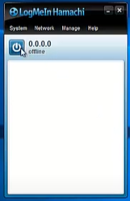

1. Login with an email or signup.

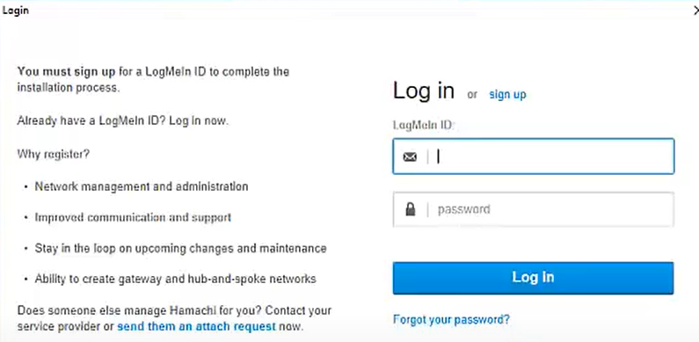

1. Create a new network

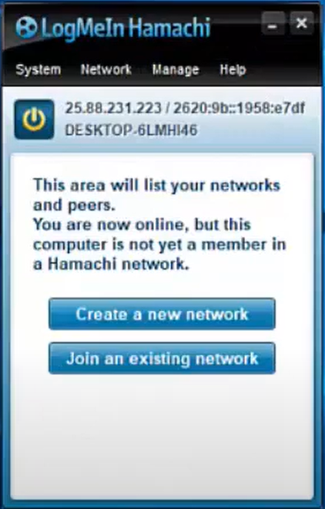

1. Name your network, give it a unique name because it will be your network ID.

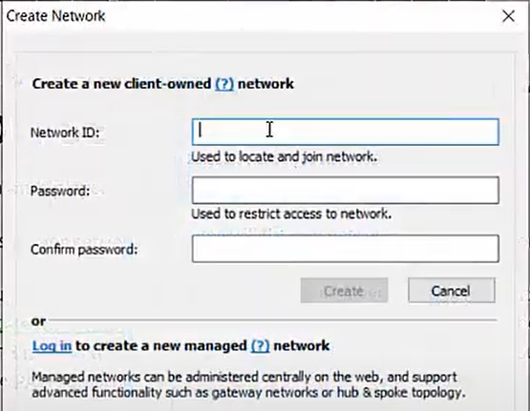

1. After creating the network, the other user should choose “Join an existing network” and fill with the network ID and password.

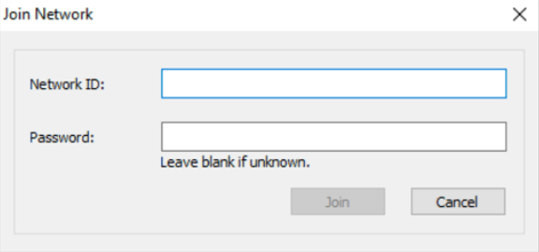

1. After that let the

|  |  |
| --- | --- |
| Team | Members |
| Connection Team | * Khaled Sardouk * Karim Hamod |
| Attacker Team | * Salah Al Deen Stouhi * Hadi Salloum |
| Defender Team | * Mohammad Kreidieh * Mohammad Al Tayyeb Soubra |