Day 8 — Authentication Note
Project: Weather Notification Automation
API Used: Open-Meteo Weather API
Location: Mansehra, Pakistan

Authentication Method: None
The Open-Meteo Weather API used in this workflow does not require an API key or authentication for the forecast request used in this project. The API can be called directly using an HTTP GET request with the required query parameters.

HTTP Request Configuration
- Method: GET
- API Endpoint: Open-Meteo Forecast API
- Authentication: None
- Query Parameter — latitude: Mansehra coordinates
- Query Parameter — longitude: Mansehra coordinates
- Query Parameter — daily: precipitation_probability_max
- Query Parameter — timezone: Asia/Karachi

Why no credentials were stored?
No API key or secret was provided or required by the Open-Meteo endpoint used in this workflow. Therefore, no authentication credential was hard-coded or stored in n8n.

Workflow
Schedule Trigger → HTTP Request → Extract Required Data → IF Condition → Gmail Notification

Conclusion
The weather API in this project uses No Authentication. The HTTP Request node retrieves the weather forecast through a GET request, and the workflow sends an email when the precipitation probability is 50% or higher.

Notification Screenshot
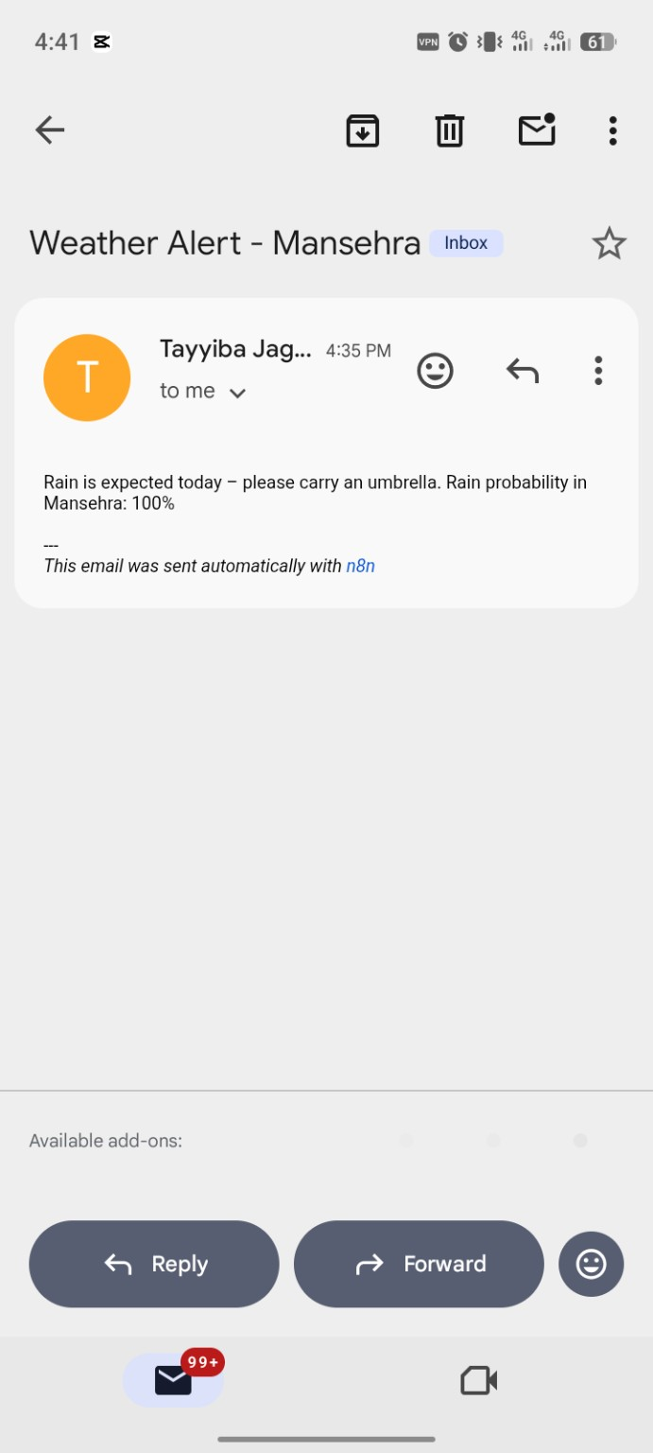
The screenshot above shows the automated Weather Alert email sent by the n8n workflow for Mansehra, with a rain probability of 100%.

