Day 9 — JavaScript for Automation
n8n Code Node Practical Task

1. Objective
The objective of this practical task was to use the n8n Code node and JavaScript to transform a messy dataset. The workflow normalizes student names, converts emails to lowercase, calculates grades from numeric scores, and filters the records to keep only students with grade A or B.

2. Workflow
The workflow contains two nodes:
Manual Trigger → Code
Code node mode: Run Once for All Items
Language: JavaScript

3. Input Dataset
The input dataset contains 15 student records with Name, Email, and Score. The data intentionally contains inconsistent capitalization and extra spaces.

Before Data
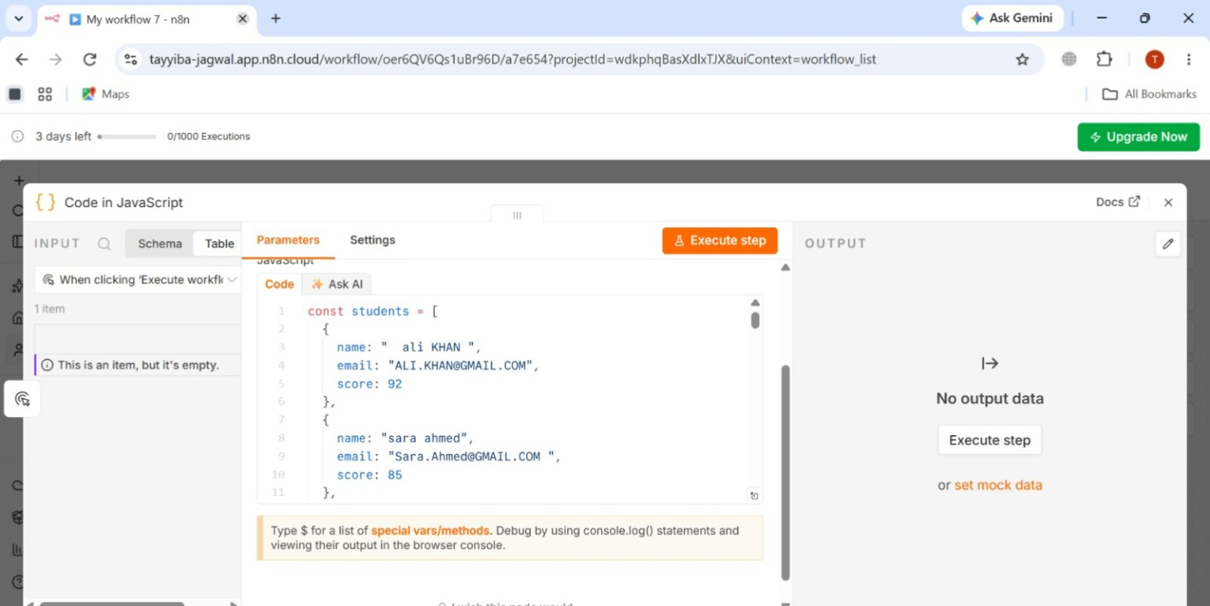

4. Transformations Performed

4.1 Name Normalization
Names are trimmed, converted to lowercase, split into words, and converted to title case.
Example: " ali KHAN " → "Ali Khan"

4.2 Email Normalization
Emails are trimmed and converted to lowercase.
Example: "ALI.KHAN@GMAIL.COM" → "ali.khan@gmail.com"

4.3 Grade Calculation
Score | Grade
90–100 | A
80–89 | B
70–79 | C
60–69 | D
Below 60 | F

4.4 Filtering
After calculating the grade, .filter() keeps only records whose grade is A or B. Students with grades C, D, and F are removed from the final output.

5. Code Node Script
const students = [
{ name: " ali KHAN ", email: "ALI.KHAN@GMAIL.COM", score: 92 },
{ name: "sara ahmed", email: "Sara.Ahmed@GMAIL.COM ", score: 85 },
{ name: " AHMED raza", email: "AHMED.RAZA@GMAIL.COM", score: 76 },
{ name: "ayesha MALIK ", email: "AYESHA.MALIK@GMAIL.COM", score: 68 },
{ name: " usman ali", email: "Usman.Ali@GMAIL.COM", score: 59 },
{ name: "fatima KHAN", email: "FATIMA.KHAN@GMAIL.COM", score: 88 },
{ name: "HAMZA iqbal ", email: "HAMZA.IQBAL@GMAIL.COM", score: 73 },
{ name: " zainab ahmed", email: "ZAINAB.AHMED@GMAIL.COM", score: 91 },
{ name: "bilal HUSSAIN", email: "Bilal.Hussain@GMAIL.COM", score: 64 },
{ name: " hina malik ", email: "HINA.MALIK@GMAIL.COM", score: 55 },
{ name: "omer FAROOQ", email: "OMER.FAROOQ@GMAIL.COM", score: 81 },
{ name: " maryam ali", email: "Maryam.Ali@GMAIL.COM", score: 78 },
{ name: "danish KHAN ", email: "DANISH.KHAN@GMAIL.COM", score: 45 },
{ name: "iqra AHMED", email: "IQRA.AHMED@GMAIL.COM", score: 89 },
{ name: " saad raza ", email: "SAAD.RAZA@GMAIL.COM", score: 62 }
];

const transformed = students.map(student => {
const cleanName = student.name
.trim()
.toLowerCase()
.split(" ")
.filter(word => word !== "")
.map(word => word.charAt(0).toUpperCase() + word.slice(1))
.join(" ");

const cleanEmail = student.email.trim().toLowerCase();

let grade;

if (student.score >= 90) {
grade = "A";
} else if (student.score >= 80) {
grade = "B";
} else if (student.score >= 70) {
grade = "C";
} else if (student.score >= 60) {
grade = "D";
} else {
grade = "F";
}

return {
name: cleanName,
email: cleanEmail,
score: Number(student.score),
grade: grade
};
});

const filtered = transformed.filter(student => {
return student.grade === "A" || student.grade === "B";
});

return filtered.map(student => ({
json: student
}));

6. After Data
After execution, the Code node produced 6 output records. The output contains normalized names, lowercase emails, numeric scores, and the computed grade. Only grades A and B remain.
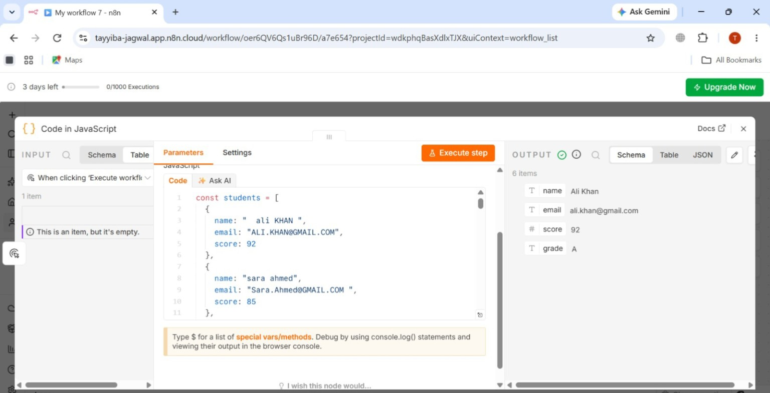

7. Result
The workflow successfully transformed the 15 input records using the n8n Code node. Names were normalized, emails were converted to lowercase, grades were calculated from the scores, and .filter() retained only students with grades A or B. The final output contained 6 records.

