

**Course Title: Data Structure Lab**

**Course Code: CSE 1302**

**Submitted to:**

Wahida Ferdose Urmi

Lecturer, CSE

University of Liberal Arts Bangladesh

**Submitted By:**

Name : Md. Tazminur Rahman Tanim

ID : 242014124

Section : 4

Spring-2025

University of Liberal Arts Bangladesh

**Submission Date: 25 March, 2025**

//Tazminur Rahman Tanim

//ID:242014124

#include<stdio.h>

#define max 10

**int** top=-1;

**int** stack[max];

**void** push(**int** element)

{

**if**(top==max-1)

{

printf("Overflow\n");

}

**else**

{

top++;

stack[top]=element; 17 printf("%d pushed \n",stack[top]);

}

}

**void** pop()

{

**if**(top==-1)

{

printf("Empty");

}

**else**

{

printf("%d popped\n",stack[top]);

top--;

}

}

**void** display()

{

**if**(top==-1)

{

printf("Stack is empty \n");

**return**;

}

printf("Elements in stack:");

**for**(**int** i=top; i>=0; i--)

{

printf("%d ",stack[i]);

}

printf("\n");

}

**int** main()

{

push(11);

push(12);

push(13);

push(14);

push(15);

push(16);

push(17);

push(18);

push(19);

push(20);

display();

pop(11);

pop(12);

pop(13);

pop(14);

pop(15);

display();

}

Output result :

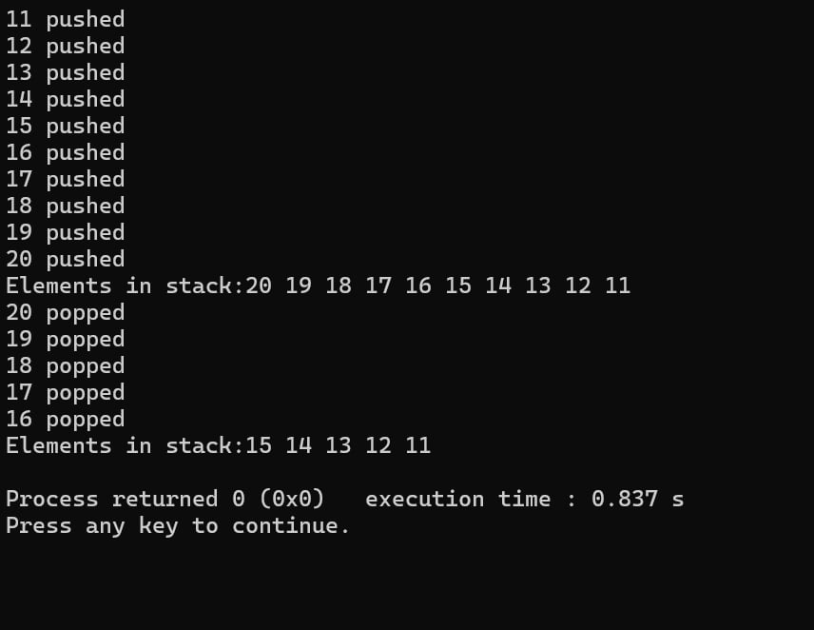

//Tazminur Rahman Tanim

//ID:242014124

#include<stdio.h>

#include<stdlib.h>

**struct** node

{

**int** data;

**struct** node *next;

};

**struct** node *head=NULL;

**void** push(**int** value){

**struct** node *newnode= malloc(**sizeof**(**struct** node));

newnode->data=value;

newnode->next=head;

head=newnode;

}

**void** pop()

{

**struct** node *temp;

**if**(head==NULL)

# {

# printf("Stack is empty");

}

**else**{

printf("Popped element %d \n",head->data);

temp=head;

head=head->next;

free(temp);

}

}

**void** display()

{

# printf("Stack: ");

**struct** node *temp=head;

**while**(temp!=NULL)

{

printf("%d ",temp->data);

temp=temp->next;

}

printf("\n");

}

**int** main()

{

push(5);

push(15);

push(25);

push(35);

push(45);

display();

pop(5);

pop(15);

pop(25);

display();

}

Output Result :

