Graph Retrieval Augmented Generation and Network Analysis of the Epstein Files
  - DSAN 6400 Network Analytics, Professor James Hickman
Tyler Blue
Andrew Moy
Ethan Wotring
2026-08-07
Table of contents

Abstract
The Epstein files have been a high profile story in the media in recent years, and many of its documents are public data. This paper constructs a knowledge graph connecting entities and persons in those files to explore various techniques and metrics in the network analytics field, such as degree, PageRank and betweenness centrality, connected component structure, and community detection. The resulting communication network is highly centralized. Jeffrey Epstein ranks first on every centrality measure examined, with a weighted degree of 2,270 against 252 for the next most active actor, and community detection within the largest weakly connected component recovers 46 distinct communication groupings. Furthermore, this knowledge graph is used to evaluate two retrieval augmented generation (RAG) systems, by comparing the effectiveness of traditional semantic search against a graph augmented RAG system. The two systems separate along the dimension the graph was built to address. Standard RAG scores higher on single entity lookups (7.4 against 6.8), while GraphRAG nearly doubles its score on one hop relational questions (6.8 against 3.6) and leads on two hop questions (5.0 against 4.0). Ultimately, neither system dominates outright, and the graph earns its cost precisely where semantic similarity has nothing to retrieve on, meaning questions about how two entities are connected rather than what a single document says.

1. Introduction and Literature Review
Over the past several years, the collection of documents known as the ‘Epstein Files’ has become a widely scrutinized body of records. The size of this collection has steadily grown through documents released in court proceedings or released by congress, today spanning thousands of emails and various related documents. Analysis of this large dataset is a challenging academic task due to the scale and lack of structure of the documents. Questions such as ‘who communicated with whom’ and ‘who was involved in this event’ cannot be answered by a single document or email, and instead require the traversal through a complicated web of interconnected events, establishments, and people. Edge et al. (2024) notes that queries directed at an entire corpus rather than at any individual record are often a failure point in context retrieval systems.
These characteristics make the Epstein Files a natural candidate for network analysis. Rather than reading through thousands of documents to identify structure and relationships, named entities can be extracted from documents and linked together based on their online communications and connections (X. Han et al. 2020). Fundamental concepts of network analytics such as centrality and community detection can help researchers discover influential groupings and make connections between those involved. Organizing extracted entities and relations into a knowledge graph is a well established way to integrate evidence spread across heterogeneous, unstructured sources (Hogan et al. 2021).
Furthermore, by constructing a knowledge graph of the Epstein Files, a RAG system can be augmented with additional context and information. Typically, RAG systems rely on semantic search through vector databases to identify relevant context to a given query (Lewis et al. 2020). This makes it difficult to connect entities through intermediaries. For example, two persons may be closely involved with a specific organization, but exchange emails only with said organization, never sharing emails between each other. A network is able to capture the relationship between these people by identifying the organization as the intermediary, whereas a semantic search would be completely ignorant to it.
This paper leverages the idea of ‘GraphRAG’ (Edge et al. 2024) to improve the performance of a simple query based RAG system. It involves mining contrived examples from the curated network itself to demonstrate the inability of vector RAG to reproduce the same results, but is then used to answer custom queries from the user via a command line interface. Test results are scored via large language model and human judgement. H. Han et al. (2025) show that neither system dominates outright, with each having distinct strengths by task. Fair comparison requires a unified protocol across both systems, which we adopt by sharing the same model, prompt, and generation parameters.

2. Methods

2.1 Corpus

2.1.1 Source and Format
The data utilized in this project was sourced from the House Committee on Oversight and Government Reform’s 12 Nov 2025 release of 2,897 documents (U.S. House Committee on Oversight and Government Reform 2025). These documents were subpoenaed from the Department of Justice and contain tens of thousands of pages of records, emails, and photos from Jeffrey Epstein’s estate.
The documents were obtained as an eDiscovery collection, which is a structured collection of files typically used in the legal sector. One distinct characteristic of this file organization is that they are shipped with load files containing per-document metadata. They are identified with a unique stamp and a “Bates” number on the first page of each document. It was also found that page text was Optical Character Recognition (OCR) output of scanned documents.

2.1.2 Corpus Profiling
Due to the presence of OCR in the data aggregation, the corpus was profiled on two independent axes. The first was “OCR quality”, to answer whether the characters came off the page correctly. The second was “Text style”, to identify whether the document has prose.
OCR quality was measured from two character level signals. The first, the vowel-less type ratio, is the share of a document’s distinct words containing no vowels and is helpful in identifying noise in the documents. The second, the non-word character ratio, is the share of a document’s uncommon characters, and is helpful at identifying non-prose.
Text style was measured from the common-word ratio, the share of tokens that are common English function words. This metric identified documents that contained running prose (ie conversations) instead of signature blocks, financial tables, or recipient lists.
Table 1: Document profiling flags (n = 2,897).
Axis | Flag | Meaning | Documents
OCR quality | clean | no garble signal | 2,763 (95.4%)
 | noisy | some garble, still readable | 100 (3.5%)
 | poor | heavily garbled | 33 (1.1%)
 | empty | effectively no text | 1 (<0.1%)
Text style | prose | running text | 2,100 (72.5%)
 | mixed | part prose, part listing | 122 (4.2%)
 | sparse | few function words, such as tables, signature blocks and lists | 49 (1.7%)
 | short | too few words to classify | 626 (21.6%)

Documents that were flagged “poor” or “empty” were excluded from the entity extraction, leaving 2,863 (98.8%) of the original 2,897.

2.1.3 Metadata Findings
The finding that shaped the rest of the ingestion pipeline was that the load file only tagged 64 documents as emails, while the OCR text contained 4,039 email header blocks across 2,208 documents. A communication network built from the load file fields alone would not capture all of the correspondence that is actually present. Figure 1 shows the coverage of each load file field across the release. While structural fields such as custodian and Bates range are fully populated, the email-specific fields that a communication network would depend on are populated for only 2% of documents.
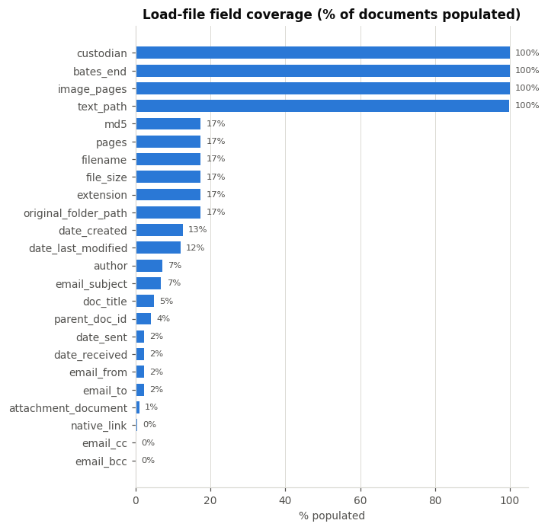
Figure 1: Load-file field coverage across the release. The email routing fields (email_from, email_to, email_cc) are effectively empty, which is why the communication network is reconstructed from OCR text rather than metadata.

2.2 Corpus Preparation

2.2.1 Load-file parsing and document identity
To start the corpus preparation, the metadata files of the document release were parsed and joined to the OCR text to produce a document manifest. This manifest is keyed on the Bates identification and contains page ranges, per-page text offsets, and metadata fields.

2.2.2 Text normalization with offset preservation
A large hurdle in this project was determining how to cite cleaned text, as any transformation applied to a document will result in a citation to the clean document, not the source. Therefore, every cleaning step was recorded as an edit over the raw text and applied in a single pass. This produced a table that supports direct mapping from cleaned to raw text. As a result of this process, 97% (3,915 of 4,050) of email edges carry an exact page citation, greatly supporting the source document tracing produced later in this paper.

2.2.3 Email header parsing
Email header blocks were extracted from the normalized text using a deterministic parser that semantically identifies the key identifiers of email headers (“From:”, “To:”, “Cc:”, “Sent:”, etc.). Additionally, the parser splits recipient lists without breaking common “Last, First” display names and repairs common OCR corruption mistakes.
Each email received a unique identification along with features such as sender, sorted recipients, subject, and timestamp. This allowed for the deduplication of forwarded copies of emails. As a result, 3,248 unique messages were obtained, of which 2,704 carried both a sender and a recipient, crucial for edge construction.

2.3 Entity Extraction

2.3.1 Strategy and Systems
With multiple systems available for entity extraction, the project team found it pertinent to evaluate multiple to make an informed decision on which to implement for the final product. Entity extraction targeted three types, namely PERSON, Organization (ORG), and Geopolitical Entity (GPE). The first system for entity extraction was the spaCy Python library (Honnibal et al. 2020), specifically the en_core_web_lg model. The benefits of this approach were that it only costs compute, is local, and takes about 35 minutes to run over the corpus. The second system for entity extraction was a direct LLM extraction using claude-sonnet-5 across the three-type set. While this approach is able to gather context more effectively than the spaCy model, the cost is higher and would require a batch run for the entire corpus. The last approach was a hybrid extraction, where an LLM was given the text and spaCy candidates and allowed to confirm, correct, reject, and add entities.

2.3.2 Evaluation Design
In order to evaluate the three extraction systems, 35 documents were sampled from the corpus and stratified on OCR quality and text style derived in the corpus profiling. Additionally, the sample was restricted to a band of 150 to 1,500 words to limit the total number of entities extracted. This limitation was implemented because outputs from all three systems were pooled per document and judged at the entity level. Two annotators determined y/n judgements of blinded, shuffled results across 1,568 judgements.
Annotator agreement was a limitation, with Cohen’s $κ$ = 0.384 over 260 shared rows. The disagreement was concentrated in ORG and was one-directional, with 48 of 56 disagreements being one annotator accepting what the other had rejected. Per system precision differed by 10 to 17 points between annotators. As a result, absolute values should be read as indicative, while the ranking of the systems is the true finding of this evaluation.

2.3.3 Results
The evaluation of all three systems, spaCy, LLM, and hybrid can be found in Table 2 and Figure 2. The LLM and hybrid approaches are not distinguishable, but both outperform spaCy. The most difficult category for all three systems was ORG, of which no system exceeded 0.66 F1 on organizations. Consequently, this was also the category that the annotators shared the most disagreements.
Table 2: Extraction system comparison. F1 is frame weighted across the sampling strata. Corpus cost is estimated for the full 28,877 chunks via the batch API.
System | F1 | ORG precision | Corpus cost
LLM | 0.78 | 0.79 | ~$64
Hybrid | 0.77 | 0.75 | ~$64
spaCy | 0.72 | 0.64 | free

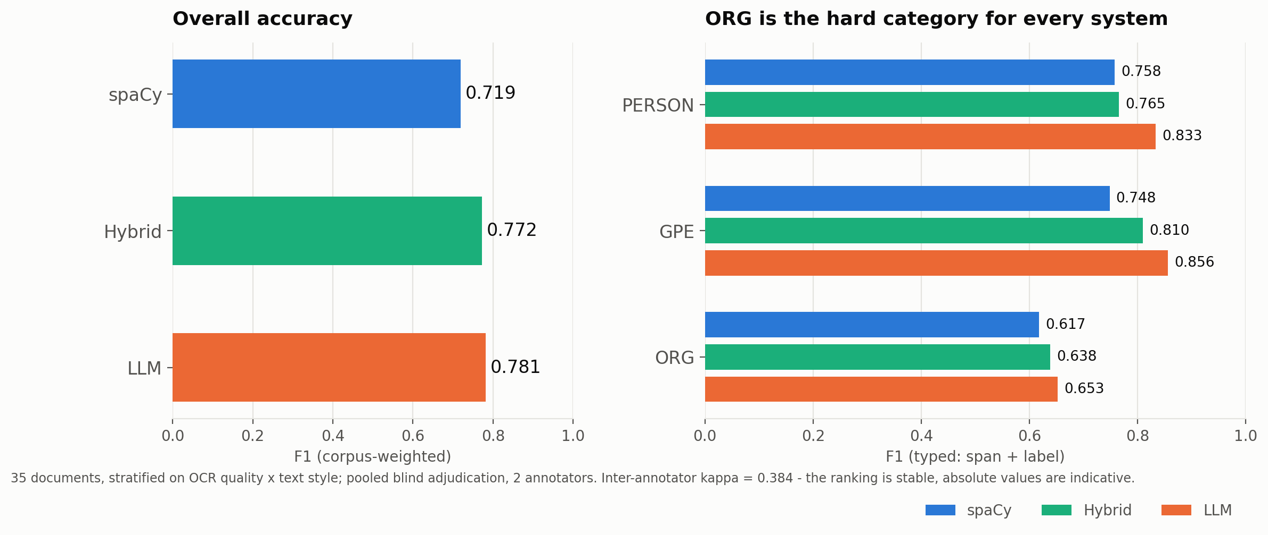
Figure 2: Extraction accuracy by system. The left panel shows overall frame weighted F1 and the right panel shows F1 by entity type, showing that ORG is the hardest category for every system.

2.3.4 Production Configuration
The final entity nodes are constructed with spaCy corpus wide, with 540,586 mentions over 2,857 documents resolving to 91,100 distinct surface forms, at around 35 minutes and at no cost. LLM extraction over the corpus was estimated at around $64 via the batch API. The decision to utilize spaCy over the LLM extraction was heavily weighted on the cost and time, at the detriment of 6 F1 points of performance.

2.4 Graph Construction

2.4.1 Entity Resolution
In examining the extracted entities, it was found that the number of real entities was lacking, and significant resolution was required. For example, one resolved entity (Jeffrey Epstein) appears as 34 different identifiable strings. The issues in merging these aliases are twofold. On the one hand, under-merging one person across many nodes could dilute their centrality. On the other hand, over-merging could fabricate relationships that propagate across the graph. Of the two, over-merging is the more consequential.
In order to merge aliases to a single entity, comparison of extracted entities was necessary. However, comparing all pairs resulted in 8.3 billion comparisons, which would result in countless hours of run time. To counteract this, candidates were compared within a block depending on the entity. For people, a block consisted of a shared surname (Epstein, Maxwell, etc.) while organizations and places consisted of a four character trimmed prefix.
Within a block, two names are only allowed to merge if their given names are compatible. For example “j epstein” could merge with “jeffrey epstein”, but “Mark Epstein” could not. If either given name is absent, merging is refused. Clusters are then formed by union-find, so every merge happens without every pair being compared. Then surnames with no given name are attached to full names using same document evidence, with a fallback on corpus wide evidence. Additionally, email addresses extracted from the deterministic header parser were attached to the person whose name they match. This matching was exact or token-order-insensitive only to preserve reliability.
As a result, 91,100 extracted strings were reduced to 81,112 entities. It was found that only 9.3% of entities had more than one alias, but those entities covered 46% of all mentions in the corpus.

2.4.2 Edge Construction
Relations were built in two tiers, deterministic and statistical. Table 3 shows Tier 1 relations, which were extracted directly from the documents.
Table 3: Tier 1 (deterministic) relations, extracted directly from parsed email headers.
Relation | n | Direction | Weight
communicated_with | 1,139 | directed | distinct messages
co_recipient_of | 693 | undirected | messages addressed to both
participated_in | 1,080 | person → thread | messages contributed

Email actors were mapped onto resolved entities by email address first, then exact or token-reordered name. No fuzzy matching was used because this is the strongest evidence of communication in the corpus and a wrong link would fabricate a conversation. Email threads were reconstructed by grouping messages that share a normalized subject, a participant, and fall within 30 days. The time window of 30 days proved necessary in thread construction, as a single participant appears in nearly every message. Threads are modelled as nodes instead of groups of participants to reduce inflation of every participant’s centrality. Temporal attributes were also applied to communication edges and 97% of email headers carried a parseable timestamp.
Tier 2 edges represent statistical associations between entities rather than relationships explicitly stated in the source documents. An edge is created when two entities appear together within the same text chunk, and its strength is measured using Normalized Pointwise Mutual Information (NPMI), which evaluates whether two entities co-occur more frequently than would be expected based on their individual occurrence rates. To reduce noise, entities were required to appear in at least three chunks, while entity pairs had to co-occur in at least three chunks across two or more documents. Additional filters removed very large chunks, such as directories, and excluded duplicated email headers introduced during chunking. Because NPMI can assign very high scores to boilerplate text (e.g., email signatures or letterheads), it was used only to identify statistically meaningful associations rather than as a measure of relationship importance. Reported co-occurrence relationships are instead ranked by their raw co-occurrence frequency. Every edge retains provenance information, including the originating documents and Bates page numbers, allowing any relationship identified by the graph or GraphRAG system to be traced back to the original source documents. The final network consists of 81,796 nodes and 113,613 edges, including 110,701 statistical co-occurrence edges spanning 12,864 unique entities.

2.5 Network Analysis
To characterize the communication structure contained within the broader knowledge graph, a directed communication network was constructed using the deterministic communicated_with relationships described above. The full graph contains several types of entities and relationships, including organizations, locations, threads, co-occurrences, and communication events. Because the purpose of this portion of the analysis was to evaluate communication behavior specifically, nodes previously flagged as noisy were excluded and the edge set was restricted to direct communication relationships. This produced a focused communication network containing 850 nodes and 1,132 directed edges. This is slightly fewer than the 1,139 communicated_with edges in Table 3, because the noise filter removed nodes along with the edges attached to them. Edge direction represents the sender to recipient flow of communication, while edge weight represents the number of distinct messages exchanged.
Several complementary network metrics were used to evaluate structural importance. Degree based measures were calculated to identify highly connected actors, with weighted degree used to capture total communication volume. PageRank (Page et al. 1999) was calculated on the weighted directed graph to identify actors whose importance was reinforced through connections to other highly connected individuals. Betweenness centrality (Freeman 1977) was calculated using network topology to identify actors that frequently lie on shortest communication paths and may therefore serve as brokers between otherwise separated portions of the network.
The overall structure of the network was then evaluated using connected component and community analysis. Weakly connected components were used to identify portions of the graph that remain connected when edge direction is ignored, while strongly connected components were used to evaluate mutual reachability through directed communication paths. Community detection was performed on the largest weakly connected component using greedy modularity optimization (Clauset, Newman, and Moore 2004) after converting that component to an undirected representation. This approach identifies clusters of actors whose communication relationships are more densely concentrated within the group than with the remainder of the network.
Finally, both static and interactive visualizations were constructed to support interpretation of the network. Static NetworkX (Hagberg, Schult, and Swart 2008) visualizations used node size to represent structural importance and node color to represent detected community membership. An interactive PyVis visualization was also produced, allowing users to search for actors, inspect local neighborhoods, zoom and pan through the graph, and explore communication structure directly.

2.6 Natural Language Querying
A major goal of this project is to build a natural language querying system that allows a user to ask questions about the Epstein files using natural language. To accomplish this, two approaches were used. Firstly, a traditional RAG based pipeline was built to answer user queries about the documents. The methodology behind the naive RAG pipeline will be discussed first below.

2.6.1 Vector Based RAG
The flowchart shown in Figure 3 below describes the overall process for the RAG pipeline. The raw email documents will be parsed/split into paragraph based text chunks, embedded into their vectorized representations, and stored in a local vector database. Queries will be submitted via command line argument, embedded into a vector, and used to retrieve similar documents via semantic search. The natural language query and retrieved documents will be fed into a large language model, which will return the answer to the query.
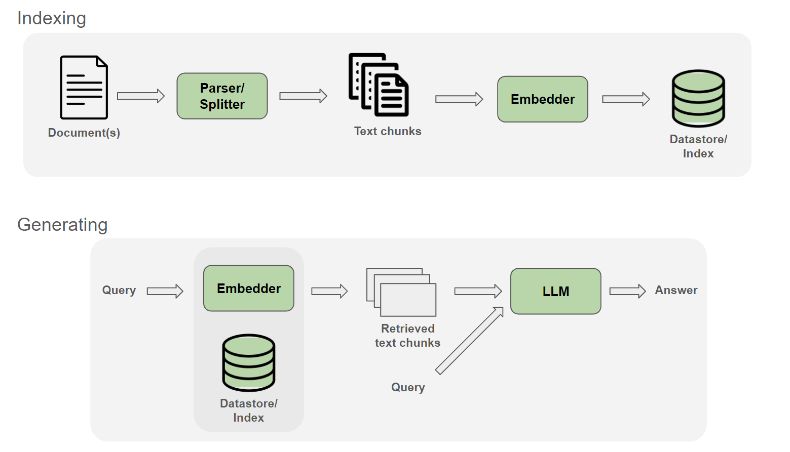
Figure 3: Flowchart for a standard RAG pipeline. Reproduced from the NVIDIA NeMo Framework user guide (NVIDIA 2024).

2.6.2 Chunking
Since the majority of the raw text data is naturally subdivided into individual ‘email’ entities, the chunking process is designed around that existing structure. Emails are treated as boundaries for chunking, and chunks do not contain material across multiple emails, unless it is an email chain (identified by subject line), in which case this boundary is ignored. Additionally, email ‘headers’ containing metadata such as sender, recipient, date, etc., are parsed deterministically and prepended to chunks derived from the email body. Emails are split by newline into paragraphs, which are either concatenated together (for paragraphs under 350 words) or divided (for paragraphs over 350 words). These chunks are then embedded into a length 384 vector using the BAAI/bge-small-en-v1.5 model (Xiao et al. 2023), and saved to a FAISS file (Douze et al. 2024) for later retrieval. In total, 8,497 chunks from 4,039 emails are extracted (and 28,877 total, including non-email chunks).

2.6.3 Retrieval
For a given query, the same BAAI/bge-small-en-v1.5 embedding model is used to vectorize the query and cosine similarity is computed against the entire vector database, returning the top k highest scoring chunks (k = 8 for this paper). These natural language chunks, in addition to the natural language query, are fed into a large language model via API, in this case, Claude Sonnet 5.

2.6.4 GraphRAG
Adding the knowledge graph to the RAG system allows for information regarding k-hop connections to be passed to the LLM as additional context. Given a query, entities of interest are extracted and their respective nodes are found by key in the graph. Relevant neighbors, edges, and associated documents must then be deterministically filtered to aggregate information to feed to the LLM that is both properly sized and effective. This presents a bevy of architectural decisions that must be made, as it is a difficult task to limit a breadth-first search to a reasonable size, as well as to identify chunks that are relevant to the query. For this paper, entity extraction is performed on a query, and their associated nodes are found inside the network. All paths between nodes of interest are fed to the LLM as context, and documents associated with the shortest path are also appended.

2.6.5 Evaluation
Typically, a RAG evaluation system entails both retrieval and generation steps. The former grades whether the correct documents were identified, while the latter grades the output of the model. For a comparison between traditional RAG and graph RAG, generation is made the focal point because any retrieved document that spanned a multi hop connection would undermine the intention and effectiveness of the graph augmentation. Therefore, metrics such as recall@k and Mean Reciprocal Rank will not be reported on in this paper in favor of judgement of the generated responses. Instead, we will focus on the quality of LLM generated responses using both LLM-as-judge and human evaluation.
Evaluation questions must be built somewhat artificially via mining the documents and the preconstructed knowledge graph because connections hidden within the Epstein Files are unknown. Questions are divided into four categories. Firstly, single entity questions for general RAG evaluation are judged, followed by three categories intended for comparison between the two systems. These are single hop questions involving entities connected by one edge, two hop questions involving entities whose shortest path is 2, and no path questions, whose nodes are far apart from each other. These questions are then fed through both the traditional RAG pipeline and the graph RAG pipeline, and their answers are compared.

3. Results

3.1 Network Analysis
The resulting communication network is highly centralized. Jeffrey Epstein ranked first across each of the principal centrality measures examined. His weighted degree was 2,270, substantially greater than the next highest value of 252 for Reid Weingarten. Epstein also received the highest PageRank score (0.2604), followed by Reid Weingarten (0.0339) and Michael Wolff (0.0152). This consistency across activity and influence based measures indicates that Epstein is not only the highest volume communicator in the network, but also occupies its dominant structural position. Figure 4 makes this structure visible, showing a dense central core surrounded by peripheral actors who connect to the rest of the network almost exclusively through it.
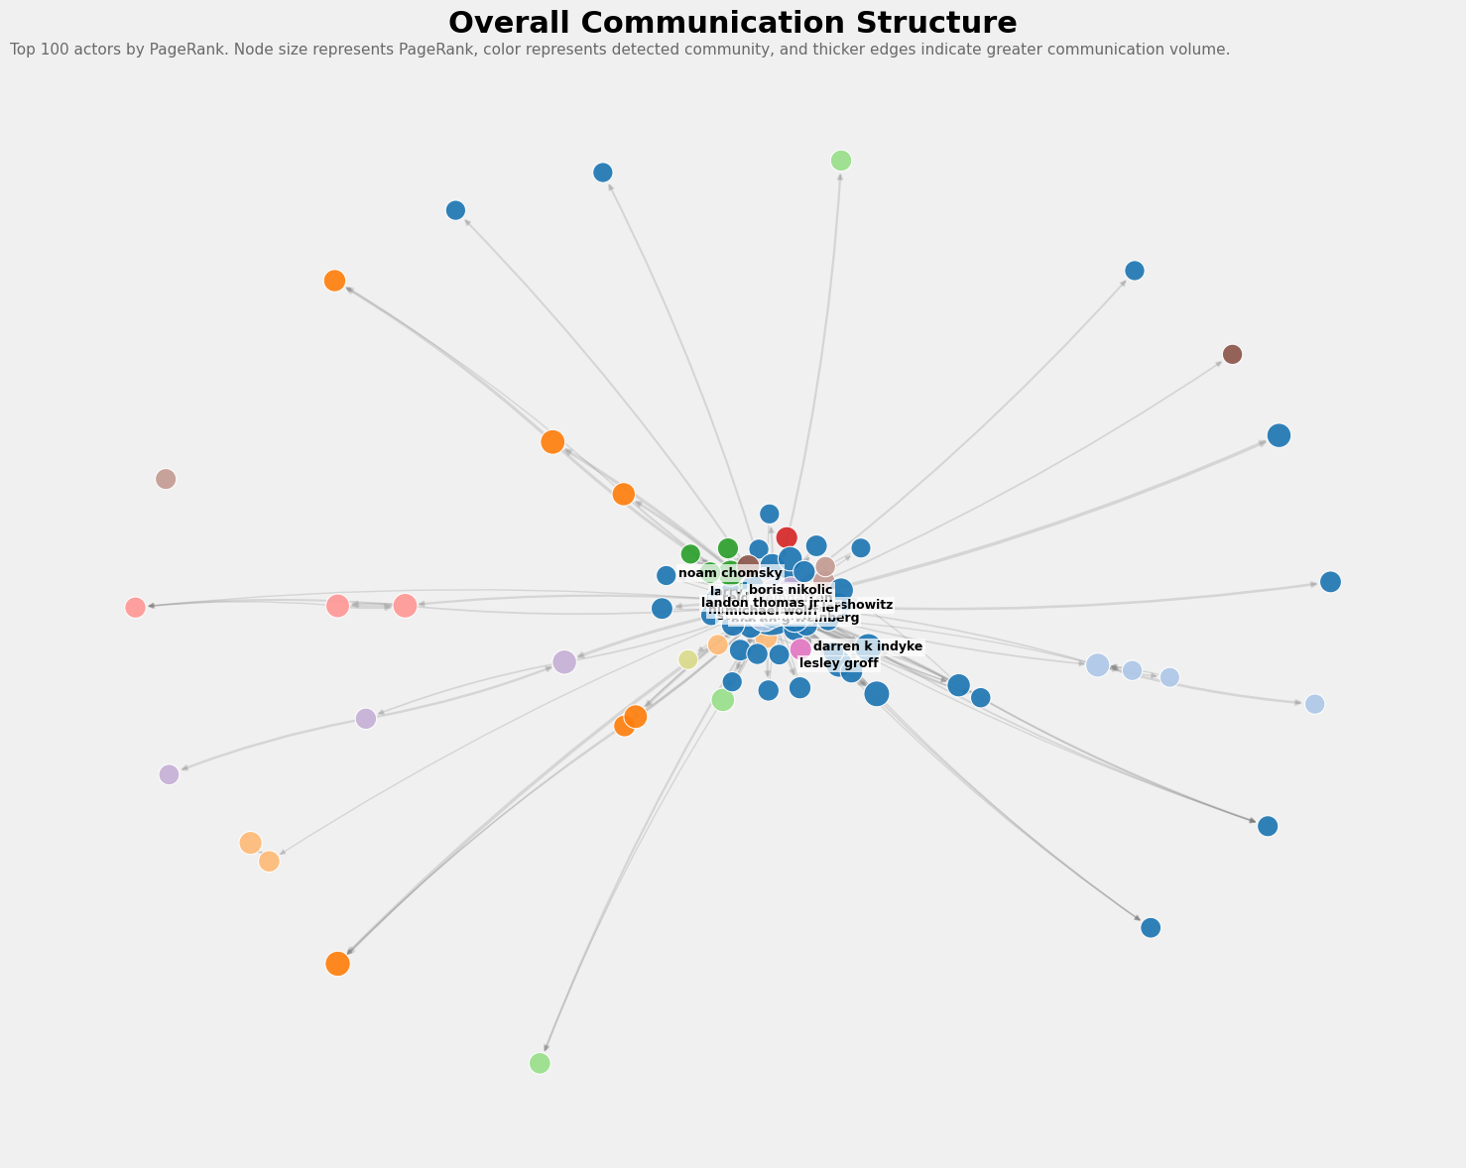
Figure 4: Overall communication structure, top 100 actors by PageRank. Node size represents PageRank, color represents detected community, and thicker edges indicate greater communication volume.
Betweenness centrality produced a somewhat different ranking after the leading node, illustrating the complementary nature of the metric. Epstein again ranked first with a betweenness score of 0.1769, while Martin G. Weinberg ranked second at 0.0083. Other actors with relatively high betweenness included Lesley Groff, Lawrence Krauss, Jay Lefkowitz, and Darren K. Indyke. These individuals do not necessarily have the largest communication volumes, but their network positions place them on communication paths connecting otherwise more separated regions of the graph. This distinction demonstrates why multiple centrality measures are necessary when evaluating influence. High activity, structural importance, and brokerage are related but not equivalent concepts.
Community detection within the largest weakly connected component identified 46 communities. The largest community contains 252 nodes, followed by communities of 72, 45, 39, and 36 nodes (Figure 5). The uneven distribution of community sizes suggests that the network is composed of several major communication environments alongside smaller, more specialized clusters. These communities should be interpreted as structural communication groupings rather than evidence of formal organizational membership or coordinated behavior.
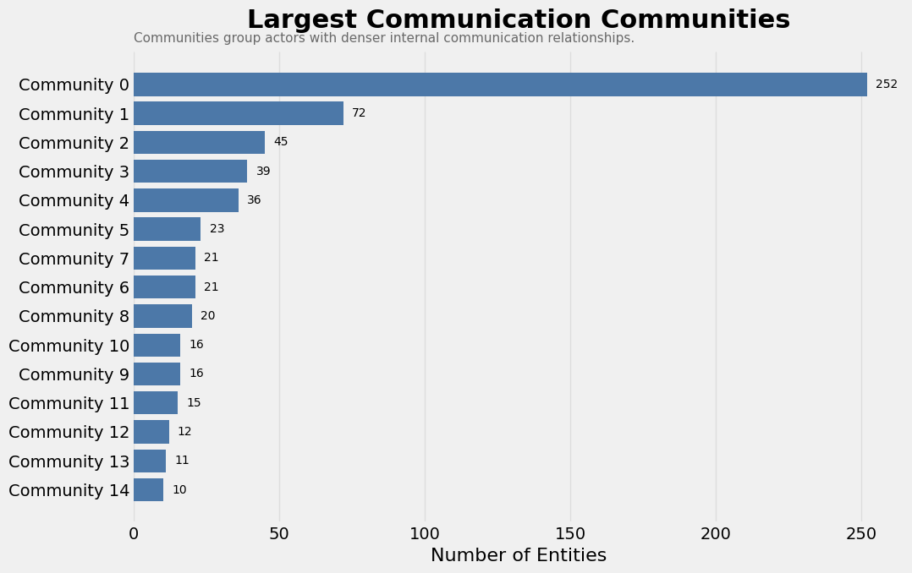
Figure 5: Community sizes within the largest weakly connected component. The distribution is heavily uneven, with one dominant community and a long tail of smaller clusters.
Taken together, the network analysis shows that the communication graph is dominated by a central hub but also contains meaningful internal structure. Centrality measures identify the actors occupying the most influential and intermediary positions, while component and community analysis reveal how those actors are organized into broader communication neighborhoods. These structural properties also provide a direct bridge to the GraphRAG portion of the project. Rather than retrieving evidence solely through semantic similarity, communities, central actors, and graph paths can be used to guide retrieval across related documents and entities.

3.2 RAG vs GraphRAG
Table 4 reports the mean judged score for each question category under both systems. The two systems separate almost exactly along the dimension the graph was built to address.
Table 4: Mean judged answer quality by question category. Higher is better.
Category | RAG | GraphRAG
Single Entity | 7.4 | 6.8
One Hop | 3.6 | 6.8
Two Hop | 4.0 | 5.0
No Path | 10.0 | 10.0

On single entity questions, where the answer is contained in one document and semantic similarity is sufficient to find it, standard RAG scores slightly higher (7.4 against 6.8). The graph adds nothing here, and the additional context it supplies appears to dilute rather than sharpen the answer.
The picture reverses on relational questions. On one hop questions GraphRAG nearly doubles the score of standard RAG (6.8 against 3.6), and on two hop questions it retains a smaller but consistent lead (5.0 against 4.0). This is the expected result. When the answer depends on a connection between two entities rather than the content of any single chunk, semantic search has nothing to retrieve on, because no document states the relationship directly. The declining margin between one hop and two hop questions suggests that the benefit of graph augmentation weakens as path length grows, likely because longer paths introduce more intermediate context for a fixed context budget.
Both systems score a perfect 10.0 on no path questions. Neither fabricated a connection between entities that are not related in the graph, which is the correct behavior and a useful negative control. A system that hallucinated relationships would be exposed by exactly this category.
These results are consistent with H. Han et al. (2025), who find that neither paradigm dominates outright across task types. The practical implication is that the two retrieval strategies are complementary rather than competing. A production system would route single entity lookups to vector retrieval and relational questions to the graph.

4. Discussion
The central finding of this project is that the structure of a document collection determines which retrieval strategy works on it. The Epstein Files are a correspondence corpus, and correspondence encodes relationships that no individual document states outright. That is precisely the case where vector retrieval fails and graph traversal succeeds. The network analysis and the GraphRAG evaluation are two views of the same property.
Three limitations qualify these results. First, entity extraction used spaCy rather than the best-performing system evaluated, trading approximately 6 F1 points for zero marginal cost. Graph derived results should therefore be read as a lower bound on what the method can achieve. Second, inter-annotator agreement on the extraction evaluation was low ($κ$ = 0.384), so the ranking of extraction systems is the defensible finding while absolute scores are indicative. Third, the evaluation question set was mined from the graph itself, which measures whether GraphRAG can retrieve what the graph already encodes rather than whether the graph encodes the right things.

5. Conclusion
This project converted 2,897 unstructured, OCR-derived documents into a knowledge graph of 81,796 nodes and 113,613 edges, and used it for two purposes. Network analysis showed a highly centralized communication structure with a single dominant hub and 46 distinct communities. The GraphRAG evaluation showed that graph augmentation nearly doubles answer quality on one hop relational questions while offering no advantage on single entity lookups. Neither retrieval strategy is uniformly better. The useful result is knowing which questions belong to which.

References
Clauset, Aaron, M. E. J. Newman, and Cristopher Moore. 2004. “Finding Community Structure in Very Large Networks.” Physical Review E 70 (6): 066111. https://doi.org/10.1103/PhysRevE.70.066111.
Douze, Matthijs, Alexandr Guzhva, Chengqi Deng, Jeff Johnson, Gergely Szilvasy, Pierre-Emmanuel Mazaré, Maria Lomeli, Lucas Hosseini, and Hervé Jégou. 2024. “The Faiss Library.” https://arxiv.org/abs/2401.08281.
Edge, Darren, Ha Trinh, Newman Cheng, Joshua Bradley, Alex Chao, Apurva Mody, Steven Truitt, Dasha Metropolitansky, Robert Osazuwa Ness, and Jonathan Larson. 2024. “From Local to Global: A GraphRAG Approach to Query-Focused Summarization.” https://arxiv.org/abs/2404.16130.
Freeman, Linton C. 1977. “A Set of Measures of Centrality Based on Betweenness.” Sociometry 40 (1): 35–41. https://doi.org/10.2307/3033543.
Hagberg, Aric A., Daniel A. Schult, and Pieter J. Swart. 2008. “Exploring Network Structure, Dynamics, and Function Using NetworkX.” In Proceedings of the 7th Python in Science Conference (SciPy2008), 11–15.
Han, Haoyu, Li Ma, Yu Wang, Harry Shomer, Yongjia Lei, Zhisheng Qi, Kai Guo, et al. 2025. “RAG Vs. GraphRAG: A Systematic Evaluation and Key Insights.” https://arxiv.org/abs/2502.11371.
Han, Xu, Tianyu Gao, Yankai Lin, Hao Peng, Yaoliang Yang, Chaojun Xiao, Zhiyuan Liu, Peng Li, Maosong Sun, and Jie Zhou. 2020. “More Data, More Relations, More Context and More Openness: A Review and Outlook for Relation Extraction.” https://arxiv.org/abs/2004.03186.
Hogan, Aidan, Eva Blomqvist, Michael Cochez, Claudia d’Amato, Gerard de Melo, Claudio Gutiérrez, José Emilio Labra Gayo, et al. 2021. “Knowledge Graphs.” https://arxiv.org/abs/2003.02320.
Honnibal, Matthew, Ines Montani, Sofie Van Landeghem, and Adriane Boyd. 2020. “spaCy: Industrial-Strength Natural Language Processing in Python.” Zenodo. https://doi.org/10.5281/zenodo.1212303.
Lewis, Patrick, Ethan Perez, Aleksandra Piktus, Fabio Petroni, Vladimir Karpukhin, Naman Goyal, Heinrich Küttler, et al. 2020. “Retrieval-Augmented Generation for Knowledge-Intensive NLP Tasks.” In Advances in Neural Information Processing Systems. Vol. 33.
NVIDIA. 2024. “RAG Overview.” NeMo Framework User Guide. https://docs.nvidia.com/nemo-framework/user-guide/24.07/rag/ragoverview.html.
Page, Lawrence, Sergey Brin, Rajeev Motwani, and Terry Winograd. 1999. “The PageRank Citation Ranking: Bringing Order to the Web.” 1999-66. Stanford InfoLab.
U.S. House Committee on Oversight and Government Reform. 2025. “Documents Produced by the Department of Justice Pursuant to Subpoena (Jeffrey Epstein Estate Records).”
Xiao, Shitao, Zheng Liu, Peitian Zhang, and Niklas Muennighoff. 2023. “C-Pack: Packaged Resources to Advance General Chinese Embedding.” https://arxiv.org/abs/2309.07597.

