**Final individual project**

**Part A. Character relations**

Moretti (2011) examines the use of network analysis to comprehend the links and interconnections between characters in novels in his article "*Network Theory, Plot Analysis*". For *Hamlet* and *The Story of the Stone*, he provides a visual summary of the network of characters, which depicts the relationships between the characters as lines on a network.

The fact that this visual summary (Graph 1) gives a clear and succinct understanding of the relationships between the characters in *Bonita Avenue* is one of its advantages. The visual summary makes it simple to identify which characters are connected to one another and to comprehend the patterns and trends in their interactions by representing these relationships as lines on a grid.

The great advantage of Graph 1 is when we talk about a character in *Bonita Avenue,* it is no longer an abstract literary theory, but automatically turns to 'consciousness' and 'interiority' (Moretti, 2011). Specifically, firstly,centrality. We can judge the centrality of Aaron Bever, Siem Sigerius and Joni Sigerius by the position of the characters. In other words, Aaron Bever, Siem Sigerius and Joni Sigerius are the typical characters in the novel. Secondly,clustering. The triangle formed by Aaron Bever, Siem Sigerius and Joni Sigerius which is the densest part of the whole network.Almost everyone in the network is associated with them and the clustering is almost 100%. Lastly, plot. According to the sparseness of the lines between the different characters, that is, the complexity of their interactions, we can infer the direction of the novel's plot. Moreover，we can conclude that the number of male characters is roughly the same as the number of female characters based on the legends, with slightly more males.

This graphic explanation does have certain drawbacks, though. For instance, it offers no details regarding the nature of the relationships between individuals. Therefore, beyond the relative strength of the associations, this visual network analysis offers no information about the nature of the links between the characters. For instance, it is clear that there is a strong connection between Aaron Bever and Siem Sigerius, but it is impossible to determine if this bond is friendly or hostile.

Additionally, as was already indicated, a network analysis of this kind cannot adequately capture the complexities of the character associations, and as a result, crucial details may be lost when they are summarized. Examples include the particular events and interactions that shaped these connections. Such a visual network analysis might exclude certain potentially intriguing but subtle connections by concentrating exclusively on the most crucial or central character interactions.

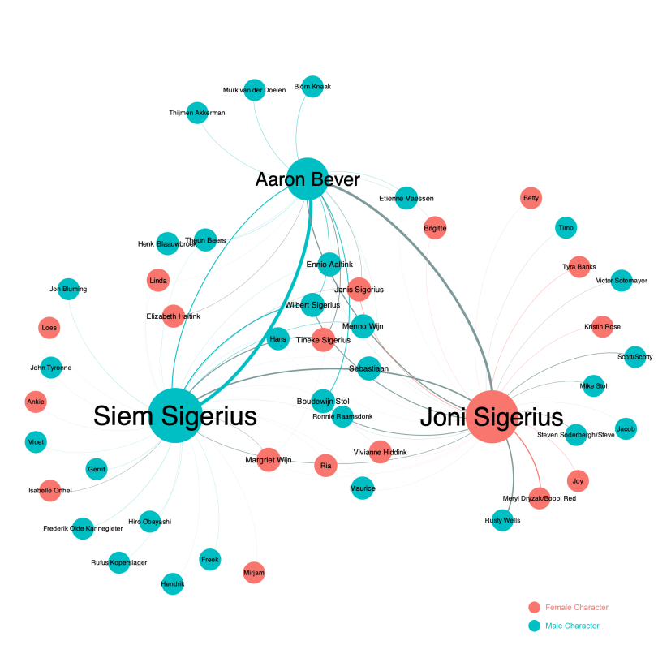

Graph 1: Network Analysis of relationships among characters in Bonita Avenue

**Part B. Textual relations**

Analysing stylometric relationships as networks is a method that considers texts as nodes and the relationships between them as edges. This method is based on the theory of stylistics, which involves analyzing the structure and features of a text by quantifying specific characteristics within the text (Eder, 2017). Using this method to analyze text relationships as a network allows for the study of broader conventions, vocabulary norms, and even literary influences. In this study, we utilized 150 British novels published between 1771 and 1930 downloaded from the NovelTM corpus as source data and used the Stylo output of this dataset as input for Gephi to analyze the stylistic relationships between these novels. Analyzing the network relationships of these 150 novels allows us to understand the literary influences between different authors, examine the associations between literary works of different periods, and explore the history of literary development as well as the similarities and differences between literary works. This method helps us investigate the scope and degree of literary influence.

The following three graphs present the visualization results of the dataset analyzed by publication year, author gender, and narrative perspective, respectively. Each node represents a novel, and its size reflects the centrality of its influence in the community or cluster, which is determined by its connections with other nodes. The more connections a novel has, the greater its influence in the community or cluster. Node positions also reflect the relationships between novels. Nodes that are closer together may have similarities in themes, styles, plots, or other aspects, while those that are further apart may have greater differences. The edges and their weights between nodes represent the strength of their connections. The higher the weight of an edge between two nodes (i.e., the thicker the edge), the stronger the connection between the corresponding novels, indicating greater similarity in genre, language, or other aspects.

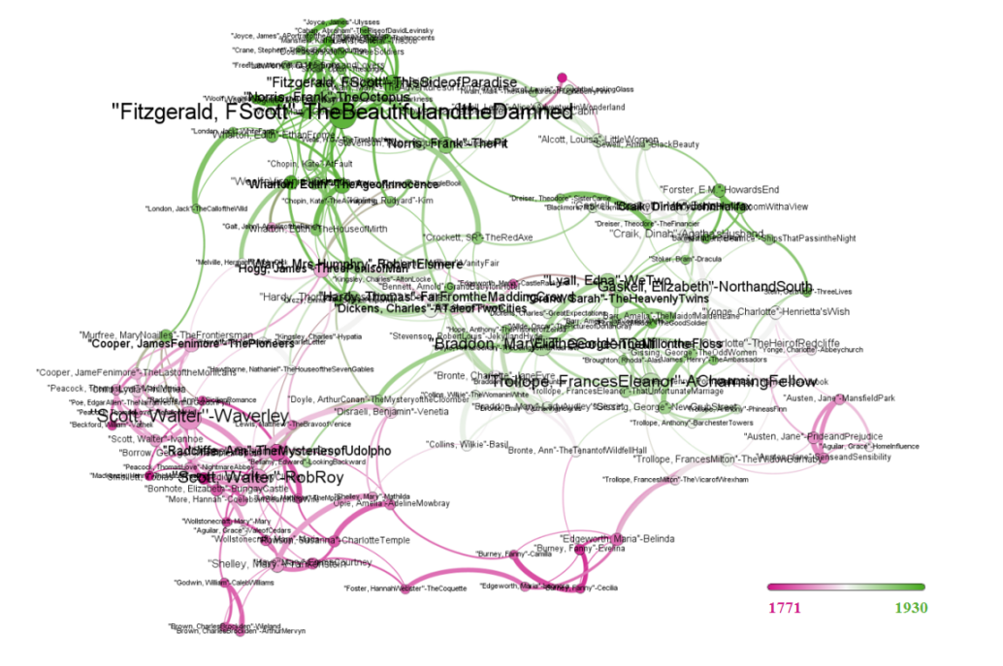

Graph 2: Network Analysis of relationships among British novels between 1771 and 1930 categorised by year

The network analysis results of 150 British novels based on their publication year are presented in Figure 2. The pink and green nodes represent publication years relatively close to 1771 and 1930, respectively, indicating a greater textual similarity among British novels published in the same era. The size of the labels is related to the influence of the nodes within the community. For example, in the community at the end of the 18th century, the works of Scott-Walter had a greater impact. Moreover, there is no prominent node in the lower right corner of Figure 2, which may suggest a relatively more diversified development trend of British novels in the 19th century.

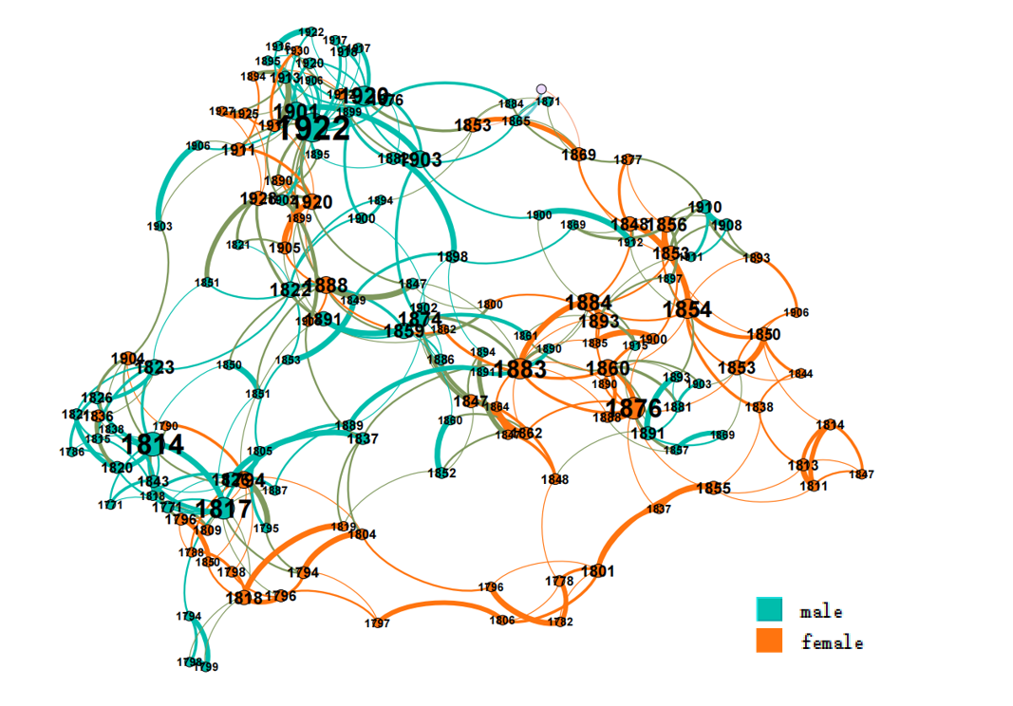

Graph 3: Network Analysis of relationships among British novels between 1771 and 1930 categorised by gender

Figure 3 depicts the positions of male and female authors in the entire network, with labels indicating the publication year of their novels. Blue nodes represent works by male authors, while coral nodes represent those by female authors. Firstly, the color distribution shows that male authors outnumber female authors in this dataset spanning 160 years. In addition, more influential novels located in the center of their respective communities are authored by men, indicating that novels written by male authors are more influential than those by female authors. However, as indicated by the combination of labels representing publication year, it also suggests that female authors have gradually emerged over time. i.e. with some influential female authors in the late 19th century. We also observe that blue and coral nodes are relatively concentrated in their respective communities, indicating a certain degree of exclusivity in the influence of male and female authors within their own gender groups.

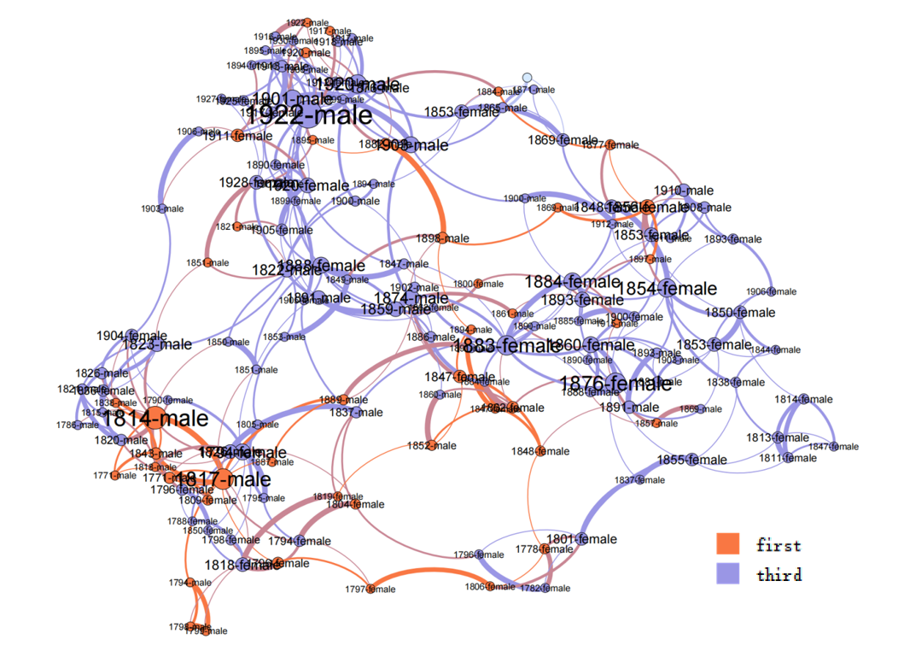

Graph 4: Network Analysis of relationships among British novels between 1771 and 1930 categorised by narrative perspective

Figure 4 displays the narrative perspectives of each novel, with red nodes representing the first-person perspective and purple nodes representing the third-person perspective, labeled with the publication year and gender of the author. The graph shows that in the late 18th century, novels written in the first-person perspective held an absolutely central position, while by the early 20th century, novels written in the third-person perspective had become dominant. When combined with the gender labels of the authors, it can also be observed that, relatively speaking, female authors tend to use the third-person perspective more often in their narrative processes.

In conclusion, analyzing stylistic and metric relationships as networks is a useful method that can help us better understand the relationships and overall structure among 150 English novels above. However, this method also has its limitations. It may not capture important differences in factors such as genre, content, and theme, which are crucial for understanding relationships among texts. Therefore, it is necessary to use this method with caution and combine it with other methods to obtain more comprehensive analytical results.

**Reference**

Eder, M. (2017). Visualization in stylometry: cluster analysis using networks. *Digital Scholarship in the Humanities, 32*(1), 50-64.

Franco Moretti, ‘Network Theory, Plot Analysis’. *New Left Review* 68 (2011): 80-102.