Verilog Module Description: ram_delay

Description

The ram_delay module implements a RAM-based delay line on the incoming input data. The internal address counters pause when the

The module's input and output word widths are parameterized. When instantiating the module, users should ensure that these word widths are of sufficient size to avoid or manage rollover of the output sum. The maximum buffer size for DELAY_A and DELAY_B are also parameterized, while the implemented widths are set by inputs to the module. The module allows initialization of the sum, and also allows

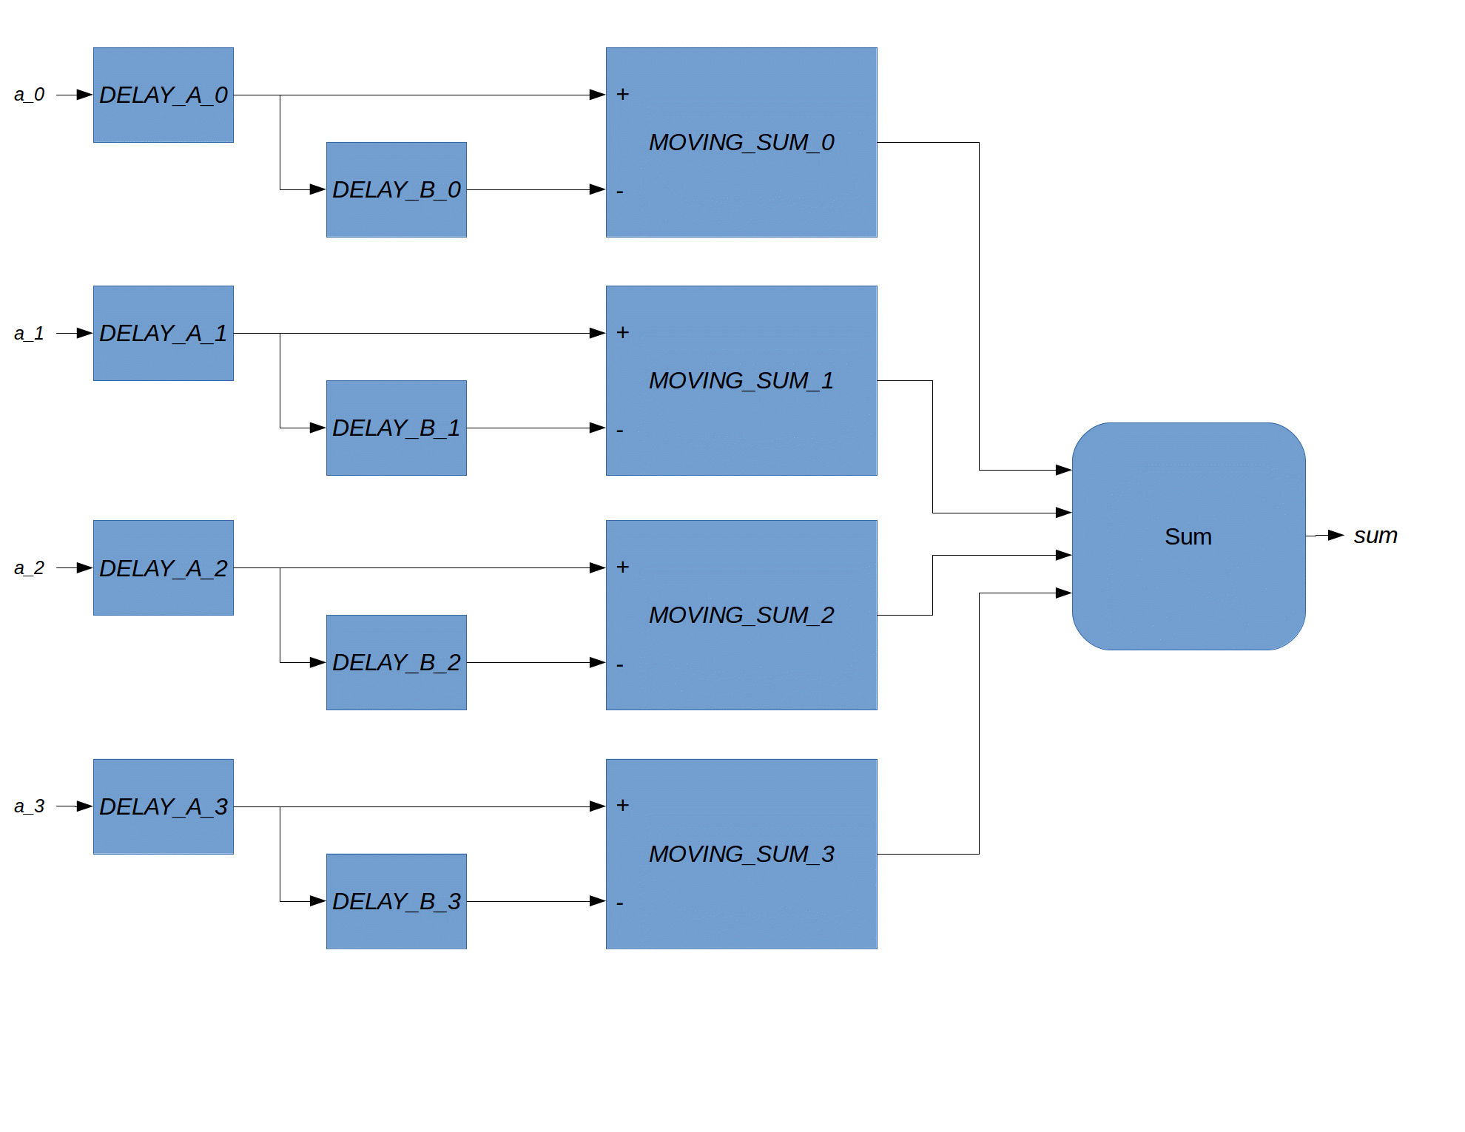

Implementation

This module was originally designed for the Altera Cyclone 5 5CEFA5F23I7 with a 14-bit input data width, a 24-bit output data width, and a maximum 512 sample delay buffer on each input data lane. A test compilation can be found in the device name directory. The design uses 142 ALMs, and Quartus maps the two sets of four 14 x 512 RAMs into two sets of three 20 x 512 M10K memory blocks. FMAX is greater than 175 MHz.

Testing and Regression

Self verifying, etc.

REVISION LOG

Date | Author | Email | Comment
2/13/19 | T. Anderson | tba109@psu.edu | V1: First revision

