Tech Challenge
Consumption Guide
Deploying and operating a modern EKS platform on AWS

Field | Value
Repository | github.com/tbadmus/tech-challenge
AWS account | 841845498000 · us-east-1
SSO profile | larry-cdw-sandadmin
Live demo | https://hello.elbeetest.com
Cluster | `tech-challenge-dev-cluster` · Kubernetes 1.35
Document date | 11 September 2026

Who this is for. An engineer who has been handed this repository and needs to deploy it, operate it, or take it apart safely. It assumes familiarity with AWS and Kubernetes concepts but not with this stack. Design reasoning lives in the ADRs; the teaching narrative lives in the walkthrough. This document is the operating manual.

1. Prerequisites
Tool | Requirement
Terraform | >= 1.11 — required for S3 native state locking. Pinned in `.terraform-version`.
AWS CLI | v2, recent. 2.17 is too old for `eks describe-cluster-versions`.
kubectl | Within one minor version of 1.35.
Helm | v3 or later (only needed for manual inspection).
Docker | With buildx. Images must be built for `linux/amd64`.
session-manager-plugin | Required for the SSM tunnel.
gh | Only for pipeline and repository administration.

On Apple Silicon: always install darwin_arm64 builds. An x86_64 Terraform under Rosetta times out starting the AWS provider plugin, and the error looks like a network fault rather than an architecture mismatch. Terraform here is managed by tfenv, not by a brew formula: upgrade with "tfenv install latest && tfenv use latest".

Authenticate
aws sso login --profile larry-cdw-sandadmin
export AWS_PROFILE=larry-cdw-sandadmin

2. Deploying step by step
The stack is two Terraform root modules plus a Kubernetes manifest set, and the order below is the order that works. Each step is one command. Run them in sequence; every step states what it produces and how to confirm it before you move on.
Where each step runs. Steps 1-5 talk only to AWS APIs, so they run anywhere -- your laptop or CI. Steps 6-9 talk to the KUBERNETES API, which is reachable only from an IP on the cluster allowlist. GitHub-hosted runners are not in the VPC and get ephemeral egress IPs, so they cannot reach a CIDR-restricted endpoint at all. In practice: let the pipeline own step 5, and run everything else from your workstation. If your IP is not on the allowlist, open an SSM tunnel instead -- see section 3.

Step 1 - authenticate
aws sso login --profile <your-profile>
export AWS_PROFILE=<your-profile>
Everything downstream derives the account id from this session. Confirm with aws sts get-caller-identity; the Arn it prints is the identity you will grant cluster access to in step 3, so keep it to hand.

Step 2 - check what will be derived
make preflight ENV=dev
Prints the account id, region, state bucket name and GitHub repository it worked out for itself, and changes nothing. No file edits are needed to deploy into a different account; if any of these four values is wrong, fix it here rather than discovering it mid-apply.

Step 3 - grant yourself access to the cluster you are about to build
Do this BEFORE the infrastructure apply, not after. Find your role ARN, then write both values into the gitignored terraform.tfvars:
cp terraform.tfvars.example terraform.tfvars
aws iam list-roles \
--query "Roles[?contains(RoleName,'AWSReservedSSO')].Arn" --output text
curl -s https://checkip.amazonaws.com

# terraform.tfvars (gitignored -- never commit either value)
cluster_endpoint_public_access_cidrs = ["<your-ip>/32"]
cluster_admin_role_arns = [
"arn:aws:iam::<id>:role/aws-reserved/sso.amazonaws.com/<your-sso-role>",
"arn:aws:iam::<id>:role/<project>-gha-apply",
]
If the pipeline will also deploy, mirror both into repository secrets so CI computes the same access entries you do: gh secret set TF_VAR_cluster_admin_role_arns and gh secret set TF_VAR_cluster_endpoint_public_access_cidrs.
Skip this and the cluster builds fine, but you cannot use it. An AWS account with AdministratorAccess grants ZERO Kubernetes RBAC. Without an EKS access entry, kubectl returns "the server has asked for the client to provide credentials", the console Resources tab shows "Unauthorized", and steps 6 and 9 both fail -- while every AWS-level check says the cluster is healthy, because it is. Include the CI apply role as well: app-deploy.yml runs kubectl as that role, and a list naming only humans silently revokes it. Do NOT put these values in environments/<env>.tfvars: a -var-file beats both terraform.tfvars and TF_VAR_, so a value there would override CI.

Step 4 - create the state backend (once per AWS account)
make bootstrap ENV=dev
Creates the S3 bucket every root module stores state in -- versioning, encryption, all four public-access blocks, a TLS-only bucket policy -- plus the GitHub OIDC provider and the two CI roles. It lives in its own root precisely so a routine teardown cannot delete it: CI has to survive in order to rebuild what it just destroyed. Prints the role ARNs; make ci-secrets pushes them to GitHub. Safe to re-run.

Step 5 - infrastructure
make init ENV=dev
make plan ENV=dev # read this before applying
make apply ENV=dev
Creates the VPC, EKS cluster, node group, managed addons, IAM, ECR, the SSM access host, and -- when enable_dns is true -- the ACM certificate and its validation records. Roughly 15 minutes, most of it the control plane. This is the step the terraform-apply workflow performs on a push to dev, so in a pipeline-driven setup you can let CI do it and pick up at step 6.
Read the plan. Two incidents in this project would have been caught by reading one: a tainted domain that planned a second 16 USD registration, and an ebs_optimized flag that planned an instance replacement for a property that was already true. A plan you do not read is not a gate.

Step 6 - wait for the cluster to be genuinely ready
make wait-cluster ENV=dev
make wait-nodes ENV=dev
Neither condition is true merely because the apply returned zero, and both are preconditions for step 7: the helm provider cannot authenticate to a cluster still CREATING, and a controller with no Ready node to schedule on will time out waiting for itself. wait-nodes also refreshes your kubeconfig, so this is the first point where kubectl get nodes should answer.

Step 7 - cluster software
make addons-init ENV=dev
make addons-plan ENV=dev
make addons-apply ENV=dev
make wait-controller ENV=dev
Installs the AWS Load Balancer Controller, ExternalDNS and the default gp3 StorageClass. This is a SEPARATE root module with its own state, because its helm and kubernetes providers must reach the Kubernetes API at PLAN time -- which a hosted CI runner cannot do. That constraint is the reason the split exists, and the reason this step is local.

Step 8 - build and push the application image
make image ENV=dev
Builds the container, pushes it to ECR tagged with the commit SHA, then records the resulting DIGEST in .backend/<env>.image. Needs a running Docker daemon, which is the other reason this belongs on a workstation rather than the SSM host. Deploying by digest rather than by tag is deliberate: the original pipeline pushed an implicit :latest into a mutable repository, so what ran was never provably what was built.

Step 9 - deploy
make deploy ENV=dev

make url ENV=dev # the address it is served on
Renders the manifests into a temporary directory with the digest injected and applies them, so nothing edits a tracked file in place and the manifests in git stay free of any account's registry hostname. Waits for the rollout to complete. Section 4 has the checks that confirm the architecture is behaving as designed rather than merely existing.

Or: all of it in one command
make up ENV=dev
Runs steps 4 through 9 in order, with the readiness gates between them, and shows the plan and prompts before applying -- pass CONFIRM=1 for unattended runs. Steps 1 to 3 are still yours: make up cannot authenticate for you, and it cannot guess which IAM role should administer the cluster. Completed stages are no-ops, so it is also the right way to resume after a failure partway through.

3. Day-to-day operations
Command | Purpose
make plan ENV=dev | Show pending infrastructure changes
make apply ENV=dev | Apply the saved plan file
make kubeconfig | Point kubectl at the cluster
make tunnel ENV=dev | SSM port-forward to the API on localhost:8443
make url ENV=dev | Print the application URL
make check | fmt + validate, the same checks CI runs
make destroy ENV=dev | Tear the environment down

When kubectl stops working
Two causes, and the error text tells them apart. A TIMEOUT is the endpoint allowlist: the cluster permits API access only from CIDRs listed in cluster_endpoint_public_access_cidrs, and your egress IP changes. Being asked to "provide credentials", or "Unauthorized" in the console, is the opposite problem -- you reached the API fine and have no EKS access entry, which no amount of IAM permission will fix. See step 3 of section 2 for that one. The rest of this section is the allowlist case.
curl -s https://checkip.amazonaws.com # your IP now
aws eks describe-cluster --name tech-challenge-dev-cluster \
--query cluster.resourcesVpcConfig.publicAccessCidrs # what is allowed

Two fixes. Immediate, works from anywhere:
make tunnel ENV=dev
kubectl --server https://127.0.0.1:8443 --insecure-skip-tls-verify get nodes

Durable — update the allowlist in the gitignored terraform.tfvars, and the matching GitHub secret so CI keeps working:
# terraform.tfvars
cluster_endpoint_public_access_cidrs = ["<new-ip>/32"]

gh secret set TF_VAR_cluster_endpoint_public_access_cidrs \
--body '["<new-ip>/32"]'
make plan ENV=dev && make apply ENV=dev

The allowlist is deliberately not in the repository. This is a public repository. Publishing the single IP permitted to reach a named cluster's API, next to the account id, is a targeting aid rather than configuration. It lives in terraform.tfvars (gitignored) and a GitHub secret. Note the precedence: a -var-file on the command line outranks terraform.tfvars, so the key must be ABSENT from environments/dev.tfvars rather than set to a placeholder.

4. Verifying a deployment
Checks that confirm the architecture is behaving as designed, not merely that resources exist.

The endpoint posture is what you think it is
aws eks describe-cluster --name tech-challenge-dev-cluster \
--query cluster.resourcesVpcConfig.'[endpointPrivateAccess,endpointPublicAccess,publicAccessCidrs]'

Expect private true, public true, and a specific /32 — never 0.0.0.0/0. The pre-modernization stack returned exactly that last value, because the field was never set and it is the AWS default.

Nodes are genuinely private
kubectl get nodes -o jsonpath='{range .items[*]}{.metadata.name}{" ext="}\
{.status.addresses[?(@.type=="ExternalIP")].address}{"\n"}{end}'

Every ExternalIP must be empty.

The ALB targets pods, not nodes
This is the single setting the whole ingress design rests on. The target group type must be "ip", and the registered targets must match the pod IPs:
TG=$(aws elbv2 describe-target-groups \
--query "TargetGroups[?contains(TargetGroupName,'hellowor')].TargetGroupArn" --output text)
aws elbv2 describe-target-groups --target-group-arns $TG \
--query TargetGroups[0].TargetType
aws elbv2 describe-target-health --target-group-arn $TG \
--query "TargetHealthDescriptions[].Target.Id"
kubectl -n demo get pods -o jsonpath='{.items[*].status.podIP}'

TLS terminates correctly
curl -s -o /dev/null -w 'verify=%{ssl_verify_result} (0=ok)\n' https://hello.elbeetest.com/
curl -s -o /dev/null -w 'http=%{http_code}\n' http://hello.elbeetest.com/ # expect 301

The running image is the one you built
The original pipeline failed silently here: it pushed an implicit :latest into a mutable repository, so the pod spec never changed and imagePullPolicy: IfNotPresent kept serving cached layers. New code never rolled out. Always compare:
kubectl -n demo get pods \
-o jsonpath='{.items[0].spec.containers[0].image}'

No drift
terraform plan -var-file=environments/dev.tfvars -detailed-exitcode
# exit 0 = no changes, exit 2 = drift, exit 1 = error

5. Evidence
The deployed application, reached from the public internet over the ALB. No bastion is involved: the load balancer sits in the public subnets and targets pod IPs in the private subnets directly.
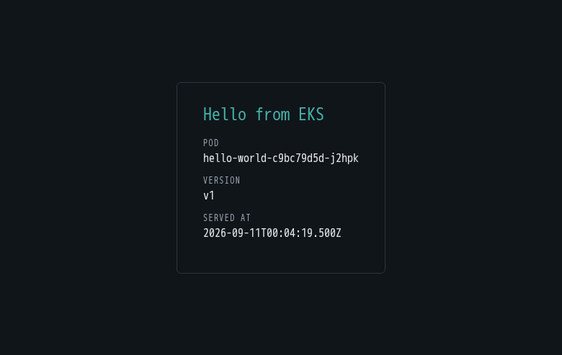
https://hello.elbeetest.com — ACM certificate, HTTP redirected to HTTPS, zero console errors. The pod name changes between requests because the ALB balances across replicas.

Before TLS, the same application served over the ALB hostname alone — the state at the end of Phase 3, kept because it shows the ingress path working independently of DNS and certificates.
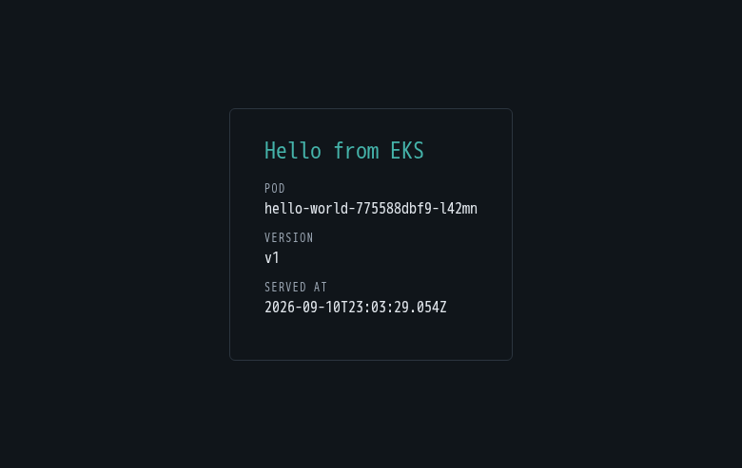
Phase 3 — internet-facing ALB on its AWS hostname, before the domain existed.

6. Logs and metrics
Log group | Contents
/aws/containerinsights/<cluster>/application | Container stdout and stderr
/aws/containerinsights/<cluster>/dataplane | kubelet, containerd, kube-proxy
/aws/containerinsights/<cluster>/host | Host system logs
/aws/containerinsights/<cluster>/performance | Container Insights embedded metrics
/aws/eks/<cluster>/cluster | Control plane: api, audit, authenticator

The nested-JSON trap. Fluent Bit wraps container stdout in the CRI envelope, so an application that logs JSON arrives with its fields as an escaped STRING inside a "log" field, not as top-level fields. Logs Insights returns rows while every field you wanted comes back empty — which reads exactly like broken logging when the pipeline is working perfectly. Use parse.

A query that works — external requests only, excluding ALB and kubelet health checks:
fields @timestamp, log
| filter log like /"msg":"request"/
| parse log '"path":"*"' as path
| parse log '"status":*,' as status
| parse log '"duration_ms":*,' as duration_ms
| parse log '"client":"*"' as client
| filter ispresent(client)
| sort @timestamp desc
| limit 50

Retention is set to 14 days by Terraform, which creates the log groups BEFORE the agent runs. Left to create them itself the agent uses "Never expire", and the logs bill forever.

7. Tearing down
Order matters. Cluster software first, because destroying the cluster while Terraform still needs to authenticate to it in order to delete Helm releases leaves an unresolvable state.
kubectl delete -k app/k8s # releases the ALB and its DNS record
cd cluster-addons && terraform destroy \
-var-file=../environments/dev.addons.tfvars
cd .. && make destroy ENV=dev

What survives a destroy. The registered domain. Registrations cannot be cancelled, so terraform destroy drops the resource from state while the registration and its renewal obligation continue. auto_renew is set to false, so elbeetest.com expires on 10 September 2027 unless renewed. The state bucket also survives, by design: it carries prevent_destroy.

Running cost
Component | Cost
EKS control plane | ~$73 / month
2 x t3.medium nodes | ~$60 / month
NAT gateway | ~$32 / month + $0.045/GB
SSM access host (t3.micro) | ~$8 / month
CloudWatch logs and metrics | usage-based, small at this scale
Domain registration | $16 / year, already paid, non-refundable
Total | approximately $173 / month

Interface VPC endpoints are disabled in dev and would add roughly $150–200/month across three AZs. They are mandatory in prod, where the API endpoint is fully private. The S3 gateway endpoint is free and always on — ECR stores image layers in S3, so without it every pull is billed as NAT data processing.

8. Troubleshooting
Symptom | Cause and fix
`kubectl` times out | Your egress IP is not allowlisted. Use `make tunnel ENV=dev`, then update the allowlist.
`terraform plan` times out on a kubernetes/helm resource | You are running the wrong root module, or you have no network path to the cluster API. Cluster software lives in `cluster-addons/`.
Error acquiring the state lock | Another apply is in progress, or one was interrupted. Confirm nothing is running before `terraform force-unlock`.
Apply fails, next plan wants to destroy | A failed apply can taint a resource. Check with `terraform show -json`, and use `terraform untaint` if the resource actually exists.
A PVC stays `Pending` | Only gp3 is marked default. A manifest naming gp2, or an older cluster with no CSI driver, will hang here with no error.
New image does not roll out | You deployed by tag rather than digest. Compare the running image against what you pushed.
ResourceInUseException: Association already exists | A Pod Identity association was declared twice. Managed addons declare `pod_identity_association`; Helm releases use the module `associations` block — never both.
ExternalDNS writes nothing | Check `--zone-id-filter`. A misnamed top-level `zoneIDFilters` Helm value is accepted and silently ignored.
Provider plugin start timeout | On Apple Silicon, an x86_64 Terraform binary under Rosetta. Use darwin_arm64.
"Unauthorized" in the console, or kubectl says "the server has asked for the client to provide credentials" | Your principal has no EKS access entry. IAM is irrelevant here -- an account with AdministratorAccess grants ZERO Kubernetes RBAC. Add the role ARN to cluster_admin_role_arns in terraform.tfvars and to the TF_VAR_cluster_admin_role_arns secret, then apply the infrastructure root. List the CI apply role too, or app-deploy loses its own kubectl access.
AlreadyExistsException creating a KMS alias | A previous teardown left the alias behind. KMS cannot delete immediately: ScheduleKeyDeletion opens a 7-30 day window and AWS does not remove the key's aliases when it opens, so an interrupted destroy orphans a name nothing can reuse and Terraform cannot see. Delete it with aws kms delete-alias. Current code gives the alias a generated suffix (name_prefix) so a rebuild cannot collide -- see ADR-0008.

Where to read next
Document | Contents
docs/architecture-review.html | The original code review and target design, with diagrams
docs/architecture.drawio | Editable architecture diagram (diagrams.net)
docs/walkthrough.md | Teaching narrative: what went wrong and what it taught
docs/adr/ | Seven architecture decision records
docs/observability.md | Log groups, working queries, the nested-JSON trap
optional/tgw/README.md | Why the Transit Gateway was removed, and when one is right
optional/efk/README.md | Post-mortem on the self-managed Elasticsearch stack
optional/jenkins/README.md | The old pipeline, defect by defect

