**EDGE COMPUTING – SOLUTION**

**INFRAMIND 2019**

Team Name: _ATOM_

from Bannari Amman Institute of Technology

**Team Members**

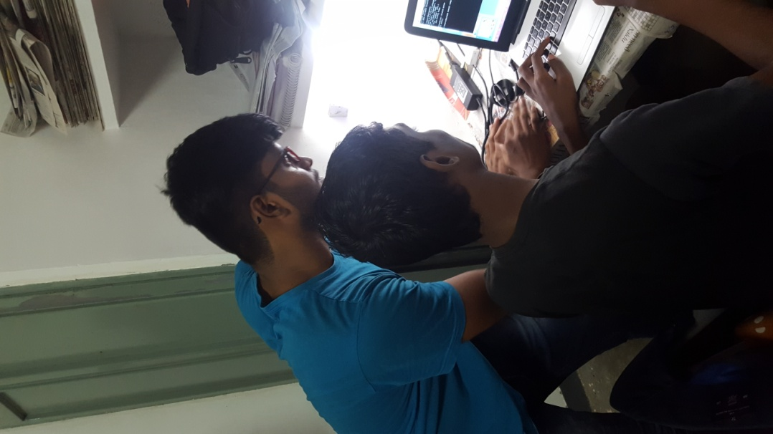

**Balamurugan T 161ME117**

* Department of Mechanical | Final Year | 9488641192 | tbala2805@gmail.com

**Praveen V 161MC167**

* Department of Mechatronics | Final Year |8883168568 | praveen241298@gmail.com



**Introduction**

Now a days in retail shops workers spend more time in checkout systems. Billing counters are not much user friendly for workers because of this customer spend more time in billing counters to bill their products. And also delayed checkout system will affect the sales of the retail stores.

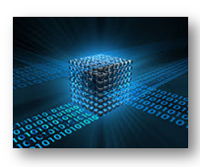

**Existing system**

In retail shops presently using barcode scanners to quickly finish the checkouts. But it is not the fastest way of doing checkouts. Some of the disadvantages are

* Cannot able to find damaged labels.
* Different products have barcodes in different sides so workers have to search for barcodes in products, so it takes time to scan different products.
* Not able to scan many products at a same time, products must be scanned one by one.

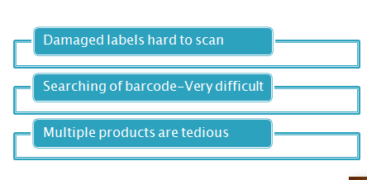

**Proposed System**

The proposed system uses edge computing along with machine learning technology to automate the checkout system. This system identifies the product by capturing image of the product and process the image using neural networks.

The machine learning model detect the product with respect to brand and size of the product.

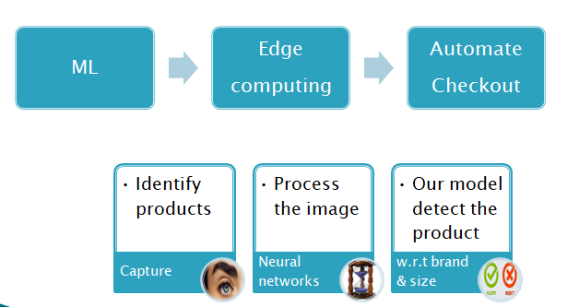

**Details of technology Used**

The technologies used to make the system are listed below

* Image processing
* Deep learning
* Edge computing
* Web technology

**Image processing**

Image processing technology is used to capture and process the image before giving input to the neural network. And also, image processing technique is used to find the size of the product by comparing with the reference object on the same plane.

**Deep learning**

Deep learning technology is the heart of this system. A deep learning model is trained to detect the various products on the store. For deep learning we are using Darknet yolo model, this yolo model is best suitable for real time object detection.

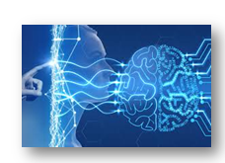

**Edge computing**

Edge computing technology is used to process the captured image in neural network closer to the retail store to reduce the latency which occurs during the cloud computing. The server which process the image and the web server and neural network is located inside or closer to retail store.

**Web technology**

Web application is created to capture the image of the product and to show the billing details of each product. Web application capture the image send image to the sever and show the results returned from the server.



**Required Software /Hardware**

Software and hardware required for this system are listed below

* Laptop
* Web camera
* Xampp
* Darkflow (github repository)
* Python 3.7
  + Tensorflow
  + Opencv
  + Numpy
  + Mysql connector

**Xampp**

Xampp is a software installed in laptop to host web server in a laptop. Xampp runs apache web server in port 8080 and 443. And also, xampp runs the mysql database in the local machine to store the data of the image captured and product details identified from image by neural network.

**Darkflow**

Darkflow is the github repository which provides the machine learning model for object detection. We trained this available model to detect the various products available in the retail store. Darkflow uses yolo (you look only once) model for object detection. Github link: <https://github.com/thtrieu/darkflow>

**Python**

Python language is used to load the machine learning model along with the weights trained and detect the product. The identified product label is stored in the database using mysql connector library. The size of the product is identified by processing the image using the opencv and numpy library.

**Architecture:**

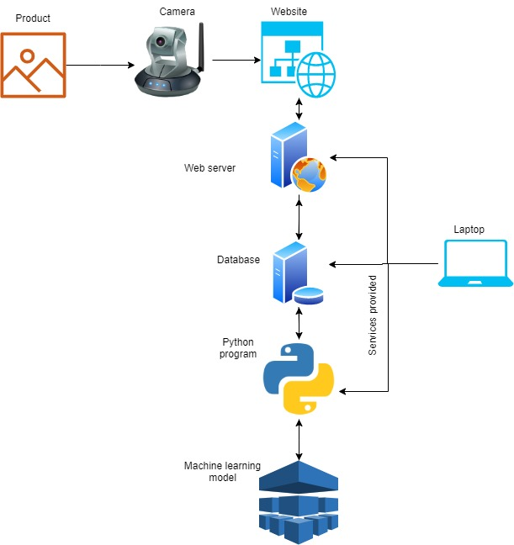

**Machine learning Model Training an Evaluation:**

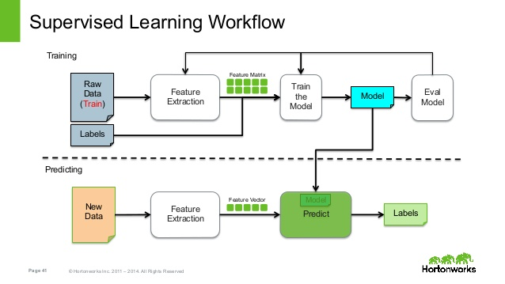

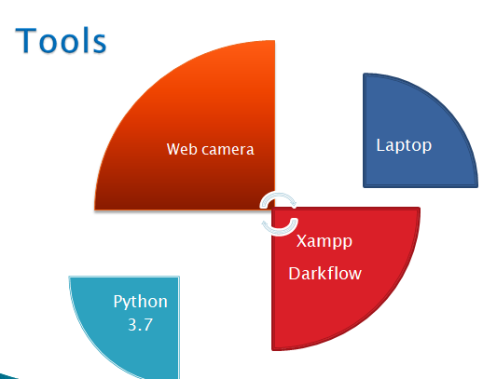**Architecture of Neural Network**

* Convolution Neural Network:
  + Convolution layers
  + Pooling layers
* Fully connected Neural Network:
  + Flatten layers
  + Hidden layers
  + Output layer
  + Activation function
    - Relu activation function - Hidden layers
    - Softmax activation function -Output layers

**Solution Brief Description:**

**Client Side:**

* First the user will open the web application, the web application shows the live video feed from the camera.
* Worker take a snapshot of the product and the add to the cart by using **take snapshot** and **add** button in web application after product is placed in front of the camera.
* After all products are added to the cart user will submit the images using **submit** button.
* On successful submission the images are submitted in base64 string format.
* If the detection process is completed the present webpage redirects to billing page which shows the bill for the submitted products.

**Server Side**

* When submit button is pressed php script receives the image in base64 string format and then image is decoded and stored in local storage and location, Id, image status and image name is updated into the database.
* Parallelly python program running on the machine which detect the change in the database.
* Python script get the image details from the database and run the neural network to detect the product. After detection, the label and size of the product is updated to the database.
* Php script get the label detail from the database and compared with the available products and shows the bill to the user.
* The size of the object is detected by comparing the size of the reference object with the product.
* The reference object and product must be in same plane to find the exact size of an object.

**Scope of Automation**

* This system able to find the products by manually taking pictures of products this will be automated in future design.
* System will be improved to detect many products from single image taken from the camera this will reduce the time further.
* By applying above improvements, we can automate the full checkout process without any human actions.

**Conclusion**

The proposed system will be better when compared to the existing system and it will reduce the time of customers in queue. Because of the deep learning method used in the system it will have high accuracy than any other systems.