**PETATL.**

Project Report

***Team 7*** : Akshay Bhatkar

Sukhada Sathaye

Vrushali Tarawade

Tarun Balani

Contents

Introduction: 3

User requirements Analysis: 3

Conceptual Design 6

Relation Normalization 7

Database Implementation 12

Web Application Design and Flow: 12

# Introduction:

PetAtl, a company specialized in dry dog food, wants to create an online retail store to sell packaged dry dog food. The online retail store should allow customers to browse all dry dog food packages and place orders for them. The online store currently accepts only credit card payment.

***Contents :***

1. Requirement Analysis
2. Conceptual design
3. Logical design
4. Database implementation
5. Online store Web application development.

# User requirements Analysis:

User requirements analysis and conceptual ER modeling.

As the scope of the database is to store and manage all the Online Store data, the analysis has been focused on areas within the given scope. The results of the analysis are presented as entity types and relationships.

**Entity Types**:

The requirements analysis identified the following entity types

**CustomerInfo:**

**IDCustomer:** a unique Customer identifier assigned by the Online Store when each Customer Joins the Online Store. It is never reused.

**FirstName:** the first name of a Customer. It may not be unique as two or more Customers may have the same name.

**LastName:** the last name of a Customer. It may not be unique as two or more Customers may have the same name.

**PrimaryPhoneNumber:** the primary phone number of the customer and it can be assumed as a unique value

**SecondaryPhoneNumber:** the secondary phone number of the customer and it can be assumed as a unique value

**e-mailAddress:** the e-mail address of the customer which is a unique field as two customers can not have same e-mail address

**Address:** This is a multi-valued attribute, the address of a Customer. A customer may have one to many Address. It is provided by the customer and may not be unique as multiple customers may have the same address. It consists of Apt, State, Building, Zip code, Area code and an IDAddress - a unique Address identifier assigned by the Online Store when each Address is added to the Online Store by the customer.

**Product:**

**IDProduct:** a unique Product identifier assigned by the Online Store for every product on the Online Store. It is never reused.

**ProductName:** Title of the Product given by the product Manufacturer.

**ShortDescription:** Short description of the product provided by the Manufacturer of the product.

**LongDescription:** Longdescription of the product provided by the Manufacturer of the product.

**Price:** Selling Price of the Product given by the online store.

**BestSelling:** is the attribute which gives the best selling price of that particular project till date

**Availability:** is the quantity of that specific product that are available with PetAtl

**ProductSize:** is the size of that specific product

**Image:** is the product’s image that will be seen in the PetAtl online store.

**ProductSize:**

**IDProductSize:** this is the unique product size number given to each size of each product in the database

**QuantityAvailable:** the quantitythat is available specific to the size of the product

**ActualWeight:** the actual weight of each size of the products

**Price:** price of the product which is specific to the size of the product

**ProductDetail:** this is a multi-valued composite attribute that has **dimensions** of the product which is size specific, **flavours** of the product, **shipping weight** of the product which is specific to the size of the product.

**Seller:**

**IDSeller:** a unique Seller identifier assigned by the Online Store when each Seller joins the Online Store. It is never reused

**SellerName:** the name of a Seller. It may not be unique as two or more Sellers may have the same name.

**Rating:** the rating of the products that were sold by the seller

**Address:** This is a multi-valued attribute, the address of a Seller. A Seller may have one to many Address. It is provided by the Seller and may not be unique as multiple Seller may have the same address. It consists of Apt, State, Building, Zip code, Area code and an IDAddress - a unique Address identifier assigned by the Online Store when each Address is added to the Online Store by the Seller.

**CreditCardInfo:**

**CardNum:** this is the unique number as a apecific card can have only single card number

**CardType:** the type of the card which the customer uses

**NameOnCard:** each card has a name printed on the card

**CVV:** the three digit number that exists on back side of the card

**ExpiryDate:** the date when this specific card expires.

**GiftCard:**

**CardNum:** the unique number which the gift card has which is specific to the gift card

**Balance:** the balance credit that is available with each gift card

**Review:**

**IDReview:** the unique ID of each review of the products

**ReviewerName:** is the name of the reviewer who is reviewing the product

**Rating:** is the rating provided to that specific product by the reviewer

**CustomerComment:** is the comment passed by the customer regarding the product that he/she knows

**Offer:**

**IDOffer:** the unique ID of the offer which the customer uses in order get the offer

**DiscountRate:** the discount amount that can be available by using that particular offer

**ExpiryDate:** the date when the product gets expired

**Cart:**

Each customer has a unique cart which has a unique IDCart and the cart has products that were short listed by the customer.

**Order:**

**IDOrder:** Each order that is placed is stored in the order database with certain specific number which is IDOrder

**GiftPack:** this asks the customer whether to gift pack the product and the values will be Yes or No

**Status:** this shows the status of the order placed like shipped, delivered or processed

**DeliveryDate:** this shows the estimated delivery date of the ordered products

**Quantity:** shows the quantity of the products in the order

**Price:** gives the price involved in the order

**PriceWithTax:** this gives the total price of the order including tax

**OrderHistory:**

**IDOrder:** Each order that is placed is stored in the order database with certain specific number which is IDOrder

**OrderNum:** this is similar to the IDOrder but has different naming convention according to the product

**OrderDate:** the date when the order is placed.

**DeliveryAddress:** this is a composite key which has street, city, state, zip code which has address of the customer of this particular order

**Questions:**

**IDQuestion:** this is the unique number which is allocated to each question asked by the customers

**Question:** this consists of the questions that were asked byt the customers regarding any specific product

**Answer:**

**IDAnswer:** this is the unique number which is allocated to each answer given by the sellers to questions that were asked by the customers

**Answer:** this is the answer given by the seller to the questions asked by the customer of the product

# Conceptual Design

The conceptual design of the Online Store Application consists of two steps:

***ER Modelling:***

***Business Rules:***

1. A customer views various products online and stores some selected products in to the cart. A customer can ask zero or many questions and he/she can use their creditcards or gift cards to pay the bill of the ordered products.
2. A seller sells various products and can answer the questions related to the products.
3. A product can have zero or many reviews based on its features and may also contain offers. A product is sold by atleast one or many sellers and the selected products by customers set stored in the cart which is specific to customer.
4. Questions related to products will be asked by the customers and the answers related to these questions will be answered by the seller.
5. Offers will be offered to certain products depends on the demand and the time.
6. Giftcards and creditcards will be used by the customers to order the products.
7. OrderedProduct is the relation between the product and the order which has the giftpack selection, delivery date and price including tax as attributes.
8. Order table is specific to the customer and time. Each time customer orders products from retail store then the software generates new IDorder specific to that particular order.
9. Product size is specific to products and it contains all the details of the product including flavours, sizes and the availablity of the particular size of the product.

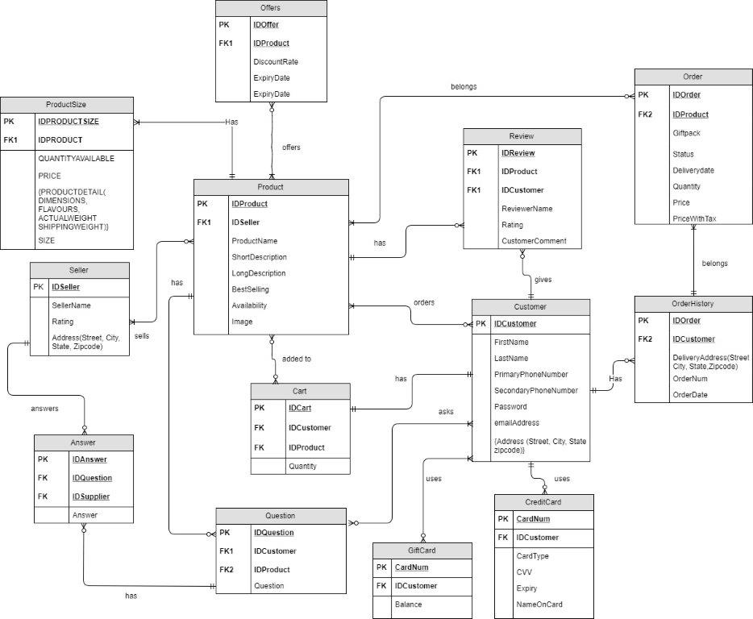

# Relation Normalization

|  |  |  |
| --- | --- | --- |
| SR. NO. | TABLE | COLUMNS |
| 1 | SELLER | (IDSELLER, SELLERNAME, RATING, STREET, CITY, STATE, ZIPCODE) |
| 2 | PRODUCT | (IDPRODUCT, PRODUCTNAME, SHORTDESCRIPTION, LONGDESCRIPTION, PRICE, BESTSELLING, AVAILABILITY, IMAGE, IDSELLER(FK)) |
| 3 | CUSTOMERINFO | (IDCUSTOMER, EMAILADDRESS, PASSWORD, FIRSTNAME, LASTNAME, PHONE1, PHONE2) |
| 4 | QUESTIONS | (IDQUESTION, QUESTION, IDCUSTOMER(FK)) |
| 5 | GIFTCARD | (CARDNUMBER, BALANCE) |
| 6 | OFFERS | (IDOFFER, DISCOUNTRATE, EXPIRYDATE, IDPRODUCT(FK)) |
| 7 | ANSWER | (IDANSWER, IDQUESTION(FK), ANSWER, IDSELLER(FK)) |
| 8 | REVIEW | (IDREVIEW, REVIEWERNAME, RATING, CUSTOMERCOMMENT, IDPRODUCT(FK)) |
| 9 | ADDRESS | (IDADDRESS, STREET, CITY, STATE, ZIPCODE, ADDRESSTYPE, DEFAULTADDRESS, IDCUSTOMER(FK)) |
| 10 | CREDITCARDINFO | (CARDTYPE, CARDNUMBER, CVV, NAMEONCARD, MONTH, YEAR, IDCUSTOMER(FK)) |
| 11 | PRODUCTSIZE | (IDPRODUCTSIZE, IDPRODUCT(FK), PRODUCTSIZE, QUANTITYAVAILABLE) |
| 12 | PRODUCTDETAIL | (IDDETAILS, DIMENSIONS, ACTUALWEIGHT, FLAVOURS, SHIPPINGWEIGHT, IDPRODUCTSIZE(FK)) |
| 13 | ORDERHISTORY | (IDORDER, ORDERNUM, ORDERDATE, IDADDRESS(FK), IDCUSTOMER(FK)) |
| 14 | CART | (IDCART, QUANTITY, IDCUSTOMER(FK), IDPRODUCT(FK)) |
| 15 | ORDEREDPRODUCT | (IDORDER(FK), IDPRODUCT(FK), GIFT, PRICEPLUSTAX, DELIVERYDATE, STATUS, QUANTITY) |

* **SELLER**

The seller entity stores the manufacturer information like : seller name, rating and address. It is an independent entity with IDSELLER as its primary key.

* **PRODUCT**

The entity stores information related to all dry dog food products sold by petAtl. It has a many to many relation with customers. The products bought by customers are stored in the cart entity.

* **CUSTOMERINFO**

CustomerInfo entity is an independent entity with primary key, IDCUSTOMER. It stores all customer specific details.

* **QUESTIONS**

A customer can have doubts related to the availability, quality, delivery time etc about products sold by petAtl. These questions are recorded in the questions table. It has a one to many relation with customers. So, a foreign key, IDCUSTOMER is created in the entity.

* **GIFTCARD**

Customer specific gift card details are stored in this entity. It has a many to many relation with customer and a IDCUSTOMER foreign key.

* **OFFERS**

Product specific offers provided by petAtl are stored in offers entity. It stores the product primary key as a foreign key.

* **ANSWER**

The answers given by manufacturers are stored in the answer table. It has a one to many relation with seller. Thus, has foreign key IDSELLER.

* **REVIEW**

Product specific reviews given by customers are stored in the review table. It stores primary keys of product and customer entity as foreign key.

* **ADDRESS**

Billing and shipping addresses of customers are stored in this table. It has customer id as foreign key.

* **CREDITCARDINFO**

Customer specific credit card details are stored in this table. It has a one to many relation with customer entity.

* **PRODUCTSIZE**

The products sold by petAtl arer available in different quantities like 200grams, 500grams, 1kg, etc. These are stored in this table. It is a weak entity. So, its primary key is a combination of product id and product size id.

* **PRODUCTDETAIL**

Product specific extra details are stored in this table. It is also a weak entity. So, its primary key is a combination of product id and product details id.

* **ORDERHISTORY**

Products ordered and purchased by customers are stored in orderhistory entity. It is a weak entity. Its primary key comprises of order id and product id.

* **CART**

Customer wish list is stored in this table till the order is not finalized. It has product and customer primary keys as foreign keys.

|  |  |  |  |
| --- | --- | --- | --- |
| **TABLE** | **CANDIDATE KEY** | **PRIMARY KEY** | **NON-PRIME ATTRIBUTES** |
| SELLER | IDSELLER, ZIPCODE | IDSELLER | SELLERNAME, RATING, STREET, CITY, STATE, ZIPCODE |
| PRODUCT | IDPRODUCT | IDPRODUCT | PRODUCTNAME, SHORTDESCRIPTION, LONGDESCRIPTION, PRICE, BESTSELLING, AVAILABILITY, IMAGE, IDSELLER(FK) |
| CUSTOMERINFO | IDCUSTOMER, EMAILADDRESS | IDCUSTOMER | EMAILADDRESS, PASSWORD, FIRSTNAME, LASTNAME, PHONE1, PHONE2 |
| QUESTIONS | IDQUESTION | IDQUESTION | QUESTION, IDCUSTOMER(FK) |
| GIFTCARD | CARDNUMBER | CARDNUMBER | BALANCE |
| OFFERS | IDOFFER | IDOFFER | DISCOUNTRATE, EXPIRYDATE, IDPRODUCT(FK) |
| ANSWER | IDANSWER | IDANSWER | IDQUESTION(FK), ANSWER, IDSELLER(FK) |
| REVIEW | IDREVIEW | IDREVIEW | REVIEWERNAME, RATING, CUSTOMERCOMMENT, IDPRODUCT(FK) |
| ADDRESS | IDADDRESS, ZIPCODE | IDADDRESS | STREET, CITY, STATE, ZIPCODE, ADDRESSTYPE, DEFAULTADDRESS, IDCUSTOMER(FK) |
| CREDITCARDINFO | CARDNUMBER | CARDNUMBER | CARDTYPE, CVV, NAMEONCARD, MONTH, YEAR, IDCUSTOMER(FK) |
| PRODUCTSIZE | IDPRODUCTSIZE, IDPRODUCT(FK) | IDPRODUCTSIZE, IDPRODUCT(FK) | PRODUCTSIZE, QUANTITYAVAILABLE |
| PRODUCTDETAIL | IDDETAILS | IDDETAILS | DIMENSIONS, ACTUALWEIGHT, FLAVOURS, SHIPPINGWEIGHT, IDPRODUCTSIZE(FK) |
| ORDERHISTORY | IDORDER | IDORDER | ORDERNUM, ORDERDATE, IDADDRESS(FK), IDCUSTOMER(FK) |
| CART | IDCART | IDCART | QUANTITY, IDCUSTOMER(FK), IDPRODUCT(FK) |
| ORDEREDPRODUCT | IDORDER(FK), IDPRODUCT(FK) | IDORDER(FK), IDPRODUCT(FK) | GIFT, PRICEPLUSTAX, DELIVERYDATE, STATUS, QUANTITY |

***Functional Dependencies***:

The relations are in 3NF because:

* The relations are not in 3NF because a transitive dependency exists.
* All non-prime attributes are fully dependent on the **whole** Primary Key.
* Each entity has a sole purpose.

***2NF:***

IDCustomer -> first name, last name, primary phone number, secondary phone number, email address, state, city street, zipcode

IDSeller -> seller name, rating, street, city, state, zipcode

IDProduct -> product name, short description, long description, price, bestselling, availability, image

IDProductSize -> QuantityAvailable, Price, ActualWeight, Dimensions, Flavours, ShippingWeight

IDCart -> IDCustomer, IDProduct , quantity

Cardnumber -> card type, IDCustomer , CVV, expiry, name on card

Giftcardnum -> IDCustomer, Balance

IDOrder -> IDAddress, OrderNum, OrderDate

IDQuestion -> IDCustomer, Question

IDAnswer -> IDQuestion, IDSeller, Answer

IDOffer -> IDProductFK , Discount rate, expiry date

IDReview -> IDProductFK, Reviewer name, rating, customer comment

***3NF:***

IDProduct 🡪 ProductName, ShortDescription, LongDescription, Price, BestSelling, Quantity Available, Image, ProductDetails, Product size, IDSeller

IDReview 🡪 ReviewerName, Rating, CustomerComment, IDProduct

IDQuestion 🡪 IDCustomer, Question

IDProductSize 🡪 QuantityAvailable, Price, ActualWeight, Dimensions, Flavours, ShippingWeight

IDSeller 🡪 SellerName, Address, Rating

IDOrder 🡪 OrderNum, OrderDate, IDAddress

IDCart 🡪 Quantity, IDCustomer, IDProduct

IDOffer 🡪 DiscountRate, ExpiryDate, IDProduct

IDAnswer 🡪 IDQuestion, Answer, IDSupplier

{IDOrder-IDProduct} – GiftPack, Price, PriceWithTax, DeliveryDate

IDCustomer 🡪 FirstName, LastName, PrimaryPhoneNumber, SecondaryPhoneNumber, emailAddress

CardNumber 🡪 CardType, CVV, Expiry, NameOnCard, IDCustomer

GiftCardNo 🡪 Balance, IDCustomer

IDAddress 🡪 Street, City, State, ZipCode

# Database Implementation

**Physical Table Design:**



**SQL Statements:**

**Create Table:**



**Insert Table:**



**Drop Table:**



# Web Application Design and Flow:

1. **Product Page** 
   1. It is the Homepage of the online application.

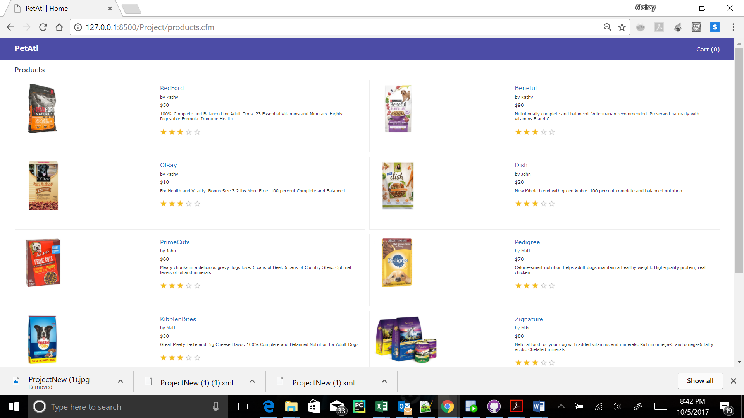

1. **Product details page:**
   1. You come to this page after clicking on one of the products on Product page.

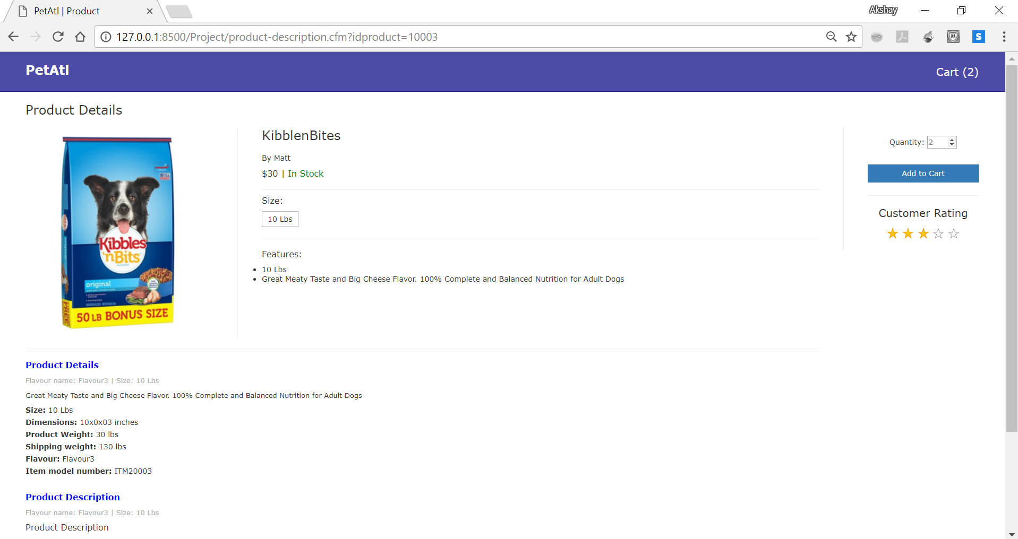

1. **Cart page:**
   1. You come to this page after clicking on **Cart(2)** onProduct Details page.

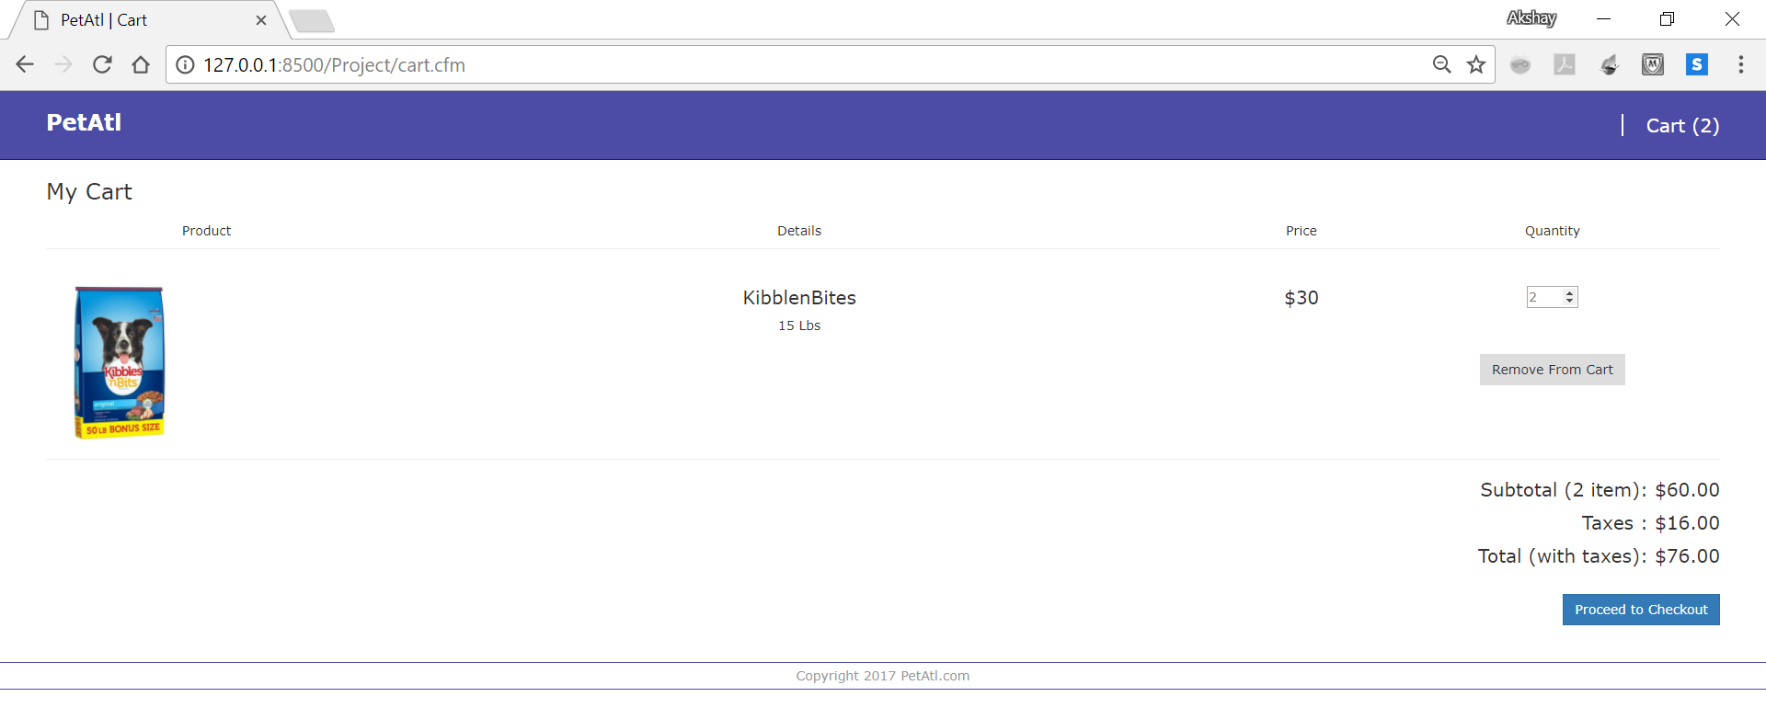

1. **Create New Account and Credit Card Info page (and hence called Payments page):**
   1. After clicking on **Proceed to checkout** button, you get navigated to this page.
   2. If you already have an account, you can click on **Login** and go to Login page.
   3. If not, you will have to fill all the details and then click on **Continue.**

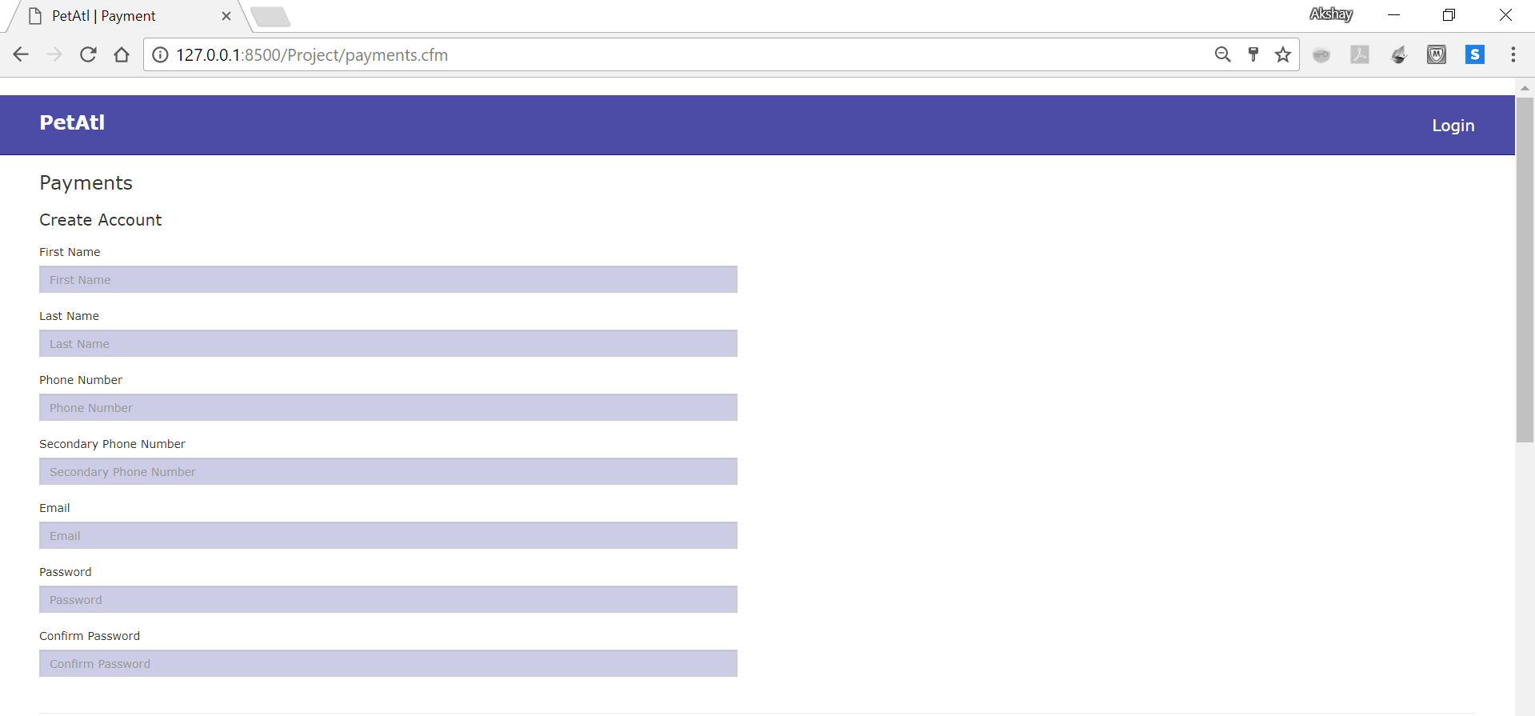

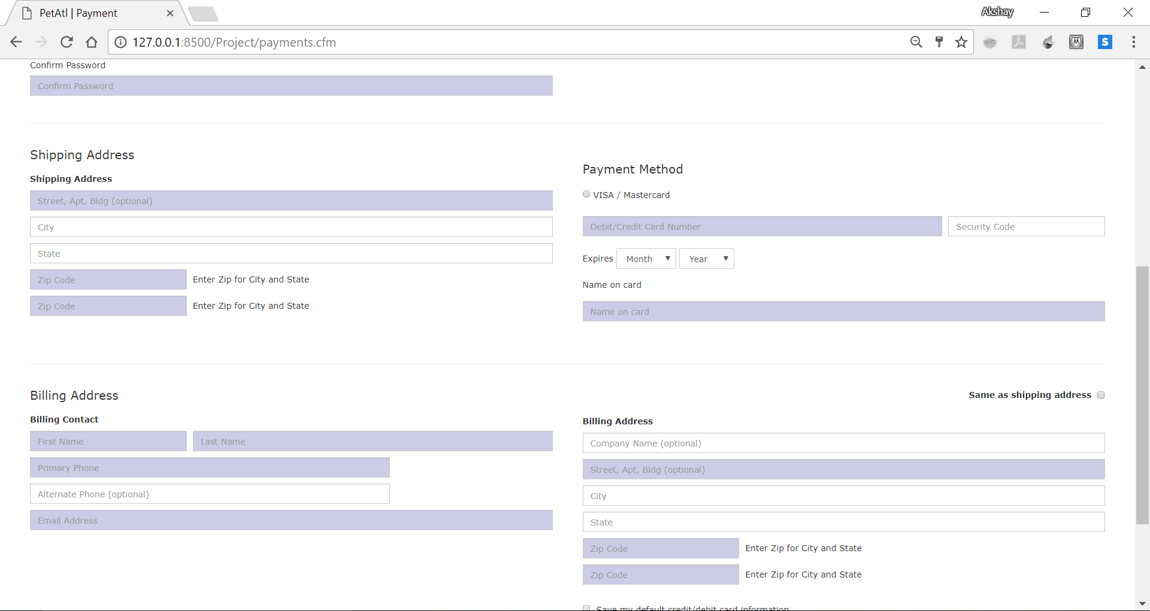

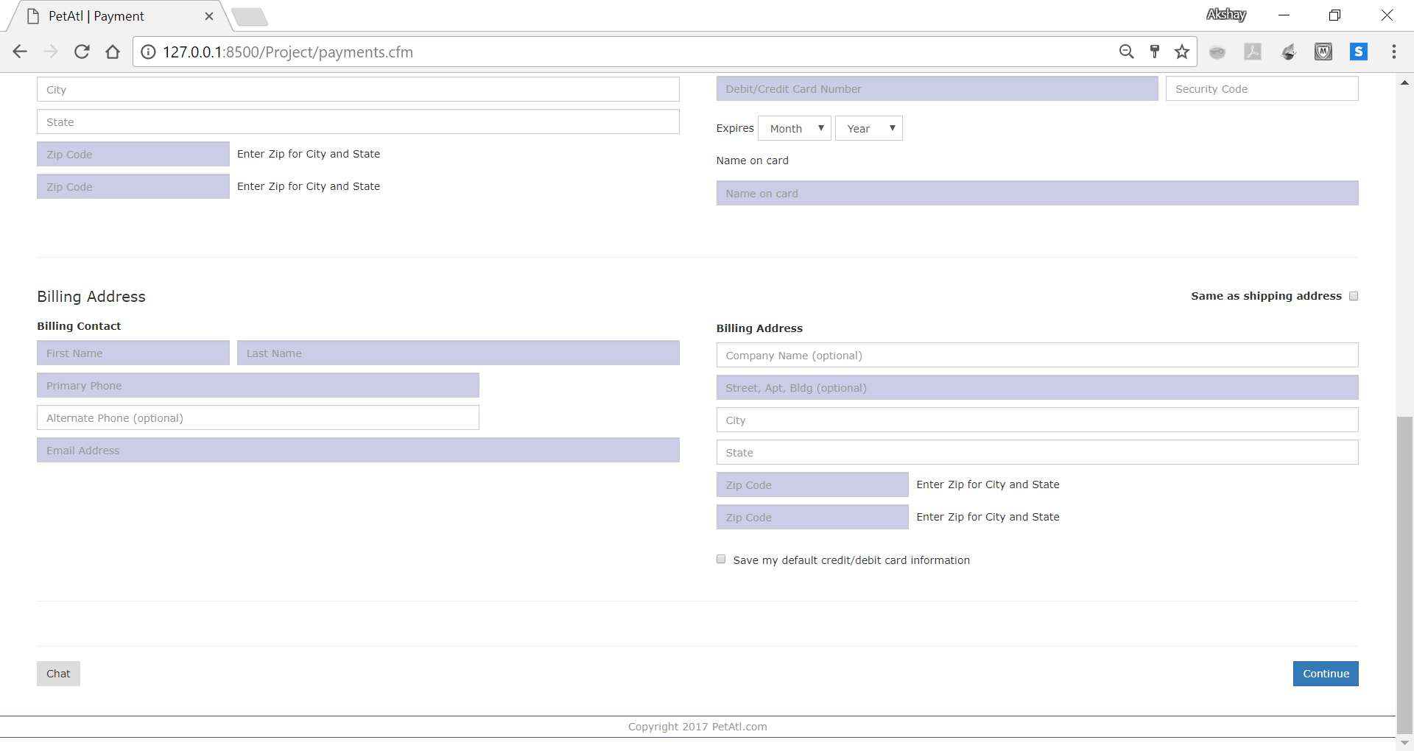

1. **Login page:**
   1. You come to this page after clicking **Continue** **button** at the bottom of **Create Account page** or the **Login link** at the top right of **Create Account page.**
   2. From here you can also go back to the **Create Account** **page** by clicking on **Register** link at the top right.

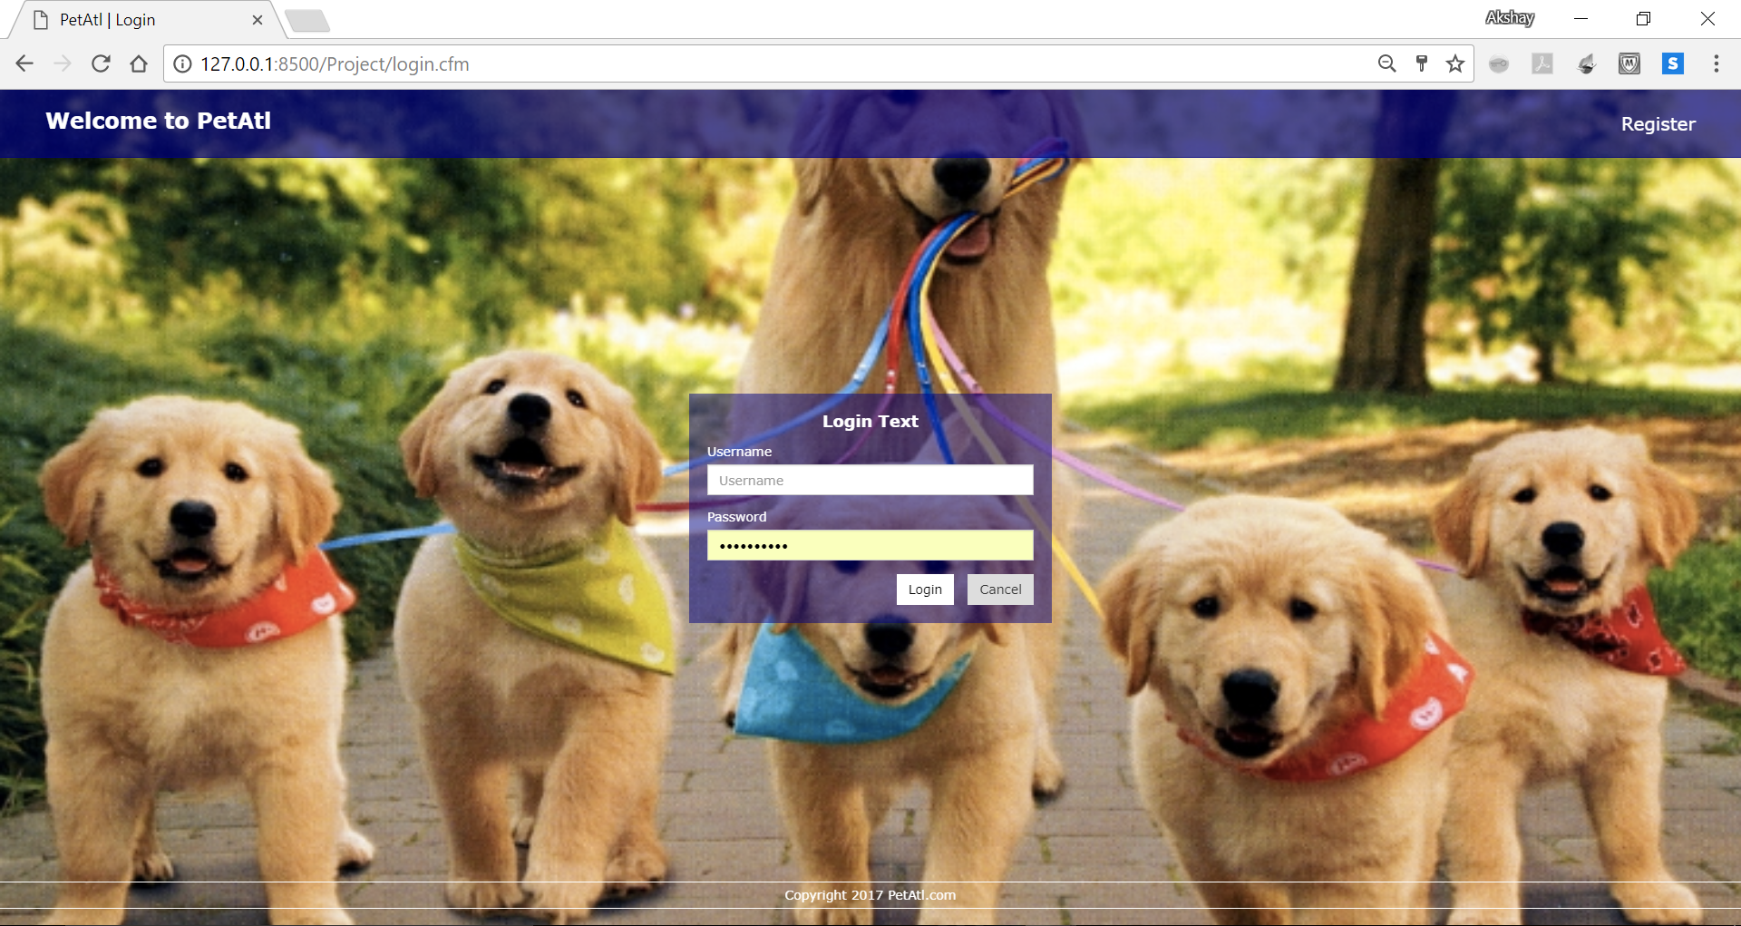

1. **Checkout Page:**
   1. After logging in with correct credentials, you come to to the checkout page.
   2. For this instance we login with the user – **Vrush Tara.** You can see the name on the topright of the page.

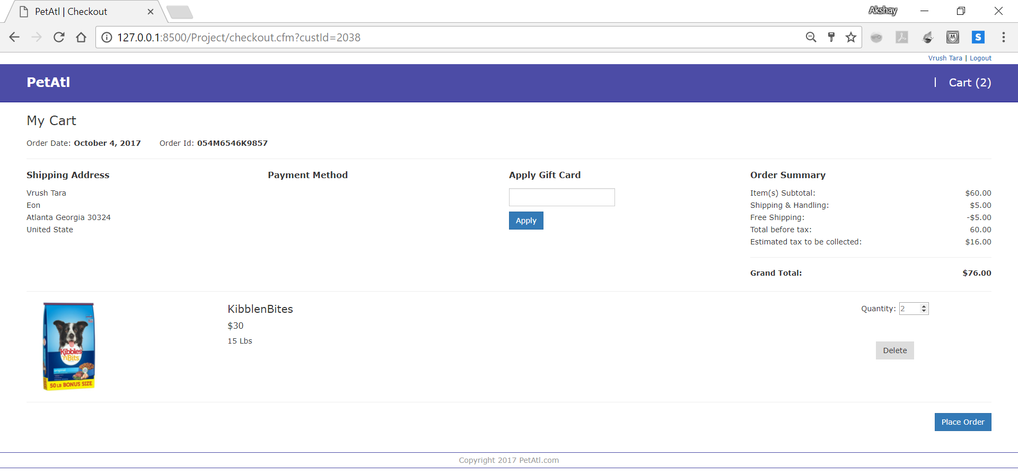

1. **Order History page:**
   1. After clicking on **Place Order button** on **Checkout page**, you come to the Order History page.
   2. Here you can see all the orders and the **status** of the products – whether order placed or dispatched or delivered.
   3. Clicking on the **Logout link** at the topright, the user is logged out and redirected to **Login page**.

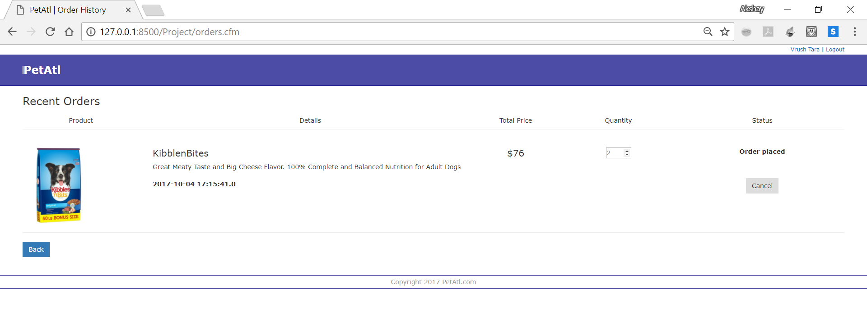

1. **User profiles page:**
   1. You come to this page by clicking on the user name at the top right of **Checkout page** or the **Order History page**.
   2. This page enables you to update the User information.
   3. Snapshots show the details of logged in user **Vrush Tara**.
   4. Clicking on the **Logout link** at the topright, the user is logged out and redirected to **Login page**.

